CPE301 – FALL 2019

Design Assignment 5

Student Name: Brysen Kokubun

Student #: 2001009068

Student Email: brysenkokubun96@gmail.com

Primary Github address: https://github.com/bkokubun99/Submission_DesignAssignments

Directory: <https://github.com/bkokubun99/Submission_DesignAssignments/tree/master/DesignAssignment_5>

1. **COMPONENTS LIST AND CONNECTION BLOCK DIAGRAM w/ PINS**

Atmel Studio 7.0 Atmega328PB-Xmini PC LM-35 Sensor NRF24L01

- Assembler -Multifunction Shield

- Simulator

- Debugger

1. **INITIAL/MODIFIED/DEVELOPED CODE OF TASK 1/A**

1. **DEVELOPED MODIFIED CODE OF TASK 2/A from TASK 1/A**

N/A

1. **SCHEMATICS**

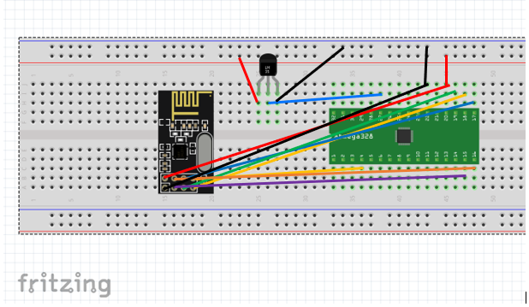

1. **SCREENSHOTS OF EACH TASK OUTPUT (ATMEL STUDIO OUTPUT)**

1. **SCREENSHOT OF EACH DEMO (BOARD SETUP)**

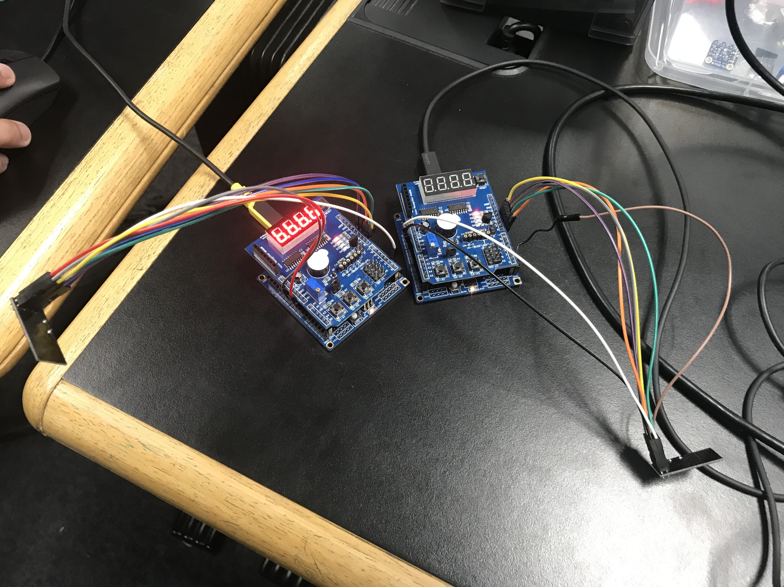

1. **VIDEO LINKS OF EACH DEMO**

YouTube Video Demo - <https://youtu.be/nQO1r27S0vw>

1. **GITHUB LINK OF THIS DA**

<https://github.com/bkokubun99/Submission_DesignAssignments/tree/master/DesignAssignment_5>

**Student Academic Misconduct Policy**

<http://studentconduct.unlv.edu/misconduct/policy.html>

“This assignment submission is my own, original work”.

Brysen Kokubun