Team Charlie

Alexander Zayas

Botiwa Konan

Caitlan Nichols

Scott Cacal

Pilot Program: Willson Financial

This final milestone document contains the database and update report output respectively.

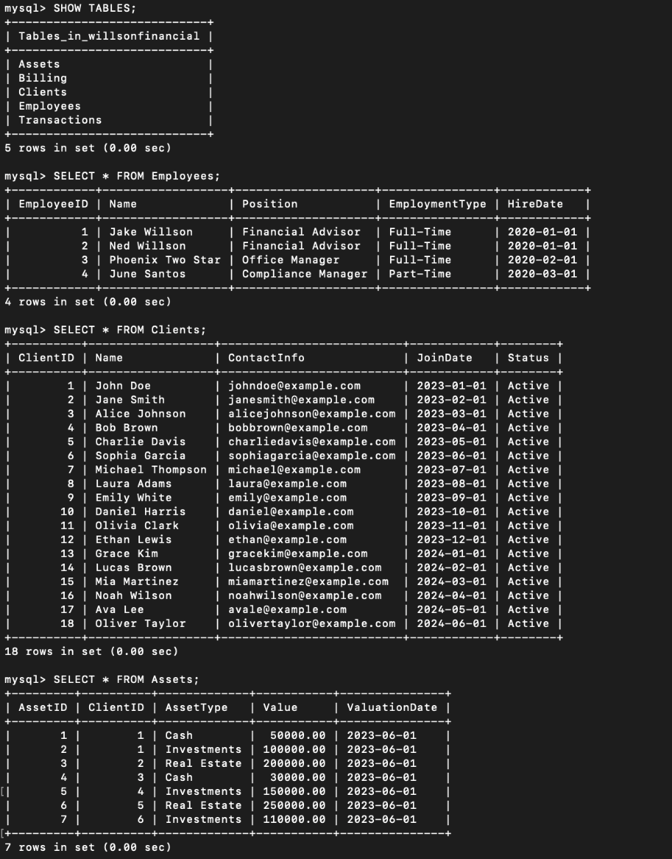

*Database Output 1*

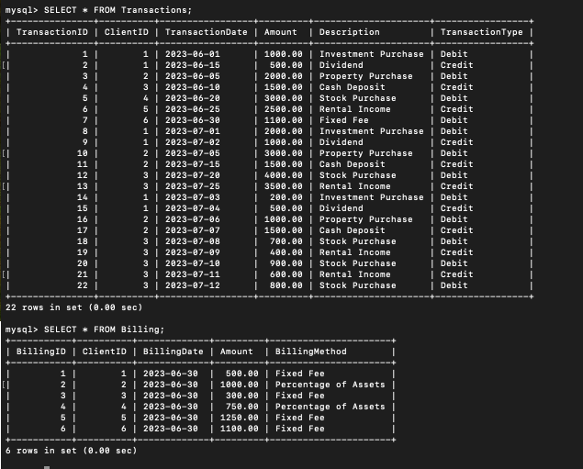

*Database Output 2*

If needed and for simplicity running the python script, ViewTables.py, will provide the same information.

**Average Client Assets Report**: This script calculates the average amount of assets for the entire client list.



*FINALAverageClientAssetsReport.py output*

**Clients with Highest Total Asset Value Report:** This script identifies clients with the highest total asset value.

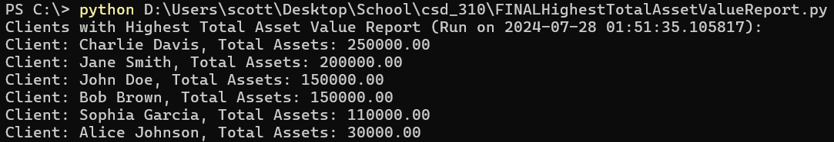

*FINALHighestTotalAssetValueReport.py output*

**New Clients Added Per Month Report**: This script needs to count the number of clients added each month for the past six months.

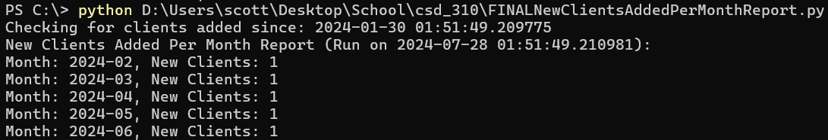

*FINALNewClientsAddedPerMonthReport.py output*