MileStone # 3

Charlie Group

July 17th, 2024

Report Output

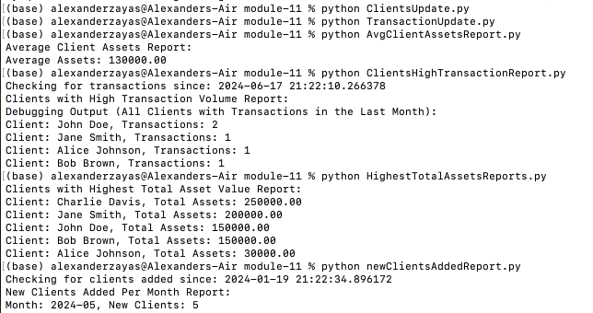

Database

