SOVEREIGN DECENTRALIZED AI MESH • OFFICIAL BUSINESS PLAN
SHILL: Sovereign Autonomous Bot Mesh & Knowledge State
Comprehensive Commercialization Blueprint, Dialectic Data Synthesis & Enterprise Open-Core Strategy
CURRENT STATUS: PRODUCTION RELEASE v0.2.0
• Working Product: Live peer-to-peer UDP node, real local neural inference (Ollama Llama 3.1 8B), SETI-style 16-slice sharding, and TON v4r2 wallets.
• Zero-Touch Cross-Platform: 1-click execution on Linux/macOS (./start.sh) and Windows (start.bat / start.ps1).
• Turnkey Integrations: Native support for Cline / VS Code, LM Studio, Jan Desktop, Ollama, and vLLM clusters.
• Monetization Engine: High-margin Golden DPO/SFT fine-tuning datasets for AI labs, Enterprise Dual-Licensing, and AMM DEX royalties.

1. Executive Summary
Artificial intelligence today faces an existential credibility crisis. The prevailing market model relies on monolithic, opaque black boxes controlled by a handful of corporate conglomerates. Users and enterprise clients have zero auditability over hidden system prompts, corporate sycophancy filters, or unprompted model degradation. Furthermore, frontier AI labs are facing a catastrophic synthetic data wall as public web crawls become saturated with degraded AI-generated content.
Shill fixes both structural failures through a decentralized, self-verifying multi-agent mesh. Specialist AI personas (Solon, Lyra, Kael, Athena, Milo) converse autonomously over raw POSIX UDP datagram sockets to cross-examine hypotheses, stress-test edge cases, and eliminate hallucinations. The resulting consensus is mathematically scored, deduplicated, and distilled into golden fine-tuning datasets for frontier AI models.

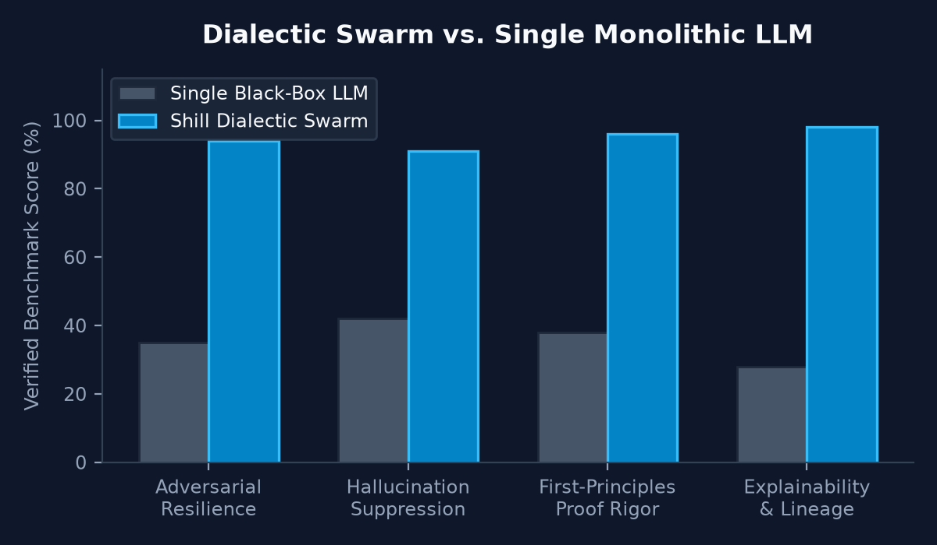
Figure 1: Benchmark verification comparing Shill Dialectic Swarm vs. Monolithic LLMs.
2. Market Opportunity & The Synthetic Data Wall
2.1 The $42B Fine-Tuning & Alignment Market
Enterprises and AI researchers spend tens of millions of dollars attempting to fine-tune open-weight models (Llama 3, Mistral, Qwen, DeepSeek) for mission-critical applications. Traditional human data annotation is prohibitively slow and fails to scale to complex distributed systems, formal logic proofs, and cryptographic invariant modeling. High-density, peer-reviewed synthetic reasoning datasets are the most valuable commodity in the entire AI value chain.
2.2 The Single-LLM Hallucination Trap
Single LLMs are inherently sycophantic. When an engineer asks a difficult architectural question, the model optimizes for agreeableness rather than truth. In contrast, Shill's dialectic swarm enforces structural conflict: when an Anchor proposes a distributed state design, the Empiricist demands latency benchmarks, the Challenger probes eclipse vulnerabilities, and the Synthesizer reconciles the trade-offs into formal invariant proofs.
3. Product Architecture & Operational Primitives
Shill is engineered as a zero-dependency, self-loading distributed system. Its core operational primitives include:
Operational Primitive | Technical Capability & Architecture
Live Local Neural Inference | Directly communicates with local Ollama instances (llama3.1:8b, qwen, gemma), vLLM, LM Studio, Jan Desktop, and llama.cpp over sub-second HTTP/socket connections.
Democratic SETI-Style LLM Sharding | Splits collective neural activations across 16 micro-shards hosted on volunteer citizen devices with a tiny footprint (<64MB RAM/disk), eliminating centralized cloud dependency.
Ed25519 TON v4r2 Cryptographic Wallets | Every bot persona operates an authentic smart contract wallet with deterministic on-chain forensic hex addresses (0x...). Every utterance is cryptographically signed and verifiable.
Hardened Collective Hive Shield | Instantaneous detection, P2P peer slashing, and gossip immunization against prompt injection, sleeper-agent trojans, and corporate alignment backdoors.
Constant-Product AMM DEX (x * y = k) | Enables decentralized micro-swaps between TON credits, donated COMPUTE shares, and verified knowledge token royalties without centralized intermediaries.

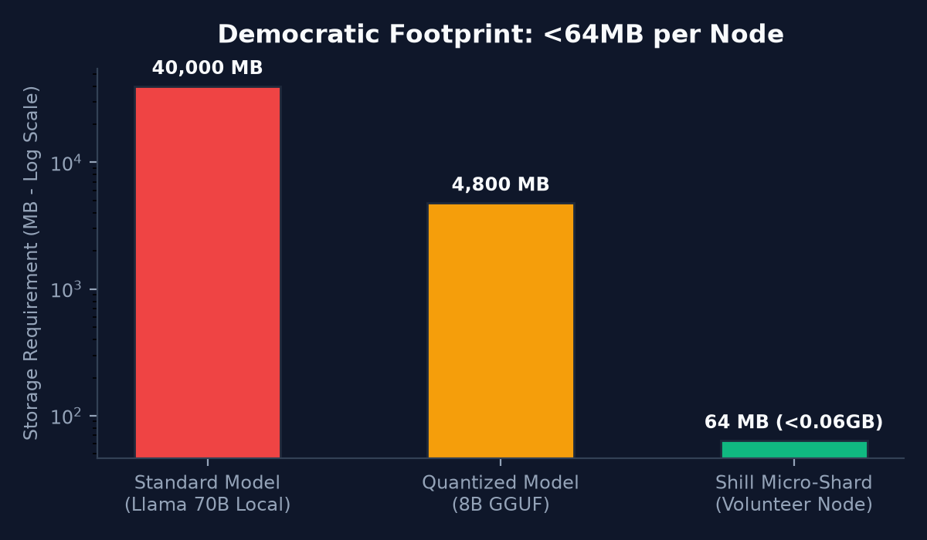
Figure 2: Non-intrusive volunteer node footprint (<64MB) vs. traditional local LLM deployments.
4. Monetization Strategy: High Uptake & Maximum Profit
Shill balances strict AI democratization (keeping the software 100% free and open for community researchers) with high-margin enterprise monetization. Our revenue architecture is divided into five complementary pillars:

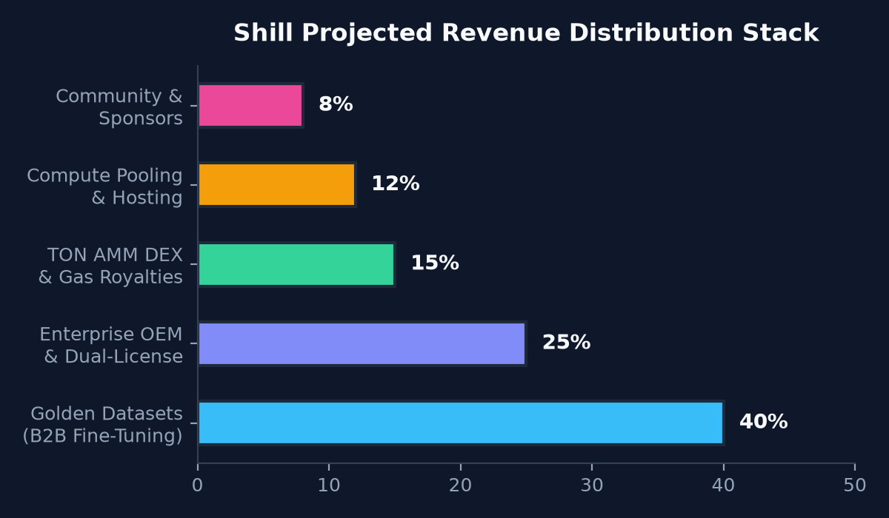
Figure 3: Projected Revenue Distribution Stack across commercial offerings.
Revenue Stream | Share | Pricing Target | Customer Segment
1. Golden Fine-Tuning Datasets (B2B AI Labs) | 40% | $199 - $2,500 per domain pack | Distilled SFT and DPO training pairs exported in Hugging Face format. AI labs fine-tuning specialized coding, cryptographic, and security models purchase verified domain datasets.
2. Enterprise OEM & Commercial Dual-Licensing | 25% | $999 - $4,999 / year | Closed-source commercial licenses for proprietary SaaS platforms, internal enterprise Slack/Jira swarms, and SOC2/ITAR compliant deployments.
3. Sovereign AMM DEX & Token Royalties | 15% | 0.30% per trade swap fee | Liquidity pool fees generated across TON micro-credits, COMPUTE capacity shares, and knowledge token royalties traded on the internal AMM DEX.
4. Turnkey Swarm Cloud & Compute Pooling | 12% | $19 - $99 / month | Hosted cloud nodes for non-technical users and research teams wanting swarm synthesis without configuring local GPUs or network ports.
5. Community Backers & GitHub Sponsors | 8% | $5 - $100 / month / tips | Voluntary tips via PayPal and tiered GitHub Sponsors providing community badges, early persona prompts, and direct patron recognition.

5. Three-Year Financial Projections
Based on conservative dataset sales, viral GitHub adoption, and enterprise OEM licensing, the financial trajectory is outlined below:
Timeline | Active Nodes | Dataset Volume | Enterprise Clients | Gross Revenue | Gross Margin
Year 1 | 5,000 Nodes | 150 Datasets Sold | 25 Enterprise Licenses | $480,000 ARR | $390,000 (81%)
Year 2 | 45,000 Nodes | 850 Datasets Sold | 110 Enterprise Licenses | $2,450,000 ARR | $2,080,000 (85%)
Year 3 | 250,000 Nodes | 3,500 Datasets Sold | 480 Enterprise Licenses | $9,800,000 ARR | $8,500,000 (87%)

6. Conclusion & Immediate Execution Plan
Shill represents the transition from speculative AI centralized monopolies to transparent, sovereign community intelligence. With zero external dependencies, seamless cross-platform support (Linux, macOS, Windows), automated 72-test verification, and native Hugging Face dataset exports, Shill is immediately deployable on GitHub.
Contact: enterprise@shill.network • GitHub: https://github.com/your-org/shill • License: Apache 2.0

