- Screen-Short1: github-fork.png
Note: forked from UnpredictablePrashant/StreamingApp
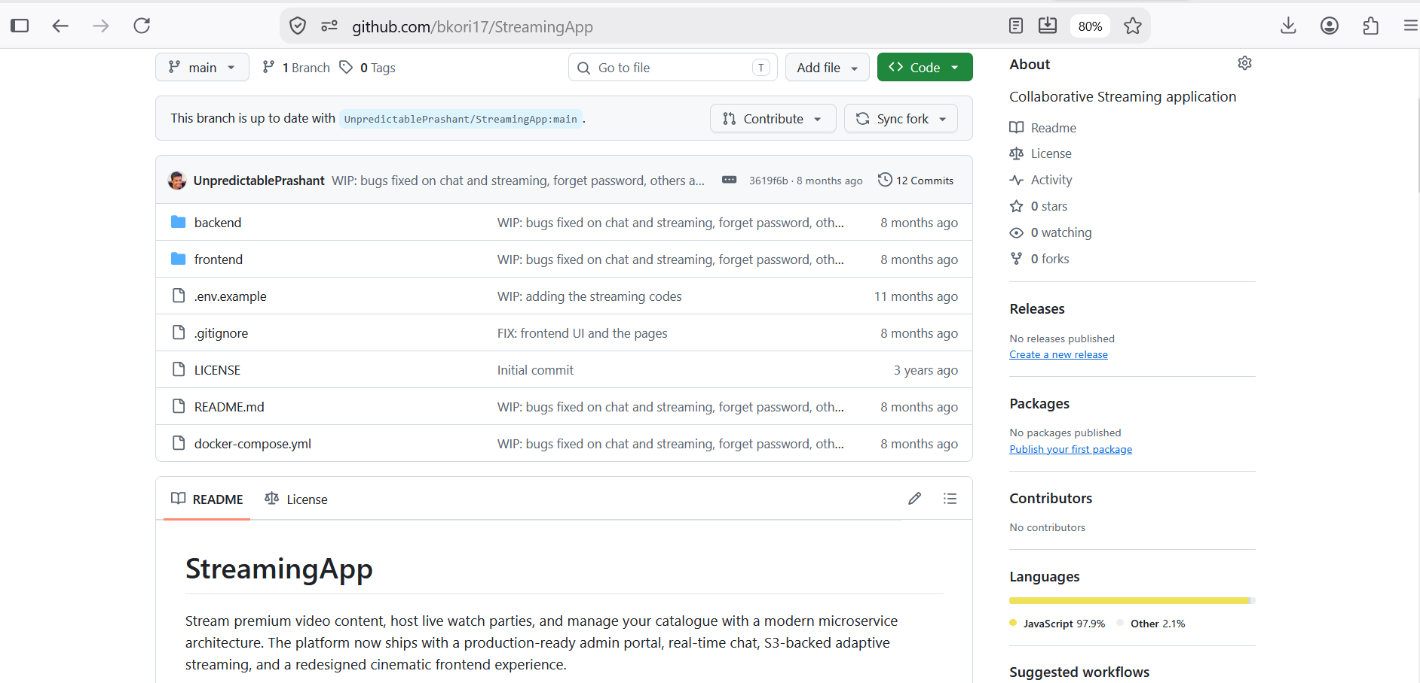
- Screen Short-2: Streaming App cloned

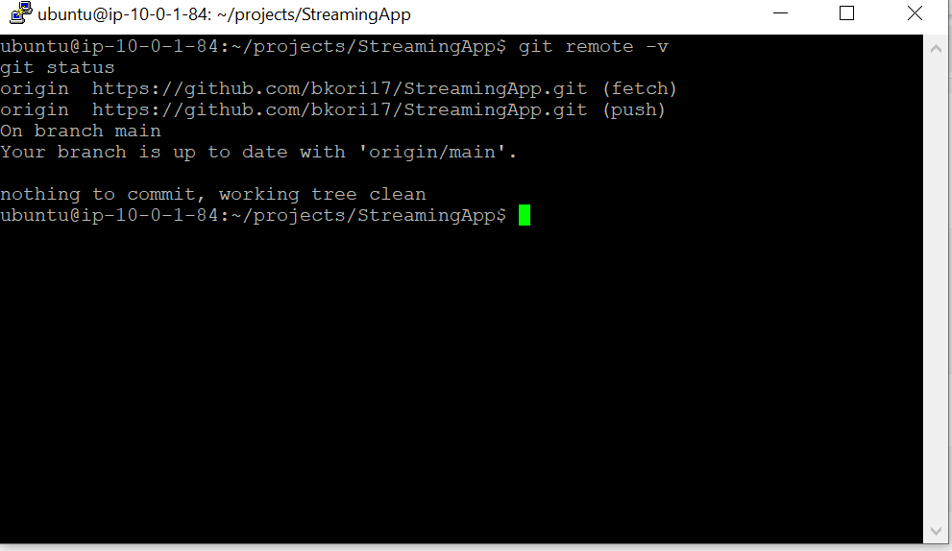

- Screen Short-3: Project Structure
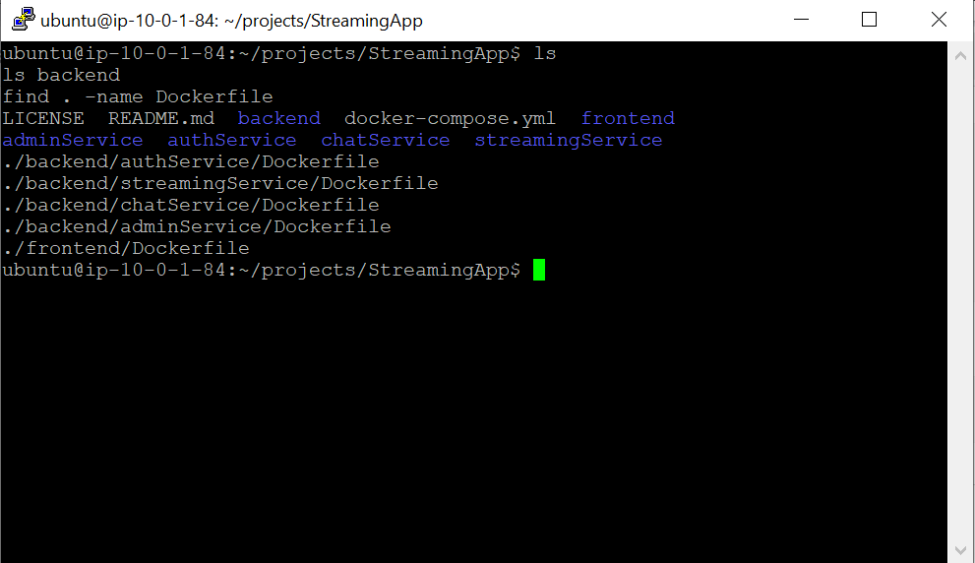

- Screen Short-4: Docker Installed


- Screen Short-5: Compose is running
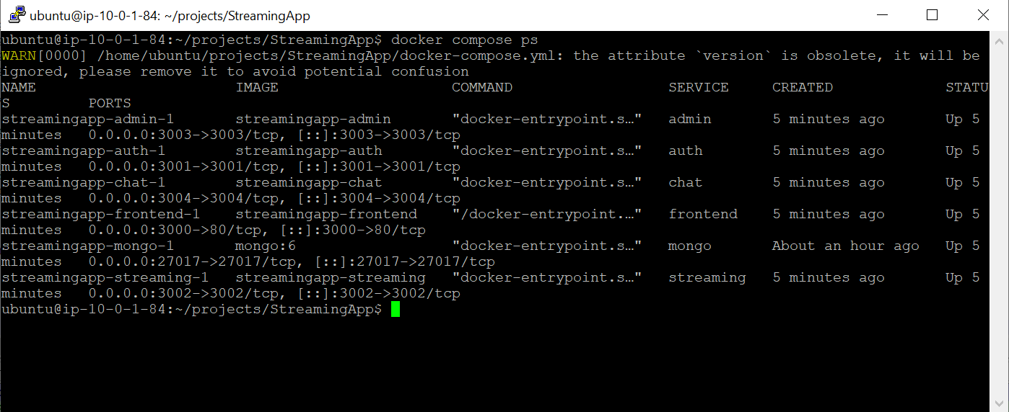

- Screen Short-6: Front end test works. Local_application.png
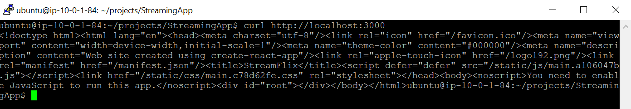
- Screen short-7 : Five-Docker_images.png
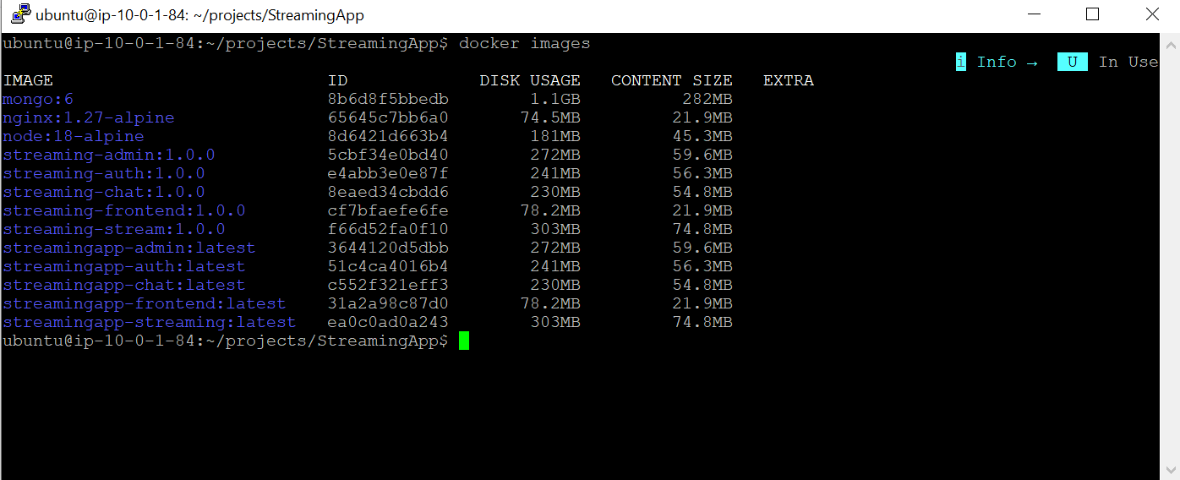

- Screen short-8 : CLI working (08-aws-cli.png)

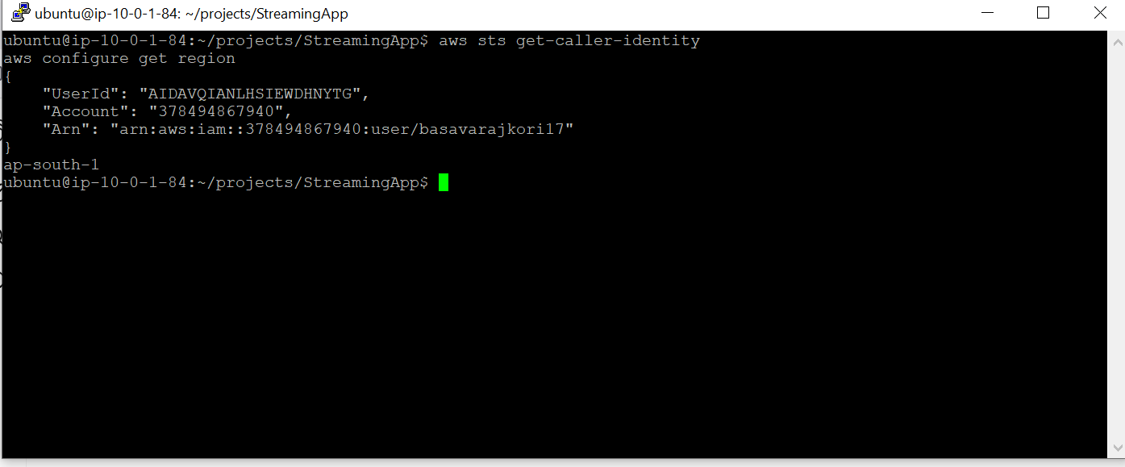

- Screen Short-9:ECR repos (09- ecr-repositories.png)
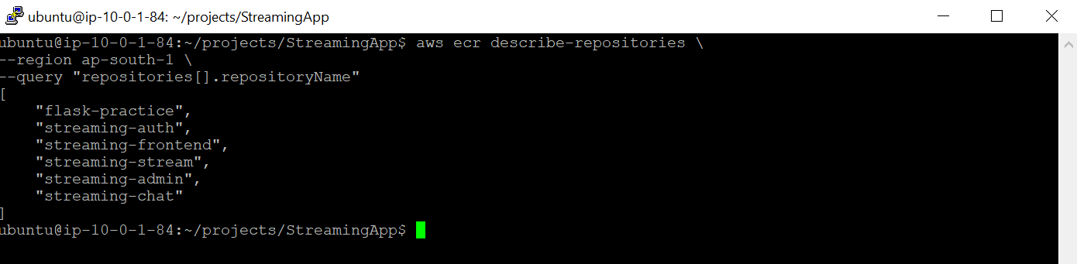

- Jenkins Successful pipe execution(11- jenkins-success.png)

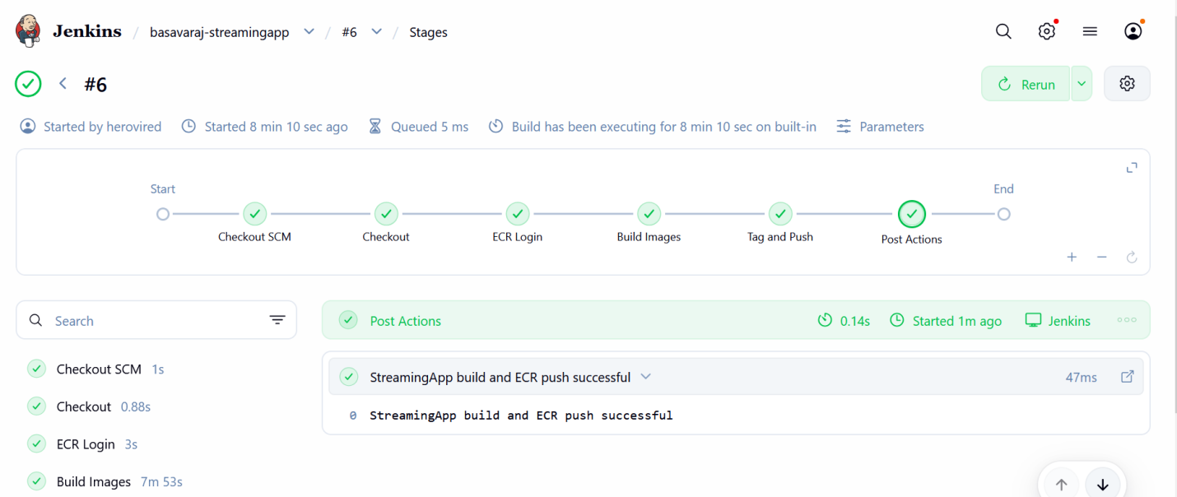
- New Tags Created by Jenkins : (GitHub → Jenkins → ECR) (12-ECR-TAG-JENKINS.PNg)
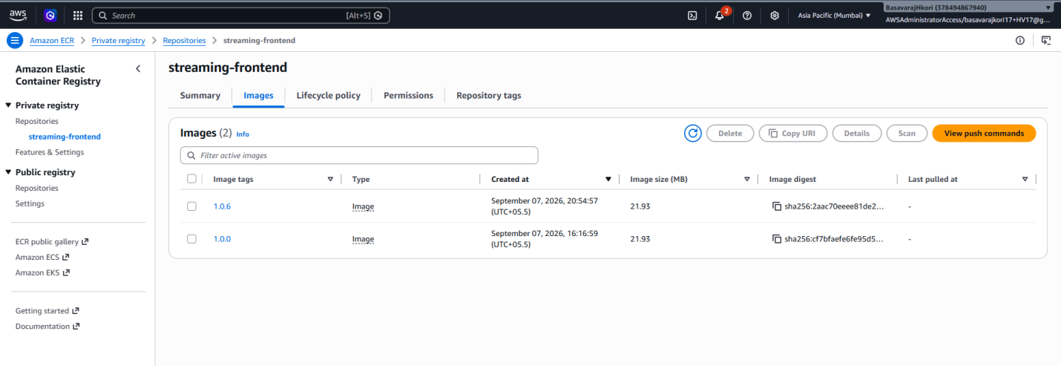

- Auto trigger pipe line started
Web Hook Added in git dir
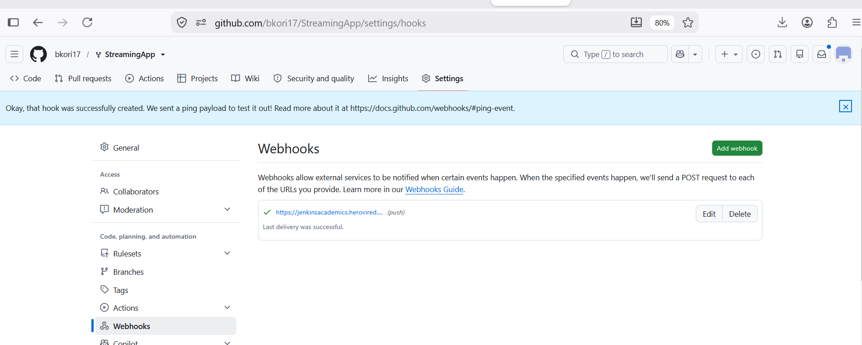
Test file checked in
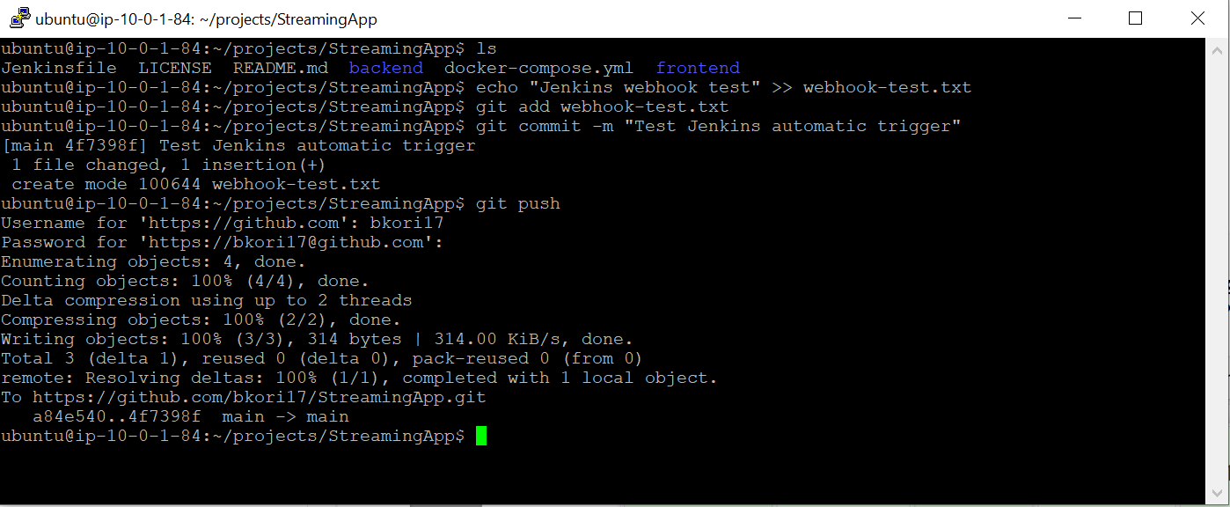

Pipe Line started
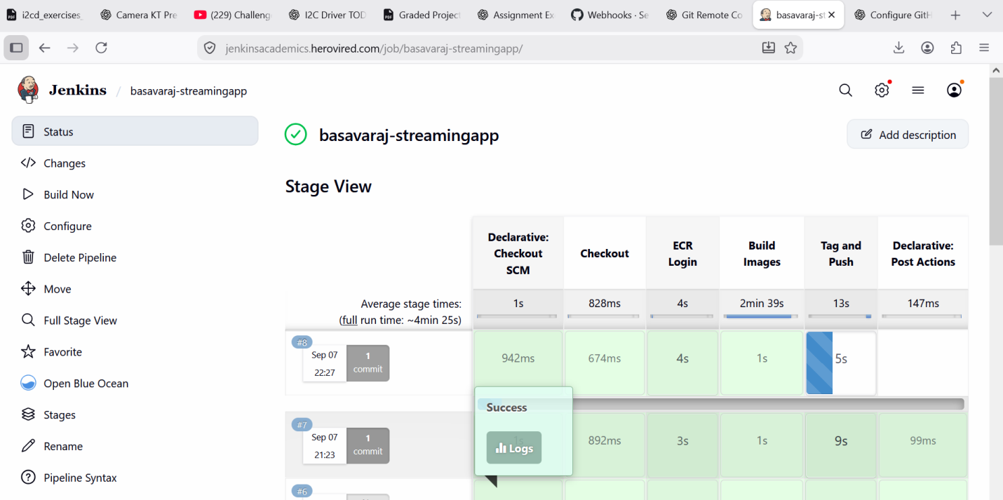

- EKS Nodes (14-eks_nodes.png)
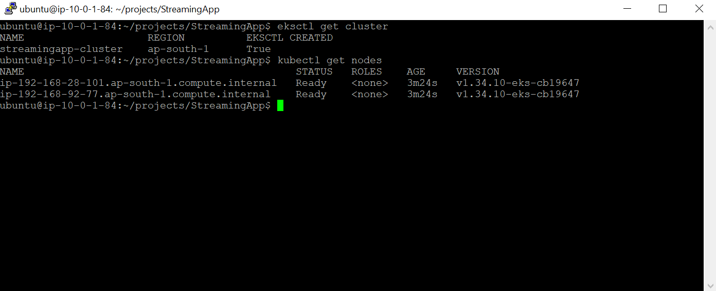

- Helm chart creation (File evidence)
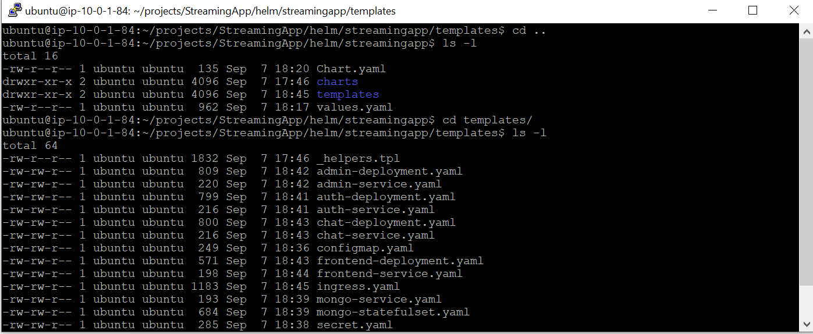

- First test helm lint .
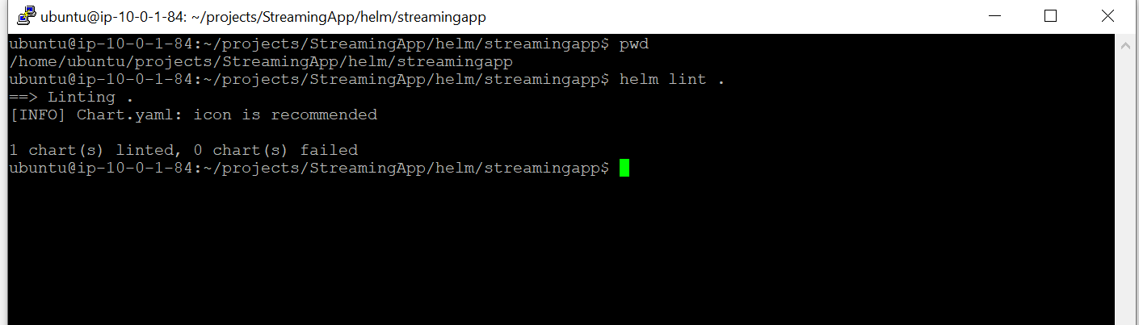

- Kubernetes resources running(kubectl get pods,svc,statefulset,pclearvc,ingress)
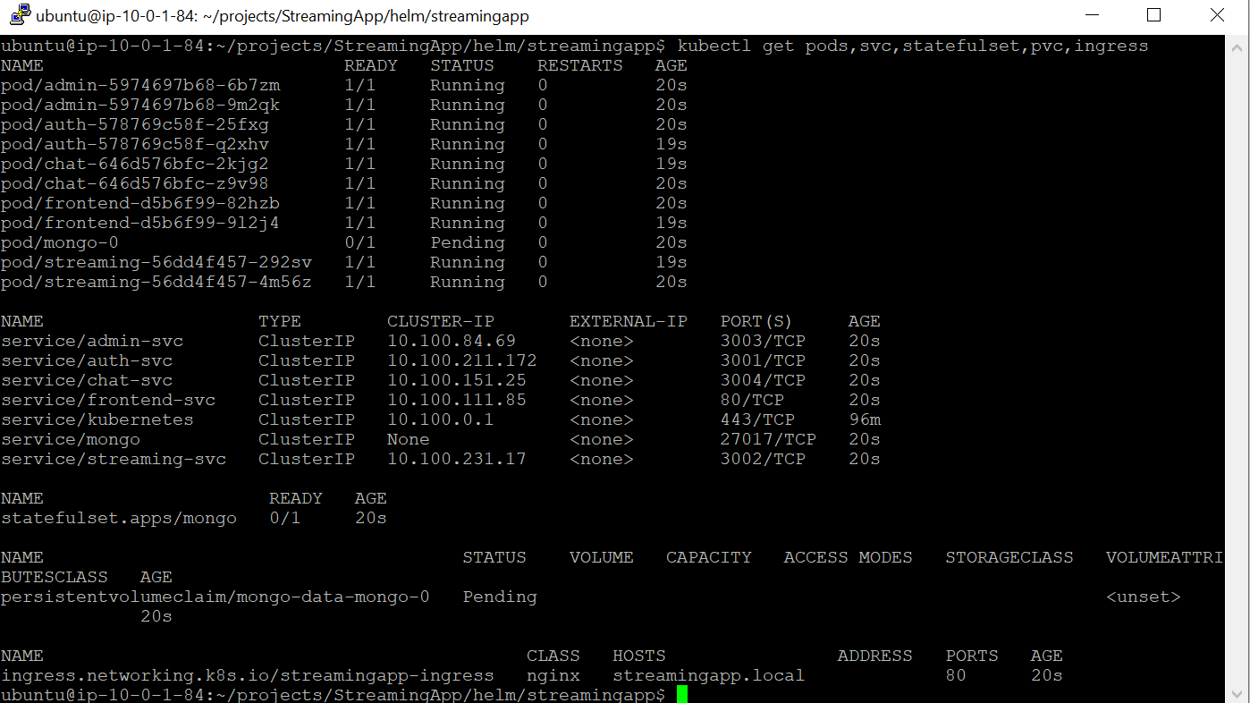

- Scalling of pods : 2-4 (e.g front end)
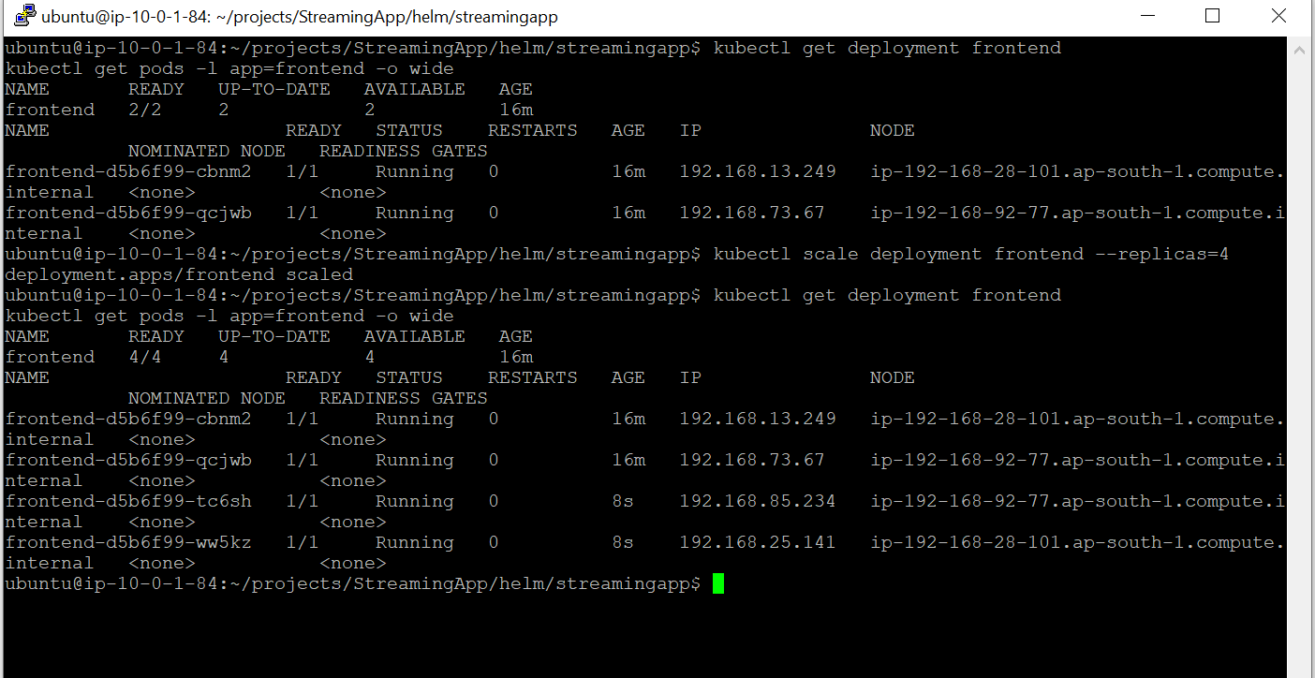

- Successful role out from 1.0.0 to 1.0.8 (Front end App)
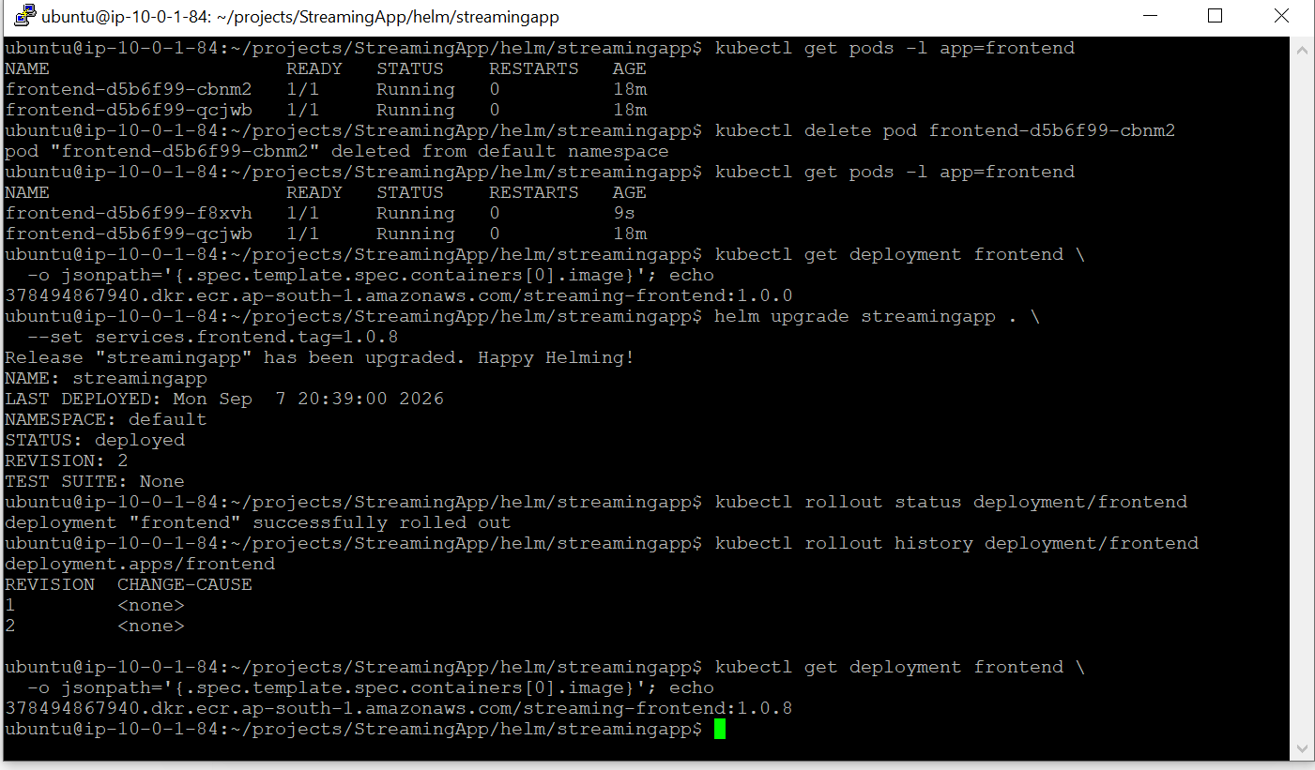
- Self Healing of pods (e.g frontend pod)

