Screen-Short-1 : Basic Execution role for cloud watch
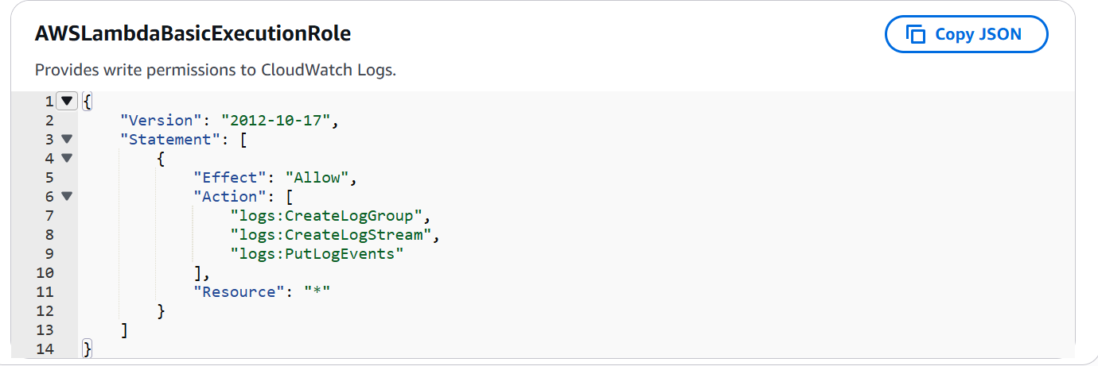
Screen-Short-2 : Inline Policy (IAM role) to create tags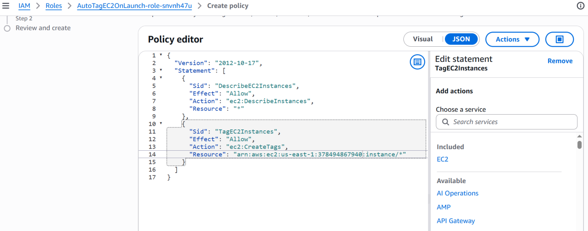

Screen-Short-3 : Environment variable of Lamda Function
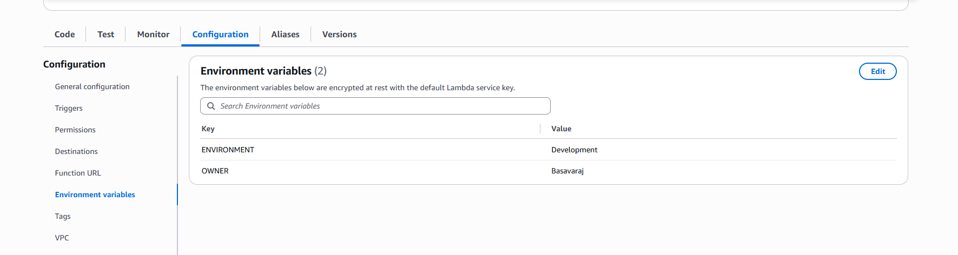
Screen-Short-4 : Lamda_Code
Refer : lambda_function.py
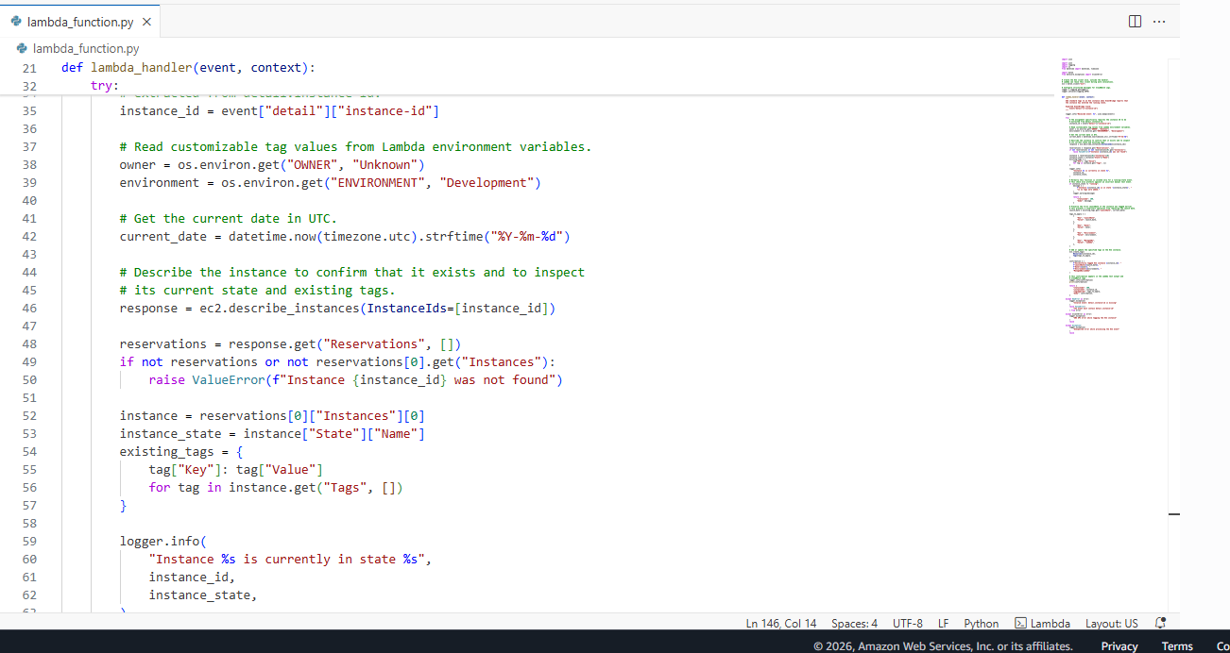

Screen-Short-5 : Manual Test Out put (Tag created)
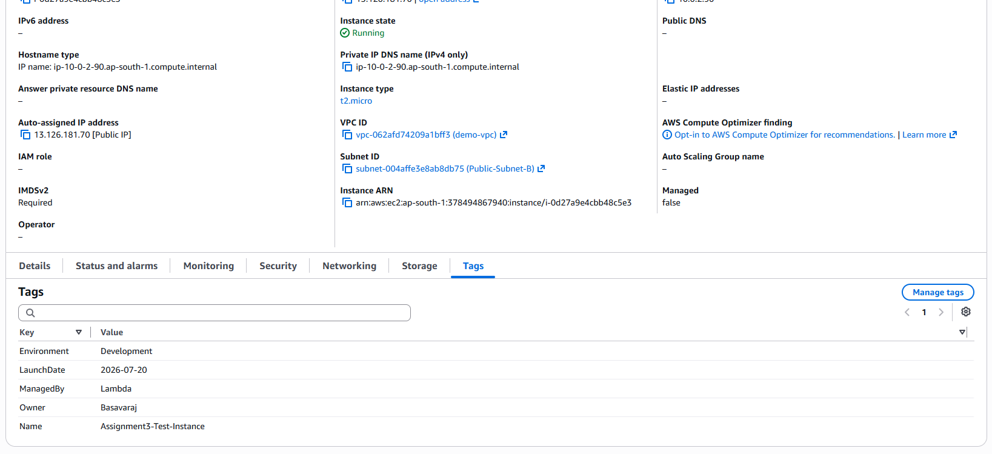
Cloud Watch Logs
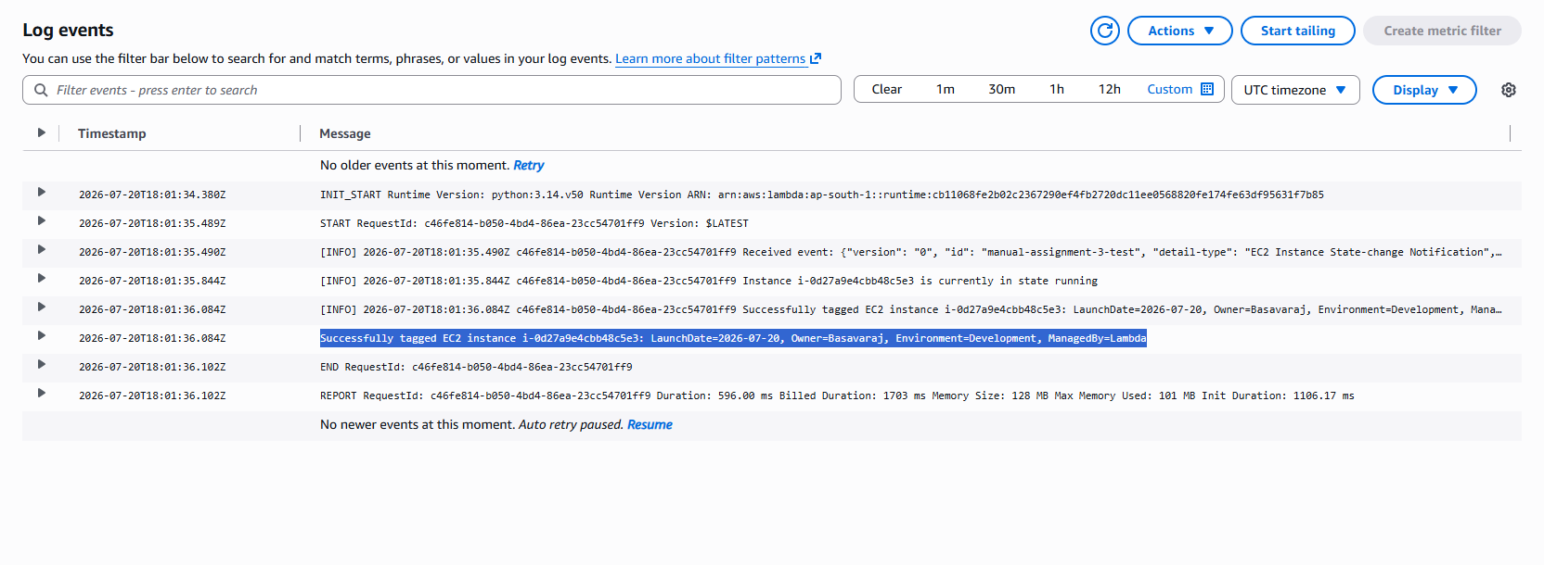
Screen-Short-6:Event Bridge Creation
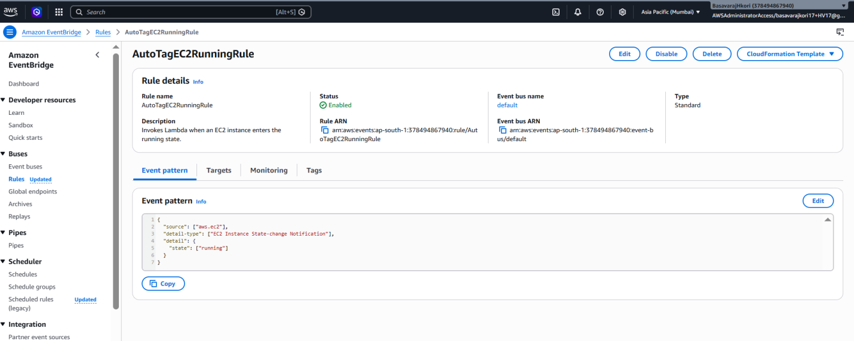

Screen-Short-7:Event Bridge Configuration
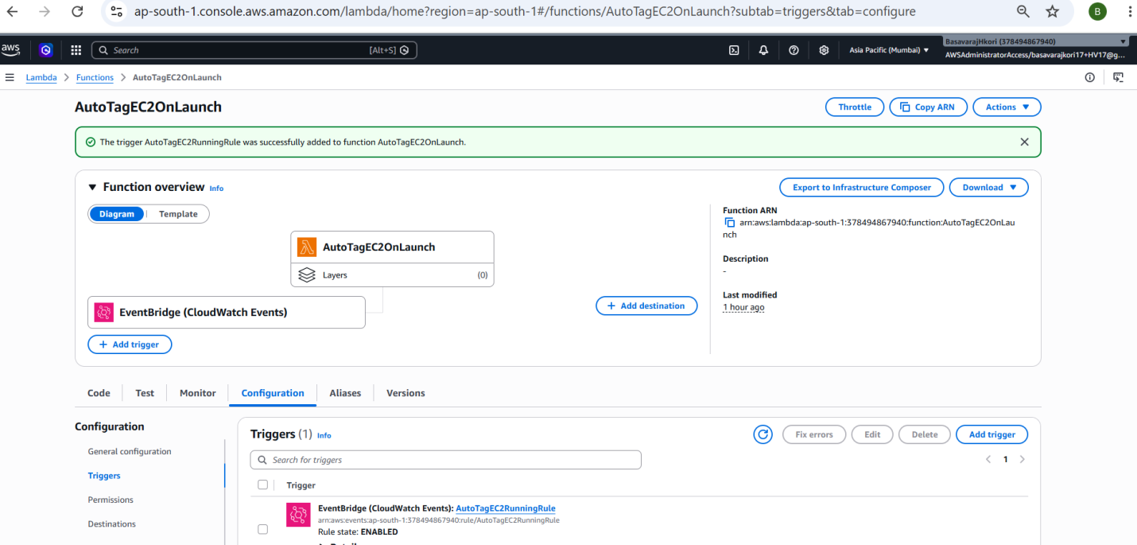

Screen-Short-8:Final End to End Testing
