- Screen-Short-1: Creating a Topic and subscribing(for mail)
Topic Creation:
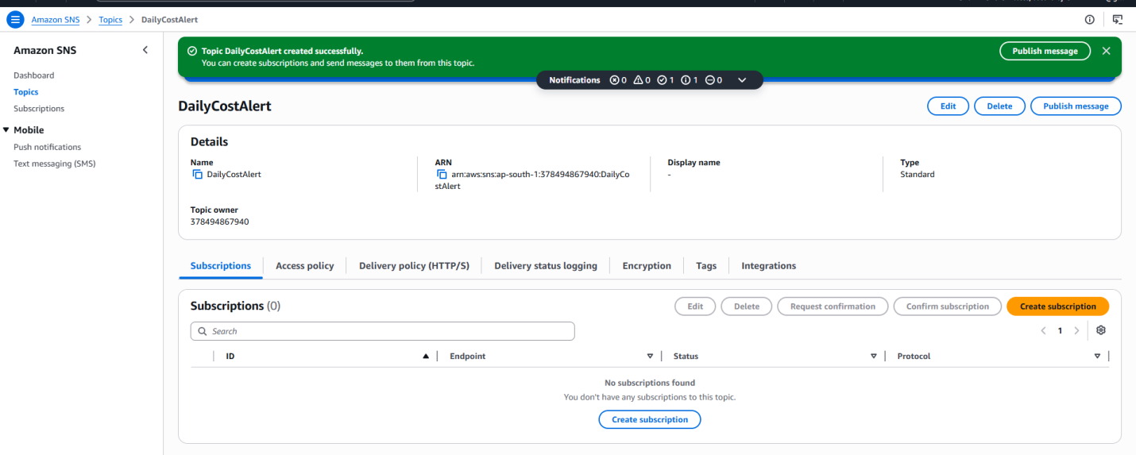
Mail Subscription:
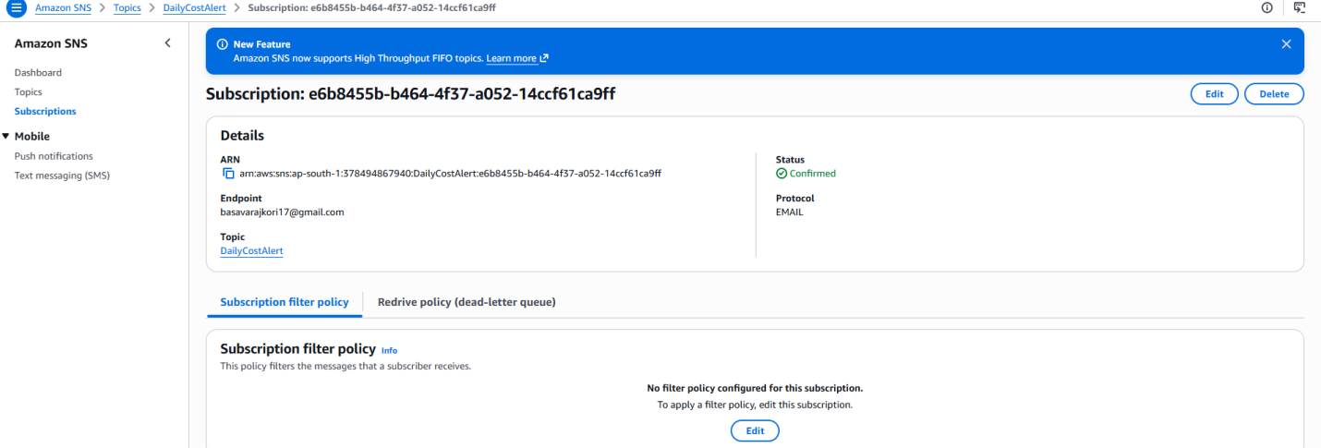

- Screen-Short-2:IAM & Inline policy created
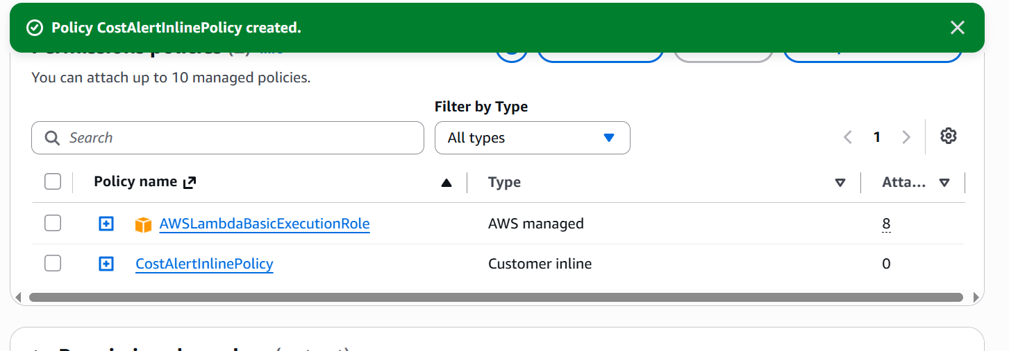

3. Screen-Short-3:Lamda Function
Refer: Lamda_Function.py
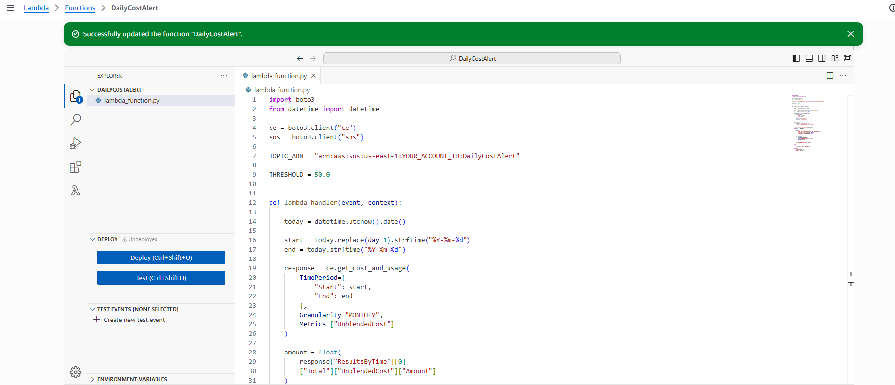

4.Screen-Short-4:Manual Test
Cloud Watch Logs:
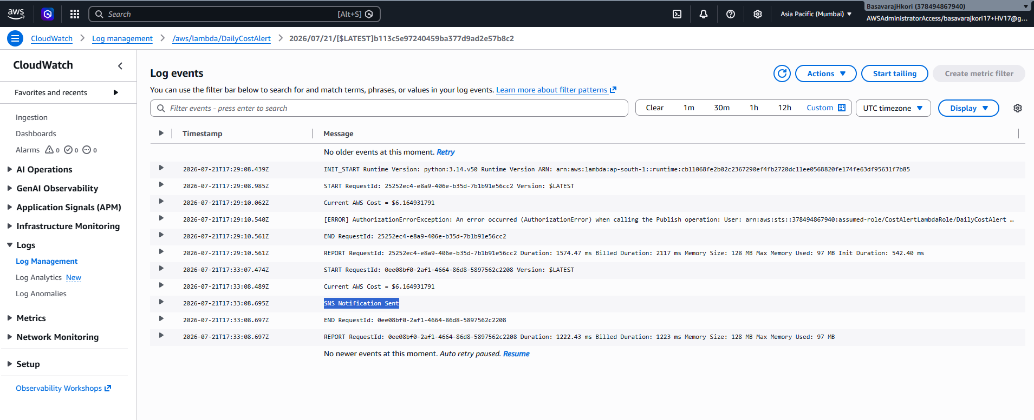
E-MAIL Received:

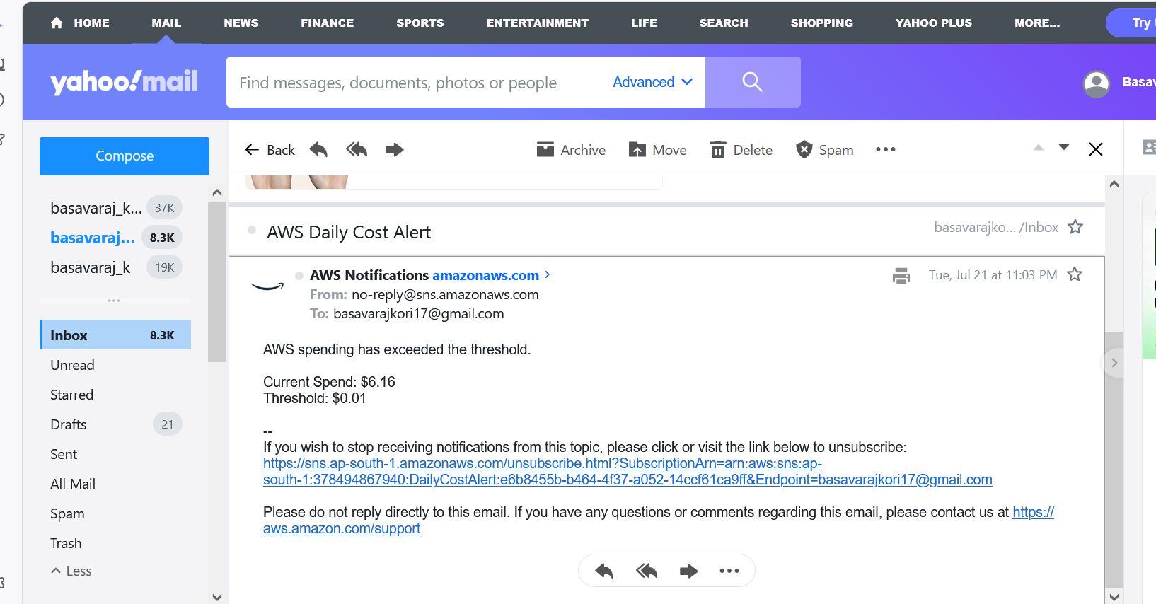

5.Screen-Short-5:Event Bridge Schedule
CRON: 0 9 * * ? *

