Environment Veriable to Control Flow:
BUCKET_NAME=basavaraj-aws-assignment1-s3-cleanup-2026
RETENTION_DAYS=30
TEST_AGE_MINUTES=5 (used only for testing)
DRY_RUN=true (Does not delete any thing but loags says what will happen)

- Screen-Short: Empty Bucket Created

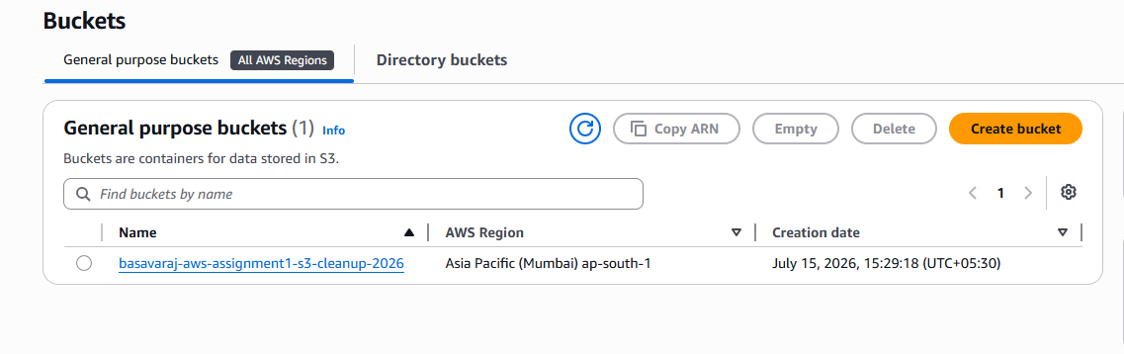
- Screen-Short: Two files Uploaded (these files deleted first)

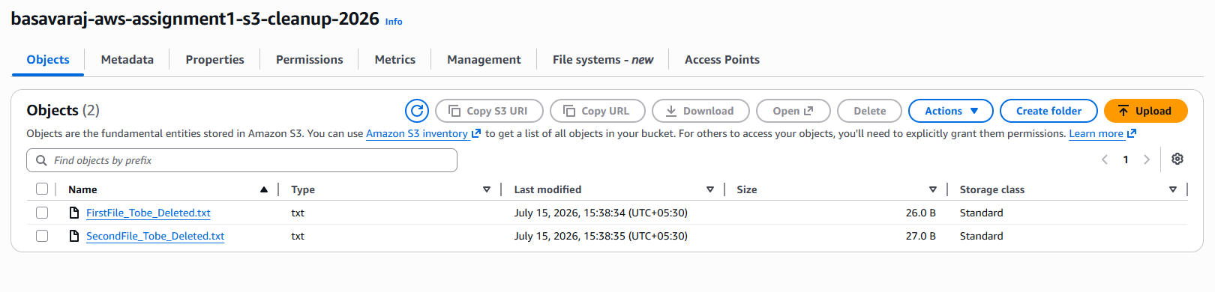
- Screen-Short: Inline Policy only to List and Delete

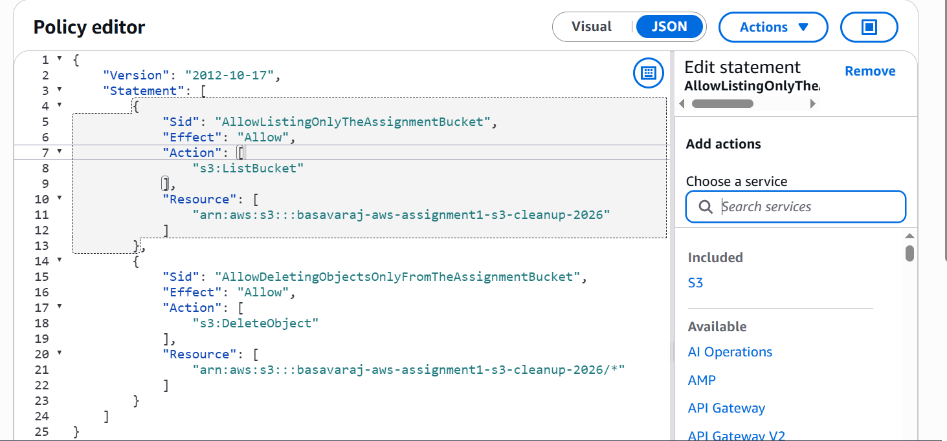

- Screen-Short: Environment Variables Added for Lamda Function Code

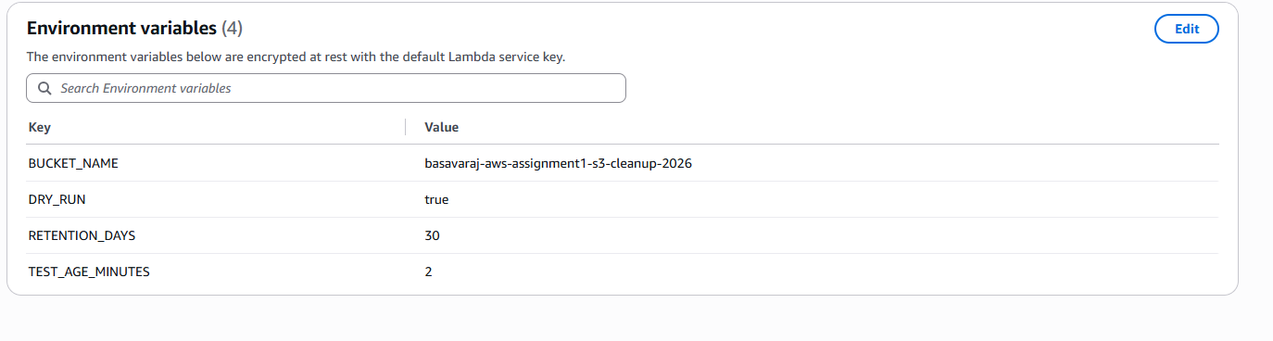
- For code refer LamdaFunction.py

- Logs : First Dry Run (not actual deletion)
START RequestId: e2d4b796-95ac-4e19-a299-3a505a133089 Version: $LATEST
==================================================
S3 CLEANUP STARTED
Bucket name : basavaraj-aws-assignment1-s3-cleanup-2026
Execution mode : TEST
Current UTC time : 2026-07-15T11:01:30.585259+00:00
Cutoff UTC time : 2026-07-15T10:59:30.585259+00:00
Active threshold : 2 minute(s)
Dry run : True
==================================================
----------------------------------------------
Checking object : FirstFile_Tobe_Deleted.txt
Last modified : 2026-07-15T10:08:34+00:00
Eligible : YES - older than 2 minute(s)
[DRY RUN] Would delete: FirstFile_Tobe_Deleted.txt
----------------------------------------------
Checking object : SecondFile_Tobe_Deleted.txt
Last modified : 2026-07-15T10:08:35+00:00
Eligible : YES - older than 2 minute(s)
[DRY RUN] Would delete: SecondFile_Tobe_Deleted.txt
==================================================
S3 CLEANUP COMPLETED
Objects scanned : 2
Objects eligible : 2
Objects deleted : 0
Deleted names : []
==================================================
END RequestId: e2d4b796-95ac-4e19-a299-3a505a133089
REPORT RequestId: e2d4b796-95ac-4e19-a299-3a505a133089 Duration: 532.69 ms Billed Duration: 968 ms Memory Size: 128 MB Max Memory Used: 99 MB Init Duration: 434.52 ms

- Screen-Short: Actual Deletion with new file uploaded

Before Running Lamda Functio (2 old files + one new file)

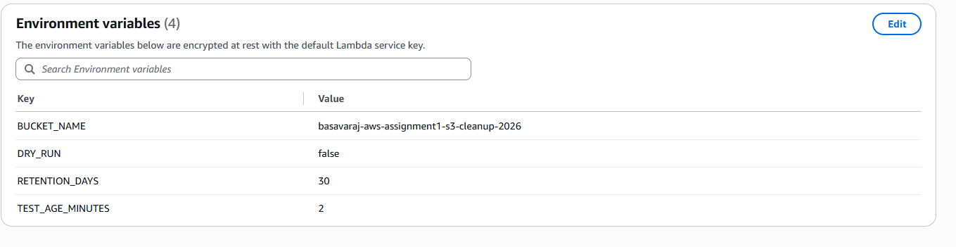
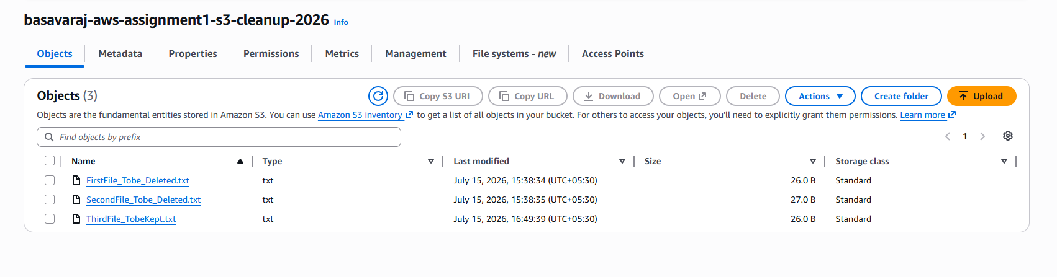

Screen-Short: After Executing Lamda Function
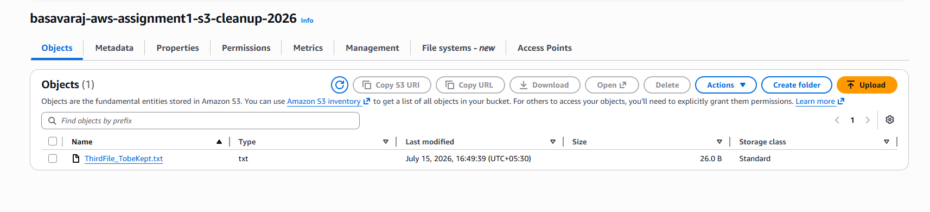
Logs: After Executing Lamda Function

Bucket name : basavaraj-aws-assignment1-s3-cleanup-2026
Execution mode : TEST
Current UTC time : 2026-07-15T11:20:18.111353+00:00
Cutoff UTC time : 2026-07-15T11:18:18.111353+00:00
Active threshold : 2 minute(s)
Dry run : False
==================================================
----------------------------------------------
Checking object : FirstFile_Tobe_Deleted.txt
Last modified : 2026-07-15T10:08:34+00:00
Eligible : YES - older than 2 minute(s)
DELETED OBJECT : FirstFile_Tobe_Deleted.txt
----------------------------------------------
Checking object : SecondFile_Tobe_Deleted.txt
Last modified : 2026-07-15T10:08:35+00:00
Eligible : YES - older than 2 minute(s)
DELETED OBJECT : SecondFile_Tobe_Deleted.txt
----------------------------------------------
Checking object : ThirdFile_TobeKept.txt
Last modified : 2026-07-15T11:19:39+00:00
Eligible : NO
RETAINED OBJECT : ThirdFile_TobeKept.txt
==================================================
S3 CLEANUP COMPLETED
Objects scanned : 3
Objects eligible : 2
Objects deleted : 2
Deleted names : ['FirstFile_Tobe_Deleted.txt', 'SecondFile_Tobe_Deleted.txt']
==================================================
END RequestId: 21f2d549-6aef-4614-aa8a-29430fd05101
REPORT RequestId: 21f2d549-6aef-4614-aa8a-29430fd05101 Duration: 623.88 ms Billed Duration: 1170 ms Memory Size: 128 MB Max Memory Used: 97 MB Init Duration: 545.90 ms

- Screen-Short: Final 30-day setting
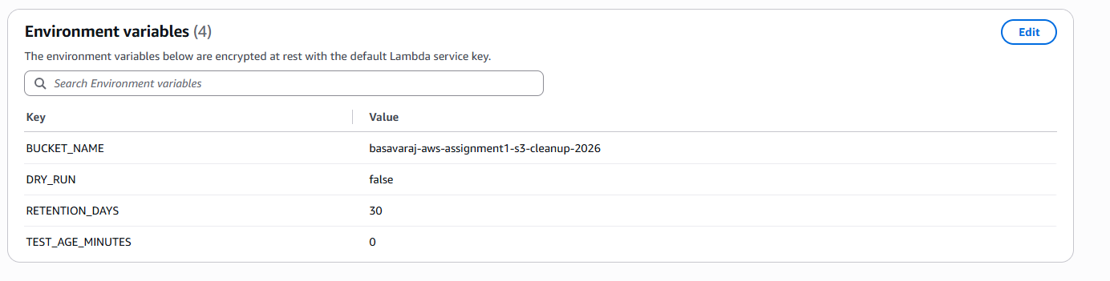

Scree n-Short: Before Lamda running 30 day trial:
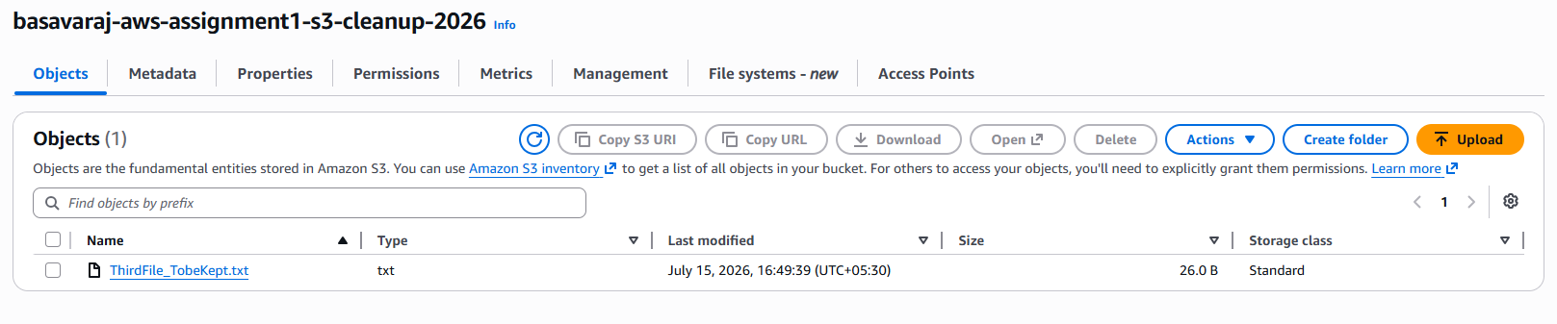
After Lamda running 30 day trial:
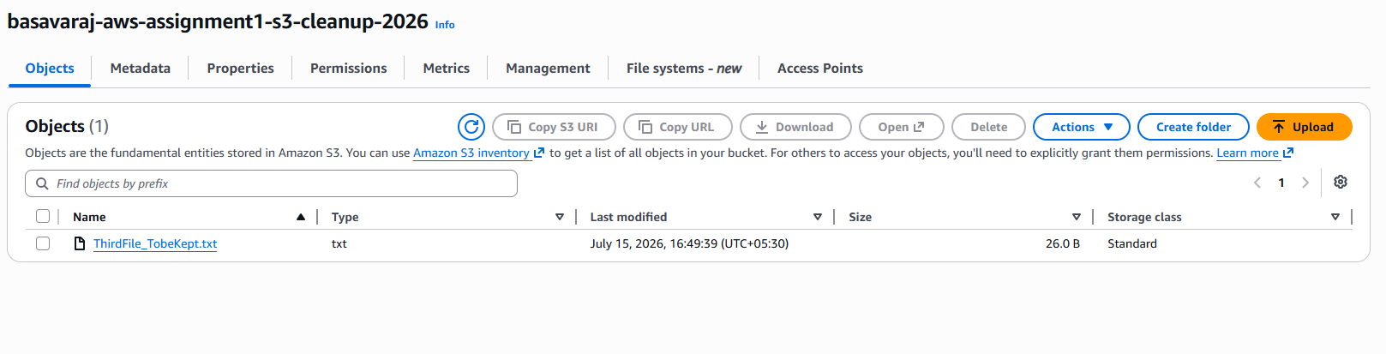
Logs when 30 days trial run(for 1 file):
START RequestId: 550e177e-f060-4232-80d3-616ca7e72afa Version: $LATEST
==================================================
S3 CLEANUP STARTED
Bucket name : basavaraj-aws-assignment1-s3-cleanup-2026
Execution mode : FINAL-30-DAY
Current UTC time : 2026-07-15T11:34:45.032415+00:00
Cutoff UTC time : 2026-06-15T11:34:45.032415+00:00
Active threshold : 30 day(s)
Dry run : False
==================================================
----------------------------------------------
Checking object : ThirdFile_TobeKept.txt
Last modified : 2026-07-15T11:19:39+00:00
Eligible : NO
RETAINED OBJECT : ThirdFile_TobeKept.txt
==================================================
S3 CLEANUP COMPLETED
Objects scanned : 1
Objects eligible : 0
Objects deleted : 0
Deleted names : []
==================================================
END RequestId: 550e177e-f060-4232-80d3-616ca7e72afa
REPORT RequestId: 550e177e-f060-4232-80d3-616ca7e72afa Duration: 536.75 ms Billed Duration: 953 ms Memory Size: 128 MB Max Memory Used: 96 MB Init Duration: 416.07 ms

