Screenshot 1 — EBS setup
volume page showing:
- Volume ID
- Name
- Size: 1 GiB
- Type: gp3
- State: Available
- Availability Zone
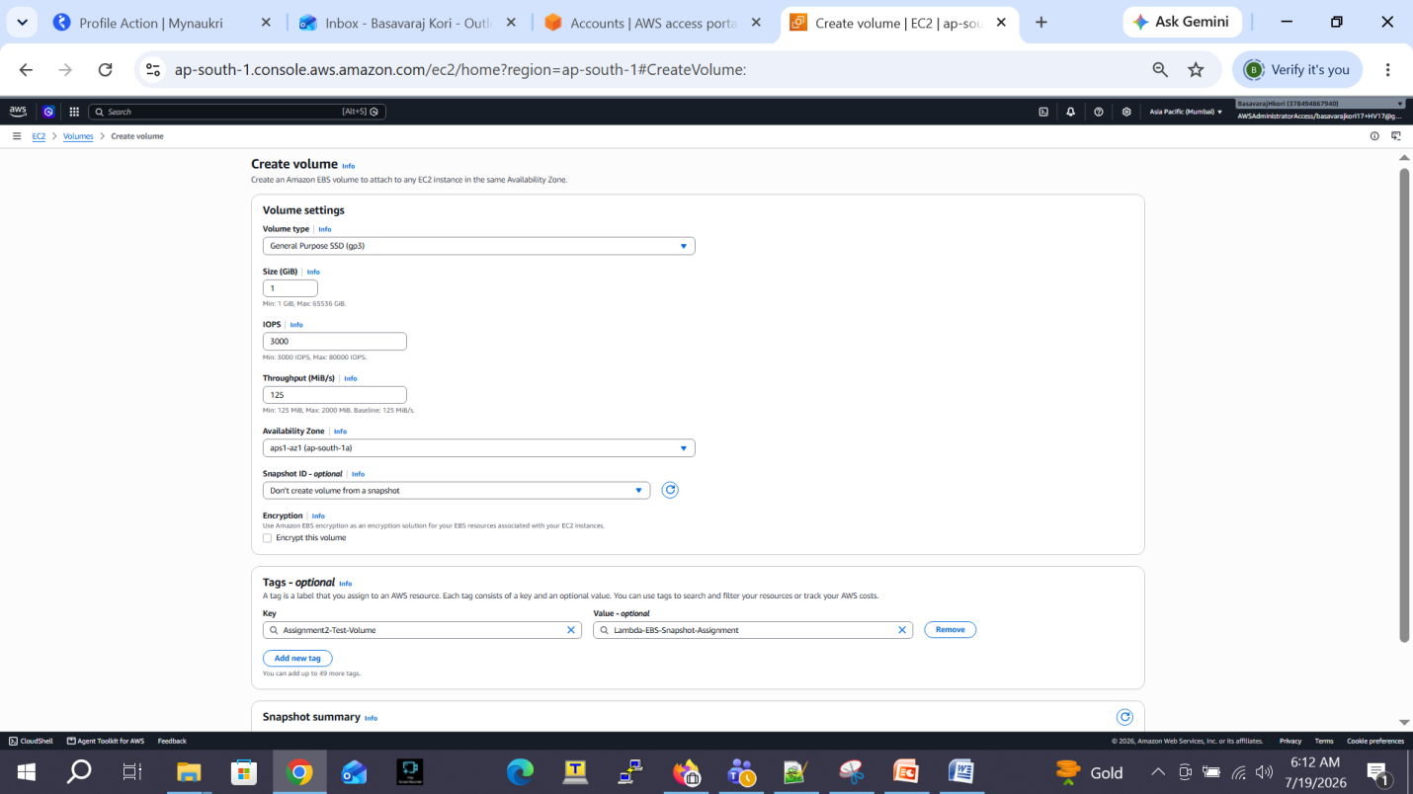

Volume ID = vol-054b7000ef2bcc90f

Screenshot 2 — Basic Policy maintained as is required for cloud watch

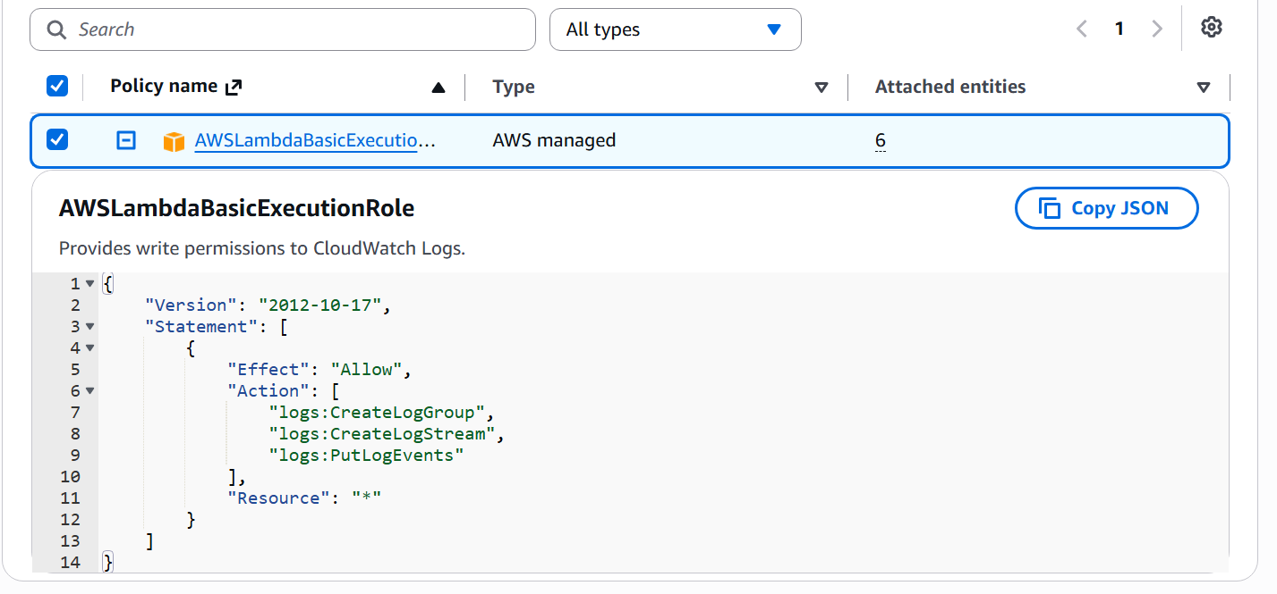

Screenshot 3 — New Policy on top of Basic Policy Added

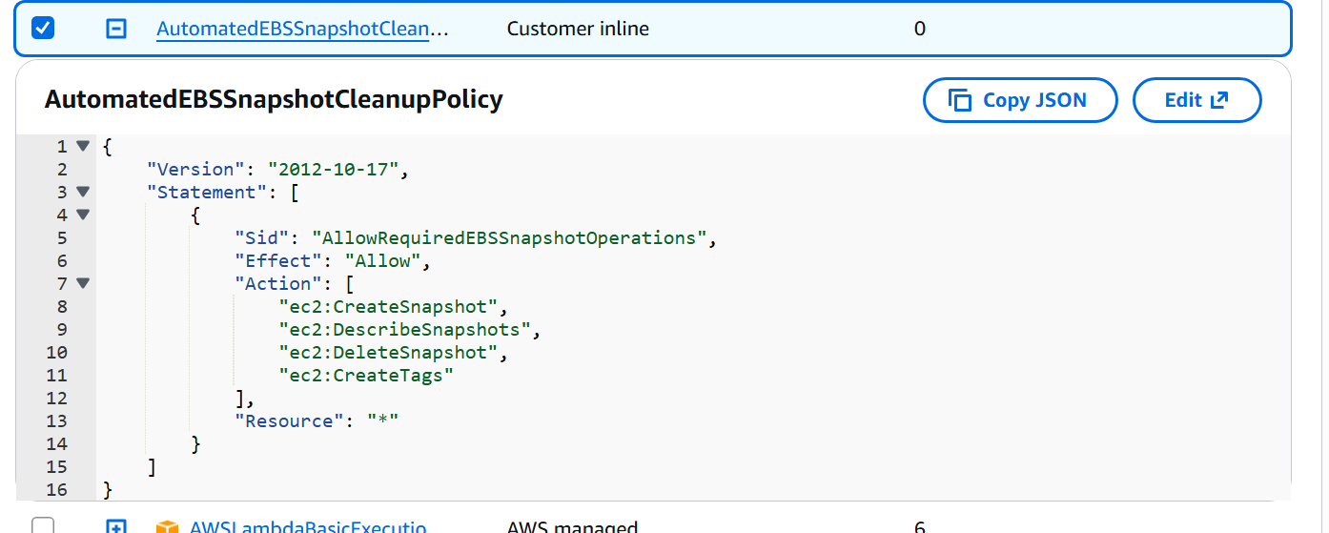

Screenshot 3 — Environment Variables Used in code

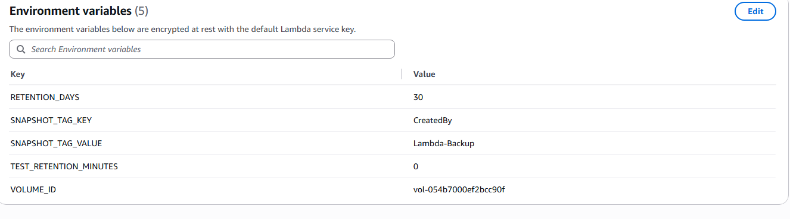

Screenshot 4 — First test invocation

Cloud Watch Logs:

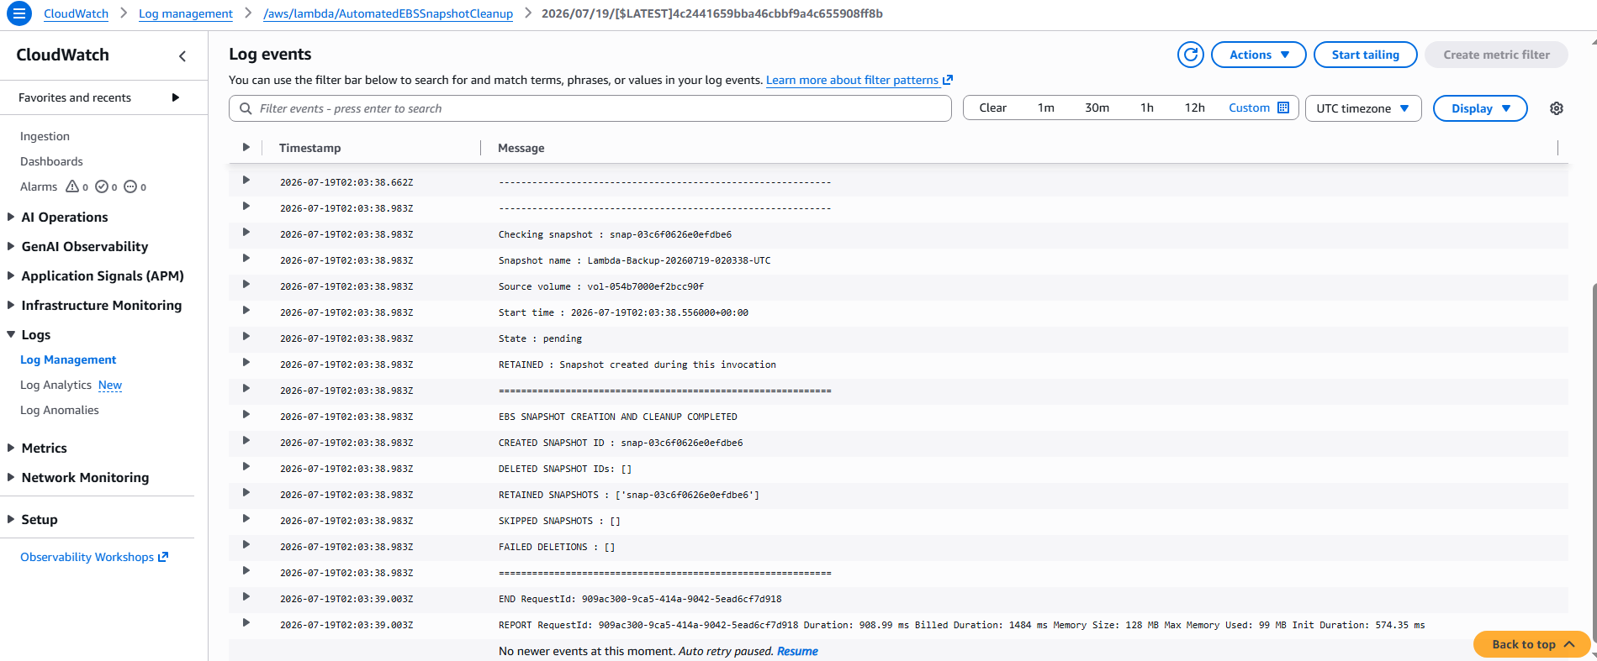

Code Logs:

START RequestId: 909ac300-9ca5-414a-9042-5ead6cf7d918 Version: $LATEST

============================================================

EBS SNAPSHOT CREATION AND CLEANUP STARTED

Volume ID : vol-054b7000ef2bcc90f

Current UTC time : 2026-07-19T02:03:38.093764+00:00

Backup tag : CreatedBy=Lambda-Backup

============================================================

CREATED SNAPSHOT ID : snap-03c6f0626e0efdbe6

Initial state : pending

------------------------------------------------------------

Cleanup mode : FINAL-30-DAY

Retention threshold : 30 day(s)

Cutoff UTC time : 2026-06-19T02:03:38.093764+00:00

------------------------------------------------------------

------------------------------------------------------------

Checking snapshot : snap-03c6f0626e0efdbe6

Snapshot name : Lambda-Backup-20260719-020338-UTC

Source volume : vol-054b7000ef2bcc90f

Start time : 2026-07-19T02:03:38.556000+00:00

State : pending

RETAINED : Snapshot created during this invocation

============================================================

EBS SNAPSHOT CREATION AND CLEANUP COMPLETED

CREATED SNAPSHOT ID : snap-03c6f0626e0efdbe6

DELETED SNAPSHOT IDs: []

RETAINED SNAPSHOTS : ['snap-03c6f0626e0efdbe6']

SKIPPED SNAPSHOTS : []

FAILED DELETIONS : []

============================================================

END RequestId: 909ac300-9ca5-414a-9042-5ead6cf7d918

REPORT RequestId: 909ac300-9ca5-414a-9042-5ead6cf7d918 Duration: 908.99 ms Billed Duration: 1484 ms Memory Size: 128 MB Max Memory Used: 99 MB Init Duration: 574.35 ms

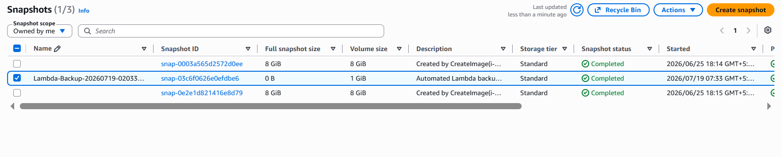
Screenshot 4— Snapshot created After First Execution
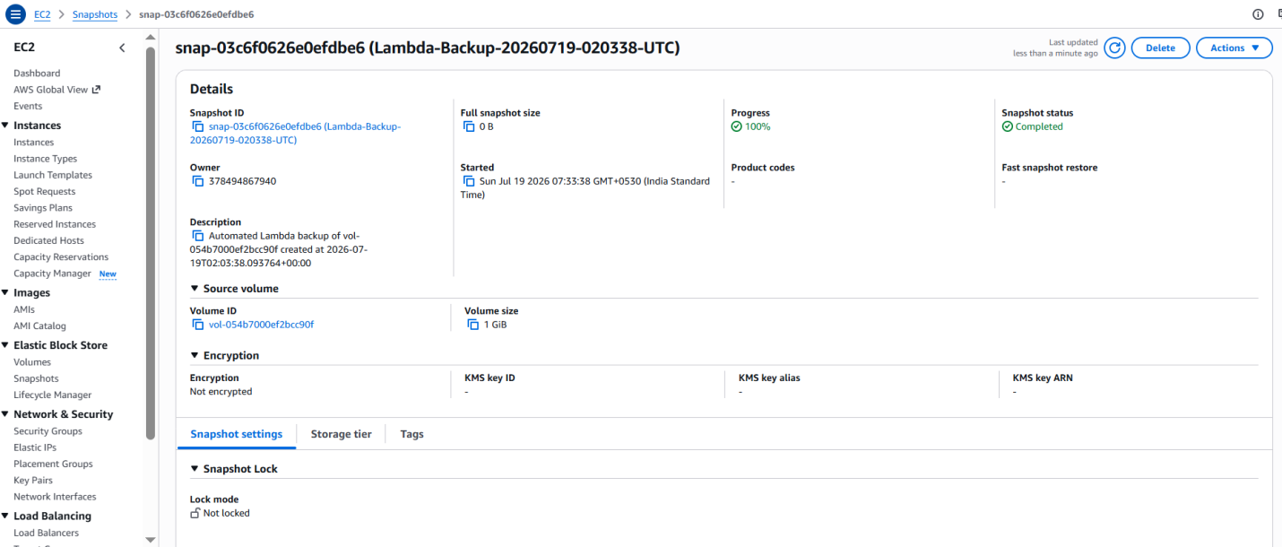
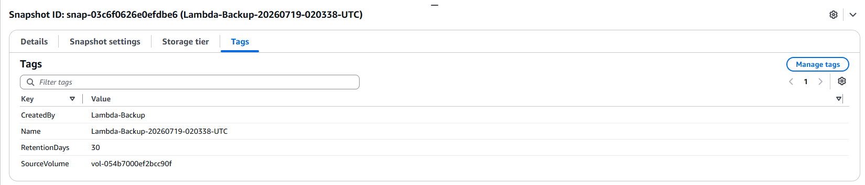

Screenshot 5 — Temporary test configuration
(Old screen short deleted after 3 minutes and new Screen short created on next test execution after 3 minutes)
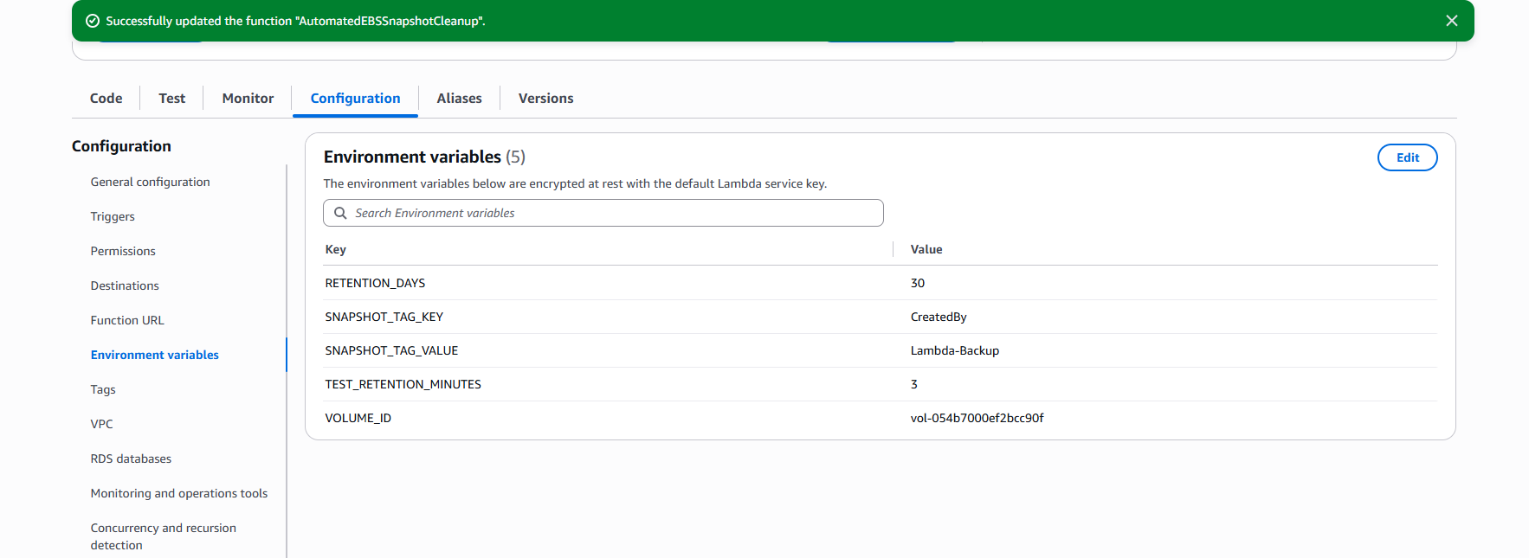

Screenshot 6 — Test invocation/output Second Execution(Delete Old Snap short and create New one)
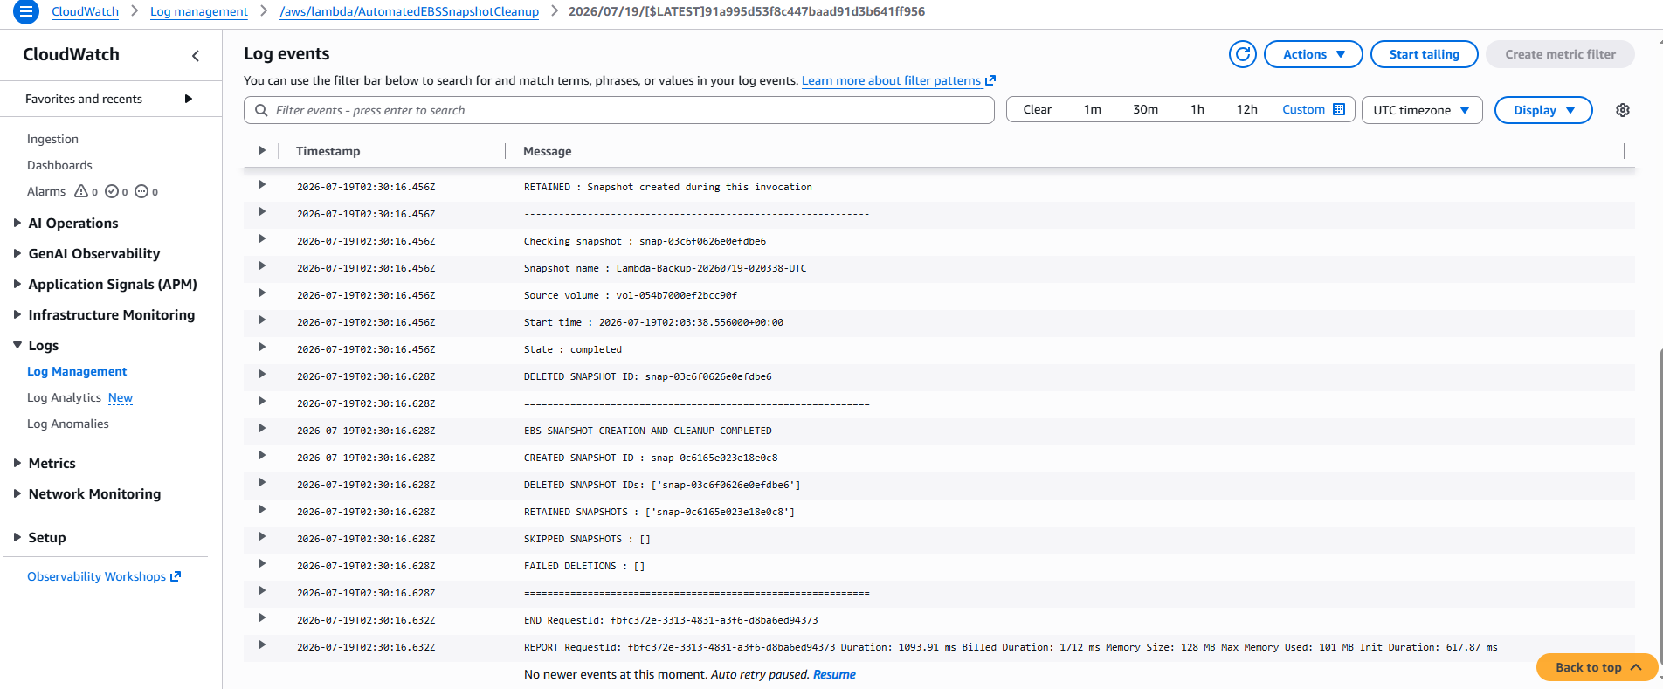
Code Logs:
============================================================
EBS SNAPSHOT CREATION AND CLEANUP COMPLETED
CREATED SNAPSHOT ID : snap-0c6165e023e18e0c8
DELETED SNAPSHOT IDs: ['snap-03c6f0626e0efdbe6']
RETAINED SNAPSHOTS : ['snap-0c6165e023e18e0c8']
SKIPPED SNAPSHOTS : []
FAILED DELETIONS : []
============================================================
END RequestId: fbfc372e-3313-4831-a3f6-d8ba6ed94373
REPORT RequestId: fbfc372e-3313-4831-a3f6-d8ba6ed94373 Duration: 1093.91 ms Billed Duration: 1712 ms Memory Size: 128 MB Max Memory Used: 101 MB Init Duration: 617.87 ms

Screenshot 7 — Old Snap shot deleted and new one Created
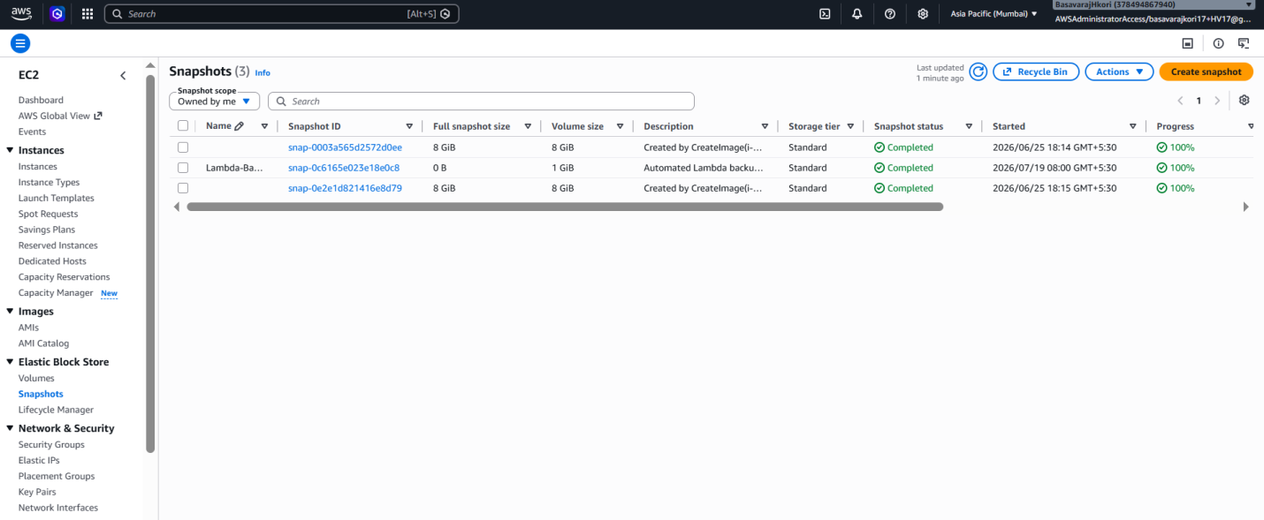

Screenshot 8 — Final 30 Days Schedule Configuration
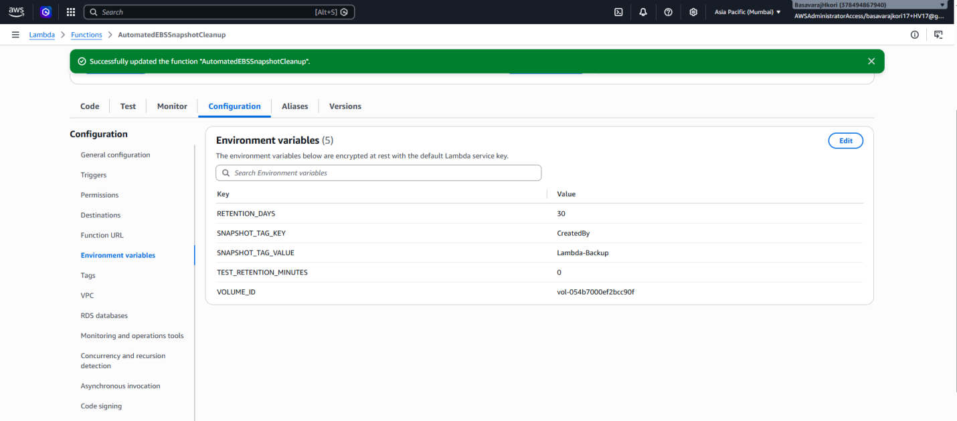

Screenshot 9 — Final 30 Days Test Out put
CloudWatch Logs:
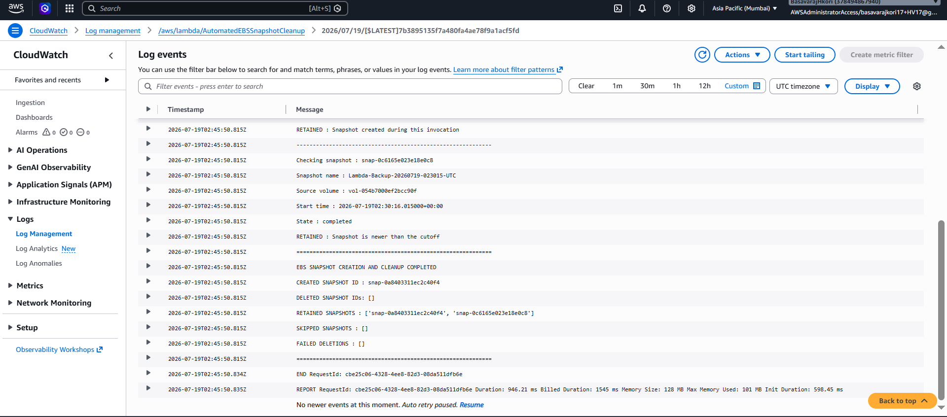
Test Code Logs:
EBS SNAPSHOT CREATION AND CLEANUP COMPLETED
CREATED SNAPSHOT ID : snap-0a8403311ec2c40f4
DELETED SNAPSHOT IDs: []
RETAINED SNAPSHOTS : ['snap-0a8403311ec2c40f4', 'snap-0c6165e023e18e0c8']
SKIPPED SNAPSHOTS : []
FAILED DELETIONS : []
============================================================
END RequestId: cbe25c06-4328-4ee8-82d3-08da511dfb6e
REPORT RequestId: cbe25c06-4328-4ee8-82d3-08da511dfb6e Duration: 946.21 ms Billed Duration: 1545 ms Memory Size: 128 MB Max Memory Used: 101 MB Init Duration: 598.45 ms

Screenshot 10 — After Final 30 Days Test Execution two snap shorts Created
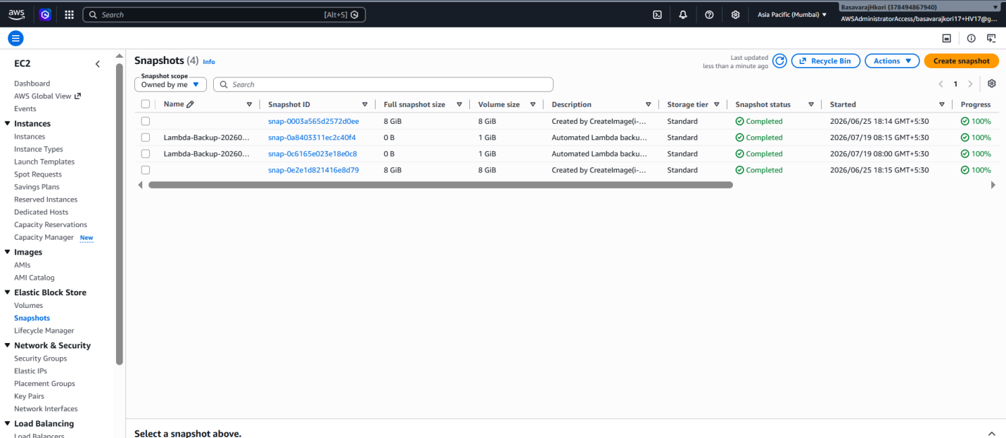
Screenshot 10 — Screenshot 13 — EventBridge schedule
