Screen Shorts of CI/CD Pipeline

- Role Creation and attaching to EC2(FlaskEC2ECRRole)
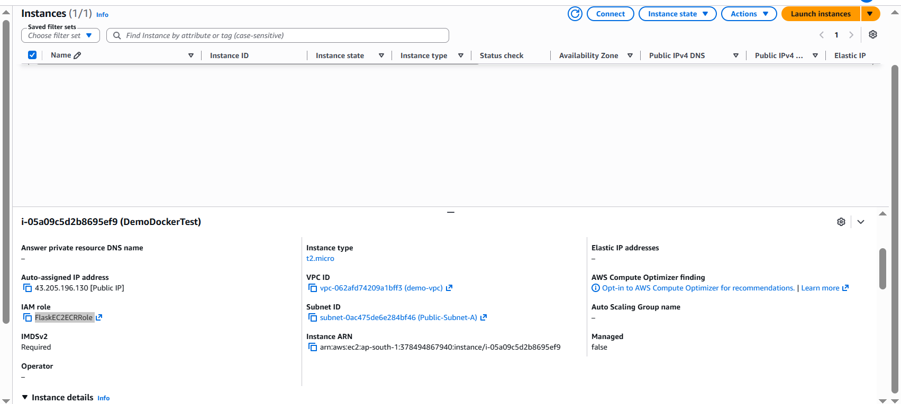

- Git hub repository secrets

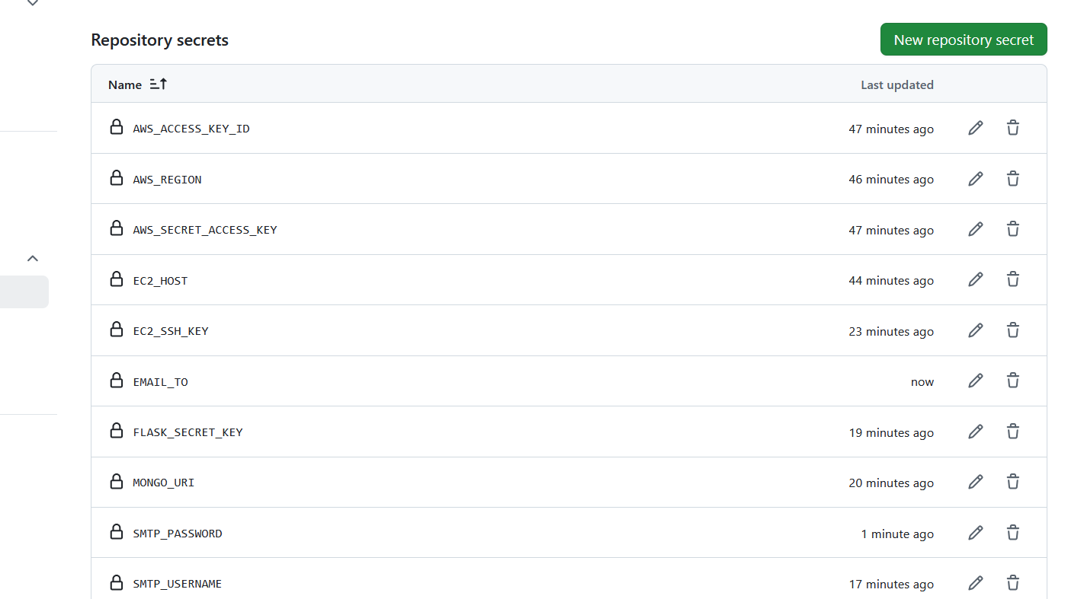

- GitHub Actions – Successful Pipeline
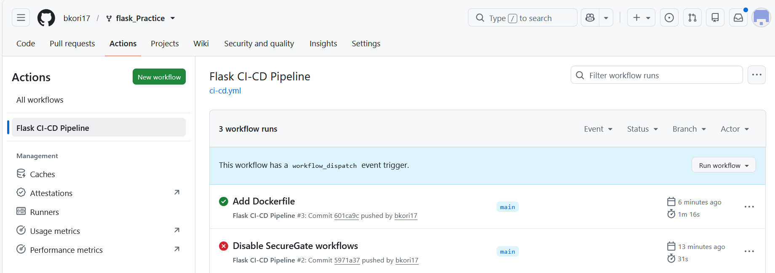

- Detailed Pipe Line Stages

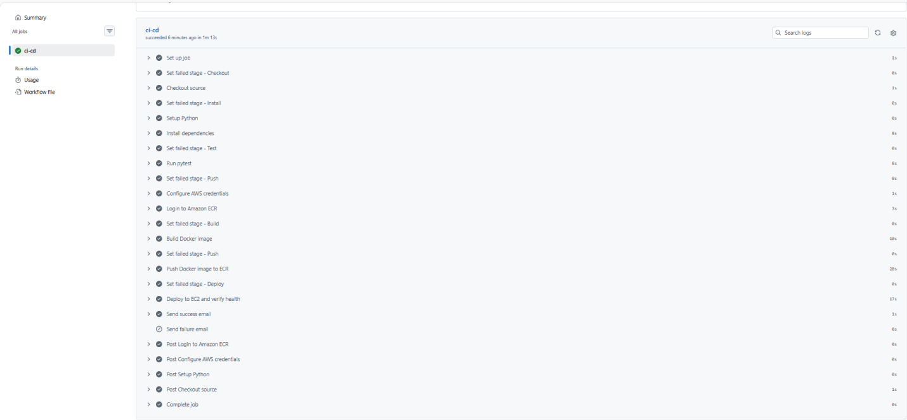

- EC2 Running Container
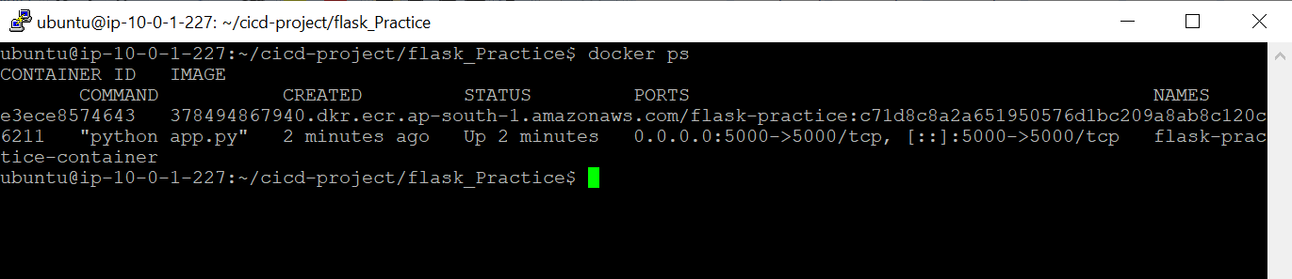
- Health Check
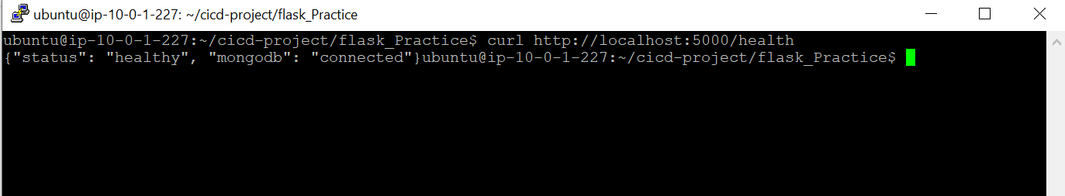

- ECR Repository
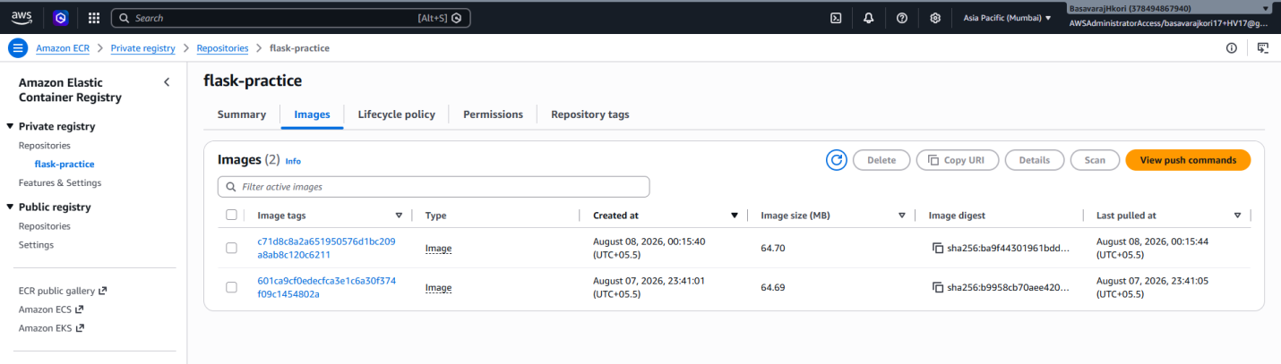

- EC2 Running Application
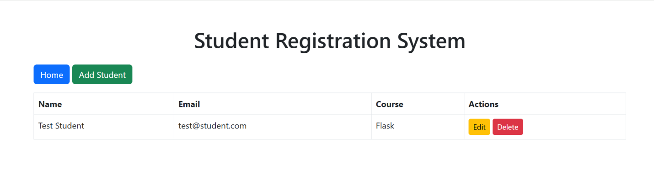

- Git Repository
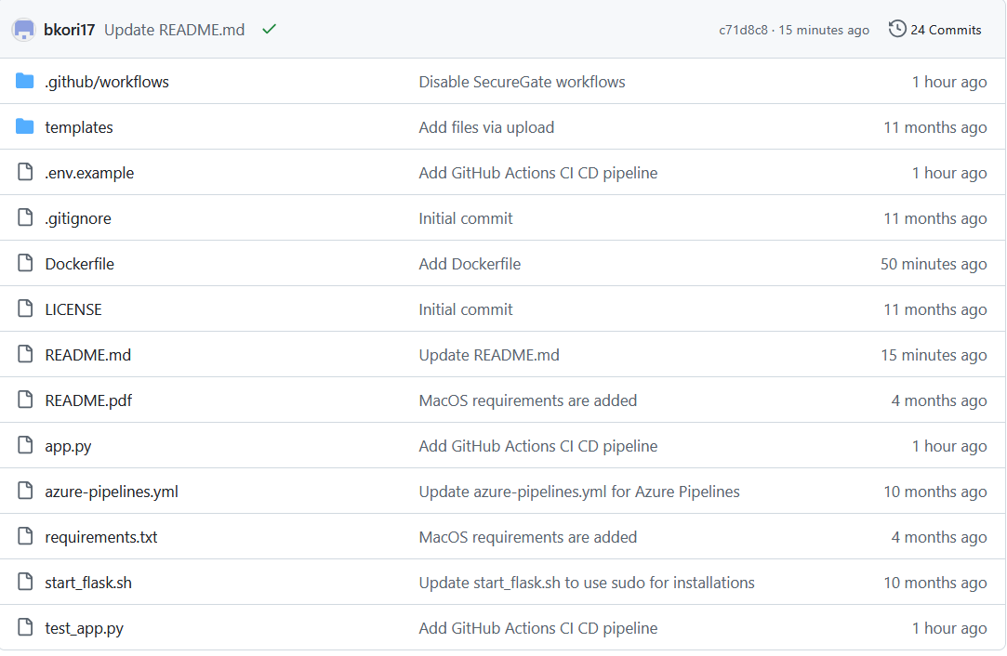

- Successful E-Mail Deployment
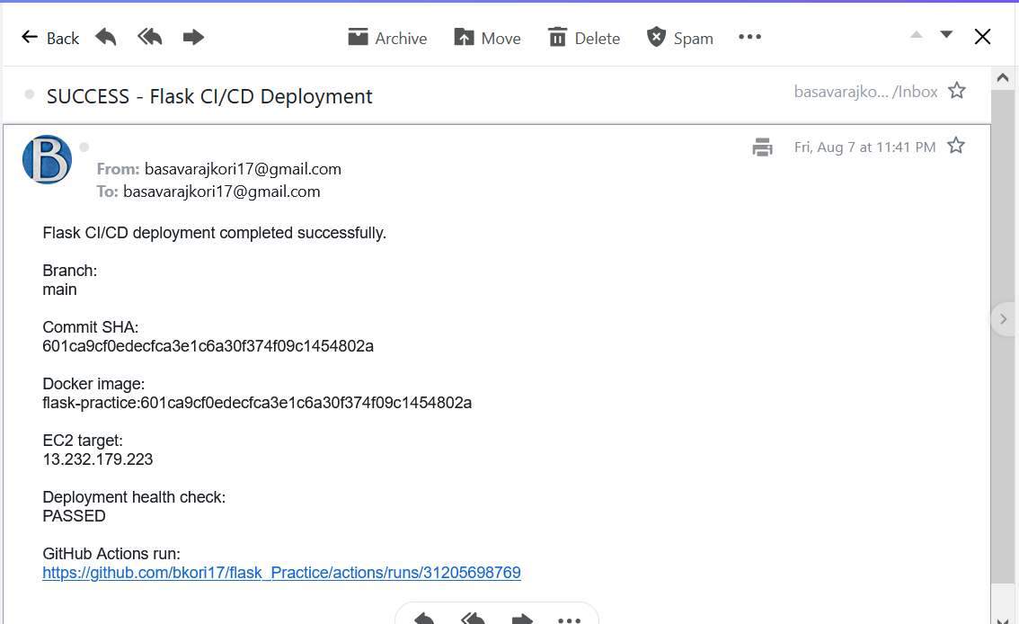

- Failure E-Mail Deployment
