<https://code-maze.com/asp-net-core-web-api-with-ef-core-db-first-approach/>

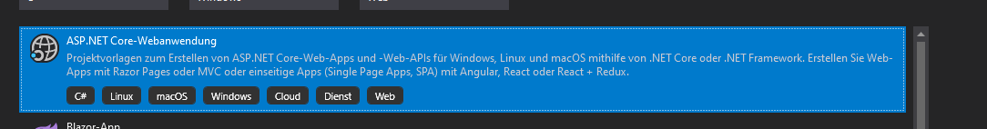

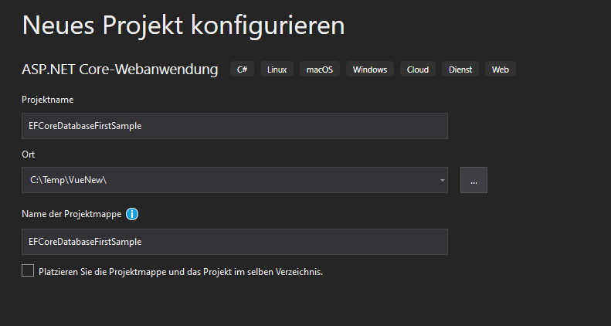

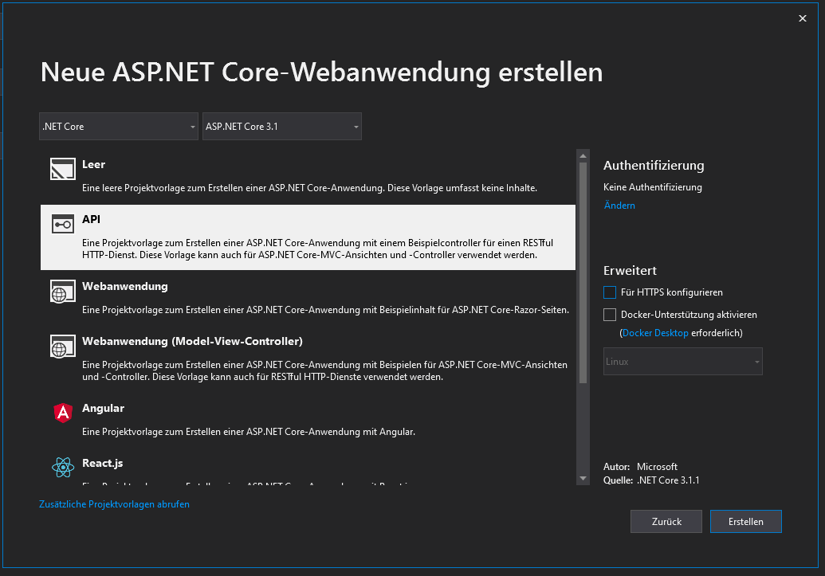

C:\Temp\VueNew\EFCoreDatabaseFirstSample\EFCoreDatabaseFirstSample\Properties\launchSettings.json

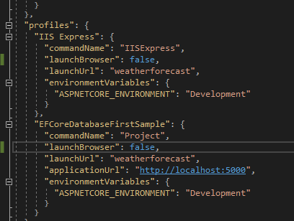

Install-Package Microsoft.EntityFrameworkCore.Tools

Install-Package Microsoft.EntityFrameworkCore.SqlServer

Scaffold-DbContext "Server=.;Database= ToDoWithLoginAPI;Trusted_Connection=True;"

Microsoft.EntityFrameworkCore.SqlServer -OutputDir Models

<https://docs.microsoft.com/de-de/ef/core/miscellaneous/cli/powershell>

Scaffold-DbContext "Server=.;Database= ToDoWithLoginAPI;Trusted_Connection=True;" Microsoft.EntityFrameworkCore.SqlServer -OutputDir Models -force

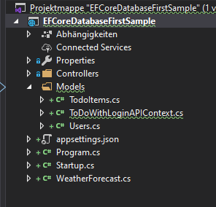

C:\Temp\VueNew\ToDoWith LoginAPI2\ToDoWithLoginAPI\ToDoWithLoginAPI\Startup.cs

public void ConfigureServices(IServiceCollection services)

{

    services.AddDbContext<ToDoWithLoginAPIContext>();

    services.AddControllers();

}

<http://localhost:58652>

EFCoreDatabaseFirstSample

