https://webdeasy.de/login-system-mit-node-vue-restapi-jwt-part-1-2/

<https://webdeasy.de/login-system-mit-nodejs-vue-js-vuex-part-2-2/>

LoginWithVuex

vue create loginwithvuex

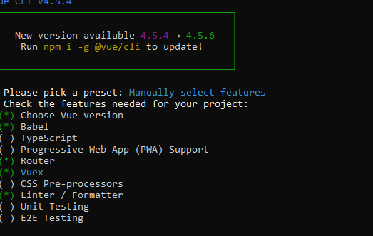

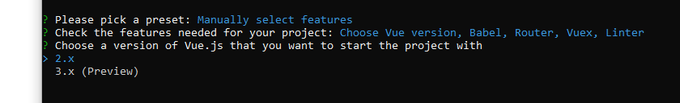

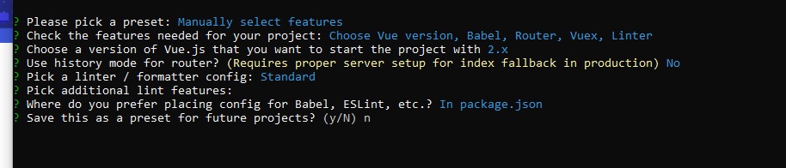

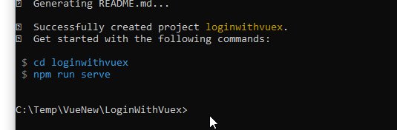

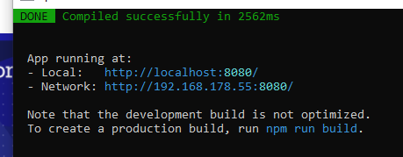

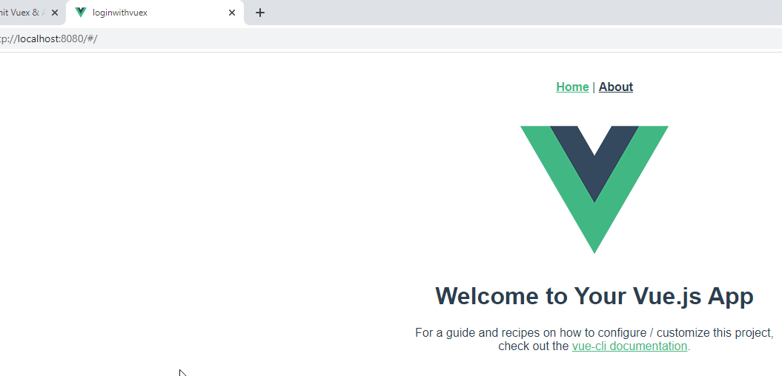

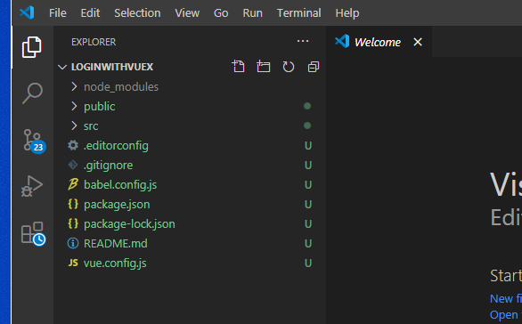

npm install axios vuex-persistedstate