[https://medium.com/@hugo.bjarred/learn-vuejs-by-building-a-simple-todo-app-44e2e7dfccae](https://deref-gmx.net/mail/client/bhwTvfUzV_A/dereferrer/?redirectUrl=https%3A%2F%2Fmedium.com%2F%40hugo.bjarred%2Flearn-vuejs-by-building-a-simple-todo-app-44e2e7dfccae" \t "_blank)

vue create todo-app

weiter bei:

**About VueJS and folder structure**

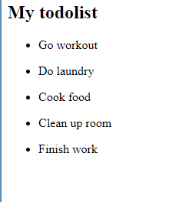

Weiter bei:

**Adding functionality**

Weiter bei:

**Marking todos as done**