[https://www.positronx.io/create-login-signup-ui-screens-in-vue-js-with-bootstrap/](https://deref-gmx.net/mail/client/kiP-eJsa-uk/dereferrer/?redirectUrl=https%3A%2F%2Fwww.positronx.io%2Fcreate-login-signup-ui-screens-in-vue-js-with-bootstrap%2F" \t "_blank)

npm install --global vue-cli

'vue' is not recognized as an internal or external command

I follow these commands, It's work fine for me.

npm install -g vue-cli

npm install -g vue

Edit the System environment variables, and enter the following path, and if still having a problem just try to add a path in System User Variables

C:\Program Files\nodejs\node.exe;

C:\Users\{UserName}\AppData\Roaming\npm

Check **vue** installed in **C:\Users{UserName}\AppData\Roaming\npm** [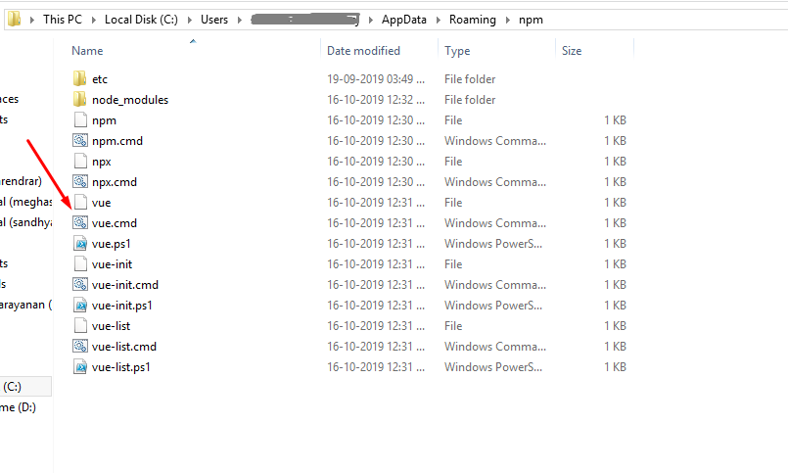](https://i.stack.imgur.com/pi3td.png)

C:\Users\korn\AppData\Roaming

C:\Users\korn\AppData\Roaming\npm

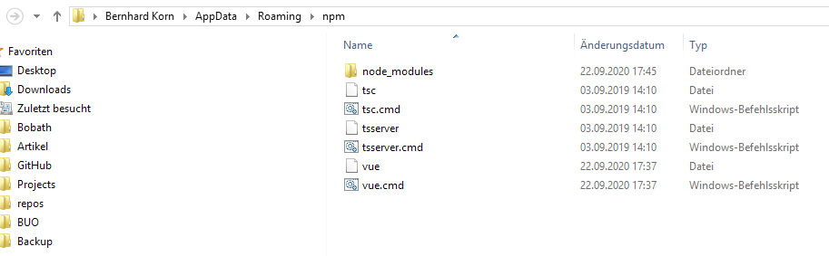

C:\Program Files\Microsoft MPI\Bin\;C:\Program Files (x86)\Intel\iCLS Client\;C:\Program Files\Intel\iCLS Client\;C:\Program Files (x86)\NVIDIA Corporation\PhysX\Common;%SystemRoot%\system32;%SystemRoot%;%SystemRoot%\System32\Wbem;%SYSTEMROOT%\System32\WindowsPowerShell\v1.0\;C:\Program Files (x86)\EgisTec MyWinLocker\x64;C:\Program Files (x86)\EgisTec MyWinLocker\;C:\Program Files (x86)\Intel\OpenCL SDK\2.0\bin\x86;C:\Program Files (x86)\Intel\OpenCL SDK\2.0\bin\x64;C:\Program Files\Intel\Intel(R) Management Engine Components\DAL;C:\Program Files\Intel\Intel(R) Management Engine Components\IPT;C:\Program Files (x86)\Intel\Intel(R) Management Engine Components\DAL;C:\Program Files (x86)\Intel\Intel(R) Management Engine Components\IPT;%USERPROFILE%\.dnx\bin;C:\Program Files\Microsoft DNX\Dnvm\;%M2\_HOME%\bin;C:\Program Files\Microsoft SQL Server\120\Tools\Binn\;C:\Program Files\Microsoft SQL Server\Client SDK\ODBC\110\Tools\Binn\;C:\Program Files (x86)\Microsoft SQL Server\120\Tools\Binn\;C:\Program Files\Microsoft SQL Server\120\DTS\Binn\;C:\Program Files (x86)\Microsoft SQL Server\120\Tools\Binn\ManagementStudio\;C:\Program Files (x86)\Microsoft SQL Server\120\DTS\Binn\;C:\Program Files\Microsoft SQL Server\Client SDK\ODBC\130\Tools\Binn\;C:\Program Files (x86)\Microsoft SQL Server\130\Tools\Binn\;C:\Program Files\Microsoft SQL Server\130\Tools\Binn\;C:\Program Files\Microsoft SQL Server\130\DTS\Binn\;C:\Program Files\dotnet\;C:\Program Files (x86)\Microsoft SQL Server\Client SDK\ODBC\130\Tools\Binn\;C:\Program Files (x86)\Microsoft SQL Server\140\Tools\Binn\;C:\Program Files (x86)\Microsoft SQL Server\140\DTS\Binn\;C:\Program Files (x86)\Microsoft SQL Server\140\Tools\Binn\ManagementStudio\;C:\Program Files\TortoiseGit\bin;C:\Program Files (x86)\GtkSharp\2.12\bin;C:\Program Files (x86)\Xoreax\IncrediBuild;C:\Windows\Microsoft.NET\Framework\v4.0.30319;C:\Program Files (x86)\Windows Kits\8.1\Windows Performance Toolkit\;C:\Program Files\Microsoft SQL Server\Client SDK\ODBC\170\Tools\Binn\;C:\Program Files\nodejs\;C:\Users\korn\AppData\Local\Programs\Microsoft VS Code\bin; \Users\korn\AppData\Roaming\npm

vue create vue-animated-ui

npm install bootstrap

Weiter bei

**Enable Vue Router**