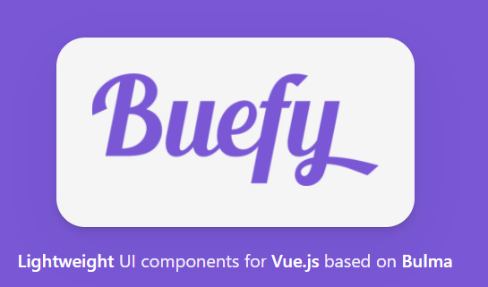

<https://buefy.org/documentation/field>

<https://vuetifyjs.com/en/components/combobox/#caveats>

<https://vuejsexamples.net/vuejs-dropdown/>

<https://vuejsexamples.com/simple-alert-for-vue-js/>

<https://www.positronx.io/create-login-signup-ui-screens-in-vue-js-with-bootstrap/>

<https://mdbootstrap.com/docs/vue/forms/basic/>

<https://www.w3schools.com/howto/howto_css_login_form.asp>

<https://npm.runkit.com/vue-spinner>

<https://vue-spinners.saeris.io/>

https://github.com/Saeris/vue-spinners