<https://www.c-sharpcorner.com/article/getting-started-with-vue-js-and-net-core-32/>

<https://github.com/sk5202/Vue-Js.git>

SOAP:

<https://www.infoworld.com/article/3323584/how-to-consume-a-wcf-soap-service-in-aspnet-core.html>

Authorizer:

<http://bogemaslive:8092/bodegaAuthorizerInternal>

<http://bogemaslive:8092/bodegaAuthorizerInternal>.svc

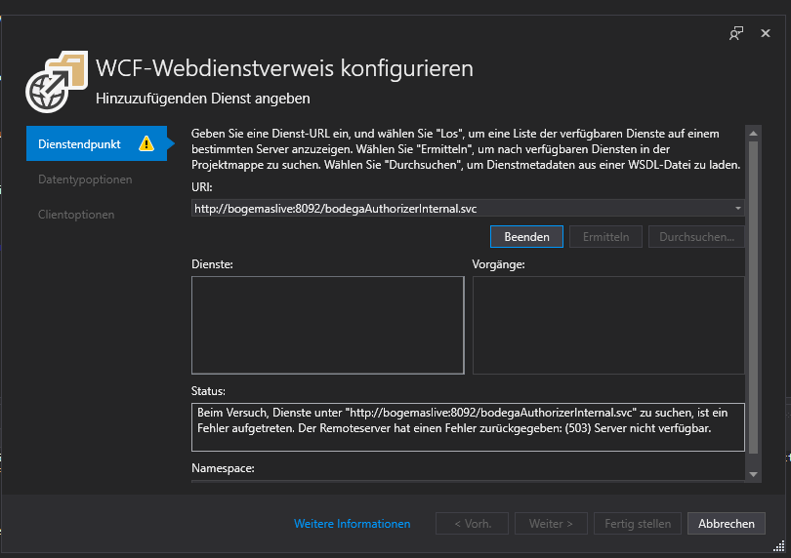

Nicht erreichbar also wsdl.

bodegaAuthorizerInternal2.wsdl

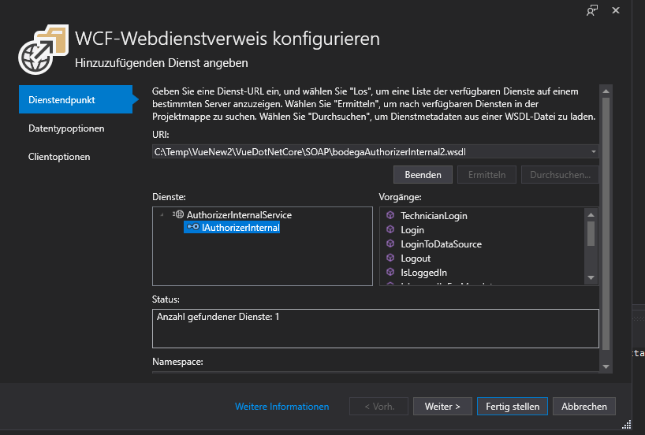

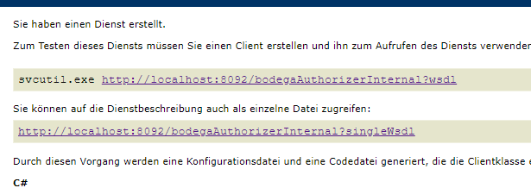

TO

<http://bogemaslive:8190/bodegaWebToolExtendedService>

<http://bogemaslive:8190/bodegaWebToolExtendedService.svc>

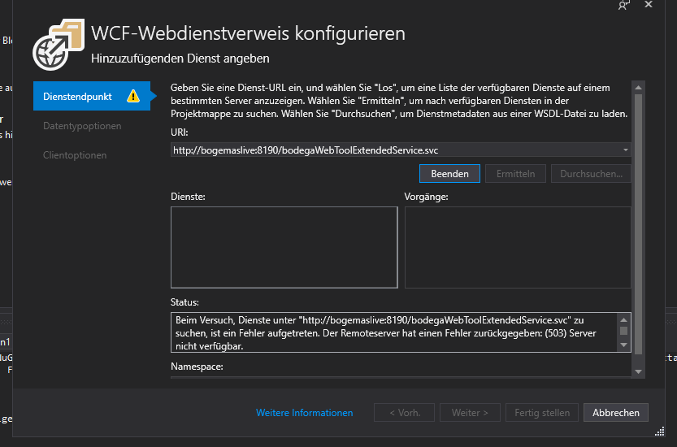

Nicht erreichbar also wsdl:

bodegaWebToolExtendedService.wsdl

