DEMO / SCREENSHOTS :

1] LOGIN USING MASTER PASSWORD

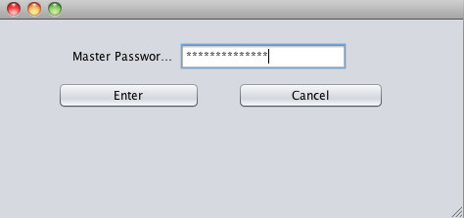

2] CREATING A BUCKET

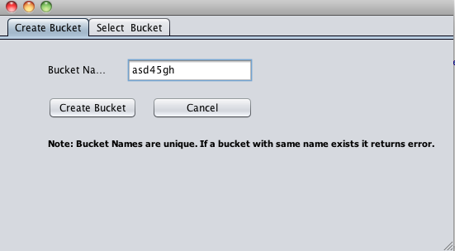

3] SELECTING THE BUCKET

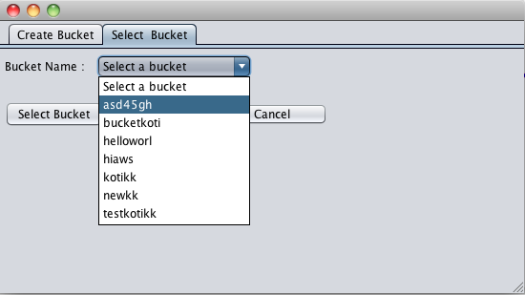
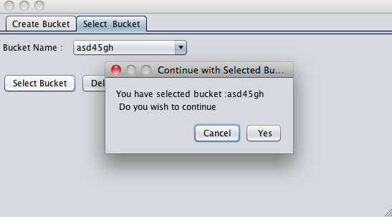

4] NEW SALT CREATED FOR A NEW BUCKET

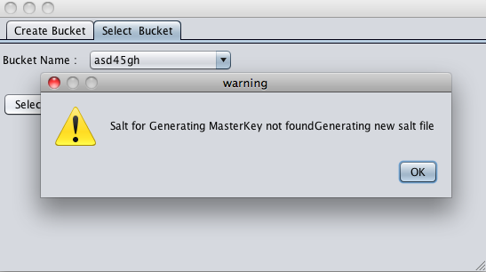

5] ENCRYPTION

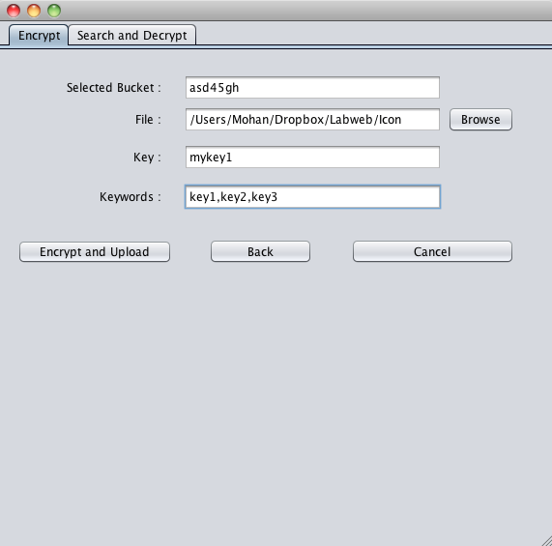

6] UPLOAD FILE

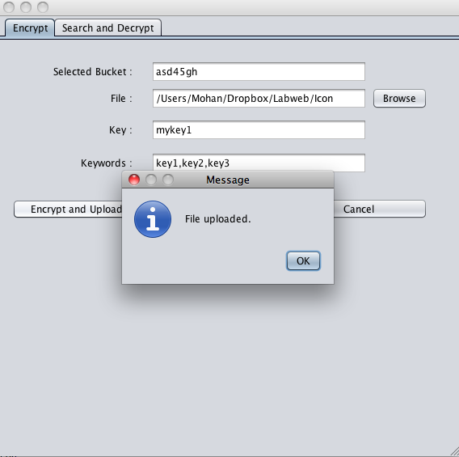

7] SEARCH THE KEYWORD

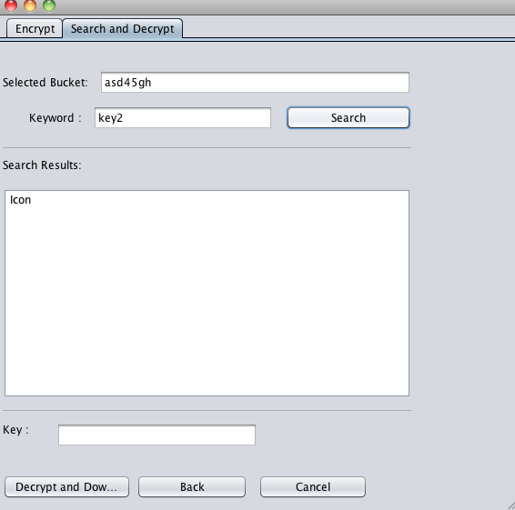
KEYWORD KEY2 IS FOUND IN ICON FILE.

8] ENTERED WRONG KEY FOR DECRYPTION

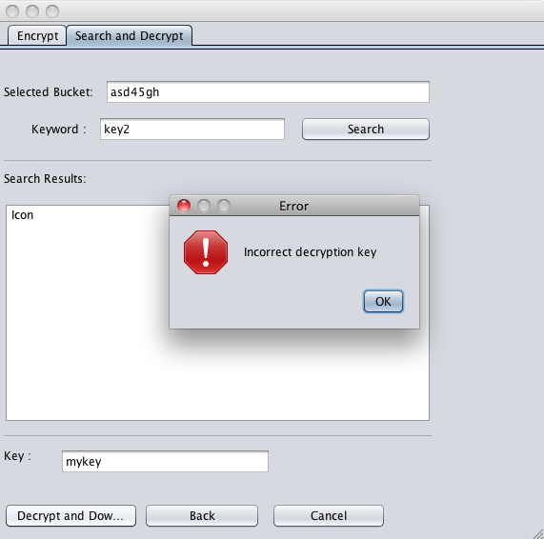

9] ENTERED CORRECT KEY FOR DECRYPTION

