BETTY KOUADIO

Professor Robert Alexander

Course: CMSC204

Assigment#3

**Reflexion**

In this assignment #3 I learn how to use generics classes to build a basics double linked list and doubled linked list. I learn the difference between basic single linked list and double linked list. I understand that the single list use only the hasext( ) function to connect and the double linked list use two functions hasnext( ) and hasprevious( ) to connect each other’s. I also learn the difference between comparable and comparator. Comparable interface has one method compareTo (obj) and the comparator interface has two methods equals(obj) and compare (obj1 , obj2)

**Screenshot**

Adding to a Basic List

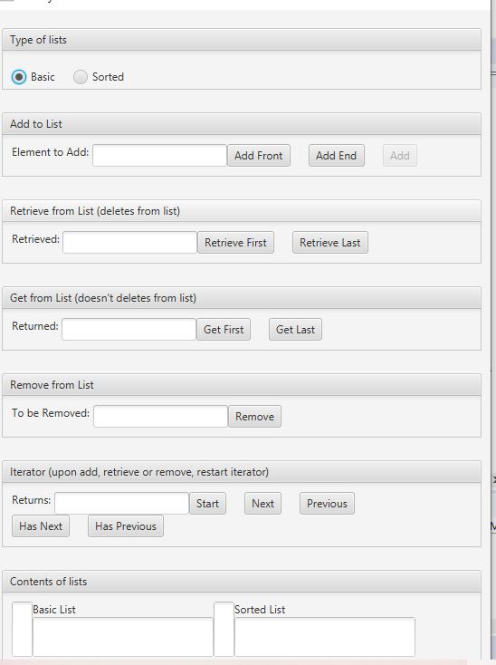

Adding to Basic and Sorted list

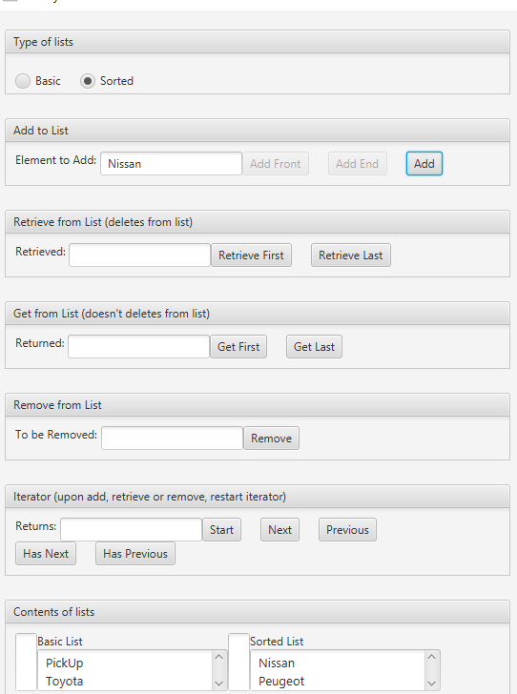

Retrieved “PickUp” from Basic list and “Nissan” from Sorted List

