Betty Kouadio

Professor: Dr. Robert Alexander

CMSC204-22378

Assignment#2

**Reflection**

In assignment#2, I wrote classes that evaluate the arithmetic expression. I needed to write an algorithm that converts infix notation to postfix notation using stack. In addition, I did the same for postfix to infix. Also, I have to evaluate the postfix expression using a stack. Infix notation is what humans use to solve normally by considering the precedence of the operators, but computers use the stack to solve expressions. Postfix notation is very easy to process left-to-right. An operand is pushed onto a stack and an operator pops its operands from the stack and pushes the result and little or no parsing is necessary.

**Screenshot of the running code**

At Start

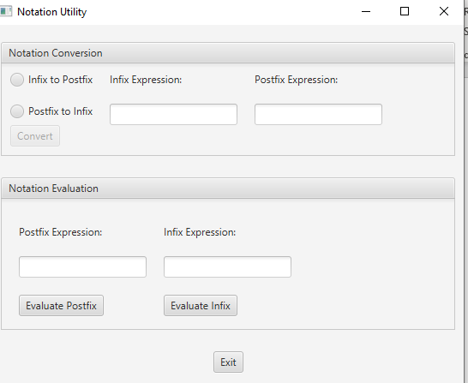

After selecting Infix to Postfix

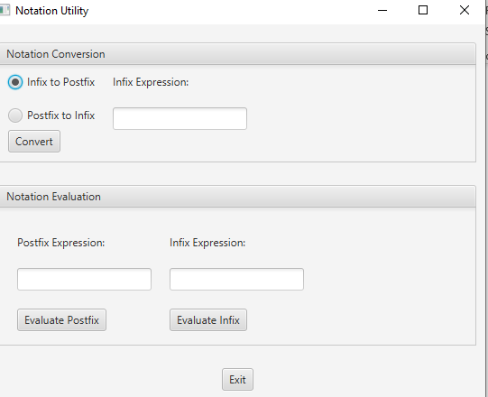

After selecting Postfix to Infix

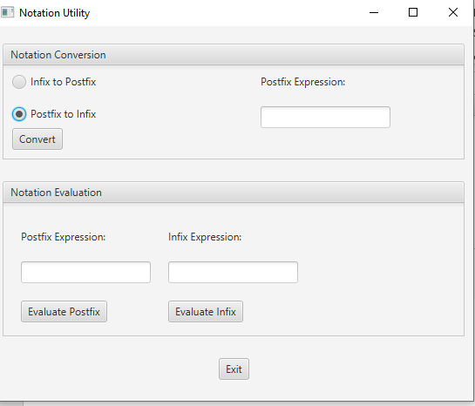

After selecting Convert Button

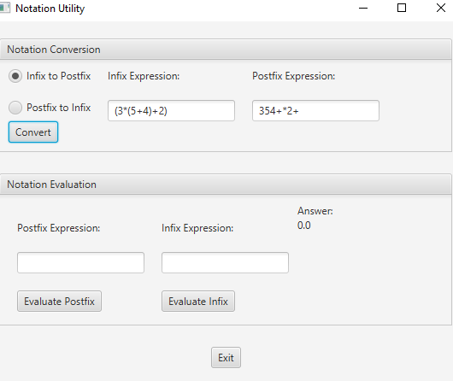

After selecting Evaluate button

