[Registered Report] Cracking the Representational Code of Verbal Working Memory

Benjamin Kowialiewski^{1,2}, Klaus Oberauer³
¹Psychology & Neuroscience of Cognition Research Unit (PsyNCog), University of Liège, Belgium
²Fund for Scientific Research F.R.S.-FNRS, Brussels, Belgium
³Department of Psychology, University of Zurich, Switzerland

The research reported in this article was supported by funding from the Swiss National Science Foundation (SNSF, grant number 100014_179002).
Correspondence concerning this article should be addressed to Benjamin Kowialiewski, Psychology & Neuroscience of Cognition Research Unit, 4000 Liège, Belgium. E-mail: bkowialiewski@uliege.be

Open Science statement:
All the data and codes have been made available on GitHub: XXX

Abstract
Verbal working memory (WM) encodes information primarily in a phonological format. This is evidenced by the phonological similarity effect, wherein items in lists composed of phonologically similar words are more frequently confused than items in lists composed of phonologically dissimilar words. This effect can serve as a proxy to understand how WM represents phonology: Because two items are confused to the extent that they are similar to each other, different representational assumptions yield distinct predictions about the similarities between words, and hence, about when and to what degree a phonological similarity effect should emerge. In this project, we implement these assumptions computationally and will compare them using a large-scale experiment involving participants encoding lists of words for serial recall. [The rest of this abstract will be written after data collection]

Keywords: Working Memory; Phonology; Phonological Similarity; Computational modeling; Serial Recall

Introduction
Verbal working memory (WM) is subject to similarity-based confusions, such that phonologically similar items are confused more often than phonologically dissimilar items (e.g., Acheson et al., 2010; Baddeley, 1966, p. 196; Camos et al., 2013; Coltheart, 1993; Fallon et al., 2005; Farrell, 2006; Gupta et al., 2005; Kowialiewski et al., 2023; Lewandowsky & Farrell, 2008; Nimmo & Roodenrys, 2004). This phonological similarity effect is one of the most replicated phenomenon in the WM literature and has been observed across a wide variety of experimental designs, such as serial recognition (Gathercole et al., 2001; Lian & Karlsen, 2004; Nimmo & Roodenrys, 2005), order reconstruction (Karlsen et al., 2007; Kowialiewski et al., 2023), backward recall (Guérard et al., 2012) and when list items are used as as a cue to retrieve a positional or spatial context (Guérard et al., 2009; Kowialiewski et al., 2023). Various ways of manipulating between-item similarity have been carried out, and larger similarity consistently yields increased confusion errors (Farrell, 2006; Gupta et al., 2005; Li et al., 2000; Nairne & Kelley, 1999; Roodenrys et al., 2022).
Current WM models explain the phonological similarity effect by calling upon a comparison mechanism between an internal representation and a set of retrieval candidates (Schweickert, 1993) that we illustrate in Figure 1. In these models, the core process of encoding into WM involves the binding between an item and a context (Farrell & Lewandowsky, 2002; Henson, 1998; Oberauer et al., 2012). In serial recall, the context is the serial position of the to-be-remembered item. Positional contexts exhibit a degree of similarity which decreases as a function of their positional distance, such that adjacent positions are more similar to each other than distant ones. This is illustrated by the overlap between ellipses in Figure 1. Due to this positional overlap, items are not only encoded in their own specific context but are also partially encoded to the contexts they share with neighboring items.
Retrieving an item starts by cueing it with its serial position, which leads to the retrieval of a distorted representation of that item. Because of the similarity between positional cues, not only the representation of the target item will be retrieved, but also the representation of other list items partially encoded to that position. This means that the distorted representation is a blend of all list items, weighted by their association strength with the current positional cue. In most cases, the representation of the target item will be the strongest, followed by items presented at adjacent positions to it. Because the retrieved representation is not the original item but a distorted version of it, it cannot be recalled as is. It must first be matched against a set of retrieval candidates competing for selection. In serial recall of words, the retrieval candidates are the words stored in the vocabulary. Comparisons between the distorted representation and the retrieval candidates lead the candidates to be activated to the extent that they match the distorted representation. The probability to retrieve each retrieval candidate is based on this activation level, such that highly activated candidates are more likely to be selected (Figure 1, left panel). When the similarity between list items increases, such as in a phonologically similar list (Figure 1, right panel), all retrieval candidates will match very strongly the distorted representation. This means that the activation level of the non-target retrieval candidates will be more similar to the activation level of the target candidate, which translates into a higher probability to retrieve a non-target candidate and therefore higher similarity-based confusions.

Figure 1
Schematic Representation of How Similarity Induces Confusion Errors
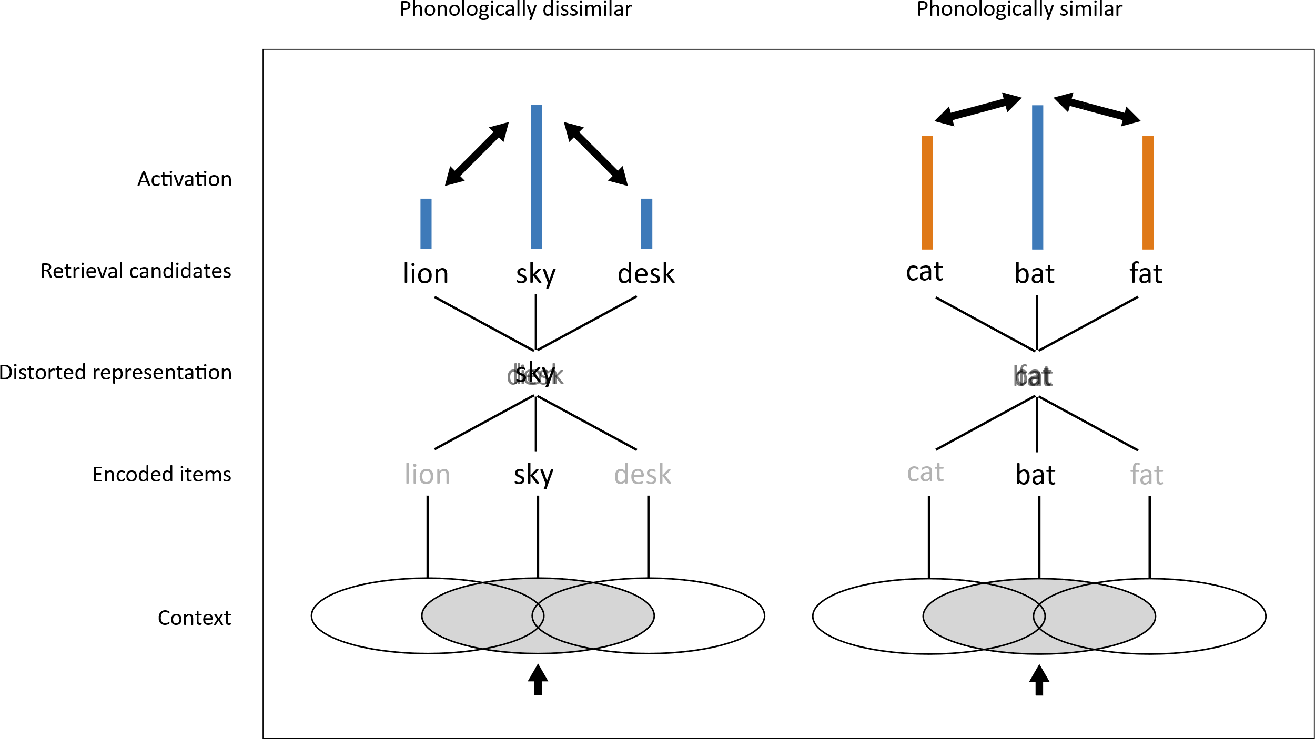
Note. XXX

The phonological similarity effect indicates that WM encodes information in a phonological format: Two items are confused to the extent that they are represented the same way. This property can be used as a proxy to uncover the representational basis of WM. Indeed, what constitutes similarity depends on the underlying theoretical assumption for how phonological information is represented. Different theoretical assumptions produce diverging similarity metrics and therefore make diverging predictions regarding the extent to which a given word list should produce a similarity effect. For instance, one way of conceptualizing phonological representations is through slot coding, in which each phoneme that constitutes a word is stored in its own slot. Each slot is dedicated to represent phonemes in a particular within-word position. In this model, the similarity between two strings is determined by the proportion of phonemes they share in the same slots. Given the two strings /kæt/ and /tæɡ/, their similarity will be 0.333, because they share 1/3 of their phonemes in the same slot. Another way of conceptualizing phonology is through a closed biphones scheme, in which words are represented as pairs of adjacents phonemes – also called “biphones” (Hannagan et al., 2013). In this model, the similarity between two strings is determined by the proportion of their shared biphones. Taking back the previous example, the biphones of /kæt/ and /tæɡ/ can be decomposed into [/_k/, /kæ/, /æt/, /t_/] and [/_t/, /tæ/, /æɡ/, /g_/], respectively. In this case, the similarity value between both strings is zero, because they share none of their biphones. Therefore, contrary to the slot coding model, the closed biphone model predicts that both strings should not be particularly confused more often with each other than any other pairs of strings.
The phonological similarity effect thus offers a key to uncover the representational format of verbal WM by assessing how well various competing similarity metrics predict similarity-based confusions. Recently, Zhang & Osth (2024) implemented and compared the ability of different letter-string representations to capture performance in recognition memory, and provided support for open-bigram representations of letter coding. The present study adopts a similar approach. We begin by introducing and implementing different similarity metrics grounded on different assumptions for how WM represents phonological information. Using a preliminary dataset, we fitted these metrics to observed confusability patterns as a proof of concept that competing similarity metrics can be distinguished. We will then conduct a large-scale experiment (N = 300) to evaluate these similarity metrics with greater precision.

Computational Modeling
In this section, we start by describing competing representational codes of the phonology of words and how they translate into similarity metrics. We next describe how these representations are integrated into a standard model of WM and can be used to predict confusion errors in serial recall.

Similarity Metrics
We quantify the similarity between two phoneme strings on a scale from 0 to 1. A value of 0 indicates that the strings are maximally dissimilar, whereas a value of 1 indicates they are maximally similar. Different representational codes generate different similarity values for any two strings of phonemes. The next paragraphs describe these representational codes, starting with the slot coding model.
Slot coding. The first metric we implement is slot coding. In a slot coding model, the phonemes in each ordinal position in a word are stored in a separate slot dedicated to that position. The phonemes of two words match when they are identical and in the same slot: The first phoneme of string $i$ is matched against the first phoneme of string $j$, and so on. Thus, a match $M$ in slot $k$ occurs when:
$$M_{k}=1ifi_{k}=j_{k}$$  $$otherwiseM_{k}=0$$ | (1)

The phonological similarity $S_{ij}$ between string $i$ and string $j$ is obtained by dividing their number of matches by their alignment length, which is the length of the longest string:
$$S_{ij}=\frac{\sum_{k=1}^{N}{M_{k}}}{max\left(\left|i\right|,\left|j\right|\right)}$$ | (2)

Where the length $\left|i\right|$ of a string $i$ corresponds to its number of phonemes. In Eq. 2, the sum runs over the number of slots $N$.
Levenshtein Distance. The second model we implement is derived from the Levenshtein distance, which is commonly used as a way to measure the distance between orthographic strings, for instance to define neighboring words (Luce & Pisoni, 1998; Yarkoni et al., 2008). The Levenshtein distance refers to the minimum number of elementary changes required to transform string $i$ into string $j$. These changes include insertions, deletions, and substitions of elements. We will not re-describe the full equation for the Levenhstein distance here. Many packages implement the Levenshtein distance in most modern programming languages. To get the similarity between two strings, their Levenshtein distance $d$ is divided by their alignment length, and the result is then subtracted to one:
$$S_{ij}=1-\frac{d}{max\left(\left|i\right|,\left|j\right|\right)}$$ | (3)

As for the slot coding model, the length $\left|i\right|$ of a string $i$ is its number of phonemes.
Syllable model. The syllable model behaves similarly to a slot coding model, except that phonemes are matched according to their position within a syllable. Each syllable is decomposed into their onset, nucleus, and coda. The onset and the coda each consist of a variable number of consonants (in the limit, zero); the nucleus consists of a single vowel. Slots are dedicated to positions within a syllable, such as the first phoneme of the onset, the second phoneme of the onset, and so on. When two words are compared, the first step is to align their syllables with each other in their order within the word.We added a degree of flexibility at this step: When two words have a different number of syllables, the starting point of the alignment is anchored at the syllable position which maximizes the similarity between both strings. For instance, when comparing “surface” and “resurface”, the alignment starts with the syllable “sur” in both words, and the excess syllable “re” in “resurface” is compared to an empty syllable in “surface”. Within each syllable, a match $M$ occurs whenever the strings share a phoneme at the same within-syllable position $k$. The similarity value is obtained by dividing the number of matches by the total number of comparisons $N$:
$$S_{ij}=\frac{\sum_{k=1}^{N}{M_{k}}}{N}$$ | (3)

When two syllables both have no phonemes in a within-syllable position, no comparison occurs in those positions. For instance, both syllables /bi/ and /ki/ miss their coda. The number of comparisons for these two syllables is therefore 2. By contrast, when /in/ and /ki/ are compared, the onset of /ki/ is compared to the empty onset of /in/, yielding a mismatch, and the coda of /in/ is compared to the empty coda of /ki/, yielding another mismatch; the number of comparisons is 3.
Closed biphone model. In the closed biphone model, words are represented as biphones, which are pairs of phonemes. Contrary to the open biphone model described below, only adjacent phonemes are considered. The computation of this similarity metric starts by extracting all biphones from each string. If a biphone appears more than once in a string, it is counted only once.
b∈B

bBThe phonological similarity between two strings is obtained by dividing the number of biphones they share by the number of biphones in the longest set. Hence, given the sets $B_{i}$ and $B_{j}$ for strings $i$ and $j$, their phonological similarity is the length of their intersection, divided by their alignment length:
$$S_{ij}=\frac{\left|B_{i}∩B_{j}\right|}{max\left(\left|B_{i}\right|,\left|B_{j}\right|\right)}$$ | (5)

Open biphone model. The open biphone model is similar to the closed biphone model and is computed using Eq. 5 above, with the exception that non-adjacent biphones are considered up to N positions between their phonemes, where N refers to the level of openness. With N = 0, the closed biphone and open biphone models are identical. We treat the level of openness as a free parameter, setting a maximum of N = 5. This means that we considered five open biphone models: One for each level of openness.

The Working Memory Model
The model we use to integrate the similarity metrics described above is a generic serial recall model including core assumptions shared by many WM models (Farrell & Lewandowsky, 2002; Henson, 1998; Oberauer et al., 2012; Oberauer & Lin, 2024). To keep the model as simple as possible, we implement only the assumptions which are necessary to produce a phonological similarity effect. This choice is justified by our purpose to differentiate the similarity metrics based on confusion errors. Modeling other phenomen a such as omission errors, extra-list intrusions and serial position curves is outside the scope of the present project, and would only have the side effect of complexifying the model unnecessarily.
Both items and contexts are represented as feature vectors. The core process of encoding an item occurs through Hebbian learning associating item and context vectors to each other. Items have pairwise similarity values as defined by the equations described in the previous section. For any two items $i$ and $j$, we transform their similarity value $S_{ij}$ into psychological similarity (Brown et al., 2007; Nosofsky, 1986):
$$η_{ij}=exp\left(-b\left[1-S_{ij}\right]\right)$$ | (6)

Where $b$ is a scale parameter that we vary freely. The $S_{ij}$ value is determined by the metric considered. Specifically, for each similarity metric, we built a matrix of similarities for the words in each trial. . The similarity between contexts decreases exponentially as their positional distances increase. Hence, the contextual overlap $C_{jk}$ between two contexts $j$ and $k$ is given by:
$$C_{jk}=P^{\left|j-k\right|}$$ | (7)

Where $P$ is a free parameter controlling the positional overlap. This theoretical assumption is required to model the fact that confusion errors are more likely to occur between close than between distant serial positions (e.g., Farrell et al., 2011; Henson, 1998).
The model retrieves the items by cueing them with the positional context to which they were encoded. This cueing process triggers the retrieval of the representation of the target item. Due to the positional overlap, other items which were partially encoded to that positional cue are also retrieved. Hence, the representation retrieved by the model is a blend of all features encoded to the positional context which serves as a retrieval cue. This representation is then compared to the retrieval candidates via the dot product, which leads to the reactivation of all retrieval candidates in an output layer $O$ that contains localist representations of each retrieval candidates:
$$O_{i}=\sum_{j=1}^{N}{η_{ij}}C_{jk}$$ | (8)

Therefore, the activation received by each item $i$ in the output layer $O$ is the sum of the contribution from all items $j$ encoded at context $k$. Selection is based on activation values in the output layer, such that the most activated item is selected for output. However, without a source of noise, the model would repeatedly recall the same item. To produce errors such as transposition errors, a normally distributed source of noise centered around zero with a standard deviation $σ$ is added to each localist unit in the output layer. The noisy selection process is modeled by transforming the activation value in the output layer into probabilities using the exponential version of Luce’s choice rule:
$$p_{i}=\frac{exp\left(\frac{O_{i}}{σ}\right)}{\sum_{i=1}^{N}{exp}\left(\frac{O_{i}}{σ}\right)}$$ | (9)

Model fitting
Table 1 reports a list of the free parameters used in the model, along with their definitions and values. Note that since we fit the model to individual participant data, free parameters vary between participants and are therefore reported as ranges.

Table 1. Free parameters of the working memory model
Symbol | Meaning | Value
$$P$$ | Contextual overlap | [0.0 – 1.0]
$$b$$ | Parameter scaling the similarity value $S$ | [0.01 – 10.0]
$$σ$$ | Standard deviation of the noise added at retrieval | [0.01 – 1.0]
Note. XXX

Fitting procedure. We fitted the model to individual participants on a trial basis. For each recall attempt, we computed the probability $p$ to recall each retrieval candidate using Eq. 9. The log-likelihood was then computed using the recall probability of the observed response o in recall attempt r:
$${logL}_{r}=log\left(p_{or}\right)$$ | (10)

We used the deviance as a loss function by summing all log-likelihoods across trials and retrieval attempts for a given participant, and multiplying this result by -2:
$$D=-2\sum{{logL}_{r}}$$ | (11)

Note that when a response other than a list item was produced (such as an omission or an extra-list intrusion), the observation was ignored and did not enter the count in the sum from Eq. 11.
Parameter estimation. The parameters were estimated using a differential evolution algorithm (Storn & Price, 1997). The number of individuals in the population was set to 10n, where n is the number of free parameters in the model. The crossover probability and differential weight were fixed to 0.9 and 0.8, respectively. We used the standard deviation of parameter values from individuals in the population as a stopping criterion (Zielinski et al., 2006). Convergence was considered reached if the standard deviation fell below 10-4. If this criterion could not be reached, the algorithm stopped after 10,000 iterations.
Model comparison. To compare models with each other, we computed an Akaike Information Criterion (AIC) for each model:
$$AIC=\sum_{i=1}^{N}{2K+D_{i}}$$ | (12)

The sum runs over the deviances across all participants and 2K reflects a penalty term for the number of free parameters. As we fit the model separately to each participant, the number of free parameters that were estimated, K, corresponds to the number of participants times the number of free parameters of the model. We therefore computed one AIC for each participant and summed all AICs to obtain an overall assessment for a particular model. After computing one AIC for each model, models can be compared by subtracting their AICs. This difference represents the likelihood of the data under a certain model, relative to another model.

Preliminary Experiment
Before running the main experiment, we tested the ability of the model to differentiate between competing explanations for how WM represents phonology using a preliminary dataset. We fitted the model to an unpublished dataset in which participants encoded lists of phonologically similar and dissimilar items for serial recall. There were two similarity conditions: A grouped conditions in which triplets of phonologically similar items were presented in subgroups (e.g., high, sky, fly, fall, ball, call) and an interleaved condition in which the triplets were presented in an interleaved fashion (e.g., tree, bright, bee, light, sea, night). We chose this experiment because of its proximity with the design we plan to use in the main experiment (see below).

Methods
Participants. Thirty-two participants from the University of Liège were recruited. This sample size was chosen because it has been sufficient for obtaining strong evidence for similarity effects in previous experiments and was feasible with the available resources. All participants were French native speakers, reported no history of neurological disorder or learning difficulties. All participants gave their electronic informed consent before starting the experiment. The experiment had been approved by the Ethic committee of the Faculty of Psychology, Speech and Language Therapy, and Education of the University of Liège.
Material. The stimuli used in this experiment were French nouns. The stimuli were drawn from 40 different rhyming categories, each composed of three rhyming items. The phonologically similar lists were built by using items from two different categories. The phonologically grouped lists were created first. The phonologically interleaved lists were created using the same sequences as the semantically grouped sequences but changing the items’ order such that the phonologically similar items were now presented in an interleaved fashion. The phonologically dissimilar lists were built by randomly sampling items from six different categories, with the constraint that all items had to have a Levenshtein distance between the letter strings larger than 2 from each other. Each item was used three times across the whole experiment: once in a grouped condition, once in an interleaved condition, and once in a dissimilar condition, which resulted in 20 trials per condition. Items were recorded by a native male French-speaking individual in a neutral voice in a soundproof booth. A filter was applied to all stimuli to suppress the residual background noise using the Audacity software. Items were then isolated on separate audio files.
Procedure. Due to the Covid-19 pandemic, participants were tested remotely. The experimenters met the subjects via a desktop application and gave instructions. Participants performed the experiment separately on an online webpage. The auditory presentation of the stimuli was made possible using the Pizzicato library (https://alemangui.github.io/pizzicato/). Participants’ oral responses were recorded for later transcription by an internship student. The task was coded in JavaScript.
Each trial started with the presentation of a six-item list to be remembered. Each item was auditorily presented at a pace of 1000 ms per item. After the last to-be-remembered item, participants recalled the items aloud in their original presentation order. If participants could not recall an item, they were instructed to say the word “blanc” (i.e., the french word for “blank”). After recalling all items, participants pressed the spacebar to initiate the next trial. Participants performed three training trials prior the main experiment.

Figure 2
Preliminary experiment - Task diagram

Note. XXX

Scoring procedure. Recall performance was assessed using a conditionalized order recall criterion in which an item was scored correct if recalled in the correct serial position, given that it had been recalled at all. Items not recalled at all are not diagnostic of confusion errors and are therefore scored as missing data. For instance, given the to-be-remembered sequence “ABCDEF” and the output sequence “A*DCEZ”, the sequence would be scored as [1, NA, 0, 0, 1, NA], resulting in an average order recall score of 2/4. Since this project is specifically interested in predicting confusion errors, we omitted other scoring methods.
Statistical analyses. Overall recall performance was assessed using a Bayesian logistic regression model. The full model included a fixed effect of similarity condition (grouped, interleaved, dissimilar), a random effect of similarity and a random intercept. To assess the strength of evidence for or against each effect, we first identified the best possible model. This was done using a top-down approach, starting from the full model and comparing it to another model which did not include a specific effect. We repeated this operation until the best model was found. We then compared this best model against the same model without the effect of interest.

Results
Results from the Bayesian logistic regression model indicate that the best model was the model including the main effect of condition and the random intercept. This model was 6.568 times more likely than the model including the random effect of condition, and 3.471e+24 times more likely than the model without the main effect of condition. These results therefore support the presence of a phonological similarity effect. As shown in Figure 3, the grouped and interleaved conditions led to lower order recall accuracy than the dissimilar condition.

Figure 3
XXX
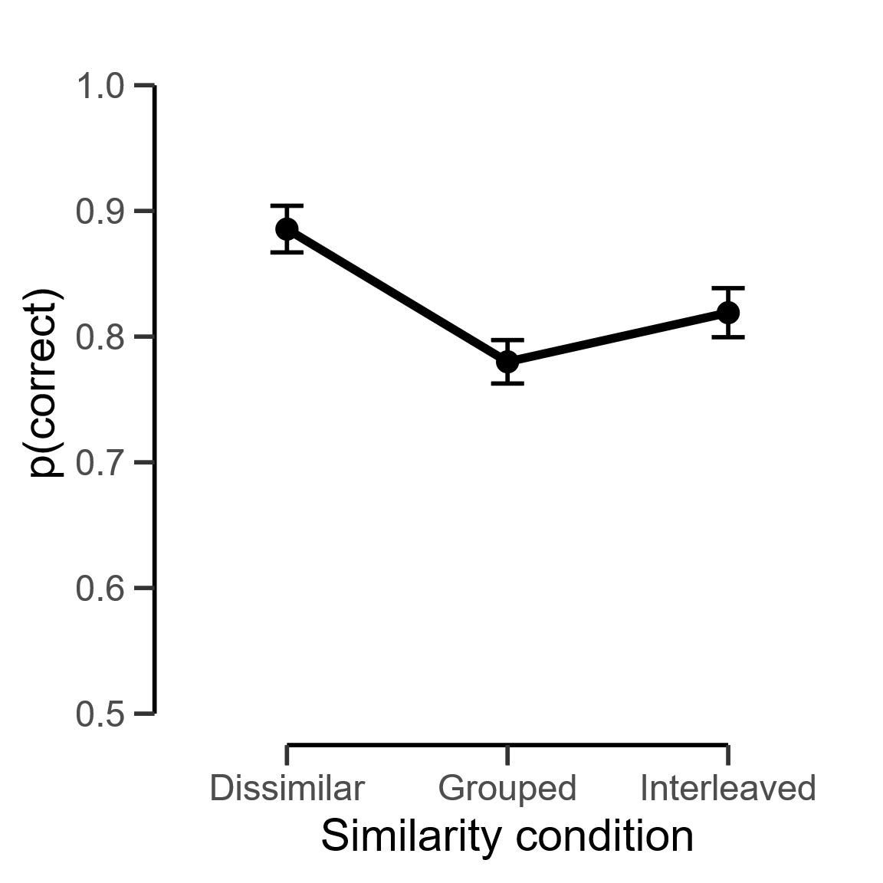
Note. Errors bars indicate the 95% confidence intervals (Morey, 2008)

Next, we fitted the WM model 9 times to the data: Once for each similarity metric. We report in Figure 4 the predictions for all models. As seen, all models reproduce the data very closely and cannot be qualitatively distinguished. This is not surprising, because all lists were constructed from rhyming categories and were not built to distinguish similarity metrics from each other. It was nonetheless possible to distinguish models with different metrics based on quantitative predictions. Table 2 lists all metrics and their associated AIC values. For ease of interpretation, this table also shows the $ΔAIC$ values, which are AIC differences with the best model. The model with the lowest AIC is the best model and has therefore a $ΔAIC$ value of zero. The best model is the syllable model. As shown by the AIC difference, the data are 25.95 times more likely under the syllable model than under the Levenshtein model, which was the second best model. The slot coding and closed biphone models had very close AIC values, with AIC differences of ~76 from the syllable model. Finally, all open biphone models performed worse than all other models, with AIC differences of more than 160to the syllable model. The level of openness did not improve model predictions.

Figure 4
XXX
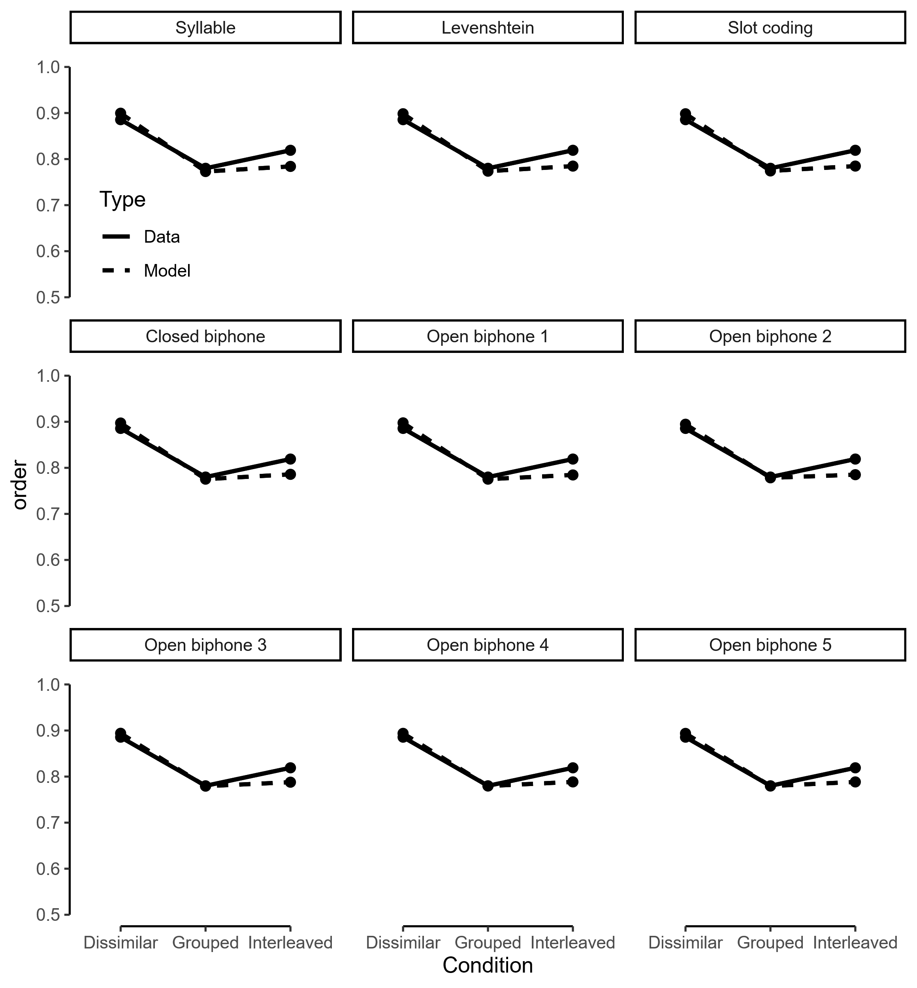
Note. Errors bars indicate the 95% confidence intervals (Morey, 2008)

Table 2. XXX
Metric | AIC | $$ΔAIC$$
Slot coding | 78213.68 | 75.46
Levenshtein | 78164.17 | 25.95
Syllable | 78138.22 | 0
Closed biphone | 78214.6 | 76.38
Open biphone 1 | 78300.76 | 162.54
Open biphone 2 | 78590.49 | 452.27
Open biphone 3 | 78395.75 | 257.52
Open biphone 4 | 78356.03 | 217.81
Open biphone 5 | 78356.35 | 218.13
Note. XXX

Discussion
Results from this preliminary experiment show the presence of a phonological similarity effect when items are presented in triplets of phonologically similar items. Under these conditions, we were able to differentiate all representational models based on quantitative predictions. One strong limitation of this experiment is the fact that its material was not originally designed to differentiate these representational models. The next experiment will aim to overcome these limitations.

Experiment
XXX

Methods
Participants. XXX
Material. XXX
Procedure. XXX
Scoring procedure. XXX
Statistical analysis. XXX

Results
[To be completed after Stage 1]

Discussion
[To be completed after Stage 1]

General discussion
[This section will be completed after Stage 1 of reviews and data collection]

Conclusion
[This section will be completed after Stage 1 of reviews and data collection]
Appendix A

References
Acheson, D. J., Postle, B. R., & MacDonald, M. C. (2010). The interaction of concreteness and phonological similarity in verbal working memory. Journal of Experimental Psychology: Learning, Memory, and Cognition, 36(1), 17–36. https://doi.org/10.1037/a0017679
Baddeley, A. D. (1966). Short-term Memory for Word Sequences as a Function of Acoustic, Semantic and Formal Similarity. Quarterly Journal of Experimental Psychology, 18(4), 362–365. https://doi.org/10.1080/14640746608400055
Brown, G. D. A., Neath, I., & Chater, N. (2007). A temporal ratio model of memory. Psychological Review, 114(3), 539–576. https://doi.org/10.1037/0033-295X.114.3.539
Camos, V., Mora, G., & Barrouillet, P. (2013). Phonological Similarity Effect in Complex Span Task. Quarterly Journal of Experimental Psychology, 66(10), 1927–1950. https://doi.org/10.1080/17470218.2013.768275
Coltheart, V. (1993). Effects of phonological similarity and concurrent irrelevant articulation on short-term-memory recall of repeated and novel word lists. Memory & Cognition, 21(4), 539–545. https://doi.org/10.3758/BF03197185
Fallon, A. B., Mak, E., Tehan, G., & Daly, Charmaine. (2005). Lexicality and phonological similarity: A challenge for the retrieval‐based account of serial recall? Memory, 13(3–4), 349–356. https://doi.org/10.1080/09658210344000215
Farrell, S. (2006). Mixed-list phonological similarity effects in delayed serial recall. Journal of Memory and Language, 55(4), 587–600. https://doi.org/10.1016/j.jml.2006.06.002
Farrell, S., & Lewandowsky, S. (2002). An endogenous distributed model of ordering in serial recall. Psychonomic Bulletin & Review, 9(1), 59–79. https://doi.org/10.3758/BF03196257
Farrell, S., Wise, V., & Lelièvre, A. (2011). Relations between timing, position, and grouping in short-term memory. Memory & Cognition, 39(4), 573–587. https://doi.org/10.3758/s13421-010-0053-0
Gathercole, S. E., Pickering, S. J., Hall, M., & Peaker, S. M. (2001). Dissociable Lexical and Phonological Influences on Serial Recognition and Serial Recall. The Quarterly Journal of Experimental Psychology Section A, 54(1), 1–30. https://doi.org/10.1080/02724980042000002
Guérard, K., Saint-Aubin, J., Burns, S. C., & Chamberland, C. (2012). Revisiting backward recall and benchmark memory effects: A reply to Bireta et al. (2010). Memory & Cognition, 40(3), 388–407. https://doi.org/10.3758/s13421-011-0156-2
Guérard, K., Tremblay, S., & Saint-Aubin, J. (2009). Short Article: Similarity and Binding in Memory: Bound to be Detrimental. Quarterly Journal of Experimental Psychology, 62(1), 26–32. https://doi.org/10.1080/17470210802215277
Gupta, P., Lipinski, J., & Aktunc, E. (2005). Reexamining the phonological similarity effect in immediate serial recall: The roles of type of similarity, category cuing, and item recall. Memory & Cognition, 33(6), 1001–1016. https://doi.org/10.3758/BF03193208
Hannagan, T., Magnuson, J. S., & Grainger, J. (2013). Spoken word recognition without a TRACE. Frontiers in Psychology, 4. https://doi.org/10.3389/fpsyg.2013.00563
Henson, R. N. A. (1998). Short-Term Memory for Serial Order: The Start-End Model. Cognitive Psychology, 36(2), 73–137. https://doi.org/10.1006/cogp.1998.0685
Karlsen, P. J., Imenes, A. G., Johannessen, K., Endestad, T., & Lian, A. (2007). Why does the phonological similarity effect reverse with nonwords? Psychological Research, 71(4), 448–457. https://doi.org/10.1007/s00426-005-0042-2
Kowialiewski, B., Krasnoff, J., Mizrak, E., & Oberauer, K. (2023). Verbal working memory encodes phonological and semantic information differently. Cognition, 233(105364). https://doi.org/10.1016/j.cognition.2022.105364
Lewandowsky, S., & Farrell, S. (2008). Phonological similarity in serial recall: Constraints on theories of memory. Journal of Memory and Language, 58(2), 429–448. https://doi.org/10.1016/j.jml.2007.01.005
Li, X., Schweickert, R., & Gandour, J. (2000). The phonological similarity effect in immediate recall: Positions of shared phonemes. Memory & Cognition, 28(7), 1116–1125. https://doi.org/10.3758/BF03211813
Lian, A., & Karlsen, P. J. (2004). Advantages and disadvantages of phonological similarity in serial recall and serial recognition of nonwords. Memory & Cognition, 32(2), 223–234. https://doi.org/10.3758/BF03196854
Luce, P. A., & Pisoni, D. B. (1998). Recognizing Spoken Words: The Neighborhood Activation Model. Ear and Hearing, 19(1), 1–36. https://doi.org/10.1097/00003446-199802000-00001
Morey, R. D. (2008). Confidence Intervals from Normalized Data: A correction to Cousineau (2005). Tutorials in Quantitative Methods for Psychology, 4(2), 61–64. https://doi.org/10.20982/tqmp.04.2.p061
Nairne, J. S., & Kelley, M. C. (1999). Reversing the phonological similarity effect. Memory & Cognition, 27(1), 45–53.
Nimmo, L. M., & Roodenrys, S. (2004). Investigating the phonological similarity effect: Syllable structure and the position of common phonemes. Journal of Memory and Language, 50(3), 245–258. https://doi.org/10.1016/j.jml.2003.11.001
Nimmo, L. M., & Roodenrys, S. (2005). The phonological similarity effect in serial recognition. Memory, 13(7), 773–784. https://doi.org/10.1080/09658210444000386
Nosofsky, R. M. (1986). Attention, Similarity, and the Identification-Categorization Relationship. Journal of Experimental Psychology: General, 115(1), 39.
Oberauer, K., Lewandowsky, S., Farrell, S., Jarrold, C., & Greaves, M. (2012). Modeling working memory: An interference model of complex span. Psychonomic Bulletin & Review, 19(5), 779–819. https://doi.org/10.3758/s13423-012-0272-4
Oberauer, K., & Lin, H.-Y. (2024). An interference model for visual and verbal working memory. Journal of Experimental Psychology: Learning, Memory, and Cognition, 50(6), 858–888. https://doi.org/10.1037/xlm0001303
Roodenrys, S., Guitard, D., Miller, L. M., Saint‐Aubin, J., & Barron, J. M. (2022). Phonological similarity in the serial recall task hinders item recall, not just order. British Journal of Psychology, bjop.12575. https://doi.org/10.1111/bjop.12575
Schweickert, R. (1993). A multinomial processing tree model for degradation and redintegration in immediate recall. Memory & Cognition, 21(2), 168–175. https://doi.org/10.3758/BF03202729
Storn, R., & Price, K. (1997). Differential evolution–a simple and efficient heuristic for global optimization over continuous spaces. Journal of Global Optimization, 11, 341–359.
Yarkoni, T., Balota, D., & Yap, M. (2008). Moving beyond Coltheart’s N: A new measure of orthographic similarity. Psychonomic Bulletin & Review, 15(5), 971–979. https://doi.org/10.3758/PBR.15.5.971
Zhang, L., & Osth, Adam. F. (2024). Modelling orthographic similarity effects in recognition memory reveals support for open bigram representations of letter coding. Cognitive Psychology, 148, 101619. https://doi.org/10.1016/j.cogpsych.2023.101619
Zielinski, K., Weitkemper, P., & Laur, R. (2006). Examination of Stopping Criteria for Differential Evolution based on a Power Allocation Problem. Proceedings of the 10th International Conference on Optimization of Electrical and Electronic Equipment.

In the closed biphone model, start and end phonemes are represented by their own biphones. We will come back to these details in the “Computational Modeling” section.

