[Registered Report] Cracking the Phonological Code of Verbal Working Memory

Benjamin Kowialiewski^{1,2}, Klaus Oberauer³
¹Psychology & Neuroscience of Cognition Research Unit (PsyNCog), University of Liège, Belgium
²Fund for Scientific Research F.R.S.-FNRS, Brussels, Belgium
³Department of Psychology, University of Zurich, Switzerland

The research reported in this article was supported by funding from the Swiss National Science Foundation (SNSF, grant number 100014_179002).
Correspondence concerning this article should be addressed to Benjamin Kowialiewski, Psychology & Neuroscience of Cognition Research Unit, 4000 Liège, Belgium. E-mail: bkowialiewski@uliege.be

Open Science statement:
All the data and codes have been made available on GitHub: XXX

Abstract
Verbal working memory (WM) encodes information primarily in a phonological format. This is evidenced by the phonological similarity effect, wherein items in lists composed of phonologically similar words are more frequently confused than items in lists composed of phonologically dissimilar words. This effect can serve as a proxy to understand how WM represents phonology: Because two items are confused to the extent that they are similar to each other, different representational assumptions yield distinct predictions about the similarities between words, and hence, about when and to what degree a phonological similarity effect should emerge. In this project, we implement these assumptions computationally and will compare them using a large-scale experiment involving participants encoding lists of words for serial recall. [The rest of this abstract will be written after data collection]

Keywords: Working Memory; Phonology; Phonological Similarity; Computational modeling; Serial Recall

Introduction
Verbal working memory (WM) is subject to similarity-based confusions, such that phonologically similar items are confused more often than phonologically dissimilar items (e.g., Acheson et al., 2010; Baddeley, 1966, p. 196; Camos et al., 2013; Coltheart, 1993; Fallon et al., 2005; Farrell, 2006; Gupta et al., 2005; Kowialiewski et al., 2023; Lewandowsky & Farrell, 2008; Nimmo & Roodenrys, 2004). This phonological similarity effect is one of the most replicated phenomenon in the WM literature and has been observed across a wide variety of experimental designs, such as serial recognition (Gathercole et al., 2001; Lian & Karlsen, 2004; Nimmo & Roodenrys, 2005), order reconstruction (Karlsen et al., 2007; Kowialiewski et al., 2023), backward recall (Guérard et al., 2012) and when list items are used as as a cue to retrieve a positional or spatial context (Guérard et al., 2009; Kowialiewski et al., 2023). Various ways of manipulating between-item similarity have been carried out, and larger similarity consistently yields increased confusion errors (Farrell, 2006; Gupta et al., 2005; Li et al., 2000; Nairne & Kelley, 1999; Roodenrys et al., 2022).
Current WM models explain the phonological similarity effect by calling upon a comparison mechanism between an internal representation and a set of retrieval candidates (Schweickert, 1993) that we illustrate in Figure 1. In these models, the core process of encoding into WM involves the binding between an item and a context (Farrell & Lewandowsky, 2002; Henson, 1998; Oberauer et al., 2012). In serial recall, the context is the serial position of the to-be-remembered item. Positional contexts exhibit a degree of similarity which decreases as a function of their positional distance, such that adjacent positions are more similar to each other than distant ones. This is illustrated by the overlap between ellipses in Figure 1. Due to this positional overlap, items are not only encoded in their own specific context but are also partially encoded to the contexts they share with neighboring items.
Retrieving an item starts by cueing it with its serial position, which leads to the retrieval of a distorted representation of that item. Because of the similarity between positional cues, not only the representation of the target item will be retrieved, but also the representation of other list items partially encoded to that position. This means that the distorted representation is a blend of all list items, weighted by their association strength with the current positional cue. In most cases, the representation of the target item will be the strongest, followed by items presented at adjacent positions to it. Because the retrieved representation is not the original item but a distorted version of it, it cannot be recalled as is. It must first be matched against a set of retrieval candidates competing for selection. In serial recall of words, the retrieval candidates are the words stored in the vocabulary. Comparisons between the distorted representation and the retrieval candidates lead the list items to be activated to the extent that they match the distorted representation. The probability to retrieve each list item is based on this activation level, such that highly activated candidates are more likely to be selected (Figure 1, left panel). When the similarity between list items increases, such as in a phonologically similar list (Figure 1, right panel), all list items will match very strongly the distorted representation. This means that the activation level of the non-target retrieval candidates will be more similar to the activation level of the target candidate, which translates into a higher probability to retrieve a non-target candidate and therefore higher similarity-based confusions.

Figure 1
Schematic Representation of How Similarity Induces Confusion Errors
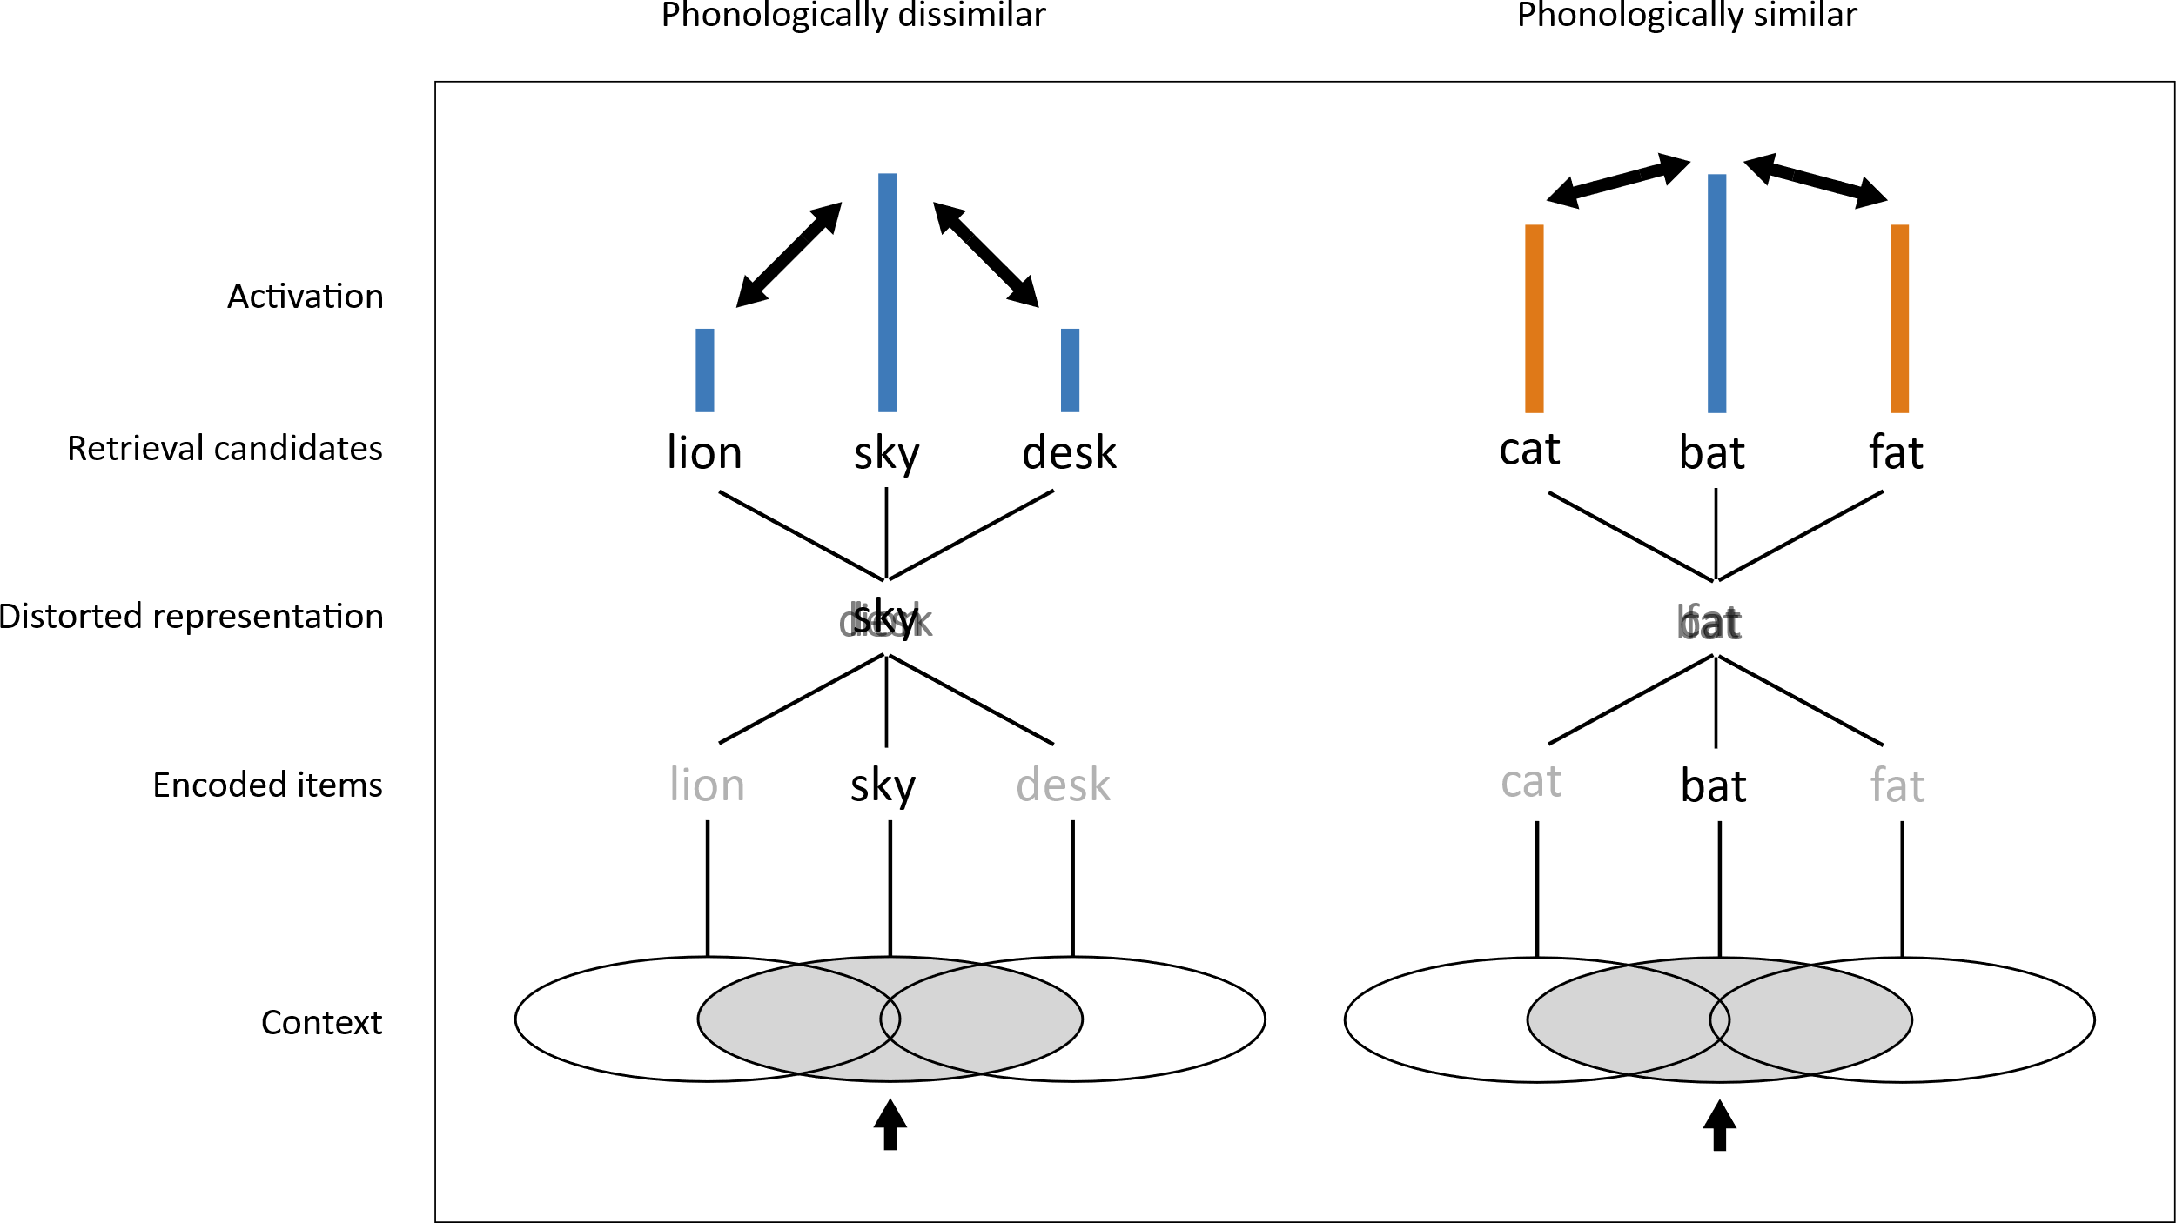
Note. XXX

The phonological similarity effect indicates that WM encodes information in a phonological format: Two items are confused to the extent that they are represented the same way. This property can be used as a proxy to uncover the representational basis of WM. Indeed, what constitutes similarity depends on the underlying theoretical assumption for how phonological information is represented. Different theoretical assumptions produce diverging similarity metrics and therefore make diverging predictions regarding the extent to which a given word list should produce a similarity effect. For instance, one way of conceptualizing phonological representations is through slot coding, in which each phoneme that constitutes a word is stored in its own slot. Each slot is dedicated to represent phonemes in a particular within-word position. In this model, the similarity between two strings is determined by the proportion of phonemes they share in the same slots. Given the two strings /kæt/ and /tæɡ/, their similarity will be 0.333, because they share 1/3 of their phonemes in the same slot. Another way of conceptualizing phonology is through a closed biphones scheme, in which words are represented as pairs of adjacents phonemes – also called “biphones” (Hannagan et al., 2013). In this model, the similarity between two strings is determined by the proportion of their shared biphones. Taking back the previous example, the biphones of /kæt/ and /tæɡ/ can be decomposed into [/_k/, /kæ/, /æt/, /t_/] and [/_t/, /tæ/, /æɡ/, /g_/], respectively. In this case, the similarity value between both strings is zero, because they share none of their biphones. Therefore, contrary to the slot coding model, the closed biphone model predicts that both strings should not be particularly confused more often with each other than any other pairs of strings.
The phonological similarity effect thus offers a key to uncover the representational format of verbal WM by assessing how well various competing similarity metrics predict similarity-based confusions. Recently, Zhang & Osth (2024) implemented and compared the ability of different letter-string representations to capture performance in recognition memory, and provided support for open-bigram representations of letter coding. The present study adopts a similar approach. We begin by introducing and implementing different similarity metrics grounded on different assumptions for how WM represents phonological information. Using a preliminary dataset, we fitted these metrics to observed confusability patterns as a proof of concept that competing similarity metrics can be distinguished. We will then conduct a large-scale experiment (N = 300) to evaluate these similarity metrics with greater precision.

Computational Modeling
In this section, we start by describing competing representational codes of the phonology of words and how they translate into similarity metrics. We next describe how these representations are integrated into a standard model of WM and can be used to predict confusion errors in serial recall.

Similarity Metrics
We quantify the similarity between two phoneme strings on a scale from 0 to 1. A value of 0 indicates that the strings are maximally dissimilar, whereas a value of 1 indicates they are maximally similar. Different representational codes generate different similarity values for any two strings of phonemes. The next paragraphs describe these representational codes, starting with the slot coding model.
Slot coding. The first metric we implement is slot coding. In a slot coding model, the phonemes in each ordinal position in a word are stored in a separate slot dedicated to that position. The phonemes of two words match when they are identical and in the same slot: The first phoneme of string $i$ is matched against the first phoneme of string $j$, and so on. Thus, a match $M$ in slot $k$ occurs when:
Mk=1 if ik=jk  otherwise Mk=0 | (1)

The phonological similarity $S_{ij}$ between string $i$ and string $j$ is obtained by dividing their number of matches by their alignment length, which is the length of the longest string:
$$S_{ij}=\frac{\sum_{k=1}^{N}{M_{k}}}{max\left(\left|i\right|,\left|j\right|\right)}$$ | (2)

Where the length $\left|i\right|$ of a string $i$ corresponds to its number of phonemes. In Eq. 2, the sum runs over the number of slots $N$. For instance, given the two phoneme strings /rɪŋ/ and /brɪŋ/ (“ring” and “bring”), their similarity value is zero, because they share none of their phonemes in the same slot.
Levenshtein Distance. The second model we implement is derived from the Levenshtein distance, which is commonly used as a way to measure the distance between orthographic strings, for instance to define neighboring words (Luce & Pisoni, 1998; Yarkoni et al., 2008). The Levenshtein distance refers to the minimum number of elementary changes required to transform string $i$ into string $j$. These changes include insertions, deletions, and substitions of elements. We will not re-describe the full equation for the Levenhstein distance here. Many packages implement the Levenshtein distance in most modern programming languages. To get the similarity between two strings, their Levenshtein distance $d$ is divided by their alignment length, and the result is subtracted from one:
$$S_{ij}=1-\frac{d}{max\left(\left|i\right|,\left|j\right|\right)}$$ | (3)

As for the slot coding model, the length $\left|i\right|$ of a string $i$ is its number of phonemes. Returning to the example above, it takes one addition to transform /rɪŋ/ into /brɪŋ/, leading to a similarity value of 0.75 (i.e., 1 - 1/4).
Syllable model. The syllable model behaves similarly to a slot coding model, except that phonemes are matched according to their position within a syllable. Each syllable is decomposed into their onset, nucleus, and coda. The onset and the coda each consist of a variable number of consonants (in the limit, zero); the nucleus consists of a single vowel. Slots are dedicated to positions within a syllable, such as the first phoneme of the onset, the second phoneme of the onset, and so on. When two words are compared, the first step is to align their syllables with each other in their order within the word. When comparing syllables, we added a degree of flexibility at this step: When two words have a different number of syllables, the starting point of the comparison alignment is anchored at the syllable position which maximizes the similarity between both strings. For instance, when comparing “surface” and “resurface”, the alignment starts with the syllable “sur” in both words, and the excess syllable “re” in “resurface” is compared to an empty syllable in “surface”. Within each syllable, a match $M$ occurs whenever the strings share a phoneme at the same within-syllable position $k$. The similarity value is obtained by dividing the number of matches by the total number of comparisons $N$:
$$S_{ij}=\frac{\sum_{k=1}^{N}{M_{k}}}{N}$$ | (4)

When the compared syllables both have no phonemes in a within-syllable position, no comparison occurs in those positions. For instance, both syllables /bi/ and /ki/ miss their coda. The number of comparisons for these two syllables is therefore 2. By contrast, when /in/ and /ki/ are compared, the onset of /ki/ is compared to the empty onset of /in/, yielding a mismatch, and the coda of /in/ is compared to the empty coda of /ki/, yielding another mismatch; the number of comparisons is 3. This method of decomposing phoneme strings into subsyllabic components for comparison closely resembles the PSIMETRICA dissimilarity metric developed by Mueller and colleagues (2003).
Closed biphone model. In the closed biphone model, words are represented as biphones, which are pairs of phonemes. Contrary to the open biphone model described below, only adjacent phonemes are considered. The computation of this similarity metric starts by extracting all biphones from each string. If a biphone appears more than once in a string, it is counted only once. The phonological similarity between two strings is obtained by dividing the number of biphones they share by the number of biphones in the longest set. Hence, given the sets $B_{i}$ and $B_{j}$ for strings $i$ and $j$, their phonological similarity is the length of their intersection, divided by their alignment length:
$$S_{ij}=\frac{\left|B_{i}∩B_{j}\right|}{max\left(\left|B_{i}\right|,\left|B_{j}\right|\right)}$$ | (5)

For instance, given the two strings /plaɪ/ and /taɪ/ (“ply” and “thai”), their biphones are [/_p/, /pl/, /la/, /aɪ/, /ɪ_/] and [/_t/, /ta/, /aɪ/, /ɪ_/], and their similarity value is 0.4, because they both share the biphones /aɪ/ and /ɪ_/.
Open biphone model. The open biphone model is similar to the closed biphone model and is computed using Eq. 5 above, with the exception that non-adjacent biphones are considered up to N positions between their phonemes, where N refers to the level of openness. With N = 0, the closed biphone and open biphone models are identical. Returning to the example above, and considering a level of openness of N = 1, the biphones of /plaɪ/ and /taɪ/ are [/_p/, /pl/, /pa/, /la/, /lɪ/, /aɪ/, /ɪ_/] and [/_t/, /ta/, /tɪ/, /aɪ/, /ɪ_/], respectively, and their similarity value is 0.286. We treat the level of openness as a free parameter, setting a maximum of N = 5. This means that we considered five open biphone models: One for each level of openness.
Note that when phonemes are matched, each comparison is treated dichotomously. In reality, phonemic differences are often more gradual, as two phonemes can differ in one, two, or more phonemic features. We intentionally omit phonemic similarity in our approach to keep the comparison simple. This omission is not problematic, as it applies equally across all similarity metrics and our focus is on comparing models with one another. Future studies should examine the role of more fine-grained phonemic changes to provide a more complete picture.

The Working Memory Model
The model we use to integrate the similarity metrics described above is the interference model recently developed by Oberauer and Lin (2024), which shares core assumptions with many other serial recall models (Farrell & Lewandowsky, 2002; Henson, 1998; Oberauer et al., 2012). In the interference model, both items and contexts are represented as feature vectors. The process of encoding an item occurs through Hebbian learning associating item and context vectors to each other. Items have pairwise similarity values as defined by the equations described in the previous section. For any two items $i$ and $j$, we transform their similarity value $S_{ij}$ into psychological similarity (Brown et al., 2007; Nosofsky, 1986):
$$ψ_{ij}=exp\left(-b\left[1-S_{ij}\right]\right)$$ | (6)

Where $b$ is a scale parameter that we vary freely. The $S_{ij}$ value is determined by the metric considered. Specifically, for each similarity metric, we build a matrix of similarities for the words in each trial. Each item in the vocabulary has a similarity value with the list items, and this similarity causes the model to produce extra-list intrusions (i.e., recalling an item that was not part of the encoding list). Instead of computing the similarity for all possible words in the lexicon, we estimate it using a free parameter $ω$ which represents the average similarity between the list items and all other items in the vocabulary:
$$S_{i,n+1}=ω$$ | (7)

Where $n$ refers to the number of memoranda; the column index n+1 in the similarity matrix S is used to represent extralist items. The similarity between contexts decreases exponentially as their positional distances increase. Hence, the contextual overlap $C_{jk}$ between two contexts $j$ and $k$ is given by:
$$C_{jk}=P^{\left|j-k\right|}$$ | (8)

Where $P$ is a free parameter controlling the positional overlap. This theoretical assumption is required to model the fact that confusion errors are more likely to occur between close than between distant serial positions (e.g., Farrell et al., 2011; Henson, 1998).
The encoding strength of an item $i$ to its context $k$ is weighted by a primacy gradient of binding strength and an automatic updating process:
$$η_{k}=\left(1.0+αγ^{k-1}\right)δ^{n-k}$$ | (9)

Where $α$ and $γ$ are free parameters controlling the initial value of the binding strength and the progressive decrease in binding strengh across serial position $k$, respectively. The $δ^{n-k}$ term is an automatic WM updating process: After each encoding event previously encoded items are proportionally downgraded by a factor δ; this occurs $n-k$ times for an item in position k. This updating process has the consequence to prioritize each newly encoded item. Together, the primacy gradient of binding strength and the automatic updating process create the primacy and recency effects typically observed in serial recall experiments.
The model retrieves the items by cueing them with the positional context to which they were encoded. This cueing process triggers the retrieval of the representation of the target item. Due to the positional overlap, other items which were partially encoded to that positional cue are also retrieved. Hence, the representation retrieved by the model is a blend of all item representations encoded in the current trial, weighted by the extent to which they were associated with the context which served as a retrieval cue. This representation is then compared to the retrieval candidates via the dot product, which leads to the reactivation of all retrieval candidates in an output layer $O$ that contains localist representations of each item in the vocabulary:
Oi=ai+j=1n+1ηjψijηjCjk | (10)

Therefore, the activation received by each item $i$ in the output layer $O$ is the sum of the contribution from all items $j$ reactivated by context $k$, weighted by the binding strength of encoding $η_{j}$ at encoding step $j$. In addition to the reactivation through the positional cue, each list item also has a persistent activation value a_{i} = A, whereas for extralist items that activation is set to zero. This persistent activation represents the general knowledge that a particular item was studied during encoding of the current list. This assumption is necessary to explain the phonological similarity effect: The persistent activation ensures that list items are stronger retrieval candidates than extralist items. Thereby, a list item that is similar to the target becomes a strong contender whereas an extralist item with equal similarity to the target does not. Without the added activation a_{i} for list items, the model would predict that targets are confused with other response candidates that are similar to them regardless of whether they were in the list. As the response set for serial recall includes all words of the language, it includes an equal number of response candidates that are similar to the target in similar and in dissimilar lists. Therefore, without the a_{i} term the model would not predict worse order recall performance for similar than for dissimilar lists.
In immediate serial recall, participants often fail to recall any item, a type of errors called omissions which we model by including a threshold for retrieval. If the activation of all retrieval candidates falls below this threshold for retrieval, the model produces an omission. We implement this principle mathematically by giving the threshold for retrieval an activation value in the output layer $O$, which means that the threshold enters the competition for retrieval. The value of the threshold for retrieval is controlled by the free parameter $θ$.
Selection is based on activation values in the output layer, such that the most activated item is selected for output. However, without a source of noise, the model would repeatedly recall the same item. To produce errors such as transposition errors, a normally distributed source of noise centered around zero with a standard deviation $σ$ is added to each localist unit in the output layer. This noisy selection process is modeled by transforming the activation values in the output layer into probabilities using the exponential version of Luce’s choice rule:
$$p_{i}=\frac{exp\left(\frac{O_{i}}{σ}\right)}{\sum_{i=1}^{n+2}{exp}\left(\frac{O_{i}}{σ}\right)}$$ | (11)

In Eq. 11, the sum runs over $n+2$ items, where n+1 refers to the extralist intrusions and n+2 the threshold for retrieval. After retrieving an item, its activation value is suppressed for the remaining retrieval attempts. This is modeled by setting the activation value a of the recalled item ato –$τ$, a free parameter. This mechanism prevents already recalled items from being recalled and therefore avoids an excess of repetition errors.

Model fitting
Table 1 reports the list of free parameters used in the model, along with their definitions and permissible ranges.

Table 1. Free parameters of the working memory model
Symbol | Meaning | Range
$$α$$ | Initial value of the binding strength | [0.0 – 6.0]
$$γ$$ | Progressive decrease in binding strengh | [0.01 – 1.0]
$$δ$$ | Strength of automatic updating | [0.01 – 1.0]
$$P$$ | Contextual overlap | [0.0 – 1.0]
$$σ$$ | Standard deviation of the noise added at retrieval | [0.01 – 1.0]
$$τ$$ | Strength of response suppression | [0.0 – 10.0]
$$b$$ | Parameter scaling the similarity value $S$ | [0.0 – 100.0]
$$A$$ | Persistent activation of list items | [0.0 – 6.0]
$$θ$$ | Threshold for retrieval | [0.0 – 2.0]
$$ω$$ | Similarity between the list items and non-list items | [0.0 – 1.0]
Note. The ranges ​​refer to the range of allowed parameter values ​​set when fitting the model.

Fitting procedure. We fitted the model to individual participants on a trial-by-trial basis. For each recall attempt, we computed the probability $p$ to recall each retrieval candidate using Eq. 11. The log-likelihood was then computed using the recall probability of the observed response o in recall attempt r:
$${logL}_{r}=log\left(p_{o}\right)$$ | (12)

We used the deviance as a loss function by summing all log-likelihoods across trials and retrieval attempts for a given participant, and multiplying this result by -2:
$$D=-2\sum{{logL}_{r}}$$ | (13)

Parameter estimation. We estimate the model’s parameters using differential evolution (Storn & Price, 1997), a global optimization algorithm which iteratively generates new candidate solutions by combining randomly selected individuals from an initial population. The algorithm runs with a fixed population size, which we set here to 10n, where n is the number of free parameters in the WM model. For each new generation, the algorithm creates trial solutions based on two parameters. The first is the crossover probability, which controls how much a trial solution inherits from the parent population; we set the crossover probability to 0.9. The second parameter is the differential weight, which scales the differences between individuals during mutation and affects the step size of the search; we set the differential weight to 0.8. We used the standard deviation of parameter values from individuals in the population as a stopping criterion (Zielinski et al., 2006). Convergence was considered reached if the standard deviation fell below 10e-8. If this criterion could not be reached, the algorithm stopped after 10,000 iterations.
Model comparison. To compare models with each other, we computed an Akaike Information Criterion (AIC) for each model:
$$AIC=\sum_{i=1}^{N}{2K+D_{i}}$$ | (14)

The sum runs over the deviances across all participants and 2K reflects a penalty term for the number of free parameters. As we fit the model separately to each participant, the number of free parameters that were estimated, K, corresponds to the number of participants times the number of free parameters of the model. We therefore computed one AIC for each participant and summed all AICs to obtain an overall assessment for a particular model. After computing one AIC for each model, models can be compared by subtracting their AICs. This difference represents the likelihood of the data under a certain model, relative to another model.

Preliminary Experiment
Before running the main experiment, we tested the ability of the model to differentiate between competing explanations for how WM represents phonology using a preliminary dataset. We fitted the model to an unpublished dataset in which participants encoded lists of phonologically similar and dissimilar items for serial recall. There were two similarity conditions: A grouped conditions in which triplets of phonologically similar items were presented in subgroups (e.g., high, sky, fly, fall, ball, call) and an interleaved condition in which the triplets were presented in an interleaved fashion (e.g., tree, bright, bee, light, sea, night). We chose this experiment because of its proximity to the design we plan to use in the main experiment (see below).

Methods
Participants. Thirty-two participants from the University of Liège were recruited. This sample size was chosen because it has been sufficient for obtaining strong evidence for similarity effects in previous experiments and was feasible with the available resources. All participants were French native speakers, reported no history of neurological disorder or learning difficulties. All participants gave their electronic informed consent before starting the experiment. The experiment had been approved by the Ethic committee of the Faculty of Psychology, Speech and Language Therapy, and Education of the University of Liège.
Material. The stimuli used in this experiment were French nouns. The stimuli were drawn from 40 different rhyming categories, each composed of three rhyming items. The phonologically similar lists were built by using items from two different categories. The phonologically grouped lists were created first. The phonologically interleaved lists were created using the same sequences as the semantically grouped sequences but changing the items’ order such that the phonologically similar items were now presented in an interleaved fashion. The phonologically dissimilar lists were built by randomly sampling items from six different categories, with the constraint that all items had to have a Levenshtein distance between the letter strings larger than 2 from each other. Each item was used three times across the whole experiment: once in a grouped condition, once in an interleaved condition, and once in a dissimilar condition, which resulted in 20 trials per condition. Table 2 reports the phonological similarity values across conditions across all representational formats. Items were recorded by a native male French-speaking individual in a neutral voice in a soundproof booth. A filter was applied to all stimuli to suppress the residual background noise using the Audacity software. Items were then isolated on separate audio files.

Table 2. Similarity values across models – Preliminary experiment
Metric | Dissimilar | Grouped / Interleaved
Slot coding | 0.077 | 0.767
Levenshtein | 0.099 | 0.767
Syllable | 0.096 | 0.767
Closed biphone | 0.032 | 0.624
Open biphone 1 | 0.029 | 0.605
Open biphone 2 | 0.03 | 0.549
Open biphone 3 | 0.029 | 0.535
Open biphone 4 | 0.029 | 0.533
Open biphone 5 | 0.029 | 0.533
Note. Values in the grouped and interleaved conditions refer to the similarity between items within triplets of phonologically similar items. Since both the grouped and interleaved conditions were created using the same triplets of phonologically similar items, they have identical similarity values.

Procedure. Due to the Covid-19 pandemic, participants were tested remotely. The experimenters met the subjects via a desktop application and gave instructions. Participants performed the experiment separately on an online webpage. The auditory presentation of the stimuli was made possible using the Pizzicato library (https://alemangui.github.io/pizzicato/). Participants’ oral responses were recorded for later transcription by an internship student. The task was coded in JavaScript.
Each trial started with the presentation of a six-item list to be remembered. Each item was auditorily presented at a pace of 1,000 ms per item. After the last to-be-remembered item, participants recalled the items aloud in their original presentation order. If participants could not recall an item, they were instructed to say the word “blanc” (i.e., the french word for “blank”). After recalling all items, participants pressed the spacebar to initiate the next trial. Participants performed three training trials prior the main experiment.
Scoring procedure. Recall performance was assessed using two criteria. The first criterion we use is an item recall criterion, in which an item is scored correct if recalled at all, independently of the serial position considered. For instance, given the to-be-remembered sequence “ABCDEF” and the output sequence “A*DCEZ”, the sequence would be scored as [1, 0, 1, 1, 1, 0], resulting in an average item recall score of 4/6. The second criterion is a conditionalized order recall criterion in which an item is scored correct if recalled in the correct serial position, given that it had been recalled at all. Items not recalled at all are not diagnostic of confusion errors and are therefore scored as missing data. Returning to the previous example, the sequence would be scored as [1, NA, 0, 0, 1, NA], resulting in an average order recall score of 2/4. Since both criteria are differentially affected by similarity manipulations (e.g., Gupta et al., 2005), it is important to distinguish between item and order recall.
Statistical analyses. Overall recall performance was assessed using a Bayesian logistic regression model. The full model included a fixed effect of similarity condition (grouped, interleaved, dissimilar), a random effect of similarity and a random intercept. To assess the presence of a similarity condition effect, we compared the full model against the model without the similarity effect. These analyses were performed using the brms R package (Bürkner, 2017).

Results
Results from the Bayesian logistic regression model indicate decisive evidence for the main effect of similarity condition, both when the item recall criterion (BF₁₀ = 2.082e+11) and the order recall criterion (BF₁₀ = 9.439e+8) were considered.
As shown in Figure 3, the grouped and interleaved conditions led to higher item recall and lower order recall accuracy than the dissimilar condition. Note that the beneficial effect of phonological similarity on item recall accuracy was specific to the grouped condition. Additional Bayesian t-tests provided decisive evidence for a phonological similarity effect when comparing the dissimilar and grouped conditions (BF₁₀ = 2.196e+8), and moderate-to-strong evidence against such an effect when comparing the dissimilar and interleaved conditions (BF₁₀ = 0.201). In contrast, phonological similarity led to poorer order recall performance both in the grouped (BF₁₀ = 662) and interleaved (BF₁₀ = 1.360e+7) conditions.

Figure 2
Main behavioral results – Preliminary experiment
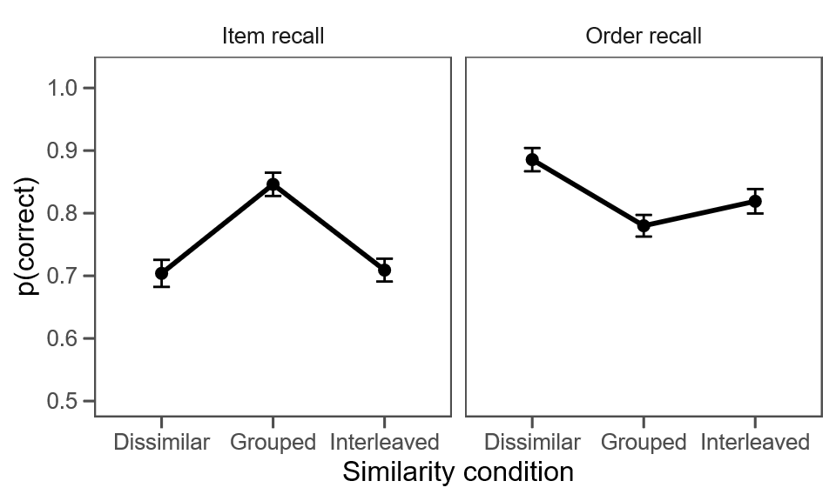
Note. Errors bars indicate the 95% confidence intervals (Morey, 2008)

Next, we fitted the WM model to the data nine times, once for each similarity metric. Figure 3 and Figure 4 show the predictions for all models. All models reproduce the data very closely. The model can also reproduce typical serial position effects, which we report in Appendix A. The model reproduces the beneficial effect of phonological similarity on item recall in the grouped condition through a reduction of interference via superposition (Kowialiewski & Oberauer, 2025; Oberauer et al., 2016): When the model tries to retrieve an item from a positional cue, it generates a distorted representation which is a blend of all encoded items, weighted by their similarity to the positional cue (see also Figure 1). When the non-target items most strongly associated to that cue are phonologically similar to the target item, their contributions add up in the distorted representation, reinforcing their shared features. When this representation is compared to the retrieval candidates, this gives the list items a strong activation in the output layer which helps them to surpass the threshold for retrieval. This reduces the rate of omission errors and increases item recall. In the interleaved condition, the effect is weaker: Non-targets similar to the target are bound to more distant positional cues, contributing less to the distorted representation than in the grouped condition. As a result, the model produces more omissions than in the grouped condition.
One important aspect of the simulations reported in Figure 3 and 4 is the fact that the models cannot be qualitatively distinguished. This is not surprising, because all lists were constructed from rhyming categories and were not built to distinguish similarity metrics from each other. It was nonetheless possible to distinguish some of the models based on quantitative predictions. Table 3 lists all metrics and their associated AIC values. For ease of interpretation, this table also shows the $ΔAIC$ values, which are AIC differences with the best model. The model with the lowest AIC is the best model and has therefore a $ΔAIC$ value of zero. The best model is the syllable model. As shown by the AIC difference, the data are 0.864 times more likely under the syllable model than under the Levenshtein model, which was the second best model. The slot coding model was the third best model with an AIC difference of 1.612 from the syllable model. Finally, all biphone models performed worse than all other models, with AIC differences of more than 40 to the syllable model. The level of openness did not improve model predictions.

Figure 3
Model predictions on item recall – Preliminary experiment
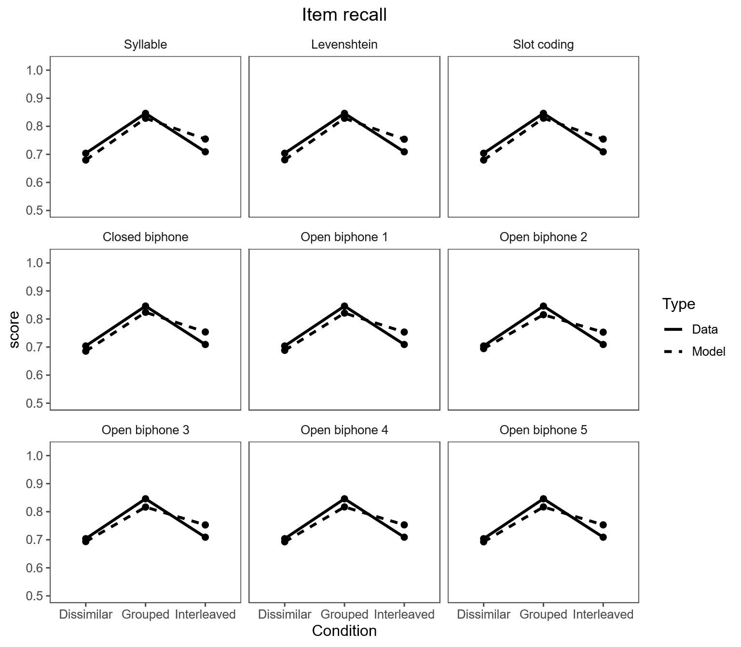
Note. XXX

Figure 4
Model predictions on order recall – Preliminary experiment
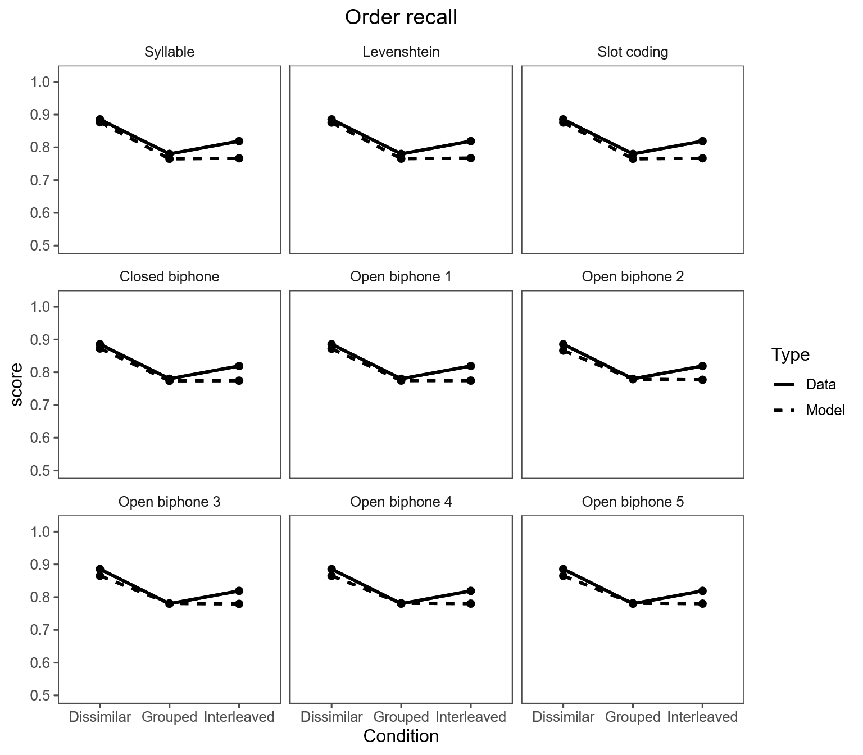
Note. XXX

Table 3. AIC values for each model – Preliminary experiment
Metric | AIC | $$ΔAIC$$
Slot coding | 22,162.594 | 1.612
Levenshtein | 22,161.846 | 0.864
Syllable | 22,160.982 | 0.0
Closed biphone | 22,203.746 | 42.764
Open biphone 1 | 22,236.77 | 75.788
Open biphone 2 | 22,316.625 | 155.643
Open biphone 3 | 22,303.954 | 142.972
Open biphone 4 | 22,296.406 | 135.424
Open biphone 5 | 22,296.406 | 135.424
Note. The $ΔAIC$ values are AIC differences with the best model, which is the syllable model.

Based on their AIC values, the slot coding, Levenshtein, and syllable models have nearly equal support. This shows a limitation of the preliminary experiment: The similarity values of the item pairs were strongly correlated. One way to visualize this is by looking at the differences in similarity values for the same item pairs across metrics. Figure 5 shows the distribution of these differences. For simplicity, we used the syllable model as the reference, subtracting its similarity values from those of the other models. As shown, the distributions for the slot coding and Levenshtein models are heavily centered around zero, reflecting strong correlations with the syllable model: The similarity values from the two metrics barely differ for most word pairs. By contrast, differences with the closed biphone and open biphone models yield bimodal distributions including some large differences between the two metrics, indicating a higher degree of decorrelation.

Figure 5
XXX
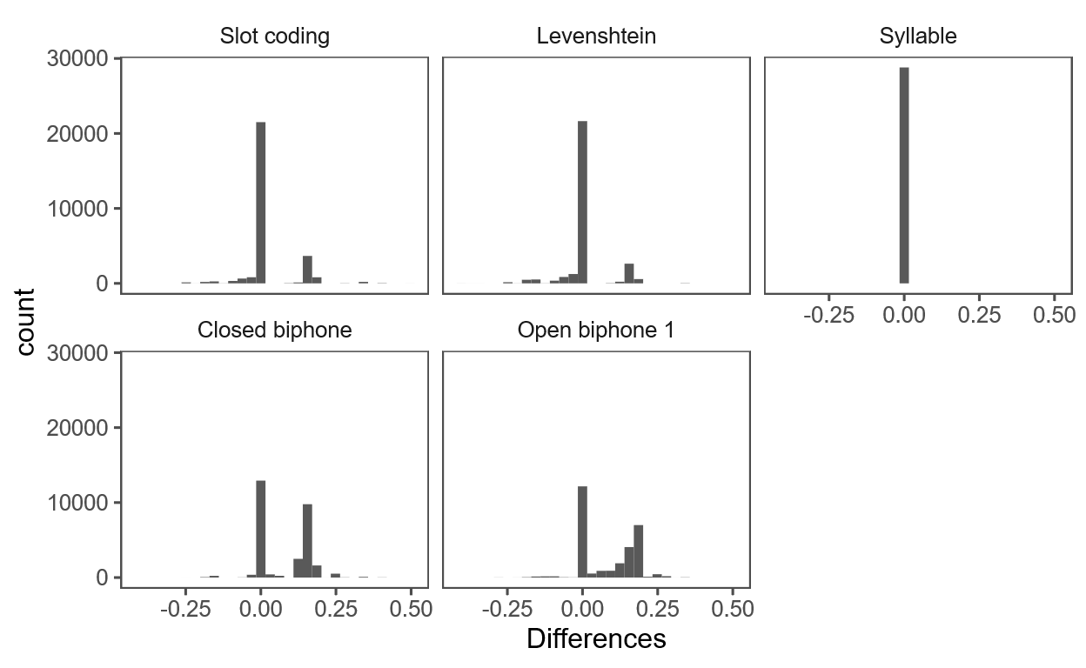
Note. For simplicity, we report only the open biphone model with a level of openness of one.

Discussion
Results from this preliminary experiment show the presence of a phonological similarity effect when items are presented in triplets of phonologically similar items. Under these conditions, we were able to differentiate some, but not all representational models based on quantitative predictions. An important limitation of this experiment is the fact that its material was not originally designed to differentiate these representational models. As shown in Figure 5, the similarity values in the slot coding, Levenshtein, and syllable models are strongly correlated, which likely explains why these models could not be differentiated based on quantitative predictions. These results suggest that representational models can be differentiated quantitatively, provided that the experimental material is appropriately designed. The main experiment addresses this limitation.

Experiment
We will run a large-scale experiment involving participants encoding and recalling lists of phonologically dissimilar and similar words. We constructed the lists such that they maximize the difference between predictions. Specifically, we constructed ten conditions: one dissimilar condition and one similar condition for each five similarity metrics. The similar conditions were constructed to maximize similarity along one metric and minimize similarity along all other metrics. The dissimilar conditions were constructed by recombining the words from the similar conditions. After data collection, we will fit the WM model to the data, and quantitatively compare the competing representational models following a similar procedure as the preliminary experiment.
When planning this experiment, we initially considered comparing the different metrics based qualitative patterns of results. This meant that, for each metric, we would have had to maximize the similarity of one metric while minimizing that of all others, so that they would have produced a similarity value close to zero. This goal turned out to be unrealistic because all similarity metrics are highly correlated with each other (see Appendix B). We therefore decided to compare models on a quantitative basis.

Methods
Participants. We will recruit at least 300 French-speaking young adults aged between 18 and 35 years on the online platform Prolific (https://prolific.co/). We will specifically recruit French-speaking individuals because a syllabic decomposition of each word is available for this language (see also the Materials section below), which is necessary for the syllabic model. Results from the preliminary experiment show that a sample size of 32 participants is sufficient to quantitatively differentiate the competing representational models. Given the importance of this theoretical question, we decided for a larger sample size (N = 300 valid participants after applying all exclusion criteria). We will exclude participants who (1) recall less than 15% of the words correctly, or (2) report in a post-experimental questionnaire that they used external aids (e.g., writing down the words), or (3) indicate in a post-experimental questionnaire that we should not use their data because they did not do the experiment properly and with full concentration. The questionnaire will state that participants should answer these questions honestly as their approval and payment on Prolific will not depend on their answers.
The experiment will be carried out in accordance with the ethical guidelines of the Faculty of Arts and Social Sciences at the University of Zurich.
Material. The stimuli were constructed using the French Lexique database (http://www.lexique.org/). We considered constructing our material in English, but the syllablic decomposition of words is currently behind a paywall (https://catalog.ldc.upenn.edu/LDC96L14), which prevented us from using this language. The construction of the material started by “cleaning-up” the lexicon. First, we ignored subtle phonemic features. The French language officially distinguishes between the phonemes /œ̃/ and /ɛ̃/ (e.g., “brun” and “brin”), /ǫ/ and /ọ/ (e.g., “bord” and “bâteau”), /ę/ and /ẹ/ (e.g., “mer” and “manger”), /œ̨/ and /œ̣/ (e.g., “neuf” and “heureux”), but in practice native speakers no longer make these distinctions and are unlikely to notice them. These subtle differences were therefore canceled by using the same symbol to represent both sounds. Second, we restricted the lexicon to the lemma form of nouns, which removed forms such as “prendre” and “reprendre” (“take” and “retake”) and plural forms such as “entend” and “entendent” (the singular and plural forms of the verb “listening”) or “cheval” and “chevaux” (“horse” and “horses”). All duplicate entries were removed based on their phonological form. Third, we included only words with a phonological length superior to two. Fourth, we restricted the lexicon to the 3,000 most frequent words based on the freqlemfilms2 variable provided by Lexique.
The experimental trials were built by generating triplets of phonologically similar words which we combined to form lists composed of two triplets. We decided to use triplets to maximize the similarity between phonologically similar words, which was much harder to achieve with complete lists. The preliminary experiment reported above shows that strong phonological similarity effects can be observed using triplets of phonologically similar words. The triplets were built by an algorithm maximizing the within-triplet similarity along a target metric, while minimizing similarity within these triplets according to all other metrics. We started by constructing similarity matrices of the 3,000 words from the lexicon for all metrics. For each target metric we then built a delta matrix summing the absolute differences of the similarity values between the target metric and all other metrics. For example, remember that the similarity between “ring” and “bring” according to the Levenshtein metric is ¾, whereas according to the slot metric it is 0. Taking the Levenshtein metric as the target metric, the delta for this word pair starts at 0, and the comparison with the similarity matrix of the slot metric increases it by ¾. The comparison to the similarity matrix of the Syllable, the closed-biphone and the open-biphone metrics add further absolute differences to the delta value.
To build similarity triplets we started by choosing a first pair of words maximizing their delta value from the delta matrix. The third word was selected so that the sum of its two delta values when paired with the two first selected words was minimized. To ensure that the words were similar to each other along the target metric, we considered only the pairs with a similarity value above a certain threshold. The thresholds differ between metrics and were adjusted manually based on the running time of the algorithm. We built 16 triplets for each of the 5 similarity metrics described above, resulting in a total of 80 triplets. Note that for practical reasons, for the triplet construction we considered only one open biphone model with an openness level of one, as the results from the preliminary experiment indicated that increasing the level of opennesss worsened the predictions. The final model comparison will nonetheless consider five levels of openness (see also the preliminary experiment above).
The phonologically similar lists were built by re-combining the triplets such as to minimize the similarity values between members of different triplets. For each target metric we formed 8 phonologically similar lists. The phonologically dissimilar lists for each target metric were built by recombining the words from different triplets of that metric in such a way that their similarity was minimized across all metrics. Note that when minimizing the similarity values between words, we summed the values across all metrics. Table 4 reports the averaged within-triplet similarity values and within-list similarity values for the phonologically similar and dissimilar lists across all metrics. As the table shows, some metrics hardly differ in terms of similarity values. A particularly good example is the slot coding model, which, when considered as the target model, always produces similarity values identical to that of the Levenshtein model. Due to the lack of flexibility of the slot coding model, there is no word pair for which the similarity value is higher than that of the Levenshtein model. This can be visualized by looking at the correlation between both metrics, as reported in Appendix B. The converse is nonetheless possible: We could produce high similarity values in the Levenshtein model when it was considered as the target metric, and low similarity values in the slot coding metric.
Overall, the item pairs displayed a stronger level of decorrelation across metrics than the randomly generated item pairs from the preliminary experiment. Figure 6 shows the distributiondifferences in similarity values for the same item pairs across metrics. These differences now show larger variations than in the preliminary experiment. We are therefore confident that the material used in this experiment is appropriate to disentangle the different similarity metrics.

Figure 6
XXX
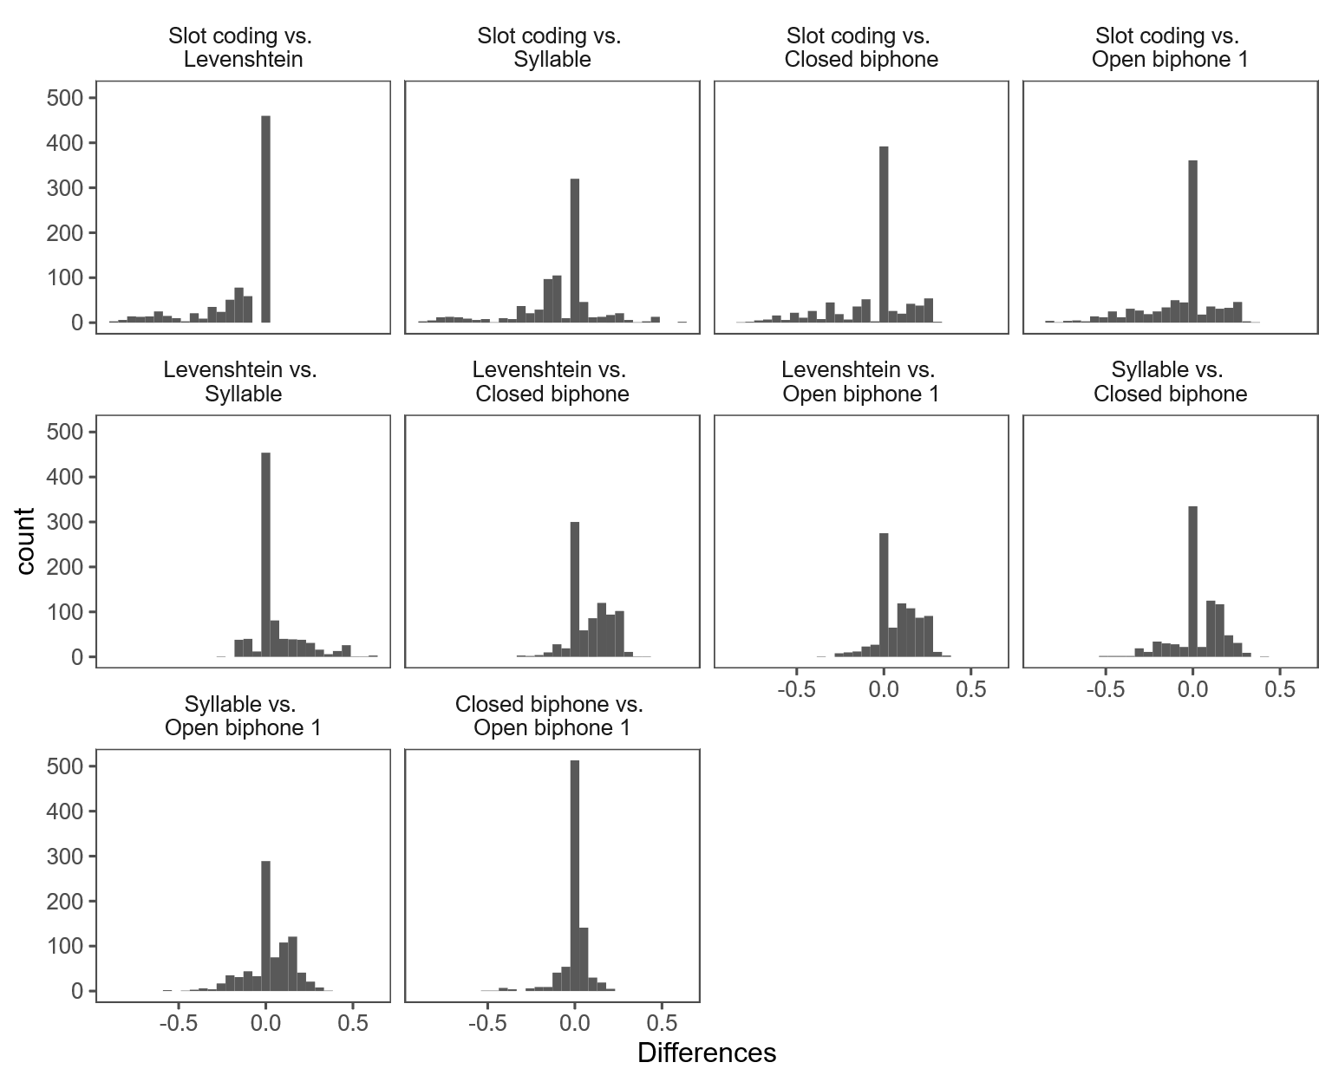
Note. XXX

We will create 300 versions of the task, by first assigning a random presentation order to each list. The testing condition (serial order recall or order reconstruction, see procedure below) will be randomly assigned within each metric and similarity conditions, with the constraint that they should be spread equally across lists. For instance, in the 8 similar lists in the slot coding metric condition, the serial recall condition will be randomly assigned to 4 lists, and the order reconstruction condition will be assigned to the remaining lists. For each version of the task, we will assign a random within-list position to each item. In the dissimilar conditions, this will be done by shuffling the items within each list. In the similar conditions, we will not only shuffle the within-triplet positions of each item, but also the within-list position of each triplet. Each participant will be randomly assigned to one of those 300 versions.

Table 4. Similarity Values Across metrics – Main Experiment
Similarity condition | Target metric | Slot coding | Levenshtein | Syllable | Closed biphone | Open biphone 1
Similar | Slot coding | 0.63 | 0.63 | 0.34 | 0.39 | 0.38
Similar | Levenshtein | 0.08 | 0.65 | 0.33 | 0.44 | 0.42
Similar | Syllable | 0.04 | 0.71 | 0.71 | 0.54 | 0.54
Similar | Closed biphone | 0.15 | 0.42 | 0.34 | 0.53 | 0.42
Similar | Open biphone 1 | 0.17 | 0.32 | 0.26 | 0.24 | 0.44
Dissimilar | Slot coding | 0.06 | 0.08 | 0.08 | 0.03 | 0.03
Dissimilar | Levenshtein | 0.03 | 0.11 | 0.06 | 0.03 | 0.03
Dissimilar | Syllable | 0.03 | 0.14 | 0.15 | 0.07 | 0.06
Dissimilar | Closed biphone | 0.05 | 0.14 | 0.11 | 0.06 | 0.05
Dissimilar | Open biphone 1 | 0.07 | 0.16 | 0.13 | 0.06 | 0.08
Note. Values in the grouped condition refer to the similarity between items within triplets of phonologically similar items.

Procedure. Words will be sequentially presented in the center of the screen in lowercase Courier font at a rate of 1s per item (1s on, 0s off). After the presentation of the last word, the retrieval phase will begin. On half the trials, participants will perform serial recall. They will enter their responses in a prompt box using the keyboard of their computer and will validate each response using the “Return” key. If participants cannot recall a word for a given position, they will leave the prompt box empty. To help participants keep track of the within-list positions, each prompt box will be associated with a number at the bottom of it, starting from “1”. On the other half of the trials, participants will perform order reconstruction. The six words will appear again on the screen, distributed over two lines in a random order. Using their computer mouse, participants will click on each item in the order in which the words have appeared at encoding. After each click, the selected word will be replaced by a string of “#” characters to signal that it will no longer be available during subsequent retrieval attempts. After recalling/selecting the last item, participants will click on a “Next trial” button to move on to the next experimental trial.
The inclusion of this combined serial recall/order reconstruction procedure is motivated by two reasons. One is that the serial-recall procedure alone yields data of limited information value. In scoring order-recall performance we treat item errors such as omissions and extra-list intrusions as missing data, as they are not diagnostic of confusion errors. In order reconstruction, such item errors are not possible, which means that every response can be exploited as a datapoint informative about similarity-driven confusions. However, we also anticipated the possibility that, in order reconstruction, participants might adopt a strategy in which they remember only the first or last letter of each word to maximize their performance. Using this strategy would reduce the likelihood of observing a phonological similarity effect and therefore weaken our manipulation. Using such a strategy would be useless in serial recall, which is why we plan to include it. The testing condition (serial recall, order reconstruction) will be post-cued: It will not be revealed before the retrieval phase and will be pseudo-randomly assigned to each trial, ensuring that items are encoded the same way for each test. One of our previous studies revealed strong phonological similarity effects across both testing conditions with this combination of experimental parameters (Kowialiewski et al., 2023). Participants will perform four training trials: Two trials in each testing condition.
The scoring procedure and statistical analyses will be performed the same way as the preliminary experiment.

Results
Predictions. XXX
[To be completed after Stage 1]

Discussion
[To be completed after Stage 1]

General discussion
[This section will be completed after Stage 1 of reviews and data collection]

Conclusion
[This section will be completed after Stage 1 of reviews and data collection]
Appendix A

Figure A1
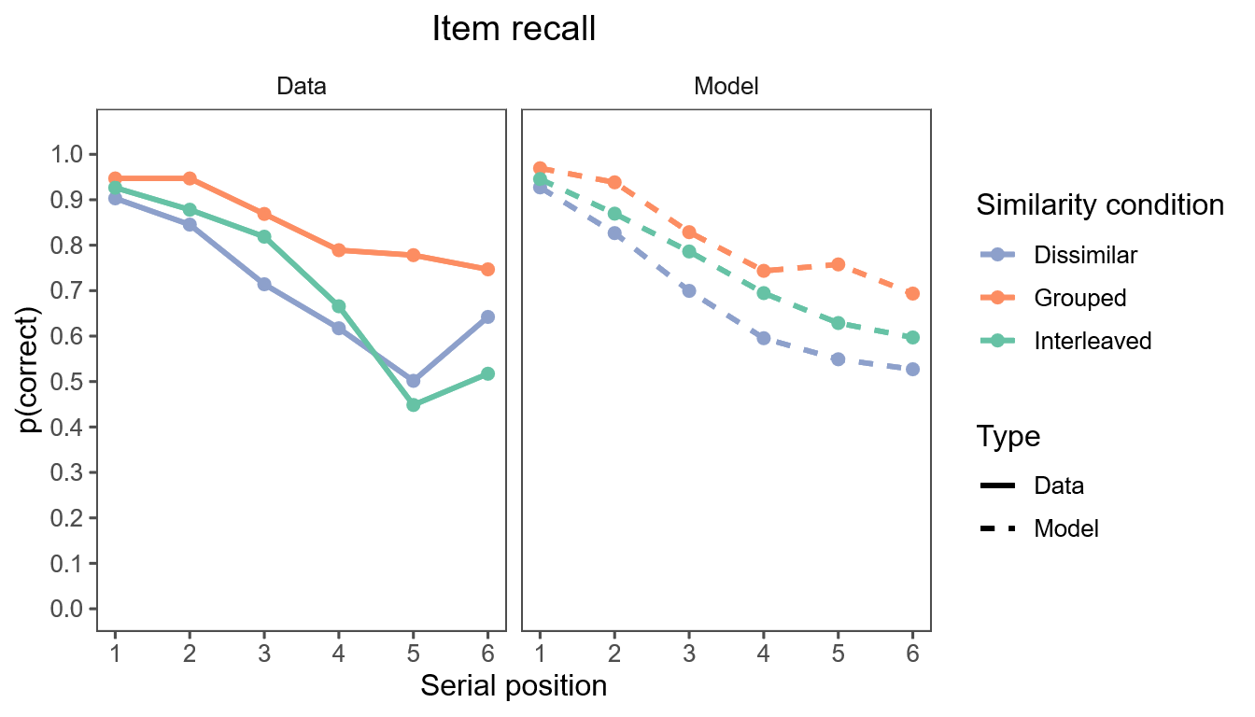
Note. We report only the results aggregated across all representational models, because they all produced very similar serial position curves.

Figure A2
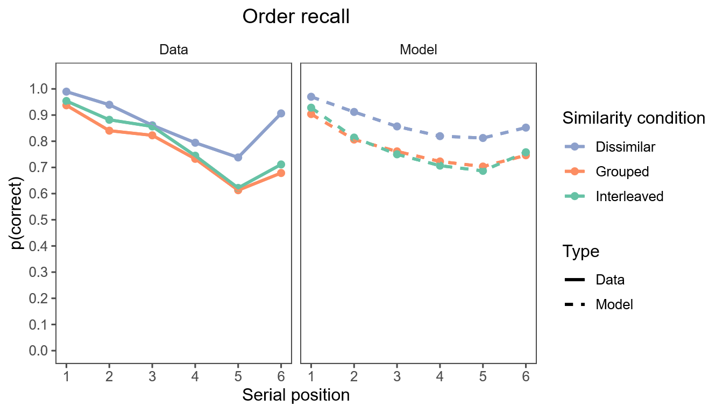
Note. We report only the results aggregated across all representational models, because they all produced very similar serial position curves.
Appendix B

Figure B
XXX
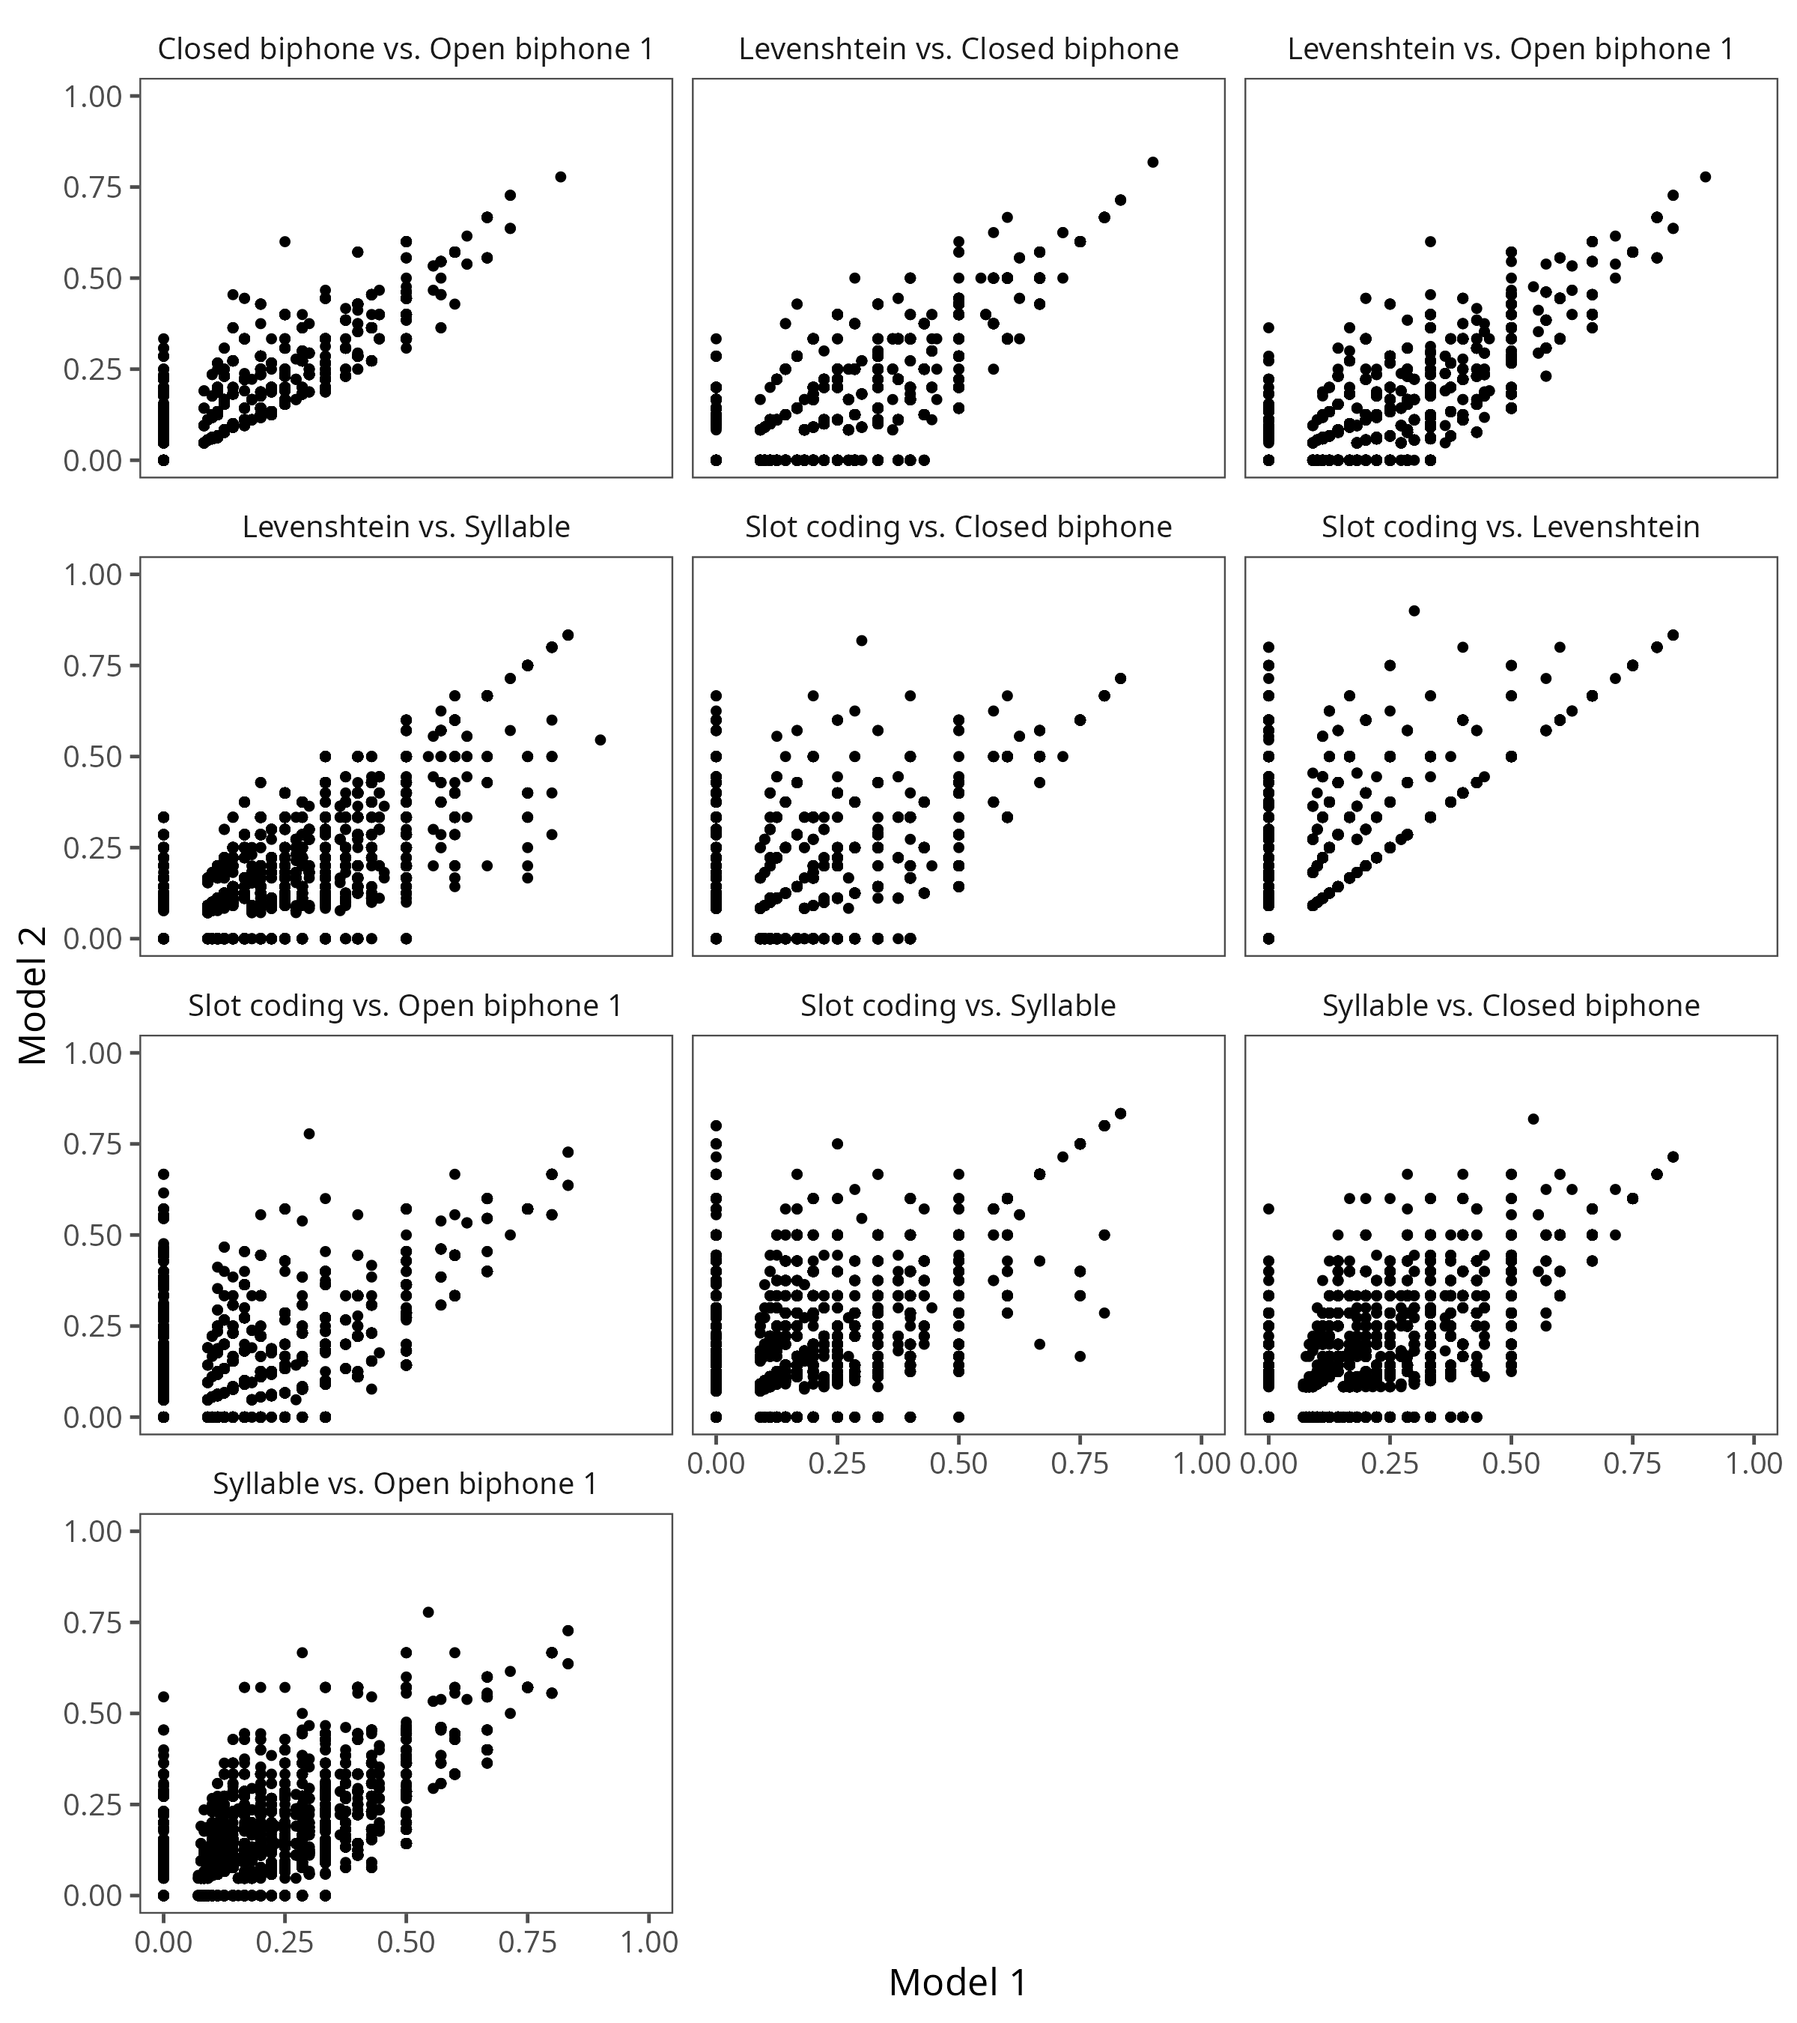
Note. XXX

References
Acheson, D. J., Postle, B. R., & MacDonald, M. C. (2010). The interaction of concreteness and phonological similarity in verbal working memory. Journal of Experimental Psychology: Learning, Memory, and Cognition, 36(1), 17–36. https://doi.org/10.1037/a0017679
Baddeley, A. D. (1966). Short-term Memory for Word Sequences as a Function of Acoustic, Semantic and Formal Similarity. Quarterly Journal of Experimental Psychology, 18(4), 362–365. https://doi.org/10.1080/14640746608400055
Brown, G. D. A., Neath, I., & Chater, N. (2007). A temporal ratio model of memory. Psychological Review, 114(3), 539–576. https://doi.org/10.1037/0033-295X.114.3.539
Bürkner, P.-C. (2017). brms: An R Package for Bayesian Multilevel Models Using Stan. Journal of Statistical Software, 80(1). https://doi.org/10.18637/jss.v080.i01
Camos, V., Mora, G., & Barrouillet, P. (2013). Phonological Similarity Effect in Complex Span Task. Quarterly Journal of Experimental Psychology, 66(10), 1927–1950. https://doi.org/10.1080/17470218.2013.768275
Coltheart, V. (1993). Effects of phonological similarity and concurrent irrelevant articulation on short-term-memory recall of repeated and novel word lists. Memory & Cognition, 21(4), 539–545. https://doi.org/10.3758/BF03197185
Fallon, A. B., Mak, E., Tehan, G., & Daly, Charmaine. (2005). Lexicality and phonological similarity: A challenge for the retrieval‐based account of serial recall? Memory, 13(3–4), 349–356. https://doi.org/10.1080/09658210344000215
Farrell, S. (2006). Mixed-list phonological similarity effects in delayed serial recall. Journal of Memory and Language, 55(4), 587–600. https://doi.org/10.1016/j.jml.2006.06.002
Farrell, S., & Lewandowsky, S. (2002). An endogenous distributed model of ordering in serial recall. Psychonomic Bulletin & Review, 9(1), 59–79. https://doi.org/10.3758/BF03196257
Farrell, S., Wise, V., & Lelièvre, A. (2011). Relations between timing, position, and grouping in short-term memory. Memory & Cognition, 39(4), 573–587. https://doi.org/10.3758/s13421-010-0053-0
Gathercole, S. E., Pickering, S. J., Hall, M., & Peaker, S. M. (2001). Dissociable Lexical and Phonological Influences on Serial Recognition and Serial Recall. The Quarterly Journal of Experimental Psychology Section A, 54(1), 1–30. https://doi.org/10.1080/02724980042000002
Guérard, K., Saint-Aubin, J., Burns, S. C., & Chamberland, C. (2012). Revisiting backward recall and benchmark memory effects: A reply to Bireta et al. (2010). Memory & Cognition, 40(3), 388–407. https://doi.org/10.3758/s13421-011-0156-2
Guérard, K., Tremblay, S., & Saint-Aubin, J. (2009). Short Article: Similarity and Binding in Memory: Bound to be Detrimental. Quarterly Journal of Experimental Psychology, 62(1), 26–32. https://doi.org/10.1080/17470210802215277
Gupta, P., Lipinski, J., & Aktunc, E. (2005). Reexamining the phonological similarity effect in immediate serial recall: The roles of type of similarity, category cuing, and item recall. Memory & Cognition, 33(6), 1001–1016. https://doi.org/10.3758/BF03193208
Hannagan, T., Magnuson, J. S., & Grainger, J. (2013). Spoken word recognition without a TRACE. Frontiers in Psychology, 4. https://doi.org/10.3389/fpsyg.2013.00563
Henson, R. N. A. (1998). Short-Term Memory for Serial Order: The Start-End Model. Cognitive Psychology, 36(2), 73–137. https://doi.org/10.1006/cogp.1998.0685
Karlsen, P. J., Imenes, A. G., Johannessen, K., Endestad, T., & Lian, A. (2007). Why does the phonological similarity effect reverse with nonwords? Psychological Research, 71(4), 448–457. https://doi.org/10.1007/s00426-005-0042-2
Kowialiewski, B., Krasnoff, J., Mizrak, E., & Oberauer, K. (2023). Verbal working memory encodes phonological and semantic information differently. Cognition, 233(105364). https://doi.org/10.1016/j.cognition.2022.105364
Kowialiewski, B., & Oberauer, K. (2025). Semantic Representations in Working Memory: A Computational Model. Psychological Review. https://doi.org/10.1037/rev0000562
Lewandowsky, S., & Farrell, S. (2008). Phonological similarity in serial recall: Constraints on theories of memory. Journal of Memory and Language, 58(2), 429–448. https://doi.org/10.1016/j.jml.2007.01.005
Li, X., Schweickert, R., & Gandour, J. (2000). The phonological similarity effect in immediate recall: Positions of shared phonemes. Memory & Cognition, 28(7), 1116–1125. https://doi.org/10.3758/BF03211813
Lian, A., & Karlsen, P. J. (2004). Advantages and disadvantages of phonological similarity in serial recall and serial recognition of nonwords. Memory & Cognition, 32(2), 223–234. https://doi.org/10.3758/BF03196854
Luce, P. A., & Pisoni, D. B. (1998). Recognizing Spoken Words: The Neighborhood Activation Model. Ear and Hearing, 19(1), 1–36. https://doi.org/10.1097/00003446-199802000-00001
Morey, R. D. (2008). Confidence Intervals from Normalized Data: A correction to Cousineau (2005). Tutorials in Quantitative Methods for Psychology, 4(2), 61–64. https://doi.org/10.20982/tqmp.04.2.p061
Mueller, S. T., Seymour, T. L., Kieras, D. E., & Meyer, D. E. (2003). Theoretical Implications of Articulatory Duration, Phonological Similarity, and Phonological Complexity in Verbal Working Memory. Journal of Experimental Psychology: Learning, Memory, and Cognition, 29(6), 1353–1380. https://doi.org/10.1037/0278-7393.29.6.1353
Nairne, J. S., & Kelley, M. C. (1999). Reversing the phonological similarity effect. Memory & Cognition, 27(1), 45–53.
Nimmo, L. M., & Roodenrys, S. (2004). Investigating the phonological similarity effect: Syllable structure and the position of common phonemes. Journal of Memory and Language, 50(3), 245–258. https://doi.org/10.1016/j.jml.2003.11.001
Nimmo, L. M., & Roodenrys, S. (2005). The phonological similarity effect in serial recognition. Memory, 13(7), 773–784. https://doi.org/10.1080/09658210444000386
Nosofsky, R. M. (1986). Attention, Similarity, and the Identification-Categorization Relationship. Journal of Experimental Psychology: General, 115(1), 39.
Oberauer, K., Farrell, S., Jarrold, C., & Lewandowsky, S. (2016). What limits working memory capacity? Psychological Bulletin, 142(7), 758–799. https://doi.org/10.1037/bul0000046
Oberauer, K., Lewandowsky, S., Farrell, S., Jarrold, C., & Greaves, M. (2012). Modeling working memory: An interference model of complex span. Psychonomic Bulletin & Review, 19(5), 779–819. https://doi.org/10.3758/s13423-012-0272-4
Oberauer, K., & Lin, H.-Y. (2024). An interference model for visual and verbal working memory. Journal of Experimental Psychology: Learning, Memory, and Cognition, 50(6), 858–888. https://doi.org/10.1037/xlm0001303
Roodenrys, S., Guitard, D., Miller, L. M., Saint‐Aubin, J., & Barron, J. M. (2022). Phonological similarity in the serial recall task hinders item recall, not just order. British Journal of Psychology, bjop.12575. https://doi.org/10.1111/bjop.12575
Schweickert, R. (1993). A multinomial processing tree model for degradation and redintegration in immediate recall. Memory & Cognition, 21(2), 168–175. https://doi.org/10.3758/BF03202729
Storn, R., & Price, K. (1997). Differential evolution–a simple and efficient heuristic for global optimization over continuous spaces. Journal of Global Optimization, 11, 341–359.
Yarkoni, T., Balota, D., & Yap, M. (2008). Moving beyond Coltheart’s N: A new measure of orthographic similarity. Psychonomic Bulletin & Review, 15(5), 971–979. https://doi.org/10.3758/PBR.15.5.971
Zhang, L., & Osth, Adam. F. (2024). Modelling orthographic similarity effects in recognition memory reveals support for open bigram representations of letter coding. Cognitive Psychology, 148, 101619. https://doi.org/10.1016/j.cogpsych.2023.101619
Zielinski, K., Weitkemper, P., & Laur, R. (2006). Examination of Stopping Criteria for Differential Evolution based on a Power Allocation Problem. Proceedings of the 10th International Conference on Optimization of Electrical and Electronic Equipment.

The “_” character indicates word boundaries.
In immediate serial recall, output interference partially contributes to the the primacy effect (Cowan et al., 2002; Oberauer, 2003). We do not model output interference in the present study, because in immediate serial recall it is mostly redundant with the primacy gradient of binding strength and would considerably increase the difficulty to fit the model to the data.

