Workload Model Document
Performance Testing Pilot Project
Scenarios: Assign Leave (Admin) & Edit Entitlement
Application Under Test: OrangeHRM (HRMS Application)
Tool: Apache JMeter 5.6+
Module: Leave Management

1. Introduction
This document defines the workload model for the two assigned performance test scenarios — Assign Leave (Admin) and Edit Entitlement — within the OrangeHRM Leave module. It translates the business requirements captured in the Requirement Analysis Document into concrete, industry-standard JMeter workload configurations for Load, Stress, and Endurance testing, and recommends a Spike test for future coverage.
A workload model simulates realistic user arrival and concurrency patterns so that test results reflect how the application will actually behave in production. Each test type below uses a different modeling technique appropriate to its objective: an open (arrival-rate) model for everyday load, and closed (fixed-concurrency) models with staged ramps for stress and endurance.

2. Scenarios in Scope
Scenario ID | Scenario | Role | JMeter Implementation
Scenario 51 | Assign Leave | Admin | Ultimate Thread Group / Open Model Thread Group
Scenario 52 | Edit Entitlement | Admin | Ultimate Thread Group / Open Model Thread Group

3. Workload Modeling Methodology
The workload model follows the standard Performance Testing Life Cycle (PTLC) approach and applies three distinct load shapes, each targeting a specific non-functional characteristic:
- Load Test — Open Model (Poisson arrivals): validates behavior under expected, real-world request rates that vary over time, rather than a fixed number of parallel users.
- Stress Test — Closed Model, stepped ramp: increases concurrent users in fixed steps to identify the system's breaking point and observe degradation trends.
- Endurance (Soak) Test — Closed Model, sustained plateau: holds a moderate, steady user count for an extended duration to surface memory leaks and slow degradation.
Industry practice (per PTLC and common load-testing standards) recommends a ramp-up period to avoid an unrealistic instantaneous surge, a steady-state hold to gather stable measurements, and a ramp-down / cool-down period to observe recovery behavior — all three models below follow this pattern.

4. Load Test Workload Model
Implemented using JMeter's Open Model Thread Group (bzm plugin), which drives traffic by arrival rate rather than fixed thread count — the industry-standard technique for modeling real user arrival patterns (a Poisson-like process) instead of a rigid closed pool of users. Both Assign Leave and Edit Entitlement use an identical schedule:
Phase | Configuration | Duration
Ramp 1 | rate(5/min) → random_arrivals | 1 min
Ramp 2 | rate(10/min) → random_arrivals | 1 min
Ramp 3 | rate(5/min) → random_arrivals | 1 min
Cool-down | pause | 2 min

This produces a repeating 5-minute cycle: the arrival rate steps up from a baseline of 5 users/min to a peak of 10 users/min (simulating a mid-cycle usage burst, e.g. a shift-start or approval-deadline rush), steps back down to 5 users/min, and is followed by a 2-minute pause that represents a natural lull before the next cycle. random_arrivals() distributes each user's arrival randomly within the minute rather than at fixed intervals, which better reflects genuine, uncoordinated user behavior than a linear ramp.
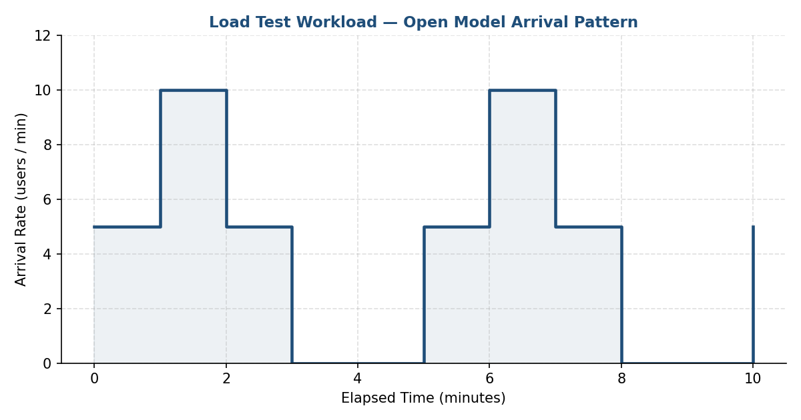
Figure 1: Load Test — Open Model Arrival Rate over Time
Recommendation: run this cycle for a minimum of 3–5 repetitions (≈15–25 minutes total) to obtain a statistically stable 95th-percentile response time under normal business load.

5. Stress Test Workload Model
Implemented using JMeter's Ultimate Thread Group (a closed model), configured identically for Assign Leave and Edit Entitlement with five overlapping ramp steps that build concurrency in increments of 10 users up to a peak of 50 concurrent users, then release load symmetrically:
Step | Start Threads | Initial Delay (s) | Startup Time (s) | Hold For (s) | Shutdown (s)
1 | 10 | 0 | 30 | 600 | 30
2 | 10 | 120 | 30 | 480 | 30
3 | 10 | 240 | 30 | 360 | 30
4 | 10 | 360 | 30 | 240 | 30
5 | 10 | 480 | 30 | 120 | 30

Because each successive step starts 120 seconds after the previous one but holds for progressively less time, the five overlapping steps combine into a single smooth staircase: concurrency climbs from 0 to 50 active users by roughly minute 8:30, briefly plateaus near peak, then symmetrically steps back down to 0 by around minute 11:40 — matching the pattern shown in the JMeter Ultimate Thread Group scheduler chart (jp@gc plugin).
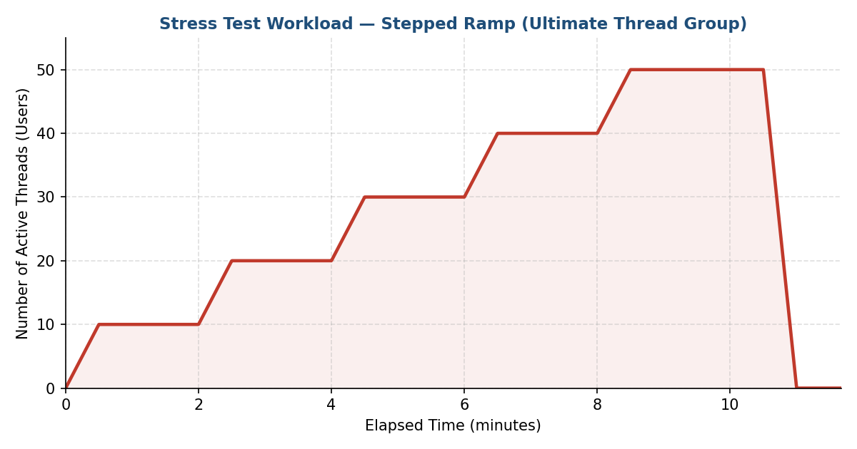
Figure 2: Stress Test — Stepped Ramp to 50 Concurrent Users
This staged approach (rather than jumping straight to 50 users) is the industry-recommended way to run a stress test: it lets analysts correlate each concurrency step with response-time and error-rate trends to pinpoint the exact point at which the application begins to degrade or fail, instead of only knowing that it fails somewhere under high load.

6. Endurance (Soak) Test Workload Model
Implemented using a single-step Ultimate Thread Group that ramps up a moderate, sustained user count and holds it for an extended duration to expose memory leaks, connection-pool exhaustion, or gradual performance decay:
Start Threads | Initial Delay (s) | Startup Time (s) | Hold For (s) | Shutdown (s)
10 | 0 | 60 | 2000 | 120

This configuration ramps up to 10 concurrent users over 60 seconds, holds that load for 2000 seconds (~33.3 minutes), and ramps down over 120 seconds — a total run of roughly 36 minutes. Industry soak tests typically run for several hours in production-scale environments; the ~36-minute duration here is a pilot-scaled equivalent intended to demonstrate the same degradation-detection technique — this can be extended (e.g. Hold For = 3–8 hours) once infrastructure and time allow.
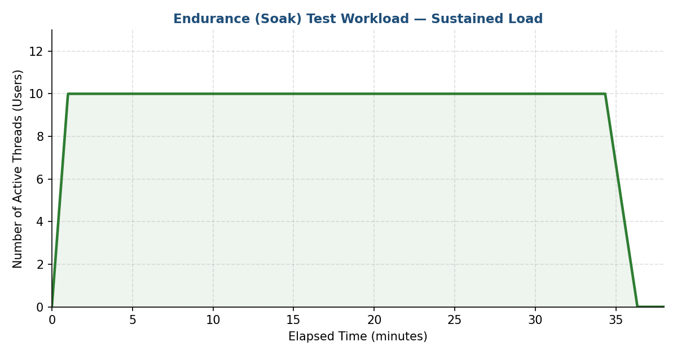
Figure 3: Endurance Test — Sustained Load at 10 Concurrent Users

7. Spike Test
Implemented using JMeter's Open Model Thread Group (bzm plugin), which drives traffic by arrival rate rather than fixed thread count — the industry-standard technique for modeling real user arrival patterns (1 → 10 → 2 users):
Phase | Concurrent Users | Suggested Duration
Baseline | 2 | 2 min
Sudden Spike | 10 | 1 min ramp-up, 2 min hold
Recovery | 3 | 2 min ramp-down + observation

This validates the application's ability to absorb a sudden, extreme traffic surge (e.g. a mass leave-approval rush at month-end) and confirms recovery to baseline response times within the 60–90 second SLA window once the spike subsides.

8. Consolidated Workload Summary
Test Type | Model | Peak Load | Approx. Duration | Primary Goal
Load | Open (arrivals) | 10 users/min | ~5 min/cycle | Validate expected business load
Stress | Closed (stepped) | 50 concurrent users | ~11.7 min | Find the breaking point
Endurance | Closed (sustained) | 10 concurrent users | ~36.3 min | Detect leaks / degradation over time
Spike | Closed (burst) | 15 concurrent users | ~7 min | Measure recovery from sudden surges

9. Success Criteria and Performance Goals
- Response Time: 95th percentile response time within 2 seconds under normal (Load Test) conditions.
- Throughput: the application must support at least 20 concurrent users without measurable degradation.
- Error Rate: below 1% during Load and Endurance testing.
- Recovery Time: after a spike, response time must return to baseline within 60–90 seconds.
- Stability: no continuous upward trend in response time or memory/thread usage during the Endurance test.

10. Assumptions
- The test environment is dedicated and representative of production.
- Valid employee/admin credentials and CSV test data (empnumber1.csv) are available and unique per virtual user.
- The network between the load generator and the OrangeHRM server is stable throughout each run.
- Correlation of dynamic values (session IDs, CSRF tokens) is already handled via the Test Fragment / Include Controller referenced in the scripts.

11. Conclusion
This workload model applies industry-standard load-shaping techniques — an open arrival model for everyday load, and staged closed models for stress and endurance — to the Assign Leave (Admin) and Edit Entitlement scenarios. Together with the recommended Spike test, it gives complete PTLC coverage (Load, Stress, Endurance, Spike) needed to confidently evaluate the speed, scalability, stability, and reliability of the OrangeHRM Leave module.

