**Coursera Capstone**

**IBM Data Science Professional**

***Opening a New Shopping Mall in Mumbai, India***

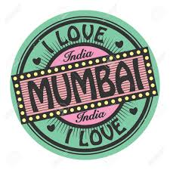

Bharat Parekh

July 2020

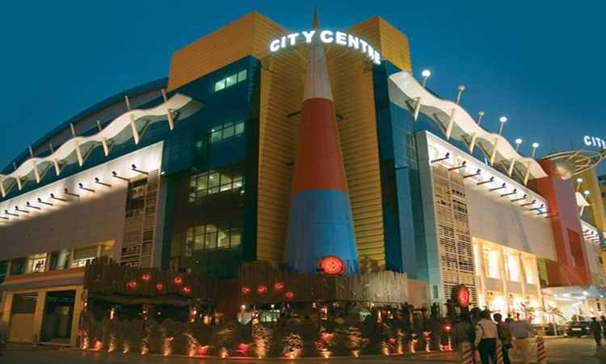

# Introduction

The legendary city of Mumbai is famous for many things. And when people start counting things to do in Mumbai, visiting a shopping mall often tops the list. Fashion and high-end retailers are a big part of this city. Moreover, being the ‘Entertainment Capital’ of the country, it doesn’t take long for people to imitate their favorite stars. This is why it is not surprising that Mumbai has seen a huge influx of global brands in the past decade. For many shoppers, visiting shopping malls is a great way to relax and enjoy themselves during weekends and holidays. Apart from completing necessity shopping like grocery they can also dine at restaurants, shop at the various fashion outlets, watch movies and perform many more activities. Shopping malls are like a one-stop destination for all types of shoppers. For retailers, the central location and the large crowd at the shopping malls provides a great distribution channel to market their products and services.

Property developers therefore want to take advantage of this trend & build more shopping malls to cater to the demand. As a result, there are many shopping malls in the city of mumbai and many more are being built. Opening shopping malls allows property developers to earn consistent rental income. Of course, as with any business decision, opening a new shopping mall requires serious consideration and is a lot more complicated than it seems. Particularly, the location of the shopping mall is one of the most important decisions that will determine whether the mall will be a success or a failure.

# Problem Statement

The objective of this capstone project is to analyse and select the best locations in the city of Mumbai, India to open a new shopping mall. Using data science methodology and machine learning techniques like clustering, this project aims to provide solutions to answer the business question: In the city of Mumbai, if a property developer is looking to open a new shopping mall, where would you recommend that they open it?

# Stakeholders for this project

This project is particularly useful to business enterprises, investors & property developers looking to open or invest in new shopping malls in the financial capital city of India i.e. Mumbai. This project is timely as the city is currently suffering from oversupply of shopping malls.

According to the Mint Journal in Oct 2019 reported with reference to JLL report (JLL is a property consultancy company specializing in property services and investment management), that Premium mall rentals have soared as demand outstrips supply of quality space. JLL report further states that brands are paying as high as 40-50% premium to stay at malls built by premium developers. Rents in some of the marquee malls have jumped threefold, particularly in properties where the occupancy rate is over 90%, according to data compiled by JLL.

# Data

## To solve the problem, we will need the following data:

* List of Neighborhoods in Mumbai. This defines the scope of this project which is confined to the city of Mumbai, the financial capital city of India in South East Asia.
* Latitude and longitude coordinates of those neighborhoods. This is required in order to plot the map and also to get the venue data.
* Venue data, particularly data related to shopping malls. We will use this data to perform clustering on the neighborhoods.

## Sources of data and methods to extract them

This Wikipedia page (<https://en.wikipedia.org/wiki/List_of_neighbourhoods_in_Mumbai>) contains a list of Neighborhoodsin Mubmai, with a total of 42 neighbourhoods. We will use web scraping techniques to extract the data from the Wikipedia page, with the help of Python requests and beautifulsoup packages. Then we will get the geographical coordinates of the Neighborhoodsusing Python Geocoder package which will give us the latitude and longitude coordinates of the neighbourhoods.

After that, we will use Foursquare API to get the venue data for those neighbourhoods. Foursquare has one of the largest database of 105+ million places and is used by over 125,000 developers.

Foursquare API will provide many categories of the venue data, we are particularly interested in the Shopping Mall category in order to help us to solve the business problem put forward. This is a project that will make use of many data science skills, from web scraping (Wikipedia), working with API (Foursquare), data cleaning, data wrangling, to machine learning (K-means clustering) and map visualization (Folium). In the next section, we will present the Methodology section where we will discuss the steps taken in this project, the data analysis that we did and the machine learning technique that was used.

# Methodology

Firstly, we need to get the list of neighborhoods in the city of Mumbai. Fortunately, the list is available in the Wikipedia page (<https://en.wikipedia.org/wiki/List_of_neighbourhoods_in_Mumbai>) .

We will do web scraping using Python requests and beautifulsoup packages to extract the list of neighborhoods data. However, this is just a list of names. We need to get the geographical co-ordinates in the form of latitude and longitude in order to be able to use Foursquare API. To do so, we use the wonderful Geocoder package that will allow us to convert address into geographical coordinates in the form of latitude and longitude. After gathering the data, we will populate the data into a pandas DataFrame and then visualize the Neighborhoods in a map using Folium package. This allows us to perform a sanity check to make sure that the geographical coordinates data returned by Geocoder are correctly plotted in the city of Mumbai.

Next, use Foursquare API to get the top 200 venues that are within a radius of 5000 meters. First register a Foursquare Developer Account in order to obtain the Foursquare ID and Foursquare secret key. Then make API calls to Foursquare passing in the geographical coordinates of the Neighborhoods in a Python loop. Foursquare will return the venue data in JSON format and we will extract the venue name, venue category, venue latitude and longitude. With the data, check how many venues were returned for each neighbourhood and examine how many unique categories can be curated from all the returned venues. Then, analyse each neighbourhood by grouping the rows by neighbourhood and taking the mean of the frequency of occurrence of each venue category. By doing so, we are also preparing the data for use in clustering. Since we are analyzing the “Shopping Mall” data, filter the “Shopping Mall” as venue category for the neighborhoods.

Lastly, perform clustering on the data by using k-means clustering. K-means clustering algorithm identifies k number of centroids, and then allocates every data point to the nearest cluster, while keeping the centroids as small as possible. It is one of the simplest and popular unsupervised machine learning algorithms and is particularly suited to solve the problem for this project. This will cluster the neighborhoods into 3 clusters based on their frequency of occurrence for “Shopping Mall”. The results will allow us to identify which neighborhoods have higher concentration of shopping malls while which neighborhoods have fewer number of shopping malls. Based on the occurrence of shopping malls in different neighborhoods, it will help us to answer the question as to which neighborhoods are most suitable to open new shopping malls

# Results

The results from the k-means clustering show that we can categorize the neighborhoods into 3 clusters based on the frequency of occurrence for “Shopping Mall”:

* Cluster 0: Neighborhoods with moderate number of shopping malls
* Cluster 1: Neighborhoods with low number to no existence of shopping malls
* Cluster 2: Neighborhoods with high concentration of shopping malls

The results of the clustering are visualized in the map below with cluster 0 in r ed colour, cluster 1 in purple colour, and cluster 2 in mint green colour.

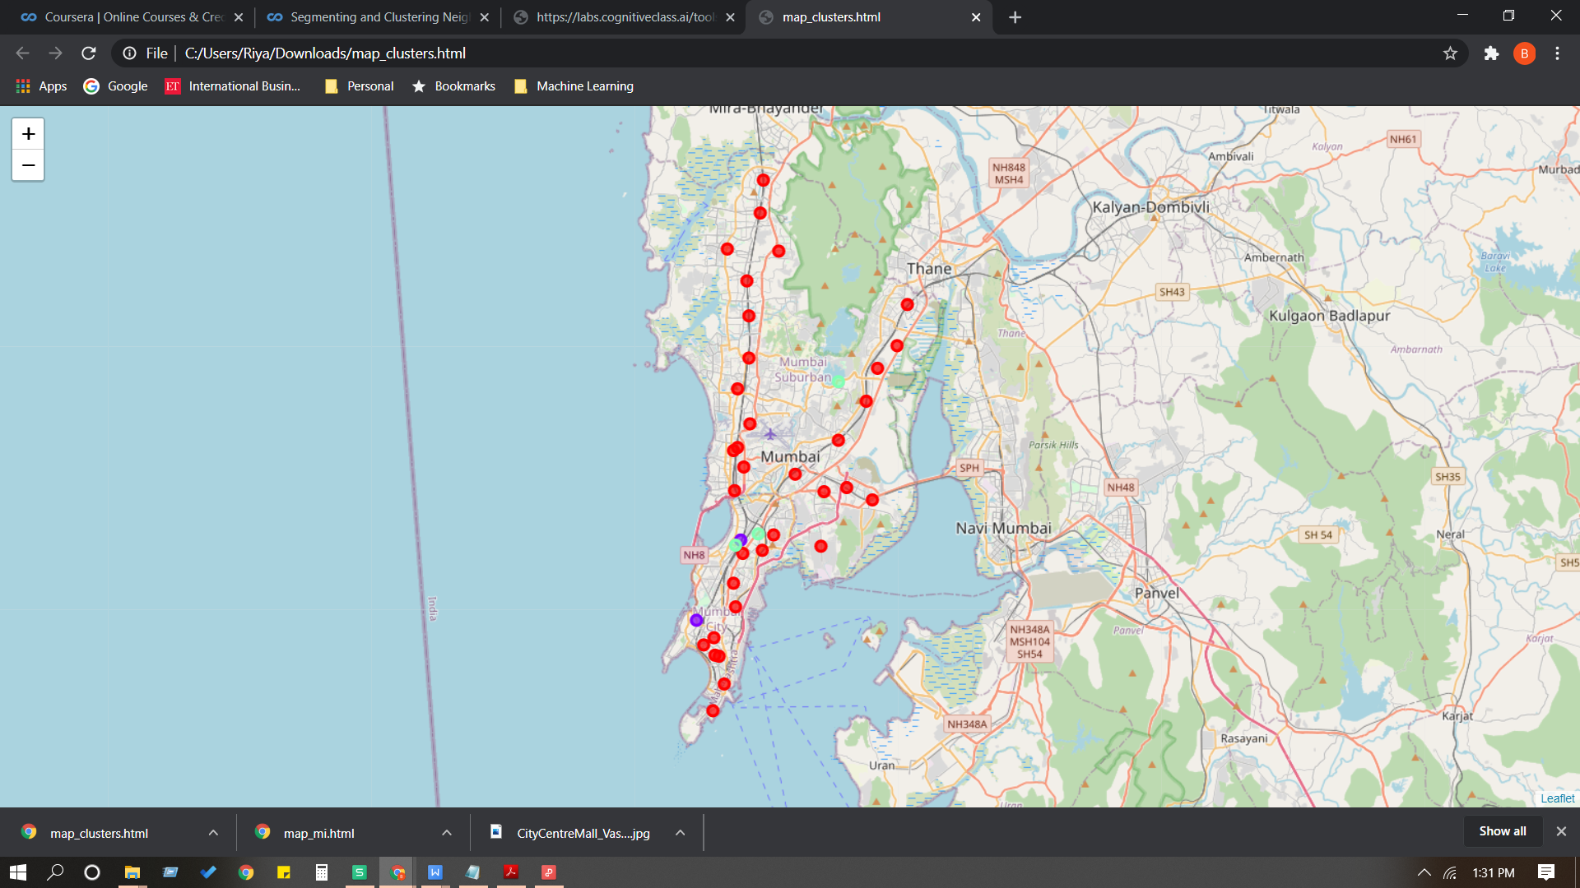

# Discussion

As observations noted from the map in the Results section, most of the shopping malls are concentrated in the central area of Western and eastern Suburbs, with the highest number in cluster 0. On the other hand, cluster 1 & 2 has very low number to no shopping mall in the neighborhoods. This represents a great opportunity and high potential areas to open new shopping malls as there is very little from existing malls. Meanwhile, shopping malls in cluster 0 are likely suffering from intense competition due to oversupply and high concentration of shopping malls. From another perspective, the results also show that the oversupply of shopping malls mostly happened in the eastern & western suburb . Therefore, this project recommends property developers to capitalize on these findings to open new shopping malls in neighborhoods in cluster 1 & 2 with little to no competition. Property developers with unique selling propositions to stand out from the competition can also open new shopping malls in neighborhoods in cluster 1 & 2 with moderate competition. Lastly, property developers are advised to avoid neighborhoods in cluster 0 which already have high concentration of shopping malls and suffering from intense competition.

# Limitations and suggestions for future work

As observations noted from the map in the Results section, most of the shopping malls are

concentrated in the western & eastern part of Mumbai city, with the highest number in cluster 0 and on the other hand, cluster 1 & 2 has very low number shopping mall in the neighborhoods. This represents a great opportunity and high potential areas to open new shopping malls as there is very little from existing malls. Meanwhile, shopping malls in cluster 0 are likely suffering from intense competition due to oversupply and high concentration of shopping malls.

Therefore, this project recommends property developers to capitalize on these findings to open new shopping malls in neighborhoods in cluster 1 & 2 with little to no competition. Property developers with unique selling propositions to stand out from the competition can also open new shopping malls in neighborhoods in cluster 1 & 2. Lastly, property developers are advised to avoid neighborhoods in cluster 0 which already have high concentration of shopping malls and suffering from intense competition.

The conclusion is based o the data obtained from foursquare needs to be up to date which may not be as accurate as other vendors lie googlmaps & bing.

Further enhancements in data about populations and income data of each area will strengthen the accuracy of the model.