Bhaumik Patel

bkpatel3108@gmail.com

Ticket Service Application

Table of Contents

1. Understanding Class Design 3

1.1. Class Diagram - Service Classes 3

1.2. Class Diagram - Value Object Classes 4

1.3. Services Understanding 5

1.3.1. SeatHoldExpireBackgroundService 5

1.3.2. SeatHoldService 5

1.3.3. SeatUpdateService 5

1.3.4. SeatSearchService 5

1.4. Value objects understanding 5

1.4.1. Venue 5

1.4.2. SeatRow 5

1.4.3. Seat 6

1.4.4. SeatHold 6

2. Application Test and Build Instructions 7

2.1. Clone Repository 7

2.2. Change Directory to Application 7

2.3. To run tests 7

2.4. To Run Integration Tests and Build project 8

3. Application Run Instructions 9

4. Example of Using Application 10

4.1. Ticket Service Configuration 10

4.1.1. Using Default Configuration 10

4.1.2. Using Manual Configuration 11

4.2. Ticket Booking Console 11

4.2.1. To check no of seats available 12

4.2.2. To find and hold seats 12

4.2.3. To confirm hold seats 13

4.2.4. To print venue chart 13

# Understanding Class Design

## Class Diagram - Service Classes

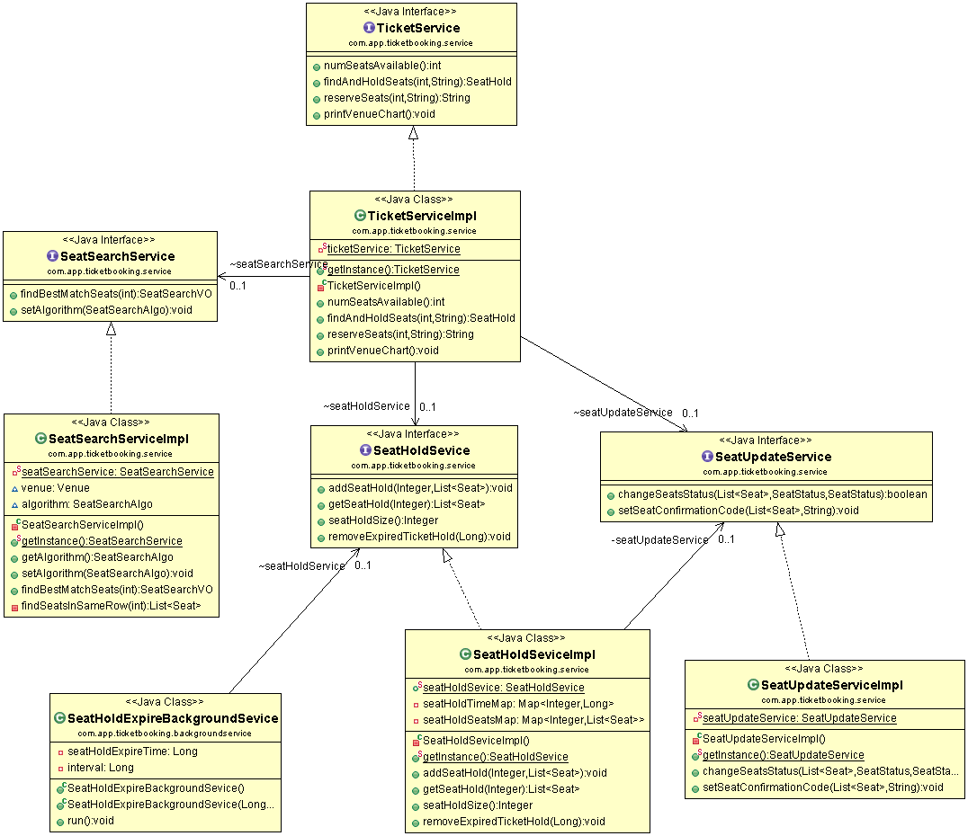

## Class Diagram - Value Object Classes

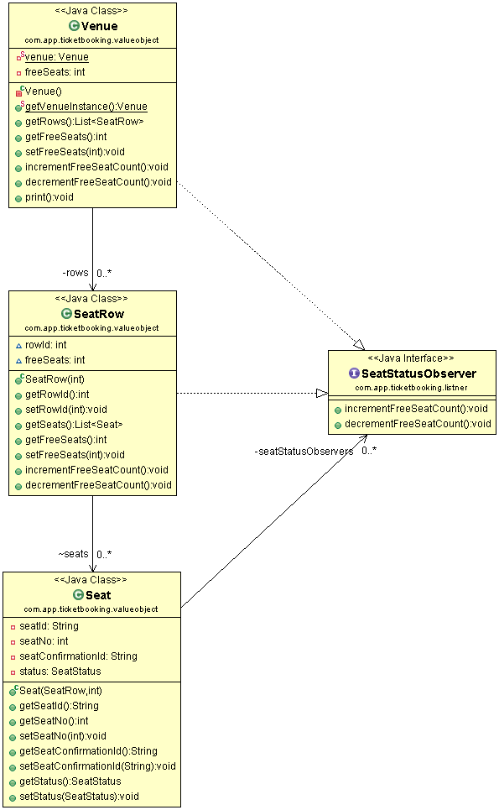

## Services Understanding

### SeatHoldExpireBackgroundService

This service runs on separate thread, and check for expired ticket after configured interval time.

Ticket considered expired if they are not booked within configured Ticket Hold Time.

### SeatHoldService

This service used to hold new tickets for customer.

It is also used to remove hold form the tickets.

### SeatUpdateService

This Service is used to update status of seats. It will first check given seats are currently in old status, and if they are in old status (double check), then it will update them with new status.

This service is used to add confirmation code to seats.

### SeatSearchService

This service is used to find best seats for customer. It can be configured to use different algorithm. It uses default algorithm – Only book in same row.

## Value objects understanding

### Venue

It consists multiple seat rows (which can be configured).

It listens for seat status change and based on that it updated available free seats in venue.

### SeatRow

It consists multiple seats (which can be configured).

It listens for seat status change and based on that it updated available free seats in seat row.

### Seat

It consists seatId (unique identifier), confirmationId (to track which customer has reserved this seat - reservation code), and Observers for seat status change (venue and seat row object).

### SeatHold

It consists seatHoldId (unique identifier), TickedHoldStatus (HELD, TIMEOUT), customer emailId, booked seat ids and error message (if any)

# Application Test and Build Instructions

## Clone Repository

Clone following Repository to your computer.

<<GitHub URL given in email>>

## Change Directory to Application

Open Terminal or Cmd, and change directory to Application (TIcketService)

Ex : $ cd njit/workspaces/java-assignments/ticketbooking/

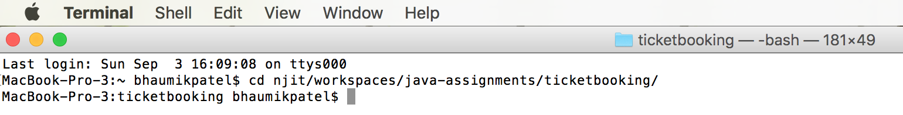

## To run tests

mvn test

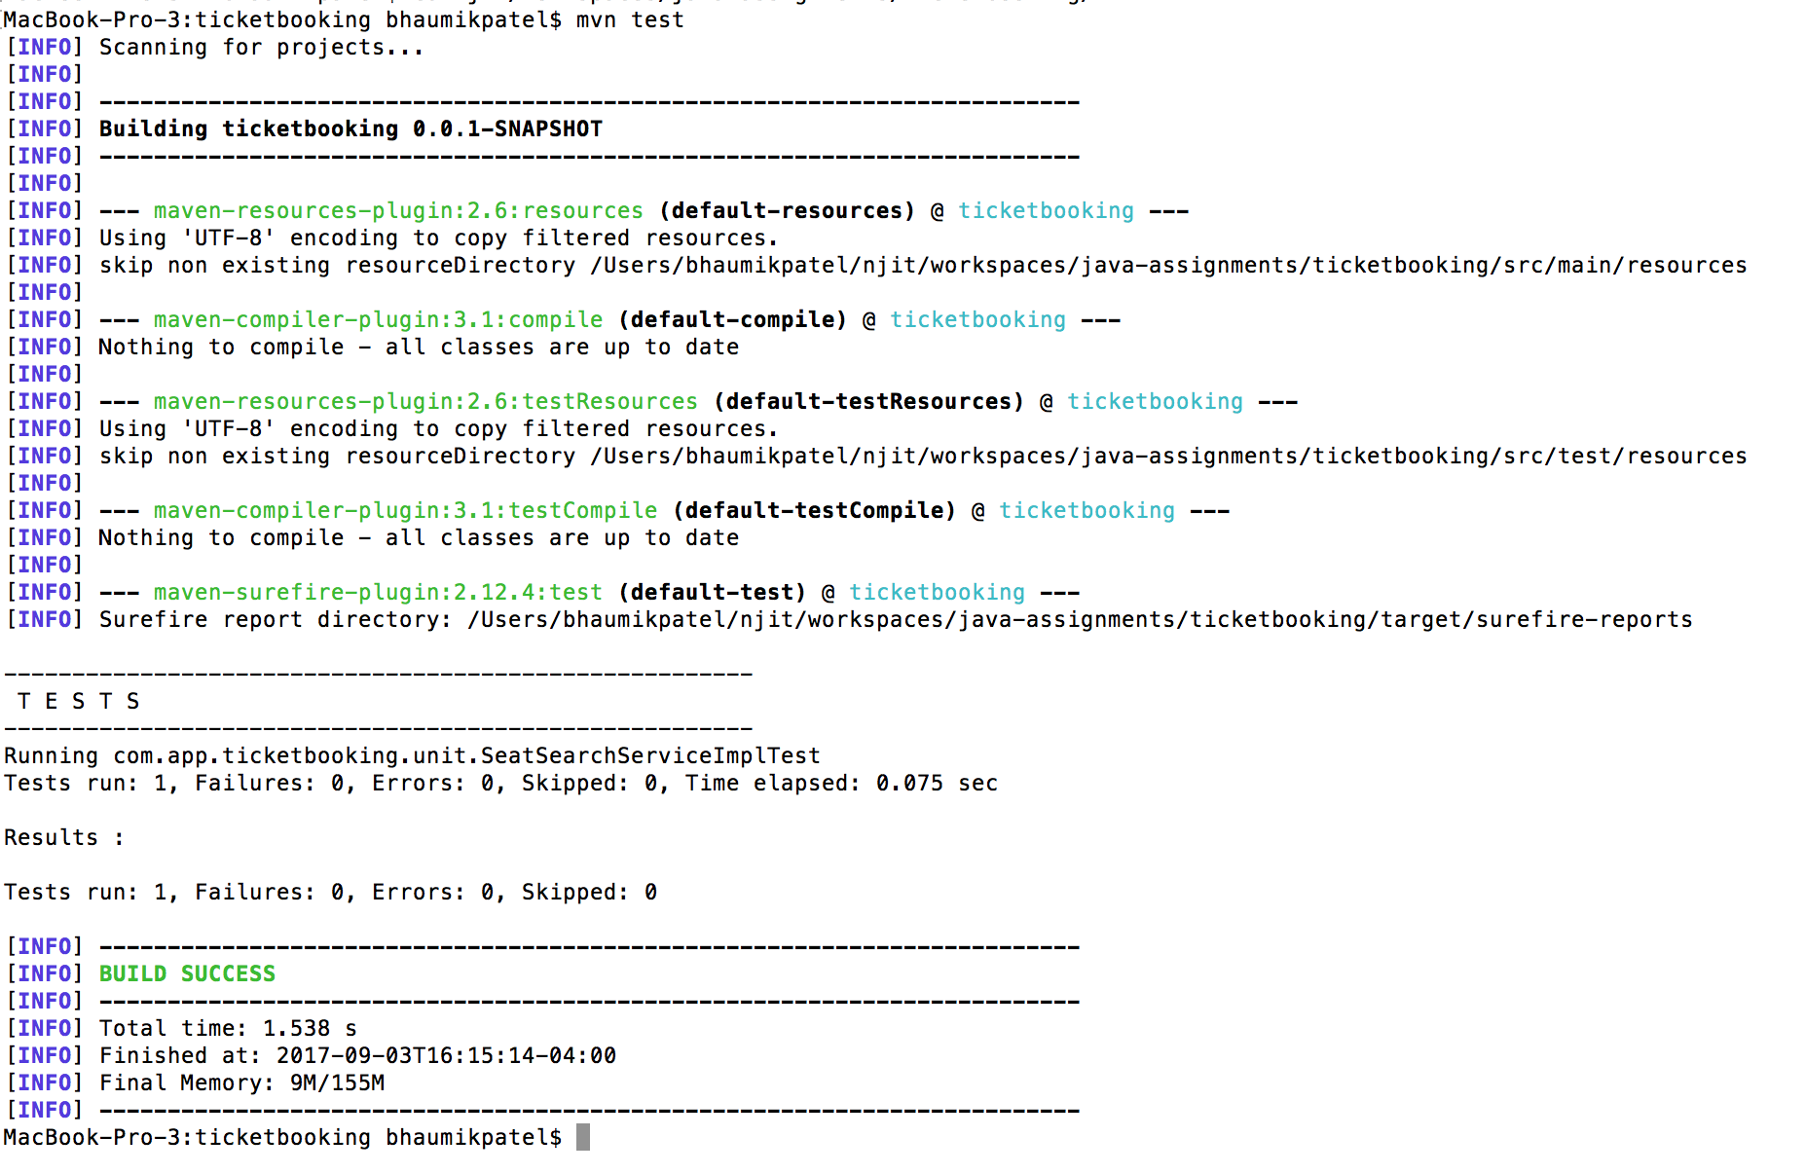

## To Run Integration Tests and Build project

$ mvn install

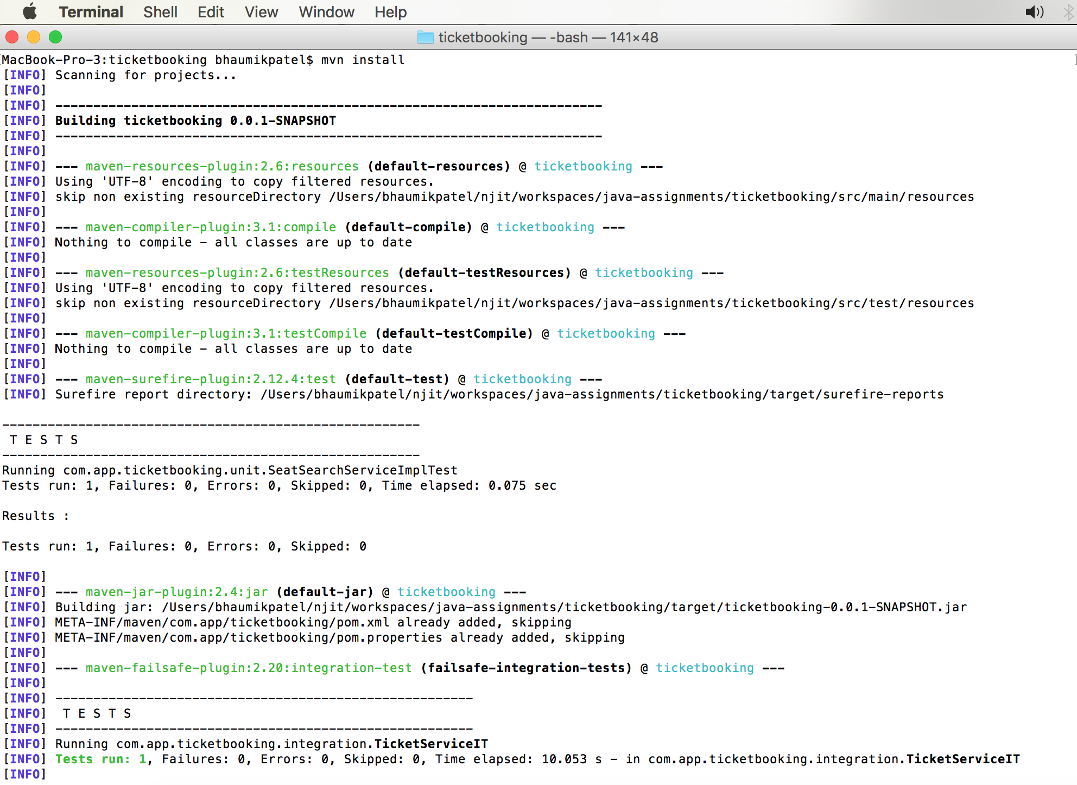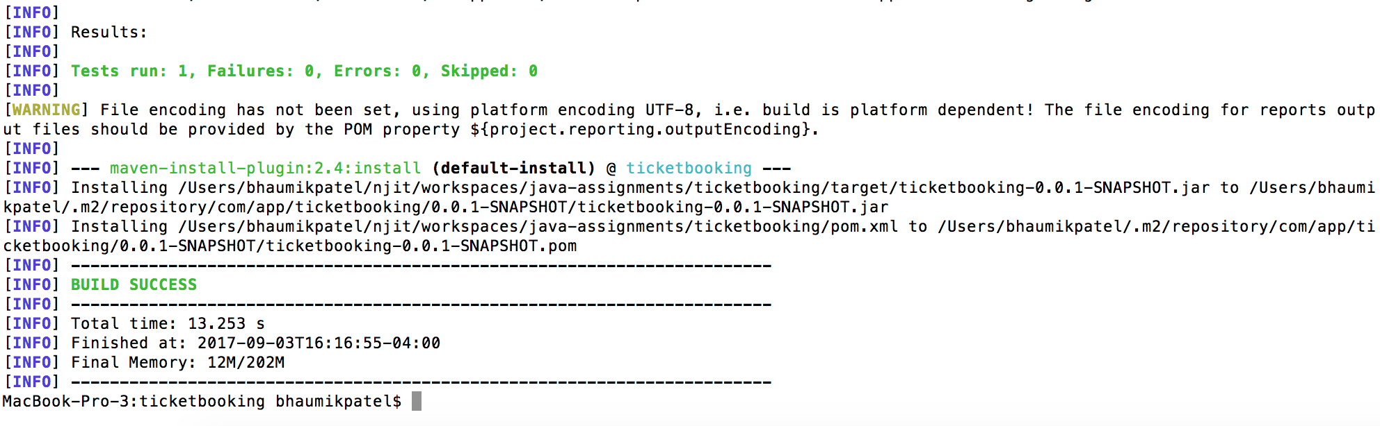

# Application Run Instructions

$ cd target/

$ java -cp ticketbooking-0.0.1-SNAPSHOT.jar com.app.ticketbooking.App

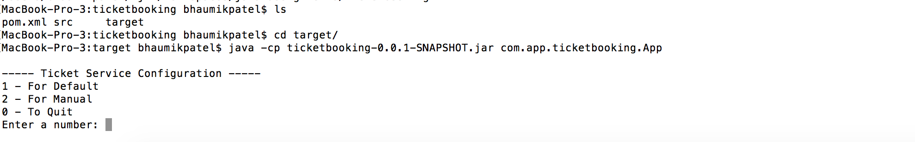

# Example of Using Application

## Ticket Service Configuration

You can configure this application in 2 ways. Using quick configuration and manual configuration.

----- Ticket Service Configuration -----

1 - For Default

2 - For Manual

0 - To Quit

### Using Default Configuration

Enter a number: 1

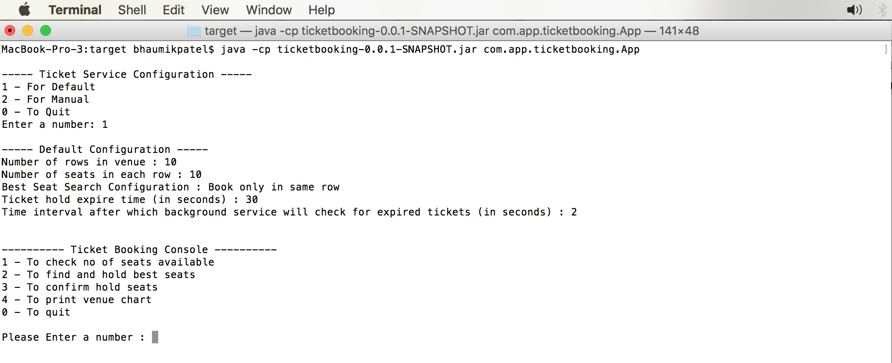

### Using Manual Configuration

Enter a number: 2

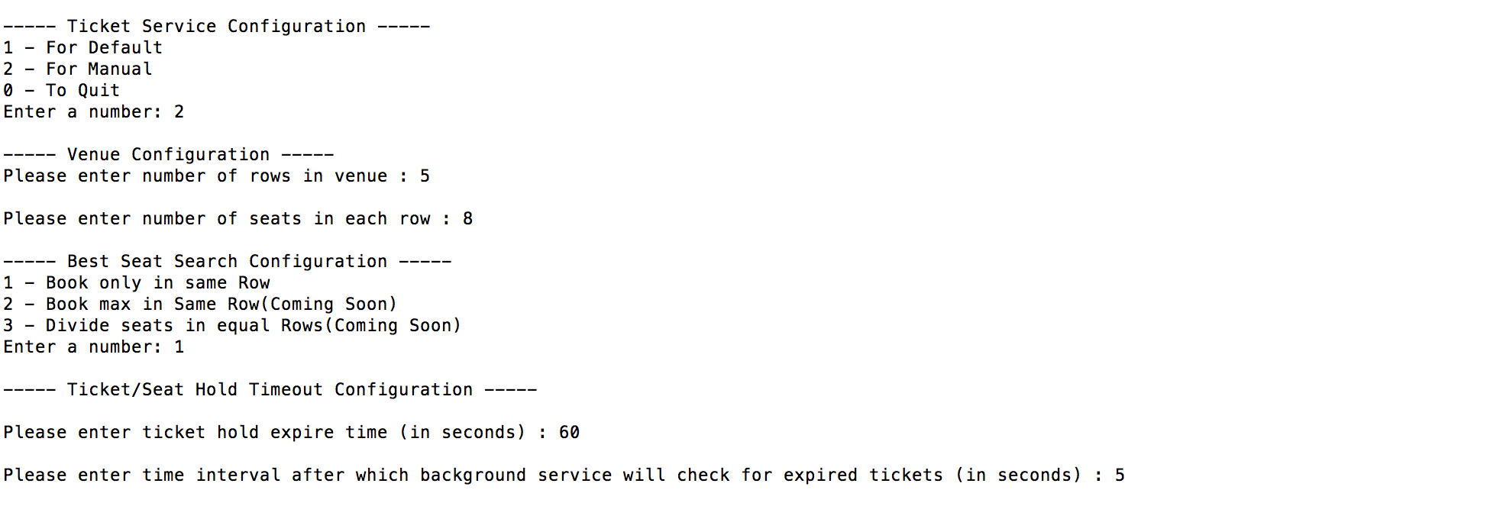

## Ticket Booking Console

On Ticket Booking Console, there are four options available.

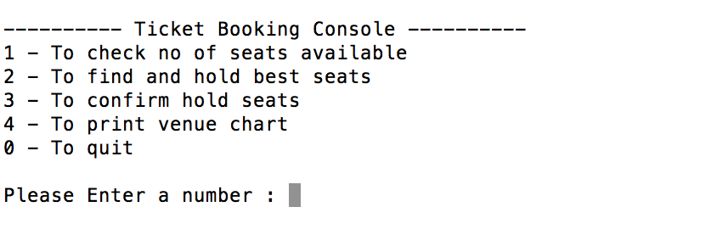

### To check no of seats available

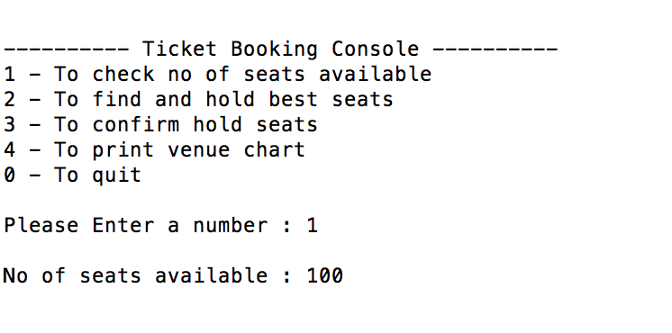

### To find and hold seats

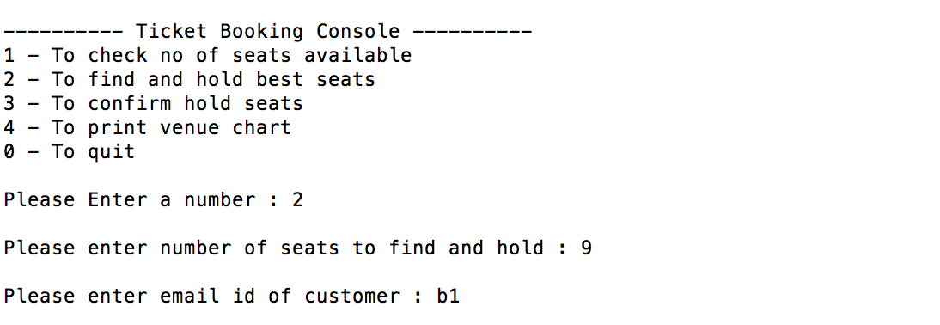

After entering number of seats to hold and customer email id, system will return ticket/seat hold details.

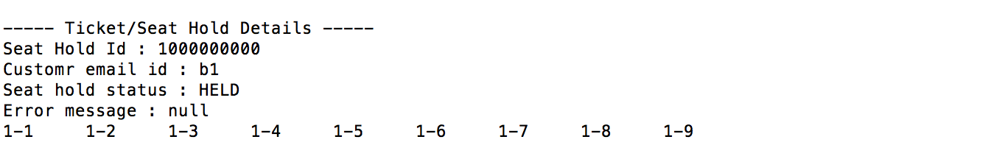

### To confirm hold seats

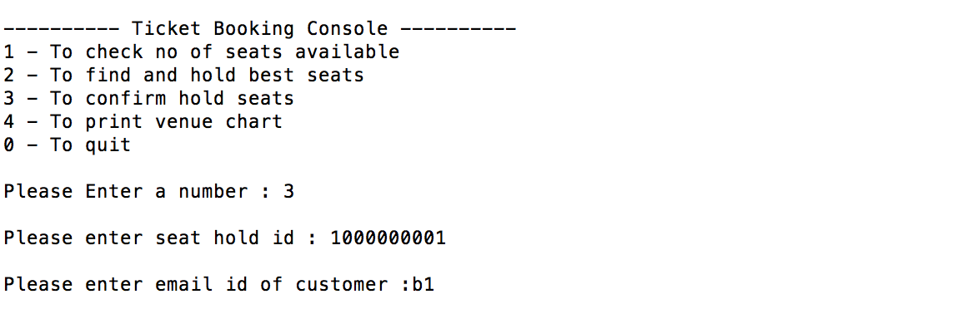

After entering seat hold id and customer email id, system will return confirmation code.



### To print venue chart

