CoupleCore
Software Requirements Specification
A Relationship & Emotional Well-being Companion

Project | UnP Project 01
Document | Software Requirements Specification
Version | 1.0 — target specification
Platform | Flutter (iOS / Android) · Firebase
Status | Full-scope spec; current build tagged inline

Contents

Document Conventions
This document specifies the full target system. Each functional requirement carries a status tag reflecting the current codebase (single-file app, lib/main.dart), so the SRS is both a build specification and an honest snapshot.
Tag | Meaning
Implemented | Exists and works today.
Partial | Partly built; meaningful behaviour missing.
Placeholder | In the UI but non-functional (snackbar only).
Planned | Specified here; not yet built.

Requirement IDs: FR-n (functional), NFR-n (non-functional). Priorities are stated per feature group.

1. Introduction

1.1 Purpose
CoupleCore is a private, two-person mobile application that helps a couple strengthen communication, understand each other's emotions, avoid misunderstandings, and coordinate shared relationship activities. This SRS defines the requirements and architecture for building it as a production product.

1.2 Product Scope
The app links exactly two people into a couple. It provides authentication, partner linking, daily mood sharing, a multi-channel emergency alert, a shared calendar, shared memories, private messaging, a good-deeds tracker, a menses reminder, and a set of emotional-support tools — including an AI-assisted problem-solving tool. Privacy between the two partners is a core, non-negotiable product value.

1.3 Intended Audience
The development team building CoupleCore, and reviewers/testers of the product.

1.4 Definitions
Term | Meaning
Partner | The other user linked to a given account.
Couple | The linked pair; owns all shared data (couples/{coupleId}).
UID | Firebase Authentication unique user identifier.
FCM | Firebase Cloud Messaging (push notifications).
Private-by-default | Data stored only for one partner until they explicitly choose to share it.
Presence disclosure | Any signal revealing whether a partner is online or active — deliberately excluded (NFR-7).

1.5 References
CoupleCore proposal (UnP Project 01); CoupleCore Current Build Summary; requirements-interview responses (this revision); IEEE Std 830-style structure; classic “5 Love Languages” model; “How Are You Feeling?” emoji chart (mood iconography).

2. Overall Description

2.1 Product Perspective
A new, self-contained mobile product backed by managed cloud services. No third-party relationship-platform integration.

2.2 User Classes
One user class — Partner — with two symmetric instances. Both have identical rights over shared data; neither can see the other's private data unless it is explicitly shared. No admin, moderator, or external-viewer role exists by design.

2.3 Operating Environment
Client: Flutter (Material 3) app for iOS and Android. Backend: Firebase (Authentication, Cloud Firestore, Cloud Storage, Cloud Messaging) plus Cloud Functions for server-side logic. Connectivity: network required for auth, sync, alerts, and AI features.
Platform decision (resolved).
The proposal's web/Next.js/MongoDB stack is superseded. The confirmed target is the Flutter + Firebase mobile app described throughout this document.

2.4 Assumptions & Dependencies
Each user has exactly one active partner. Both partners install the same app. External dependencies: an LLM provider (for AI features), a telephony provider for emergency SMS/voice (e.g. Twilio), and device location services. Secrets for these live server-side in Cloud Functions, never in the client.

3. System Architecture
CoupleCore uses a client + serverless architecture. The Flutter app talks directly to Firebase for identity, data, media, and push, and delegates anything that needs a secret key or cross-user coordination (AI calls, emergency escalation, scheduled reminders, unlink cleanup) to Cloud Functions.
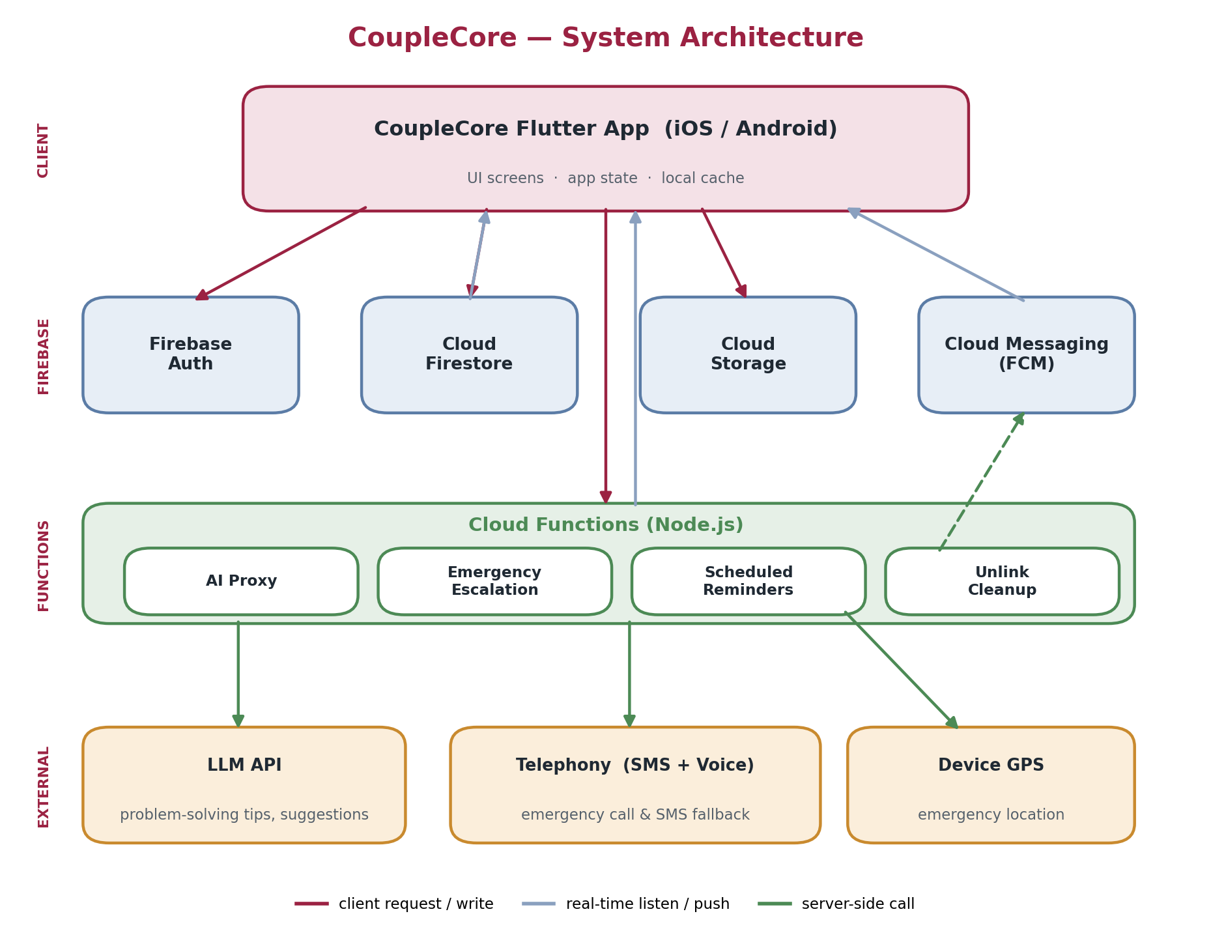
Figure 1 — CoupleCore system architecture.

3.1 Components
Layer | Component | Responsibility
Client | Flutter app (Dart, Material 3) | UI, state, local cache, real-time listeners.
Identity | Firebase Auth | Email/password, Google, Apple sign-in; password reset.
Data | Cloud Firestore | Couple-scoped documents with security rules.
Media | Cloud Storage | Photos/videos for Memories.
Push | Cloud Messaging (FCM) | Reminders, gentle nudges, emergency delivery.
Serverless | Cloud Functions (Node.js) | AI proxy, emergency escalation, scheduled jobs, unlink cleanup.
AI | LLM API (via Function) | Problem-solving tips, suggestion generation.
Telephony | SMS/Voice provider (via Function) | Emergency SMS + call fallback.

3.2 Key Data Flows
Mood: app writes to Firestore; the partner's app listens and re-renders. No write triggers a notification (NFR-7).
Problem-solving (AI): app calls a Cloud Function with the couple's relevant problem/resolution history; the Function calls the LLM and returns tailored tips. The API key never leaves the server; only minimal, need-to-know context is sent (NFR-6).
Emergency: app writes an alert (with location) to Firestore and invokes the escalation Function, which pushes a full-screen FCM alert and, as fallback, sends SMS and places a voice call to the partner. The partner acknowledges back into Firestore.
Unlink: a Function deletes the couple document, its subcollections, and associated media, and clears both users' link fields — severing sharing and reclaiming storage (NFR-9).

3.3 Privacy-Scoped Data Model
Data is partitioned into three scopes so that security rules are simple and privacy is enforced by structure, not by convention:
Scope | Location | Who can access
Account | users/{uid} | The owner (profile, settings, link state).
Private | users/{uid}/private/** | The owner only — encrypted; onboarding answers, private menses, sensitive notes.
Shared | couples/{coupleId}/** | Only the two members in memberUids.

Private-by-default items (e.g. onboarding Q&A) live in the owner's private scope with a per-item share flag; sharing copies/moves them into the couple scope only on explicit action.

Principal collections
users/{uid} profile, authProviders[], loveLanguage?, partnerUid?, coupleId?, settings{ quietHours, notifPrefs }
users/{uid}/private/{docId} onboarding answers (shared:false), private menses, sensitive fields (encrypted)
invites/{code} fromUid, email?, status, expiresAt
couples/{coupleId} memberUids[2], status, createdAt
couples/{coupleId}/moods/{uid} mood, updatedAt (server-only; never surfaced)
couples/{coupleId}/moodHistory/... daily entries, source: tracker | quiz
couples/{coupleId}/calendar/{id} title, type, start, end?, recurrence?, reminders[]
couples/{coupleId}/memories/{id} kind: photo|video|note, storageRef?, text?, createdBy
couples/{coupleId}/messages/{id} fromUid, text, kind: chat|loveNote, sentAt
couples/{coupleId}/goodDeeds/{id} byUid, description, status: pending|confirmed, points
couples/{coupleId}/menses/{id} predictedDate, actualDate?, visibility: shared|private, ownerUid
couples/{coupleId}/alerts/{id} fromUid, toUid, message, location, status, channels[], acknowledgedAt?
couples/{coupleId}/problems/{id} byUid, description, resolution?, tags[] (feeds the AI tool)

3.4 Security Rules & Encryption
Firestore rules grant read/write on couples/{coupleId}/** only when request.auth.uid is in that couple's memberUids, and on users/{uid}/private/** only to the owner. Sensitive private fields (menses, onboarding answers, personal notes) are additionally encrypted so they are unreadable even in a raw data dump. This realises the proposal's promise that no one outside the couple can see their data (NFR-5).

4. Functional Requirements

4.1 Accounts & Authentication — High
FR-1 Partial Register with email/password, Google, or Apple. (Email/password exists; social providers planned.)
FR-2 Partial Sign in with any supported provider.
FR-3 Planned Reset a forgotten password / recover the account.
FR-4 Implemented AuthGate routes signed-in users to the Dashboard, signed-out users to the Auth screen.
FR-5 Planned Manage profile and settings (notification preferences, quiet hours) from a Settings screen.
FR-6 Planned Delete the account, removing personal and shared data.
FR-7 Planned Export the user's data on request.

4.2 Partner Linking — High
FR-8 Planned Generate a single-use invite code to link a partner.
FR-9 Planned Link by entering a partner's invite code.
FR-10 Partial Link by email invitation that the partner explicitly accepts. (Current build silently resolves by email with no acceptance.)
FR-11 Planned A couple becomes active only after mutual confirmation; a couples/{coupleId} record is then created.
FR-12 Planned Onboarding Q&A during linking: answers are private by default and shared only when the owner chooses.
FR-13 Planned Unlink at any time: severs the connection, revokes all shared access, and deletes shared data/media to reclaim storage. A user has at most one active partner.

4.3 Mood Tracker — High
FR-14 Implemented Log one of six moods (Happy, Neutral, Sad, Stressed, Loved, Frustrated) via a picker.
FR-15 Implemented The dashboard shows both partners' current moods live via Firestore listeners.
FR-16 Planned Mood is logged once per day; the last logged mood persists on display until updated.
FR-17 Planned A daily reminder prompts the user to log today's mood until they do (respecting quiet hours).
FR-18 Planned A private history/trends view of the user's own moods over time.
FR-19 Planned Pattern detection over mood history, with healthy-action recommendations.
No presence disclosure (design rule, NFR-7).
Logging a mood never notifies the partner, and because the last mood persists until updated, the partner cannot infer whether the other came online today. The app exposes no online status, “last seen,” or read receipts anywhere.

4.4 Happiness Detector — Medium
FR-20 Planned A daily quiz of five fixed questions captures emotional state.
FR-21 Planned If the result is sad, the partner receives a gentle, supportive notification that does not reveal timing or activity.
FR-22 Planned Quiz results feed the mood history (source: quiz).

4.5 Emergency Alert — High
FR-23 Implemented A floating button plus confirmation dialog sends an emergency alert addressed to the partner.
FR-24 Planned The alert carries a custom message and the sender's current location.
FR-25 Critical The partner receives and sees the alert: a full-screen notification with sound, escalating to SMS and an automated voice call if unacknowledged. (Today nothing reads the alerts data, so alerts never arrive — highest-priority gap.)
FR-26 Planned The partner can acknowledge/respond; status is recorded.
FR-27 Planned An alert history is retained.
FR-28 Planned A clear notice states the feature is not a substitute for emergency services, with a shortcut to call local emergency.

4.6 Shared Calendar — Medium
The calendar is the single home for all date-based events and their reminders.
FR-29 Placeholder Create, edit, and delete events: anniversaries, birthdays, special days, exam timetables, lecture times, discussion times.
FR-30 Planned Support recurring events.
FR-31 Planned Per-event reminders delivered by push (respecting quiet hours).
FR-32 Planned Both partners can view and edit shared events.

4.7 Menses Reminder — Medium (separate module)
FR-33 Planned Predict the cycle from previously logged dates and remind the owner.
FR-34 Planned When the owner records the actual date, it corrects the prediction for that entry.
FR-35 Planned Default visibility is shared (both partners can see and update). It can be set private, in which case only the owner sees it and it is stored in the owner's private, encrypted scope.
FR-36 Planned When shared, entries can be surfaced and corrected from the shared calendar.

4.8 Memories — Medium
FR-37 Placeholder Add photos, videos, and notes/stories.
FR-38 Planned Browse memories in a timeline view.

4.9 Messaging — Medium
FR-39 Placeholder A private couple chat (text, and optionally media).
FR-40 Planned Quick “love-note” sending, drafted with help from the Suggestion Generator (FR-46).

4.10 Good Deeds (“Good Collector”) — Medium
FR-41 Placeholder Log a good deed performed for the partner.
FR-42 Planned The partner confirms the deed, which awards points (confirmation prevents self-inflation).
FR-43 Planned Show running totals and a periodic summary.

4.11 Emotional-Support Tools — Medium
FR-44 Planned Love-language quiz at signup using the classic five love languages; result stored on the profile.
FR-45 Planned Daily personalized suggestions tailored to each partner's love language.
FR-46 Planned Suggestion Generator produces compliments and mood-boosting notes.
FR-47 Planned Problem journal: each partner records problems and how they were resolved.
FR-48 Planned AI problem-solving: using the couple's prior problem/resolution data, generate tailored communication tips and calming steps (via the AI-proxy Function).

4.12 Notifications & Reminders — High (cross-cutting)
FR-49 Planned Push delivery via FCM. (firebase_messaging is a declared dependency but not yet wired up.)
FR-50 Planned User-configurable notification preferences and quiet hours; reminders are suppressed during quiet hours.
FR-51 Planned Triggers: upcoming calendar events, the daily mood-log nudge, a sad happiness-detector result, emergency alerts, and menses reminders.

4.13 Dashboard & Navigation — High
FR-52 Implemented Dashboard with header (day/date), mood section, and feature grid.
FR-53 Placeholder The “Wisdom” card presents rotating content driven by data/date (currently static).
FR-54 Partial Bottom navigation switches between real Home, Timeline, Alerts, and Settings screens (currently only the icon highlight changes).

5. Non-Functional Requirements

5.1 Performance
NFR-1 Mood, message, and alert updates propagate to the partner in near-real-time via snapshot listeners. NFR-2 The app stays responsive on a mid-range device; media loads progressively.

5.2 Security & Privacy — High
NFR-3 All traffic is encrypted in transit (TLS). NFR-4 Credentials are handled by Firebase Auth (secure storage, token issuance). NFR-5 Firestore security rules restrict shared data to the two couple members and private data to its owner. Sensitive private fields are additionally encrypted.
NFR-6 AI processing sends only the minimal necessary context to the LLM provider; keys stay server-side, and the provider's data-handling terms are reviewed before launch. NFR-8 Private-by-default: personalized/sensitive data is stored per-partner and shared only on explicit action.
NFR-7 No presence disclosure.
The app must never reveal whether a partner is online, recently active, or has opened the app today — no presence dots, “last seen,” typing or read indicators. Mood persistence and the gentle-notification wording are designed to uphold this.

5.3 Safety — High
NFR-10 The emergency feature is presented as a private signal to the partner, not a replacement for emergency services (FR-28). NFR-11 Emergency escalation (push → SMS → call) must be reliable and its delivery status observable; the feature must not be exposed as “working” until end-to-end delivery exists.

5.4 Usability & Accessibility
NFR-12 Core actions (log mood, send love-note, trigger emergency) take one or two taps. NFR-13 UI follows Material 3 conventions for consistency and accessibility.

5.5 Reliability
NFR-14 The app degrades gracefully offline with clear messaging and syncs when reconnected.

5.6 Maintainability
NFR-15 Refactor the single-file build (lib/main.dart) into modular layers (screens, models, services) before feature growth.

5.7 Scalability & Data Efficiency
NFR-16 Data is partitioned per couple, so it scales horizontally. NFR-9 Storage efficiency is a first-class concern: avoid duplication, cap/compress media, and delete shared data and media on unlink so no orphaned couple data remains.

6. Suggested Build Roadmap
A phased path from the current build to the full spec, front-loading the architecture the rest depends on.
Phase | Focus | Key requirements
1 — Foundation | Auth providers + reset, robust linking (invite code / email accept / mutual confirm), couple data model + security rules, settings & quiet hours. | FR-1–3, 5, 8–13; NFR-5
2 — Core emotional | Mood history & patterns, happiness detector, full emergency pipeline (receive + location + escalation), FCM notifications. | FR-16–28, 49–51; NFR-7, 10, 11
3 — Shared life | Calendar + reminders, memories, messaging, good deeds, menses module. | FR-29–43
4 — AI & polish | Problem journal + AI tips, love-language suggestions, suggestion generator, dashboard/nav completion. | FR-44–48, 53–54; NFR-6

7. Open Issues & Decisions
Item | Detail
Emergency delivery (critical) | Build FR-25 end-to-end before exposing the feature. Choose the telephony provider (SMS + voice) and budget for per-message/call costs. Note platform constraints: Android full-screen intents and iOS critical-alert / CallKit entitlements.
AI provider & privacy | Select the LLM provider; review its data-retention terms; minimize/anonymize the problem data sent (NFR-6).
Encryption scheme | Decide client-side field encryption vs. rules-only for sensitive private data, and key management per couple.
Gentle-notification wording | Must support the partner without revealing activity timing, to uphold NFR-7.
Good-deeds & messaging scope | Confirmed as partner-confirmed points and chat-plus-love-notes respectively; refine rewards/summary cadence during Phase 3.
Migration | Move current flat data (users/{uid}, moods/{uid}, alerts) into the couple-scoped model in Phase 1.

End of document — CoupleCore SRS v1.0, target specification synthesized from the proposal, current build, and requirements interview.

