How to calculate dew point?

Many equations describing this relationship have been formed. None of them are perfect, though. This dew point calculator uses the Magnus-Tetens formula (Sonntag90) that allows us to obtain accurate results (with an uncertainty of 0.35°C) for temperatures ranging from -45°C to 60°C.

The dew point is calculated according to the following formula:

Ts = (bα(T,RH)) / (a - α(T,RH))

where:

* Ts is the dew point;
* T is the temperature;
* RH is the relative humidity of the air;
* a and b are coefficients. For Sonntag90 constant set, a = 17.62 and b = 243.12°C;
* α(T,RH) = ln(RH/100) + aT/(b+T).

If you want to calculate relative humidity, you need to know the dew point and temperature to use the equation derived from the above formula.

## Dew point applications

You might be surprised, but the dew point calculator may be useful in many different areas. To mention only a few:

* **Meteorology** - the most obvious one: the dew point is used to express the amount of moisture in the air
* **Aviation** - the dew point temperature is calculated to assess the probability of a carburetor icing, or fog appearing
* **Agriculture** - to sustain optimal humidity in a greenhouse and avoid water condensation on the plants
* **Technology** - dew point meters are used in the generation and usage of various technical gases (e.g. H2, N2, O2, Ar) and in electronics and optics domains (vapor deposition and thin films)
* **Medicine** - e.g., monitoring of the sterilization process

## Current Transformer Connection

To connect a CT sensor to an ADC, the output signal from the CT sensor needs to be conditioned so it meets the input requirements of the ADC analog inputs, i.e. a **positive voltage between 0V and the ADC reference voltage.**

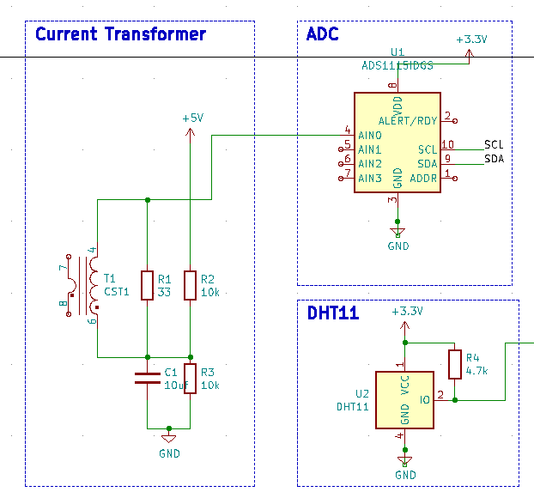

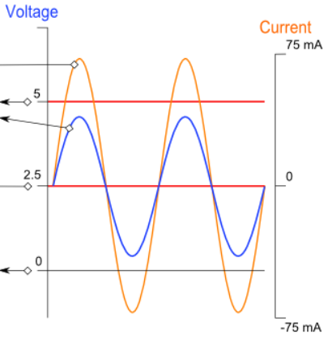

## Calculating a Suitable Burden Resistor Size

If the CT sensor is a "current output" type such as the YHDC SCT-013-000, the current signal needs to be converted to a voltage signal with a burden resistor. If it is a voltage output CT you can skip this step and leave out the burden resistor, as the burden resistor is built into the CT.

**a) Choose the current range you want to measure**

The YHDC SCT-013-000 CT has a current range of 0 to 100 A. For this example, let's choose 100 A as our maximum current.

**b) Convert maximum RMS current to peak-current by multiplying by √2.**

Primary peak-current = RMS current × √2 = 100 A × 1.414 = 141.4A

**c) Divide the peak-current by the number of turns in the CT to give the peak-current in the secondary coil.**

The YHDC SCT-013-000 CT has 2000 turns, so the secondary peak current will be:

Secondary peak-current = Primary peak-current / no. of turns = 141.4 A / 2000 = 0.0707A

**d) To maximise measurement resolution, the voltage across the burden resistor at peak-current should be equal to one-half of the Arduino analog reference voltage. (AREF / 2)**

If you're using an Arduino running at 5V: AREF / 2 will be 2.5 Volts. So the ideal burden resistance will be:

Ideal burden resistance = (AREF/2) / Secondary peak-current = 2.5 V / 0.0707 A = 35.4 Ω

35 Ω is not a common resistor value. The nearest values either side of 35 Ω are 39 and 33 Ω. Always choose the smaller value, or the maximum load current will create a voltage higher than AREF. We recommend a 33 Ω ±1% burden. In some cases, using 2 resistors in series will be closer to the ideal burden value. The further from ideal the value is, the lower the accuracy will be.

Here are the same calculations as above in a more compact form:

Burden Resistor (ohms) = (AREF * CT TURNS) / (2√2 * max primary current)

#### Adding a DC Bias

If you were to connect one of the CT wires to ground and measure the voltage of the second wire, relative to ground, the voltage would vary from positive to negative with respect to ground. However, the Arduino analog inputs require a positive voltage. By connecting the CT lead we connected to ground, to a source at half the supply voltage instead, the CT output voltage will now swing above and below 2.5 V thus remaining positive.

Resistors R1 & R2 in the circuit diagram above are a voltage divider that provides the 2.5 V source (1.65 V for the emonTx). Capacitor C1 has a low reactance - a few hundred ohms - and provides a path for the alternating current to bypass the resistor. A value of 10 μF is suitable.