MemoriAI – Architecture Overview

Course: INFO8665 – Projects in Machine Learning  
Instructor: Anasuya Bhima  
Institution: Conestoga College  
Date: October 2025  
  
Team Members:  
Tessa Nejla Ayvazoglu | Krishna Reddy Bovilla | Adhitya Kondeti | Bhupender Sejwal | Kumari Nikitha

# 1. Executive Summary

MemoriAI is an AI-powered assistive platform designed to support individuals with Alzheimer's disease through cognitive reinforcement, daily reminders, and caregiver collaboration. The architecture emphasizes modularity, explainability, and safety to ensure ethical AI practices. It offers a multi-service ecosystem that promotes independence for patients while easing caregiver workload.

# 2. System Context

MemoriAI operates using RESTful APIs within a secure Azure cloud environment. Actors include patients, caregivers, and backend cognitive and reminder services. All data is transmitted over TLS-encrypted HTTPS, maintaining privacy and data integrity.

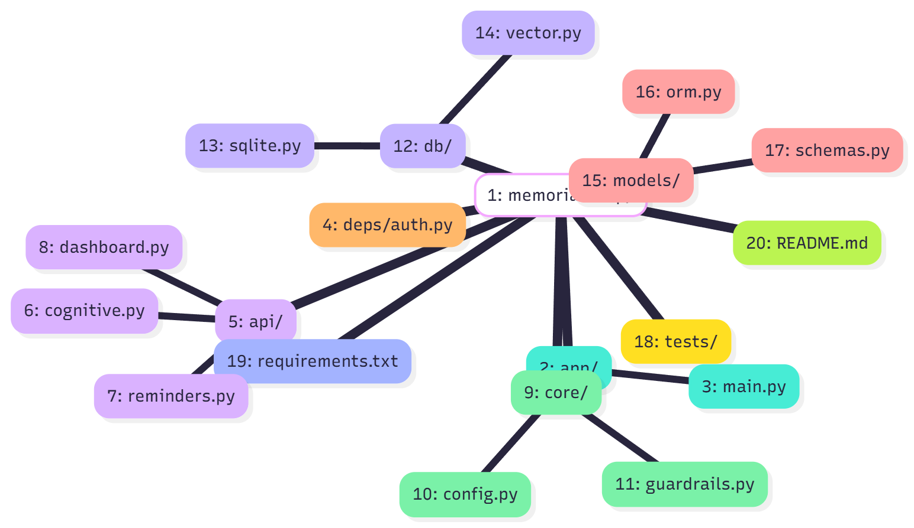

Diagram: System Context

# 3. MVP Architecture

The MVP version employs a modular REST architecture connecting core services through a unified API Gateway. This design facilitates low coupling and independent scaling across cognitive, reminder, and dashboard components.

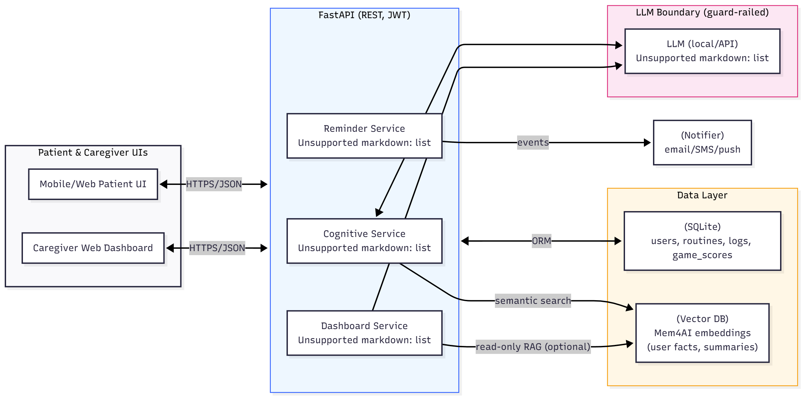

Diagram: MVP_Architecture

# 4. Functional Flows

## 4.1 Cognitive & Identity Flow

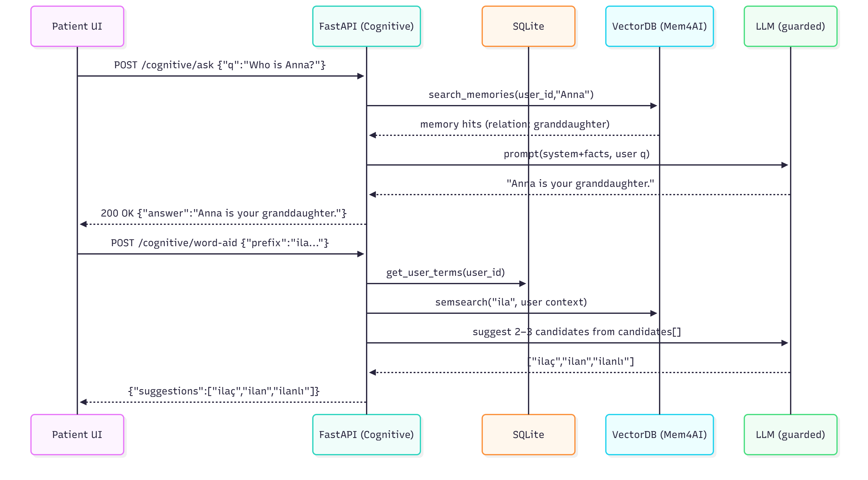

Diagram: CognitivedentityWord-Aid

Patients play cognitive games or ask questions about their identity. The Cognitive Service retrieves data from vectorized memory embeddings and provides personalized feedback.

## 4.2 Daily Reminder Flow

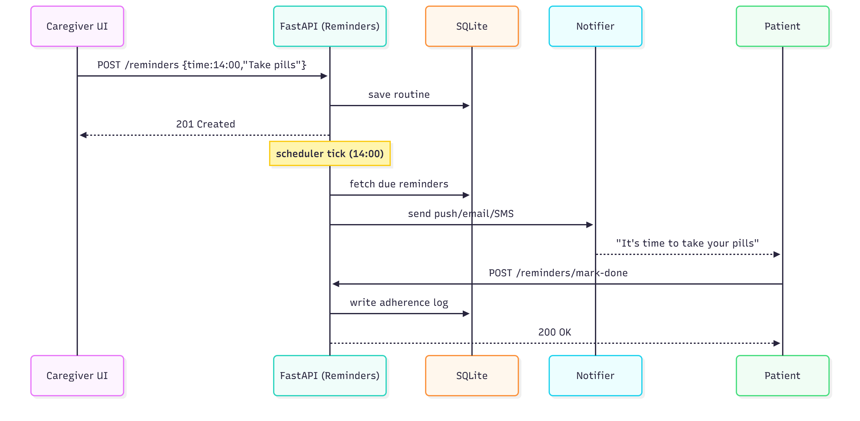

Diagram: DailyReminderFlow

The Reminder Service schedules and adapts patient routines, sending notifications and escalating missed reminders to caregivers.

## 4.3 Caregiver Dashboard Flow

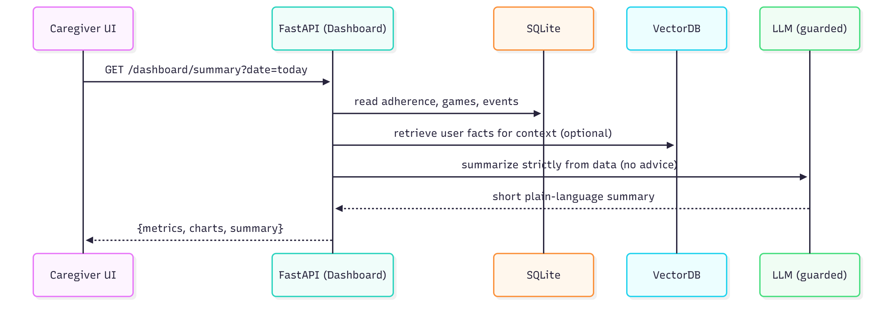

Diagram: CaregiverDashboardDailySummary

Caregivers view daily adherence, risk trends, and receive educational insights from the dashboard.

# 5. AI/ML & Data Layer

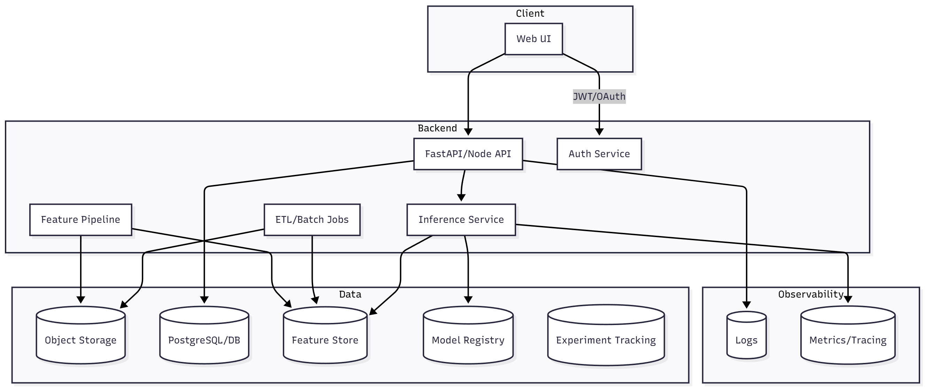

Diagram: ML-focused Container Diagram  
The AI stack integrates LangChain with FAISS for semantic memory retrieval and context management. Machine learning models extract cognitive features like response speed and accuracy. Core data entities include patients, reminders, embeddings, and audit logs stored across SQL and vector databases.

# 6. Deployment & Infrastructure

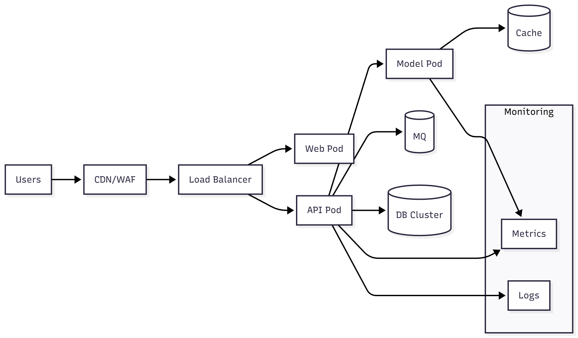

Diagram: Deployment.png  
The application runs in Microsoft Azure, using containerized microservices orchestrated through Docker and Azure App Service. Key integrations include Azure Key Vault for secure credentials, and continuous deployment through Azure Pipelines.

# 7. Security & Compliance Summary

Security measures include TLS 1.3 encryption, OAuth2 with JWT-based authentication, and strict RBAC controls. Data minimization and anonymization are enforced at every layer. The AI components follow guardrail protocols to prevent unverified or unsafe content generation.

# 8. Appendix

References:  
• Alzheimer’s Association (2024). Dementia Facts & Figures.  
• Brookmeyer et al. (2018). Forecasting global burden of Alzheimer’s.  
• Etters et al. (2008). Caregiver stress in Alzheimer’s disease.  
• Nature (2024). Empowering caregivers with AI.  
  
Additional Diagram: Untitled diagram-2025-10-15

