1️⃣ Save the information

In Swagger, click the POST /profile/ endpoint → Execute.

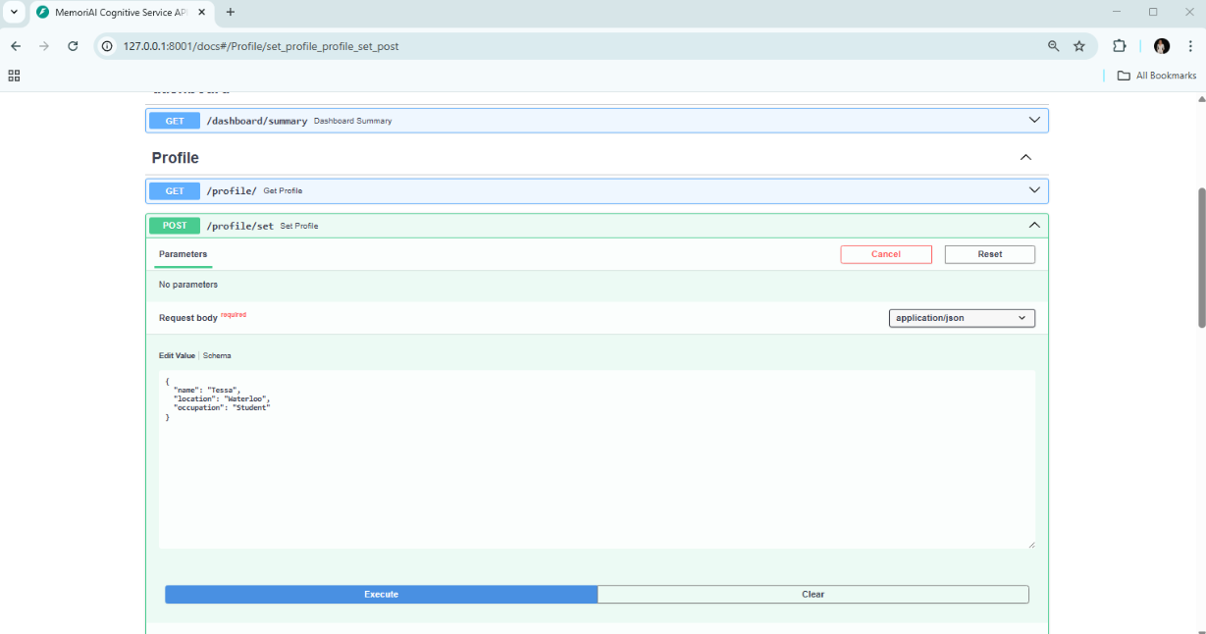

Step 1️⃣ – Verify the saved information.

Open Swagger, select the GET /profile/ endpoint, and click *Execute*.

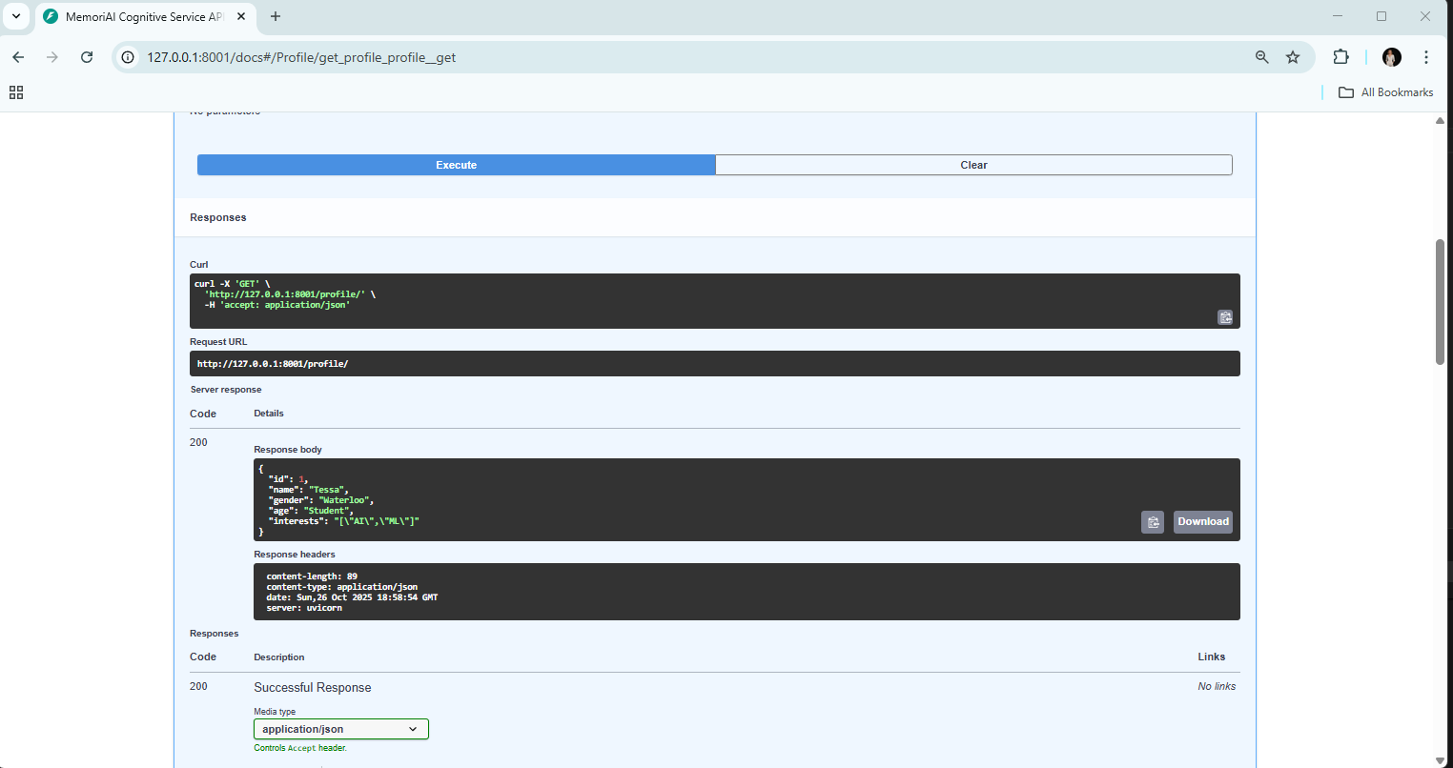

2️⃣ Test if the chatbot remembers this information

Start the chat application in the terminal:

python chat_in_terminal.py

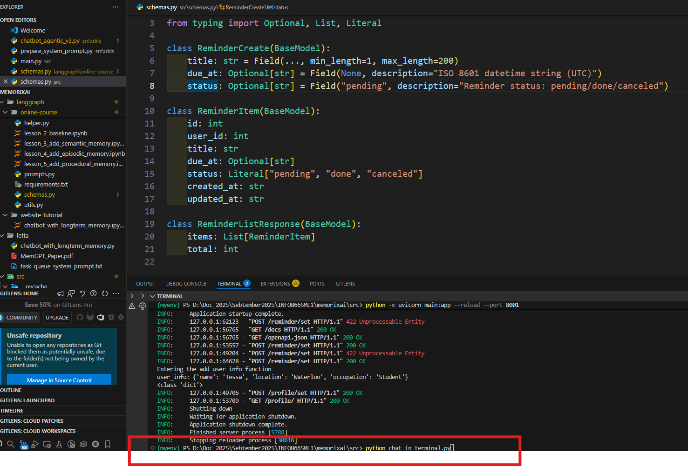

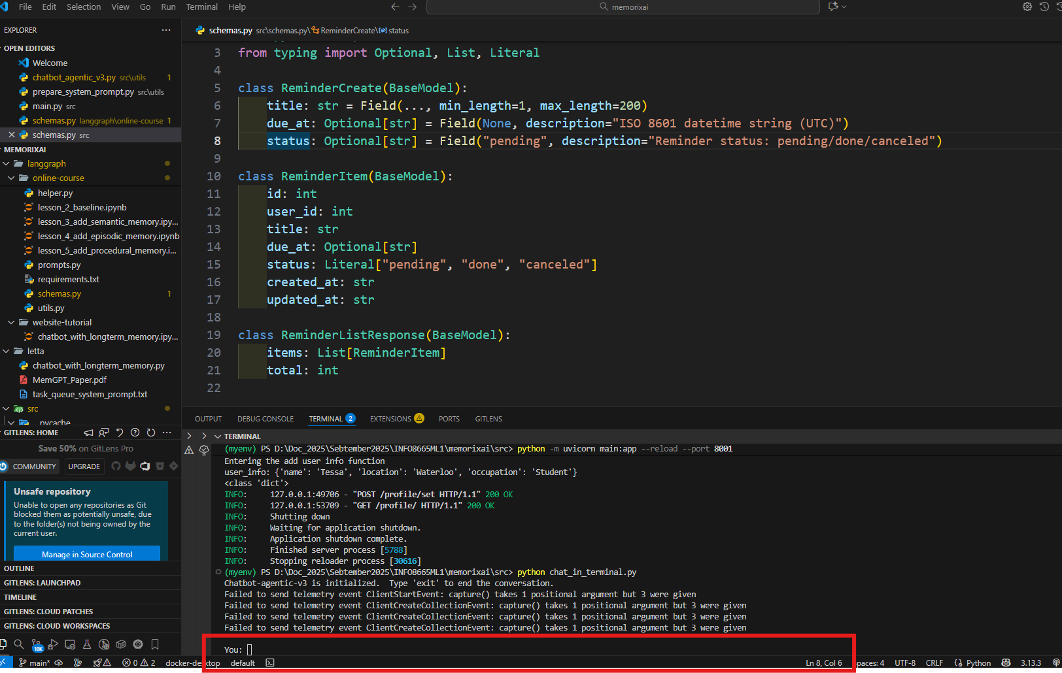

Then type the following messages in order:

Where do I live?

→ Expected answer: “You live in Waterloo.”

What is my occupation?

→ Expected answer: “You work as a Student.”

What is my name?

→ Expected answer: “Your name is Tessa.”

