MQTT command set

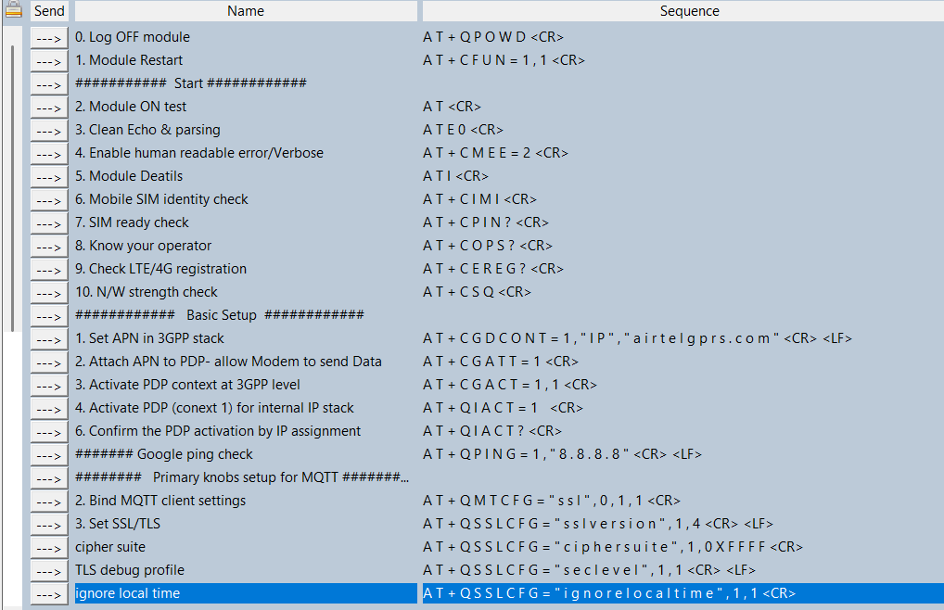
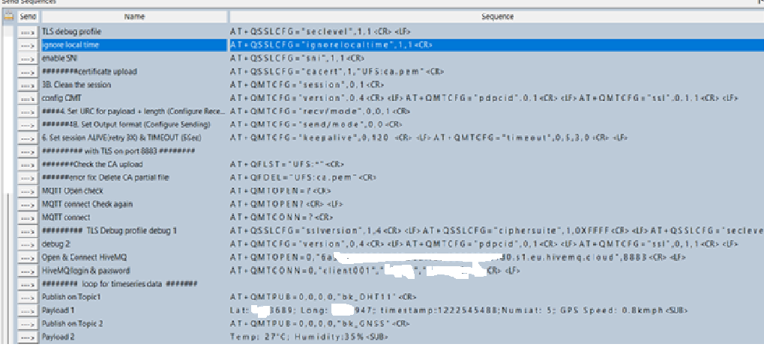

23-11-2025 17:53:12.718 [TX] - AT<CR>

23-11-2025 17:53:12.731 [RX] - <CR><LF>
OK<CR><LF>

23-11-2025 17:53:14.968 [TX] - ATE0<CR>

23-11-2025 17:53:14.985 [RX] - <CR><LF>
OK<CR><LF>

23-11-2025 17:53:16.760 [TX] - AT+CMEE=2<CR>

23-11-2025 17:53:16.776 [RX] - <CR><LF>
OK<CR><LF>

23-11-2025 17:53:18.139 [TX] - ATI<CR>

23-11-2025 17:53:18.152 [RX] - <CR><LF>
Quectel<CR><LF>
EC200U<CR><LF>
Revision: EC200UCNAAR0M08<CR><LF>
<CR><LF>
OK<CR><LF>

23-11-2025 17:53:19.791 [TX] - AT+CIMI<CR>

23-11-2025 17:53:19.814 [RX] - <CR><LF>
40446687<CR><LF>
<CR><LF>
OK<CR><LF>

23-11-2025 17:53:21.669 [TX] - AT+CPIN?<CR>

23-11-2025 17:53:21.681 [RX] - <CR><LF>
+CPIN: READY<CR><LF>
<CR><LF>
OK<CR><LF>

23-11-2025 17:53:23.077 [TX] - AT+COPS?<CR>

23-11-2025 17:53:23.090 [RX] - <CR><LF>
+COPS: 1,0,"airtel",7<CR><LF>
<CR><LF>
OK<CR><LF>

23-11-2025 17:53:24.943 [TX] - AT+CEREG?<CR>

23-11-2025 17:53:24.955 [RX] - <CR><LF>
+CEREG: 0,1<CR><LF>
<CR><LF>
OK<CR><LF>

23-11-2025 17:53:27.307 [TX] - AT+CSQ<CR>

23-11-2025 17:53:27.320 [RX] - <CR><LF>
+CSQ: 23,99<CR><LF>
<CR><LF>
OK<CR><LF>

23-11-2025 17:53:30.574 [TX] - AT+CGDCONT=1,"IP","airtelgprs.com"<CR><LF>

23-11-2025 17:53:30.590 [RX] - <CR><LF>
OK<CR><LF>

23-11-2025 17:53:32.688 [TX] - AT+CGATT=1<CR>

23-11-2025 17:53:32.701 [RX] - <CR><LF>
OK<CR><LF>

23-11-2025 17:53:34.812 [TX] - AT+CGACT=1,1<CR>

23-11-2025 17:53:34.830 [RX] - <CR><LF>
OK<CR><LF>

23-11-2025 17:53:37.025 [TX] - AT+QIACT=1 <CR>

23-11-2025 17:53:37.039 [RX] - <CR><LF>
OK<CR><LF>

23-11-2025 17:53:39.578 [TX] - AT+QIACT?<CR>

23-11-2025 17:53:39.594 [RX] - <CR><LF>
+QIACT: 1,1,1,"100.122.150.65"<CR><LF>
<CR><LF>
OK<CR><LF>

23-11-2025 17:53:48.032 [TX] - AT+QMTCFG="ssl",0,1,1<CR>

23-11-2025 17:53:48.044 [RX] - <CR><LF>
OK<CR><LF>

23-11-2025 17:53:51.407 [TX] - AT+QSSLCFG="sslversion",1,4<CR><LF>

23-11-2025 17:53:51.413 [RX] - <CR><LF>
OK<CR><LF>

23-11-2025 17:53:52.794 [TX] - AT+QSSLCFG="ciphersuite",1,0XFFFF<CR>

23-11-2025 17:53:52.806 [RX] - <CR><LF>
OK<CR><LF>

23-11-2025 17:53:55.121 [TX] - AT+QSSLCFG="seclevel",1,1<CR><LF>

23-11-2025 17:53:55.138 [RX] - <CR><LF>
OK<CR><LF>

23-11-2025 17:55:12.921 [TX] - AT+QSSLCFG="ignorelocaltime",1,1<CR>

23-11-2025 17:55:12.933 [RX] - <CR><LF>
OK<CR><LF>

23-11-2025 17:55:14.472 [TX] - AT+QSSLCFG="sni",1,1<CR>

23-11-2025 17:55:14.484 [RX] - <CR><LF>
OK<CR><LF>

23-11-2025 17:55:18.171 [TX] - AT+QMTCFG="session",0,1<CR>

23-11-2025 17:55:18.183 [RX] - <CR><LF>
OK<CR><LF>

23-11-2025 17:55:22.003 [TX] - AT+QMTCFG="version",0,4<CR><LF>
AT+QMTCFG="pdpcid",0,1<CR><LF>
AT+QMTCFG="ssl",0,1,1<CR><LF>

23-11-2025 17:55:22.013 [RX] - <CR><LF>
OK<CR><LF>
<CR><LF>
OK<CR><LF>
<CR><LF>
OK<CR><LF>

23-11-2025 17:55:27.969 [TX] - AT+QMTCFG="keepalive",0,120 <CR><LF>
AT+QMTCFG="timeout",0,5,3,0<CR><LF>

23-11-2025 17:55:27.977 [RX] - <CR><LF>
OK<CR><LF>
<CR><LF>
OK<CR><LF>

23-11-2025 17:55:32.400 [TX] - AT+QMTOPEN=?<CR>

23-11-2025 17:55:32.411 [RX] - <CR><LF>
+QMTOPEN: (0-5),"hostname",(1-65535)<CR><LF>
<CR><LF>
OK<CR><LF>

23-11-2025 17:55:35.524 [TX] - AT+QMTOPEN?<CR><LF>

23-11-2025 17:55:35.528 [RX] - <CR><LF>
OK<CR><LF>

23-11-2025 17:55:40.344 [TX] - AT+QMTCONN=?<CR>

23-11-2025 17:55:40.356 [RX] - <CR><LF>
+QMTCONN: (0-5),"clientid","username","password"<CR><LF>
<CR><LF>
OK<CR><LF>

23-11-2025 17:55:47.501 [TX] - AT+QMTCFG="version",0,4<CR><LF>
AT+QMTCFG="pdpcid",0,1<CR><LF>
AT+QMTCFG="ssl",0,1,1<CR><LF>

23-11-2025 17:55:47.510 [RX] - <CR><LF>
OK<CR><LF>
<CR><LF>
OK<CR><LF>
<CR><LF>
OK<CR><LF>

23-11-2025 17:55:50.399 [TX] - AT+QMTOPEN=0,"6a996248smvdnskjvskdjvbskdjdvbsk8824d0.s1.eu.hivemq.cloud",8883<CR><LF>

23-11-2025 17:55:50.406 [RX] - <CR><LF>
OK<CR><LF>
<CR><LF>
+QMTOPEN: 0,5<CR><LF>

23-11-2025 17:56:01.962 [TX] - AT+QMTOPEN=0,"6a9sjhjvbvsdjh3kjbkskbvskbskjbcsj24d0.s1.eu.hivemq.cloud",8883<CR><LF>

23-11-2025 17:56:01.979 [RX] - <CR><LF>
OK<CR><LF>
<CR><LF>
+QMTOPEN: 0,5<CR><LF>

23-11-2025 17:56:07.920 [TX] - AT+QMTCONN=0,"client001","login","password"<CR><LF>

23-11-2025 17:56:07.928 [RX] - <CR><LF>
ERROR<CR><LF>

23-11-2025 17:56:10.482 [TX] - AT+QMTOPEN=0,"6a9sjvbskdvsdvksdlsddnlksd824d0.s1.eu.hivemq.cloud",8883<CR><LF>

23-11-2025 17:56:10.485 [RX] - <CR><LF>
OK<CR><LF>
<CR><LF>
+QMTOPEN: 0,5<CR><LF>

23-11-2025 17:56:13.199 [TX] - AT+QMTCFG="version",0,4<CR><LF>
AT+QMTCFG="pdpcid",0,1<CR><LF>
AT+QMTCFG="ssl",0,1,1<CR><LF>

23-11-2025 17:56:13.201 [RX] - <CR><LF>
OK<CR><LF>
<CR><LF>
OK<CR><LF>
<CR><LF>
OK<CR><LF>

23-11-2025 17:56:19.270 [TX] - AT+QSSLCFG="sslversion",1,4<CR><LF>
AT+QSSLCFG="ciphersuite",1,0XFFFF<CR><LF>
AT+QSSLCFG="seclevel",1,0<CR><LF>
AT+QSSLCFG="ignorelocaltime",1,1<CR><LF>
AT+QSSLCFG="sni",1,1<CR><LF>

23-11-2025 17:56:19.285 [RX] - <CR><LF>
OK<CR><LF>
<CR><LF>
OK<CR><LF>
<CR><LF>
OK<CR><LF>
<CR><LF>
OK<CR><LF>
<CR><LF>
OK<CR><LF>

23-11-2025 17:56:22.926 [TX] - AT+QFDEL="UFS:ca.pem"<CR>

23-11-2025 17:56:22.941 [RX] - <CR><LF>
OK<CR><LF>

23-11-2025 17:56:25.556 [TX] - AT+QFLST="UFS:*"<CR>

23-11-2025 17:56:25.568 [RX] - <CR><LF>
+QFLST: "UFS:boot",15004<CR><LF>
+QFLST: "UFS:firm",286000<CR><LF>
+QFLST: "UFS:gnss_data",4644<CR><LF>
+QFLST: "UFS:gnss_loca",47<CR><LF>
+QFLST: "UFS:gnss_time",21<CR><LF>
+QFLST: "UFS:cacert.pem",1024<CR><LF>
<CR><LF>
OK<CR><LF>

23-11-2025 17:56:27.713 [TX] - AT+QFDEL="UFS:ca.pem"<CR>

23-11-2025 17:56:27.730 [RX] - <CR><LF>
+CME ERROR: 418<CR><LF>

23-11-2025 17:56:29.903 [TX] - AT+QFLST="UFS:*"<CR>

23-11-2025 17:56:29.916 [RX] - <CR><LF>
+QFLST: "UFS:boot",15004<CR><LF>
+QFLST: "UFS:firm",286000<CR><LF>
+QFLST: "UFS:gnss_data",4644<CR><LF>
+QFLST: "UFS:gnss_loca",47<CR><LF>
+QFLST: "UFS:gnss_time",21<CR><LF>
+QFLST: "UFS:cacert.pem",1024<CR><LF>
<CR><LF>
OK<CR><LF>

23-11-2025 17:56:32.525 [TX] - AT+QMTOPEN=?<CR>

23-11-2025 17:56:32.542 [RX] - <CR><LF>
+QMTOPEN: (0-5),"hostname",(1-65535)<CR><LF>
<CR><LF>
OK<CR><LF>

23-11-2025 17:56:33.853 [TX] - AT+QMTOPEN?<CR><LF>

23-11-2025 17:56:33.869 [RX] - <CR><LF>
OK<CR><LF>

23-11-2025 17:56:35.331 [TX] - AT+QMTCONN=?<CR>

23-11-2025 17:56:35.342 [RX] - <CR><LF>
+QMTCONN: (0-5),"clientid","username","password"<CR><LF>
<CR><LF>
OK<CR><LF>

23-11-2025 17:56:36.701 [TX] - AT+QSSLCFG="sslversion",1,4<CR><LF>
AT+QSSLCFG="ciphersuite",1,0XFFFF<CR><LF>
AT+QSSLCFG="seclevel",1,0<CR><LF>
AT+QSSLCFG="ignorelocaltime",1,1<CR><LF>
AT+QSSLCFG="sni",1,1<CR><LF>

23-11-2025 17:56:36.716 [RX] - <CR><LF>
OK<CR><LF>
<CR><LF>
OK<CR><LF>
<CR><LF>
OK<CR><LF>
<CR><LF>
OK<CR><LF>
<CR><LF>
OK<CR><LF>

23-11-2025 17:56:38.598 [TX] - AT+QMTCFG="version",0,4<CR><LF>
AT+QMTCFG="pdpcid",0,1<CR><LF>
AT+QMTCFG="ssl",0,1,1<CR><LF>

23-11-2025 17:56:38.599 [RX] - <CR><LF>
OK<CR><LF>
<CR><LF>
OK<CR><LF>
<CR><LF>
OK<CR><LF>

23-11-2025 17:56:40.046 [TX] - AT+QMTOPEN=0,"6knmndcvbksdcbkasjscbkasjsddcsdjdvskldjdnkjbd0.s1.eu.hivemq.cloud",8883<CR><LF>

23-11-2025 17:56:40.054 [RX] - <CR><LF>
OK<CR><LF>

23-11-2025 17:56:41.659 [TX] - AT+QMTCONN=0,"client001","LOGIN","PASSWORD"<CR><LF>

23-11-2025 17:56:41.668 [RX] - <CR><LF>
OK<CR><LF>
<CR><LF>
+QMTOPEN: 0,0<CR><LF>
<CR><LF>
+QMTCONN: 0,0,0<CR><LF>

23-11-2025 17:56:49.583 [TX] - AT+QMTPUB=0,0,0,0,"bk_DHT11"<CR>

23-11-2025 17:56:49.595 [RX] - <CR><LF>
>
23-11-2025 17:56:53.326 [TX] - Lat: 26.3689; Long: 24.8947; timestamp:1222545488;Numsat: 5; GPS Speed: 0.8kmph<SUB>
23-11-2025 17:56:53.331 [RX] - <CR><LF>
OK<CR><LF>
<CR><LF>
+QMTPUB: 0,0,0<CR><LF>

23-11-2025 17:57:03.014 [TX] - AT+QMTPUB=0,0,0,0,"bk_GNSS"<CR>

23-11-2025 17:57:03.026 [RX] - <CR><LF>
>
23-11-2025 17:57:05.391 [TX] - Temp: 27'C; Humidity:35%<SUB>
23-11-2025 17:57:05.404 [RX] - <CR><LF>
OK<CR><LF>
<CR><LF>
+QMTPUB: 0,0,0<CR><LF>

23-11-2025 17:57:08.153 [TX] - AT+QMTPUB=0,0,0,0,"bk_GNSS"<CR>

23-11-2025 17:57:08.169 [RX] - <CR><LF>
>
23-11-2025 17:57:13.547 [TX] - Temp: 27'C; Humidity:35%<SUB>
23-11-2025 17:57:13.551 [RX] - <CR><LF>
OK<CR><LF>
<CR><LF>
+QMTPUB: 0,0,0<CR><LF>

23-11-2025 17:57:16.842 [TX] - AT+QMTPUB=0,0,0,0,"bk_DHT11"<CR>

23-11-2025 17:57:16.855 [RX] - <CR><LF>
>
23-11-2025 17:57:18.354 [TX] - Lat: 26.3689; Long: 24.8947; timestamp:1222545488;Numsat: 5; GPS Speed: 0.8kmph<SUB>
23-11-2025 17:57:18.363 [RX] - <CR><LF>
OK<CR><LF>
<CR><LF>
+QMTPUB: 0,0,0<CR><LF>

