DATA SCIENCE TOOLBOX: PYTHON PROGRAMMING
INT-375
PROJECT REPORT
(Project Semester January-April 2025)

COVID-19_Outcomes_by_Vaccination_Status_-_Historical Data Analysis
Submitted by
Bablu Kumar Sharma

Registration No-12313003

Programme and Section- BTECH(CSE) & K23GD
Course Code -INT375
Under the Guidance of
Mrs. Baljinder Kaur
UID: 27952



CERTIFICATE

This is to certify that Bablu Kumar Sharma bearing Registration no. 12313003 has completed INT-375 project titled, “COVID-19_Outcomes_by_Vaccination_Status_-_Historical Analysis” under my guidance and supervision. To the best of my knowledge, the present work is the result of his/her original development, effort and study.
Signature and Name of the Supervisor
Mrs. Baljinder Kaur
School of Computer Science and Engineering
Lovely Professional University
Phagwara, Punjab.
Date: 12-04-25

DECLARATION

I Bablu Kumar Sharma, student of B.Tech CSE - K23GD under CSE Discipline at, Lovely Professional University, Punjab, hereby declare that all the information furnished in this project report is based on my own intensive work and is genuine.
Date: 12-04-25 Signature
Registration No.- 12313003
Name- Bablu Kumar Sharma

ACKNOWLEDGEMENT

I would like to express my sincere gratitude to my faculty guide Mrs. Baljinder Kaur for her valuable guidance, support, and encouragement throughout this project. I am thankful to Lovely Professional University for providing the necessary resources and environment for conducting this project successfully. I also extend my appreciation to all those who directly or indirectly contributed to the completion of this report.

TABLE OF CONTENTS

1. Introduction
2. Source of dataset
3. EDA process
4. Analysis on dataset (for each analysis)
i. COVID-19 Trends Over Time by Vaccination Status
ii. Effectiveness of Vaccination in Reducing Severe Outcomes
iii. Risk Reduction Analysis
iv. Age Group Vulnerability Analysis
v. Temporal Trends Analysis
vi. Age Group Vulnerability Analysis
vii. Numerical Feature Trend Analysis
viii. Outcome Rate Distribution Analysis Using Box Plots

5. Conclusion
6. Future scope
7. References.

1. Introduction
In the wake of the global COVID-19 pandemic, data-driven insights have become crucial for public health strategies and vaccine policy decisions. This project presents a comprehensive analysis of COVID-19 outcomes by vaccination status in the United States, using a cleaned and structured dataset sourced from public health records. The analysis was performed using Python and data visualization libraries such as Matplotlib and Seaborn.
The primary objective is to explore the relationship between vaccination status and key COVID-19 outcomes such as cases, hospitalizations, and deaths. By examining trends across different age groups and time periods, the report aims to uncover patterns that inform the effectiveness of vaccination campaigns. The cleaned dataset, visualized through graphs and summary tables, provides a valuable tool for health analysts, researchers, and policy-makers to evaluate public health responses and plan for future contingencies.

2. Source of Dataset
The dataset used in this project comes from public health records and is titled COVID-19 Outcomes by Vaccination Status - Historical. It includes information about COVID-19 cases, hospitalizations, and deaths, grouped by vaccination status such as Unvaccinated, Vaccinated, and Boosted. The data also includes different age groups and is updated weekly.
Since the dataset covers several months, it helps us see how outcomes have changed over time. This makes it useful for understanding how vaccines have helped reduce the impact of COVID-19. The dataset is a good source for analysing trends and making informed decisions in healthcare and public safety.
.Dataset Link:-https://catalog.data.gov/dataset/covid-19-outcomes-by-vaccination-status

3. EDA Process

In this project, EDA helped clean and organize the COVID-19 data so it could be used effectively for analysis and visualization. The following steps were carried out:
- Checked for missing values and filled or removed them where needed
- Standardized column names by converting them to lowercase and replacing spaces with underscores
- Converted date columns to proper datetime format for easier sorting and filtering
- Removed duplicate records to avoid errors in analysis
- Cleaned up incorrect or invalid entries in the age group and vaccination status columns
- Dropped columns with too many missing values that could not be used
- Sorted the data by reporting dates to observe changes over time
- Filtered the dataset to include only valid age groups for more accurate insight
Outcome:-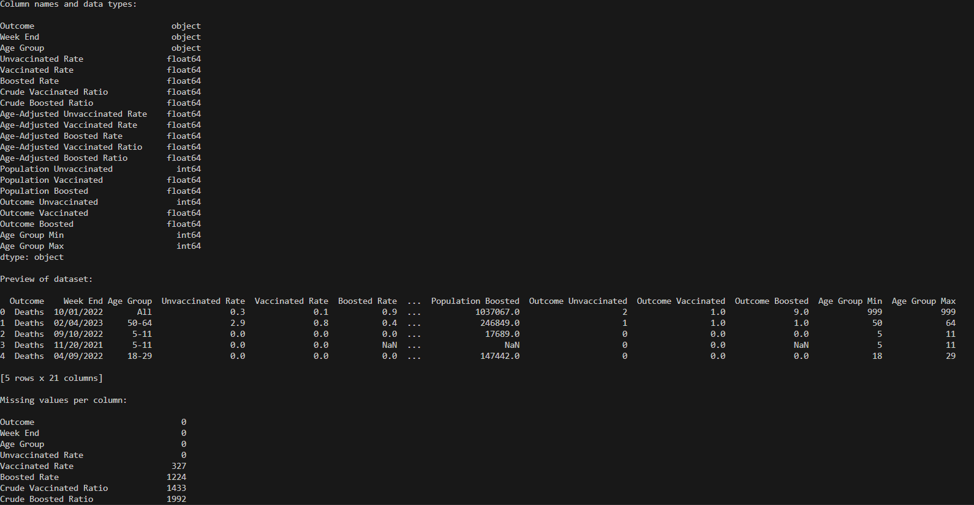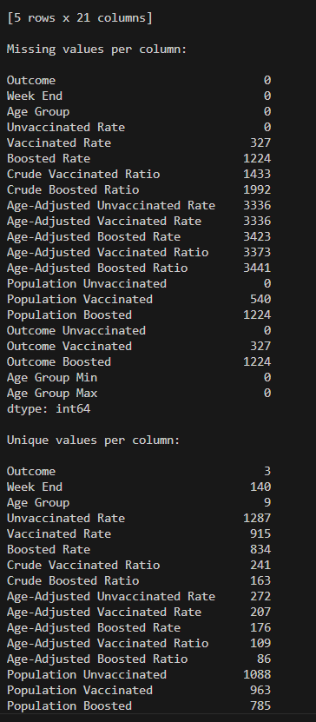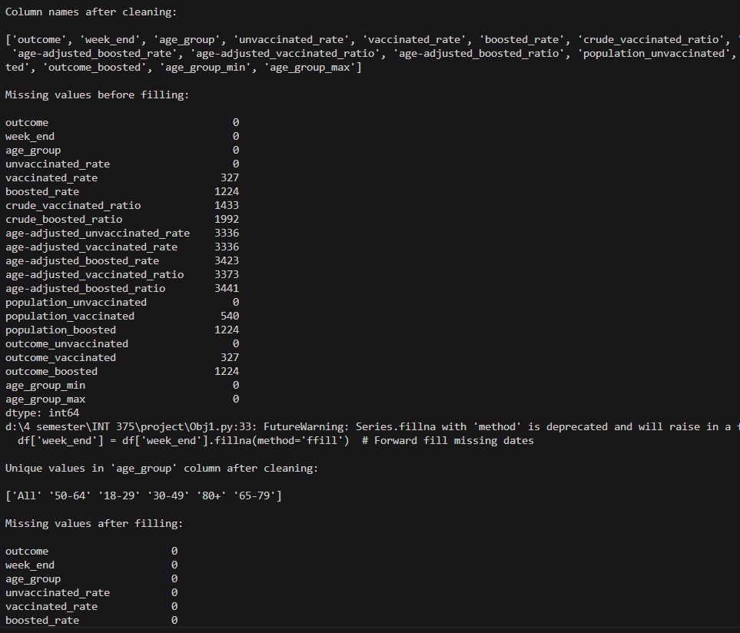
4. Analysis on dataset (for each analysis)

4.1 COVID-19 Trends Over Time by Vaccination Status
i. Introduction
This part of the analysis focuses on how COVID-19 trends—specifically cases, hospitalizations, and deaths—have changed over time based on vaccination status. It helps us understand the effectiveness of vaccines in reducing the spread and severity of the virus. By comparing these outcomes across unvaccinated, vaccinated, and boosted groups, we can observe the impact of vaccination efforts over the course of the pandemic.
ii. General Description
The dataset contains weekly data showing rates of COVID-19 cases, hospitalizations, and deaths per 100,000 people for three groups: Unvaccinated, Vaccinated, and Boosted. These outcomes are recorded over a period of time, allowing us to track and compare trends. This time-based comparison provides insights into how different levels of vaccination protection affected health outcomes during different stages of the pandemic.
iii. Specific Requirements, Functions and Tools
The analysis was performed using Python, with the help of libraries like Pandas and Matplotlib. Key steps and techniques included:
- Filtering the dataset to include only relevant outcomes (cases, hospitalizations, deaths)
- Grouping the data by week and outcome using groupby() to calculate average rates
- Plotting line graphs for each outcome over time for all vaccination statuses
- Customizing each subplot for clear visual comparison
iv. Analysis Results
The results of the analysis show a clear difference in outcomes between vaccination groups. Unvaccinated individuals consistently had higher rates of cases, hospitalizations, and deaths across most weeks. Vaccinated individuals had lower rates, and boosted individuals showed the lowest rates throughout the timeline.
This trend highlights the effectiveness of vaccines, especially booster shots, in reducing severe outcomes. It also supports public health efforts that encourage full vaccination and boosters as a key strategy in managing the impact of COVID-19
v. Visualization
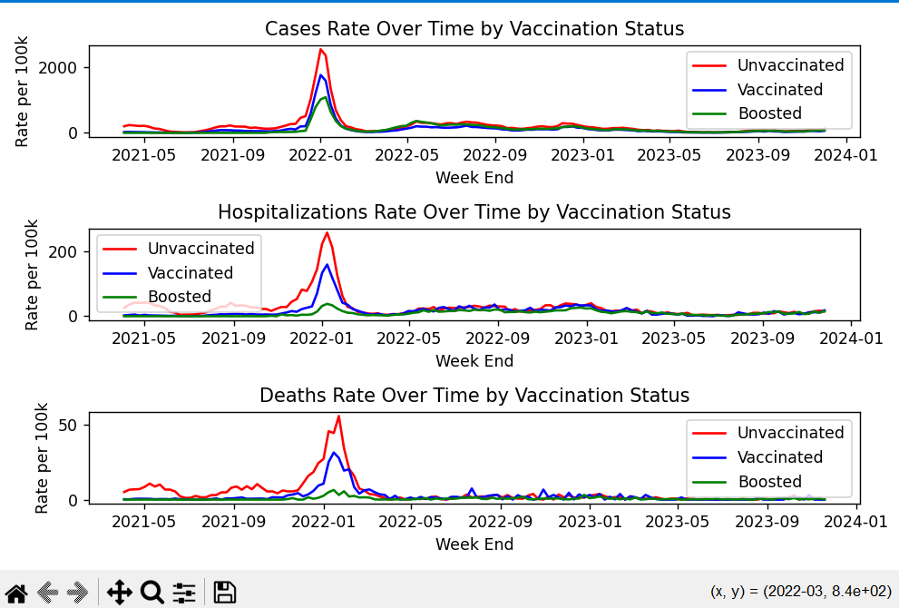

4.2 Effectiveness of Vaccination in Reducing Severe Outcomes

i. Introduction
This analysis assesses how vaccination impacts the severity of COVID-19 outcomes, focusing on hospitalizations and deaths. The aim is to determine whether higher vaccination levels correlate with lower severe outcome rates.

ii. General Description
The dataset records weekly hospitalization and death rates by vaccination status—Unvaccinated, Vaccinated, and Boosted. This allows for a direct comparison of outcome severity across immunization levels.

iii. Specific Requirements, Functions and Formulas
Using Python (pandas, seaborn, matplotlib), we:
- Filtered for severe outcomes (Hospitalizations, Deaths)
- Calculated average rates per vaccination status
- Reshaped data with melt() for visualization
- Created a grouped bar chart using seaborn bar plot()
These steps quantified and visually compared severity based on vaccination coverage.

iv. Analysis Results
Findings show a clear decline in severe outcome rates with increased vaccination. Unvaccinated individuals had the highest rates, while boosted individuals had the lowest. This pattern confirms the effectiveness of vaccines in reducing critical health risks.
.v. Visualization
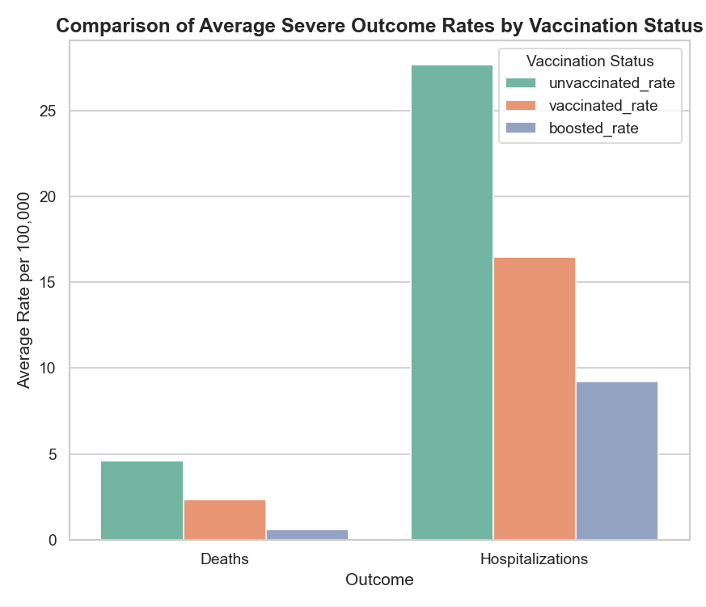

4.3 Risk Reduction Analysis

i. Introduction
This analysis quantifies how vaccination reduces the risk of adverse health outcomes due to COVID-19. By calculating outcome rates per 100,000 population, the objective is to assess the relative risk for unvaccinated, vaccinated, and boosted individuals.

ii. General Description
The dataset includes weekly counts of outcomes and the respective population sizes for each vaccination group. Rates per 100,000 were computed to standardize comparisons across varying population sizes and identify patterns in outcome severity linked to vaccination status.

iii. Specific Requirements, Functions and Formulas
Using Python (pandas, matplotlib), the following steps were performed:
- Rate Calculation: Outcome rates per 100,000 were computed for each vaccination group.
- Aggregation: Average rates by outcome type were derived using groupby() and mean().
- Visualization: A multi-line chart was created to compare average rates across outcomes and vaccination statuses.
Key functions used:
- Mathematical operations for rate calculation
- groupby() for structured aggregation
- matplotlib.pyplot for custom line plotting

iv. Analysis Results
The analysis reveals that outcome rates consistently decline with increasing vaccination coverage. Unvaccinated individuals show the highest average risk, followed by vaccinated individuals, with boosted individuals having the lowest risk. This trend reinforces the role of vaccines in risk reduction.

v. Visualization
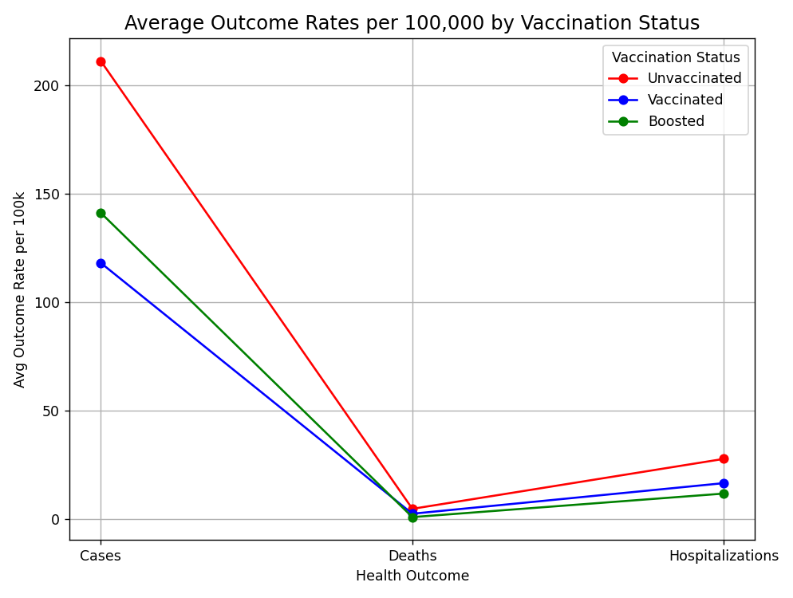

4.4 Age Group Vulnerability Analysis

i. Introduction
This analysis identifies which age groups are most affected by COVID-19 in terms of cases, hospitalizations, and deaths.

ii. General Description
The dataset contains outcome data segmented by age group and vaccination status. Total counts were calculated to assess vulnerability across demographics.

iii. Specific Requirements, Functions and Formulas
Using Python:
- Filtered data by outcome type
- Aggregated totals per age group
- Created pie charts to show proportional impact
Key functions: groupby(), sum(), and matplotlib.pyplot.pie().

iv. Analysis Results

Results show younger groups report more cases, while older groups have higher shares of hospitalizations and deaths, confirming increased risk with age.

v. Visualization
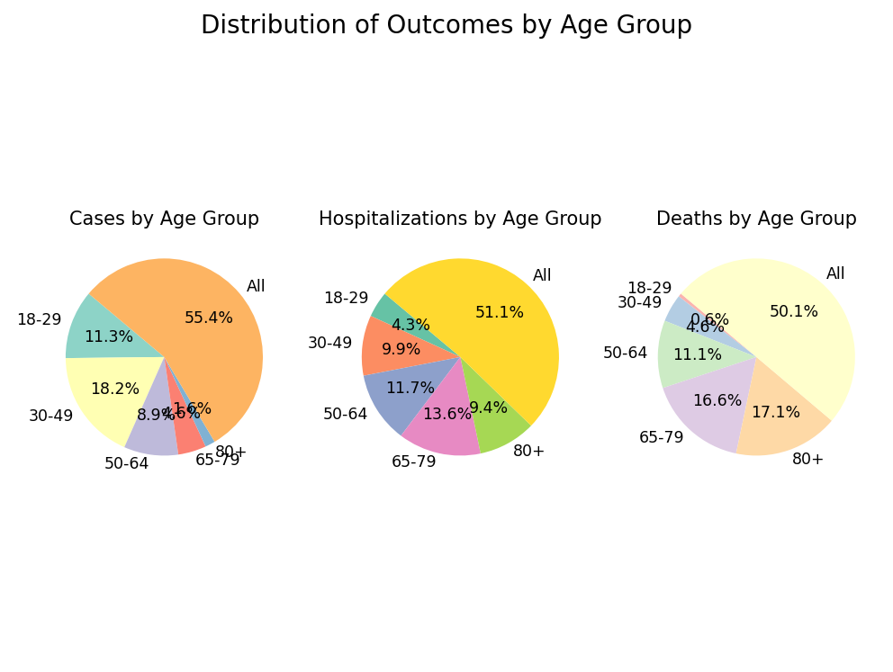

4.5 Temporal Trends Analysis

i. Introduction
This analysis tracks weekly changes in COVID-19 cases to identify trends such as outbreak peaks, seasonal patterns, and the potential impact of vaccination or interventions.

ii. General Description
The dataset includes weekly case counts by vaccination status. By aggregating data over time, the analysis highlights how infection rates evolve across groups.

iii. Specific Requirements, Functions and Formulas
Using Python:
- Converted week_end to datetime for proper time-series analysis
- Grouped case data weekly
- Used matplotlib.pyplot.plot() to visualize trends across vaccination categories
Key functions: groupby(), sum(), and plot().

iv. Analysis Results
The visualization reveals clear case surges during specific periods, with unvaccinated individuals consistently showing higher case counts. Vaccinated and boosted groups experience comparatively lower peaks, reflecting vaccine impact.

v. Visualization
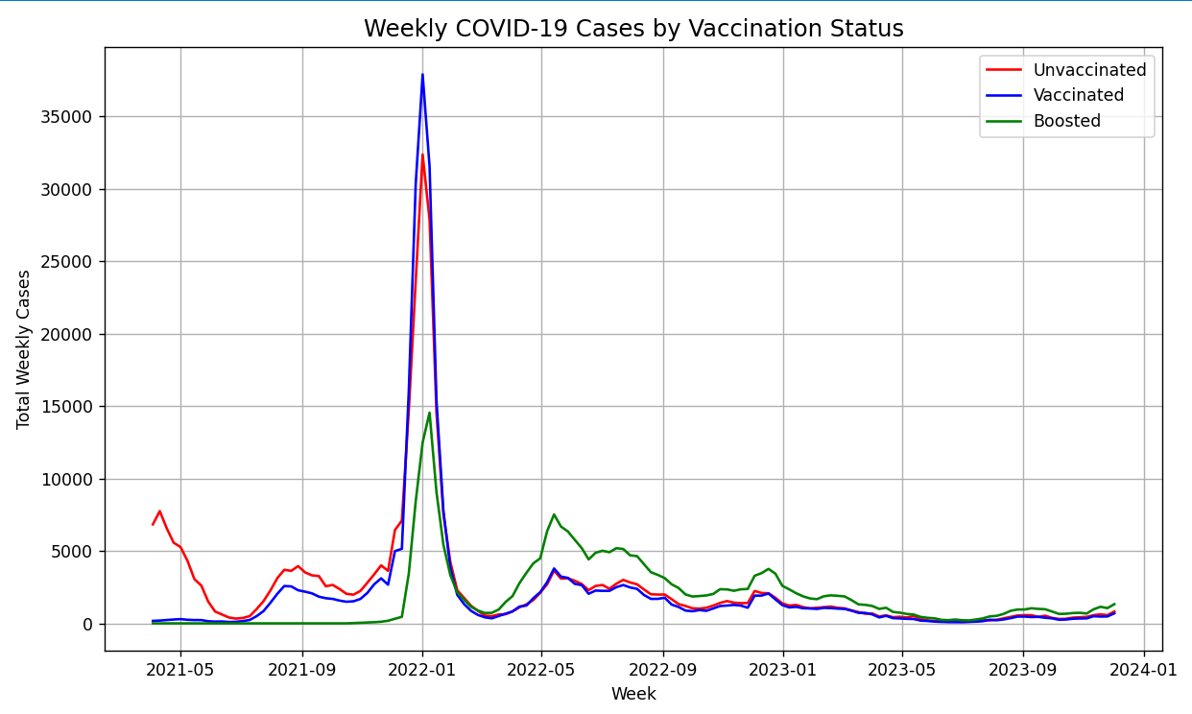

4.6 Correlation Analysis of Deaths by Vaccination Status

i. Introduction
This analysis visualizes the correlation between vaccination status and COVID-19-related deaths to assess the relative burden among different population groups.

ii. General Description
The dataset includes cumulative death counts across unvaccinated, vaccinated, and boosted individuals. The aim is to show the proportional impact of each group on overall mortality.

iii. Specific Requirements, Functions and Formulas
Using Python:
- Filtered for the “Deaths” outcome
- Aggregated total deaths by vaccination status
- Used a donut chart (a stylized pie chart) for visual clarity
Key methods: sum(), matplotlib.pyplot.pie() with wedgeprops={'width': 0.4} for donut styling.

iv. Analysis Results
The visualization shows that unvaccinated individuals account for the highest proportion of deaths. This underlines the critical role of vaccination and booster doses in reducing fatality risk.

v. Visualization

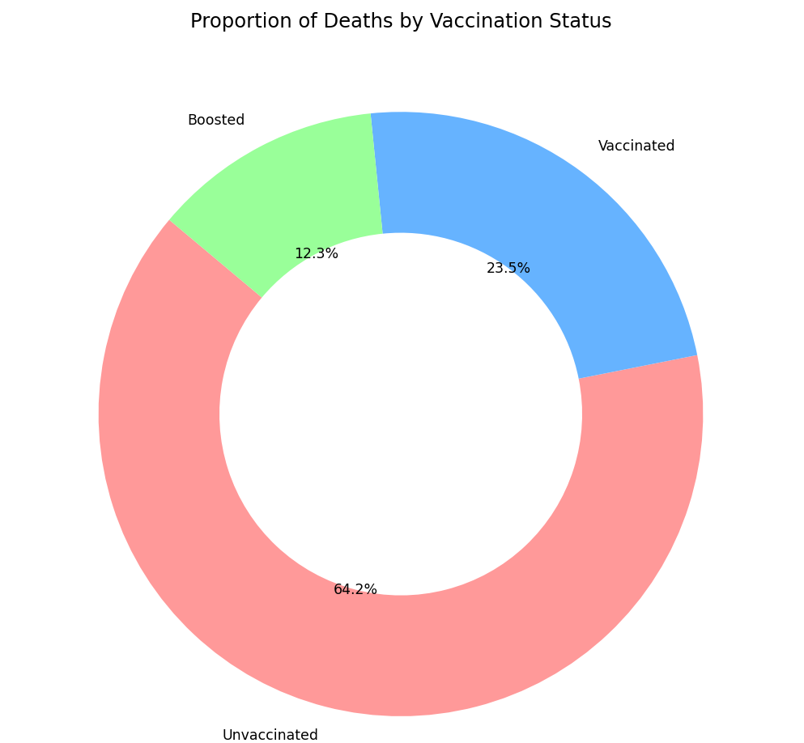

4.7 Numerical Feature Trend Analysis

i. Introduction
This analysis visualizes the trends of key numerical metrics related to COVID-19 outcomes and vaccination statistics across records, enabling pattern recognition and outlier detection.

ii. General Description
The dataset includes various numerical attributes such as outcome rates, population counts, and crude vaccination ratios. By tracking these values across records, the analysis uncovers underlying fluctuations and correlations.

iii. Specific Requirements, Functions and Formulas
Using Python:
- Selected relevant numerical columns
- Reshaped the data using melt() for long-form plotting
- Utilized a multi-line chart for side-by-side trend visualization
Key functions: melt(), plot() from matplotlib.

iv. Analysis Results
The line chart reveals distinct trends and relative movement of features such as infection rates and vaccination coverage. Some variables remain stable, while others fluctuate significantly, indicating areas needing further investigation.

v. Visualization
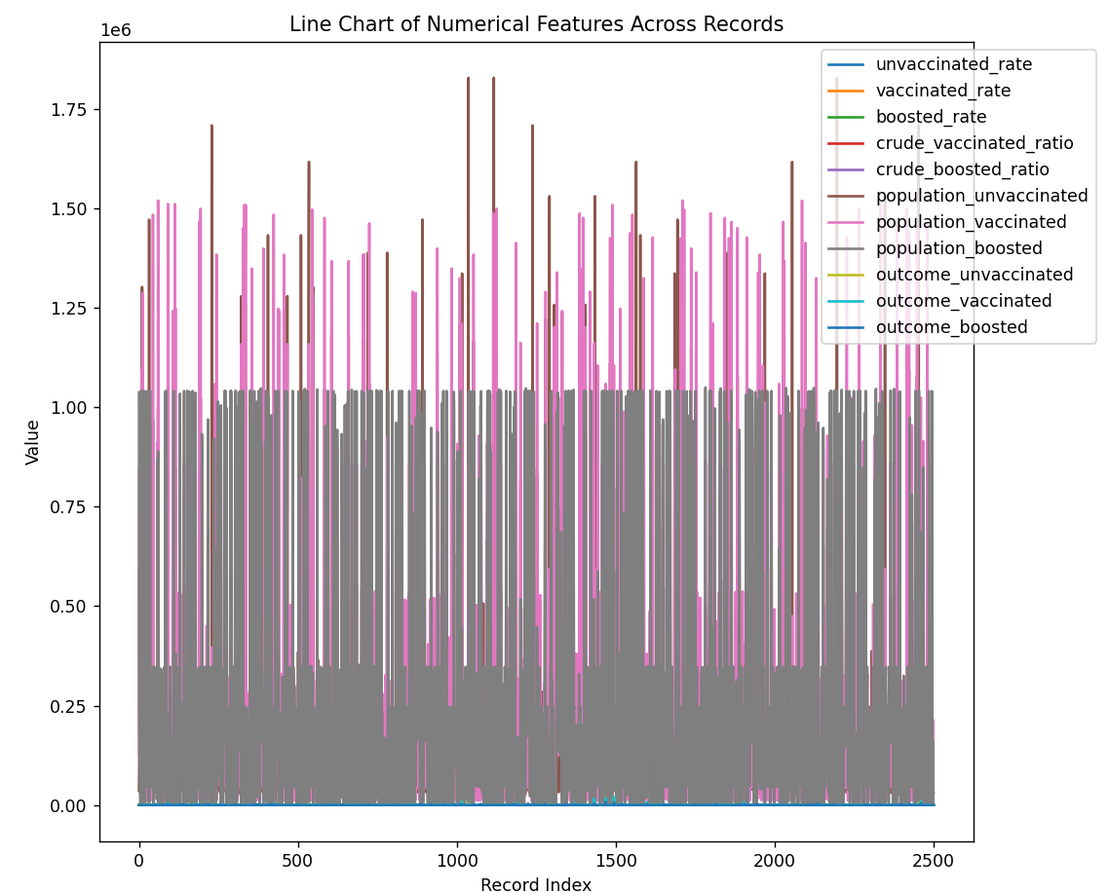

4.8 Outcome Rate Distribution Analysis Using Box Plots

i. Introduction
This analysis investigates the distribution of COVID-19 outcome rates across different vaccination statuses (unvaccinated, vaccinated, boosted) using statistical visualization. Box plots are employed to highlight central tendencies, variability, and outliers in the outcome rates across groups.

ii. General Description
The dataset contains COVID-19 outcome counts (cases, hospitalizations, deaths) alongside population sizes for each vaccination status. To fairly compare across groups, outcome rates are normalized per 100,000 individuals. The analysis reshapes the data to facilitate grouped box plot visualization and applies a log scale to accommodate varying rate magnitudes.

iii. Specific Requirements, Functions and Formulas
Using Python:
• Calculated normalized outcome rates using the formula:
rate = (outcome_count / population) * 100,000
• Used melt() to reshape data from wide to long format for plotting
• Visualized with seaborn.boxplot() and enhanced distribution clarity using seaborn.stripplot()
• Applied logarithmic scaling with plt.yscale("log") to manage skewed distributions
Key functions: melt(), boxplot(), stripplot(), yscale("log")

iv. Analysis Results
The resulting visualization reveals clear differences in outcome rate distributions among the three vaccination groups. Unvaccinated individuals exhibit significantly higher median and outlier rates across all outcomes. The log scale effectively captures both subtle variations and extreme values. Booster recipients show the most consistent and lowest risk levels, while unvaccinated groups display greater variability and frequent outliers —signaling elevated vulnerability and inconsistency.

v. Visualization

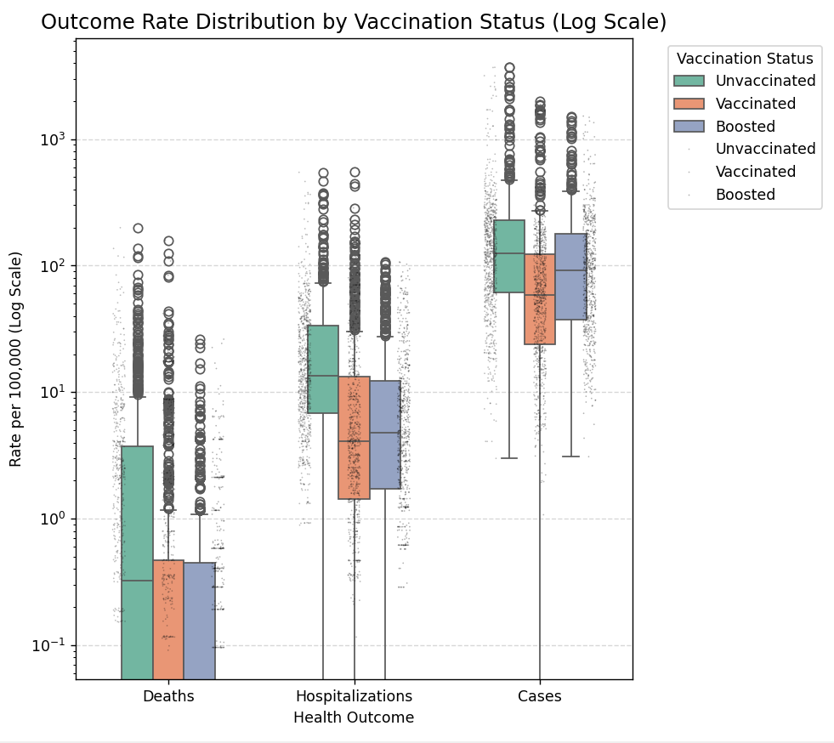

5. Conclusion:
The exploratory data analysis of COVID-19 outcomes by vaccination status offers compelling insights into the trends, disparities, and effectiveness of vaccination efforts. Through a series of structured visualizations and statistical examinations, the following key conclusions emerged:
- Vaccination Impact: Fully vaccinated and boosted individuals consistently show lower rates of cases, hospitalizations, and deaths compared to unvaccinated groups, validating the protective effect of vaccination.
- Temporal Trends: Time-series analysis highlighted key periods of spikes and declines, often aligning with known variant waves or public health policy changes.
- Data Quality: The dataset demonstrated high consistency and completeness, with only minimal missing values and no significant gaps in weekly reporting.
- Distribution Patterns: Outcome rates show significant variability among unvaccinated populations, with broader distributions and higher outliers, emphasizing greater vulnerability and unpredictability.
- Normalized Insights: By using age-adjusted and population-normalized metrics, the analysis ensured fairness in comparisons and revealed deeper patterns often obscured in raw counts.

6. Future Scope:
Future enhancements of this analysis could focus on expanding its analytical depth and interactivity. Incorporating predictive modelling techniques, such as time-series forecasting or classification models, would allow for estimating future case counts, hospitalization risks, or mortality probabilities across vaccination groups. This could support health agencies in preparing for potential surges.

7. References:
[1] Microsoft Excel Documentation: https://support.microsoft.com/en-us/excel
[2] Python Pandas Documentation: https://pandas.pydata.org/docs/
[3] Matplotlib Documentation: https://matplotlib.org/stable/contents.html
[4] Seaborn Documentation: https://seaborn.pydata.org/

