
NMAM INSTITUTE OF TECHNOLOGY, NITTE
Nitte, Karkala-574110

REPORT ON ODOO ERP SYSTEM
A Comparative Analysis of SDLC Models and Requirements Engineering
Course Name: Introduction to Software Engineering
Course Code: IS1103-1
Assignment Number & Title: 1. Software Process Models and Requirements Engineering
Submitted by Student Name: Bhuvan Kumar Shetty H
USN: NNM24IS057 Semester & Section: 4th Semester, Section A
Department: Information Science
Academic Year: 2025-2026
Under the Guidance of
Instructor Name: Dr. Jason Elroy Martis
Date of Submission: 15-02-2026
ABSTRACT
This report shall discuss the three most common Software development lifecycle methodologies: waterfall, spiral and incremental development process within the context of Odoo that is currently rated as one of the most popular open source ERP software. Instead of putting these methodologies in a purely theoretical perspective, the current report will look at these methodologies in real life ERP development projects, where the requirements are constantly changing, the budget is constrained, and the environment is constantly varying. In this report, the researcher will focus on how these three methodologies apply to one of the most crucial issues of managing changing requirements, risk management, budget and timeline management and scaling to meet constantly growing needs of the business.
By examining the adequacy degree of both models according to the examination of the modularity of Odoo, the information layer established on PostgreSQL and the business logic denied in Python, it is manly apparent that the disparity in the degree of adequacy of both models is significant. Waterfall is highly rigid but inflexible. Spiral is extremely good in risk management yet overly sophisticated. Incremental Development, in its turn, appears to appear to be a great fit with the modularity of Odoo and is going to allow working on the system-development in phases without affecting the stability of it.
It also provides a distinctive requirements engineering unlike the other reports which address both the functional and non-functional requirements, especially aimed at implementation of Odoo. It describes a validation methodology to address such common issues as alignment, traceability, and continuous improvement. Concisely, the report output provides a very important information to software development teams, working with ERP projects in which flexibility, scalability, and responsiveness were not necessary but demanded.

TABLE OF CONTENTS
1. Introduction
2. Problem Statement
3. Methodology
4. Requirements
5. Requirements Validation Strategy
6. Results and Analysis
7. Risk Management and Quality
8. Limitation and Future Work
9.Conclution
10.Reference
11.Declaration

1. INTRODUCTION
The choice of a Software Development Lifecycle (SDLC) process is not just a technicality; it falls among the most important factors that can or may break an enterprise-level undertaking [3], [4] without any noise. The requirement to deliver in a sophisticated ERP system like Odoo, where the accounting, inventory, human resources system, and the customer relationship modules are interconnected, is even more pressing. Any misstep on the way, and the project schedule is maximized, the budget is inflated, and the quality of the final product is compromised. The process of development must be aligned with use of technology, as well as alignment with organizational goals.

Odoo community brings a very interesting dimension to this discussion. This initiative which began as TinyERP in 2005 has become a highly popular, open-source ERP system consisting of dozens of core applications and thousands of community-written modules [5]. Its high power and flexibility are largely due to its modularity, three-tier MVC structure, PostgreSQL database and Python business logic [6], [21], which also render it very complex. This will require a process of development that is not only at the head but even one that comprehends evolution.
In the context of Odoo implementation, the three basic SDLC models that will be compared and contrasted in this report include Waterfall, Spiral and incremental Development. Waterfall is highly predictable and structured though it might appear hard to change. Spiral model is highly efficient in risk management and even it is not simple. Incremental Development and its stage-by-stage and flexible technique appears better suited to the modular nature of Odoo, and it would fit best when the changes are always anticipated in an ERP implementation.

Similarly, in an incomparable manner, the paper also provides a requirements engineering framework, but specifically designed to apply to Odoo. It does not only address the functional requirements, including multi-currency support and automated workflows but also those of non-functional priorities, including scalability, performance, and security. More to the point, it also talks about the manner in which the requirements can be checked that would have taken into consideration the actualities of the world pertaining to alignment, completeness, and traceability throughout the lifetime. Anyway, in the ERP system development, clarity is not an option it is all.

2. Problem Statement
2.1.1 The Task to be Solved
•Analyse Core Problem: Doing a reverse-engineering of the SDLC process that is essential in a large and modular ERP system such as Odoo whose thousands of mini modules must ultimately work together as a new system

•Test the Appropriate Model: In order to test what development process is capable of managing the complexity, scale, and changeability of the requirements of the Odoo system, critically assess the Waterfall, Spiral and Incremental models.

•Sort Requirements: Clearly Separate requirements, a sharp point into those that are critical to the business and those that are critical and non-functional.

2.2 Expected Outcomes
- Recommend SDLC: a recommendation of the SDLC model which is indeed applicable to Odoo, on the basis of real analysis .

- Reference document: The simplified but formal Software Requirements Specification document that is in a public repository and contains the single true source of project related information.

- Real Devops Environment: there is no fixed requirement in the simulating of an controlled change like a real ERP development environment.
2.3 Assumptions.
•Greenfield Assumption: It is simply, a clean sheet of paper to make a just comparison of the SDLC methodologies.

•Concentrated Application: limit our SRS to ensure we have a realistic scope of our analysis.

•Planning: We keep on with planning nothing to actually code in Python or PostgreSQL.

3.METHODOLOGY/ MODEL ARCHITECTURE
3.1 The Waterfall Model

One of the earliest structured approaches developed in the process of developing the software is the Waterfall Model, which was developed by Winston W. Royce, in 1970 [2]. Waterfall Model is highly linear and structured: requirements, design, implementation, testing and installation and lastly maintenance [2], [8]. The steps must be completed one by one and there is little possibility of a chance to go back. It is like a normal engineering project, like constructing a house, should have a good foundation before erection of walls. It is quite a predictable process which is very linear, but this predictability proves quite rigid as change knocks at the door.
Advantages

Clear Structure Predictability: This can be applied to cases where the requirements are rather stable and the structure is clear, and there are clear milestones with easier budgeting and planning [8], [22].

Documentation and Compliance Support: it offers an excellent documentation that is invaluable regarding auditing, compliance and long-term support needs [2], [3]

Eliminates Risk: A significant amount of planning and design is done prior to the actual code. [22]

Disadvantages

Less Flexibility: Coming back to the system after the completion of a phase is expensive and time-consuming[8], [22].

High Risk of Cost & Schedule Overruns: A change at the end may cause a massive amount of rework on various phases, and this will lead to increased costs.

Late User Feedback: The delivery of working software is done at the end of the process, and this leads to a lack of early user feedback[3].

Assumption About Requirements: the stakeholders have a complete understanding of their requirements from the start [2], [3] is not realistic

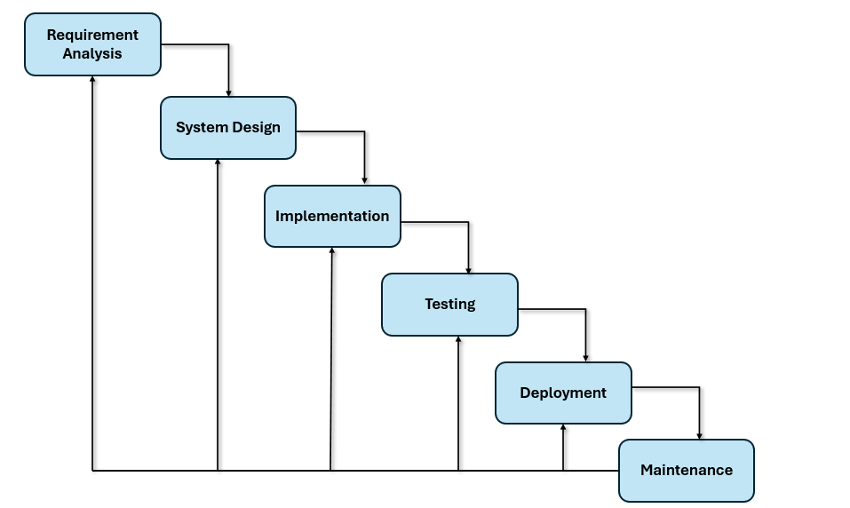

Fig1:The Waterfall Model diagram

3.2 The Spiral Model

Put forward by Barry Boehm in 1986 [1], the Spiral Model of development also focuses the idea of risk management as the integral phase of the development process[10], instead of having a linear flow such as in the Waterfall Model, it is characterized by a series of loops, developing a solution, testing it, and reviewing the solution, and then the cycle can repeat again, but with a noticeable increase of risk involved in the development thus necessitating costly surprises to be resolved rather quickly; using loops to develop a solution, test it, and review the solution renders the model the most useful when the

Advantages

Risk Management: Every cycle proactively seeks and tackles risks [1], [10]

Uncertainty effectively: Adaptable in a wide range of environments where requirements are poorly known, where the underlying technology has never been tested [24].

Provides Feedback and Flexibility: Delivers a prototype or a functioning segment of the product as part of every cycle and the stakeholders can thus see the progress as well as affect it [10].

Disadvantages

High Expertise Required: It requires high expertise in risk analysis, as not all teams have this expertise. [10], [24]

Adds Cost & Overhead: Continuous risk analysis in every cycle may add to the cost and time [24]

Difficult to Explain to Stakeholders: The spiral model may be difficult to explain to stakeholders who are used to a clear plan divided into phases. [10]

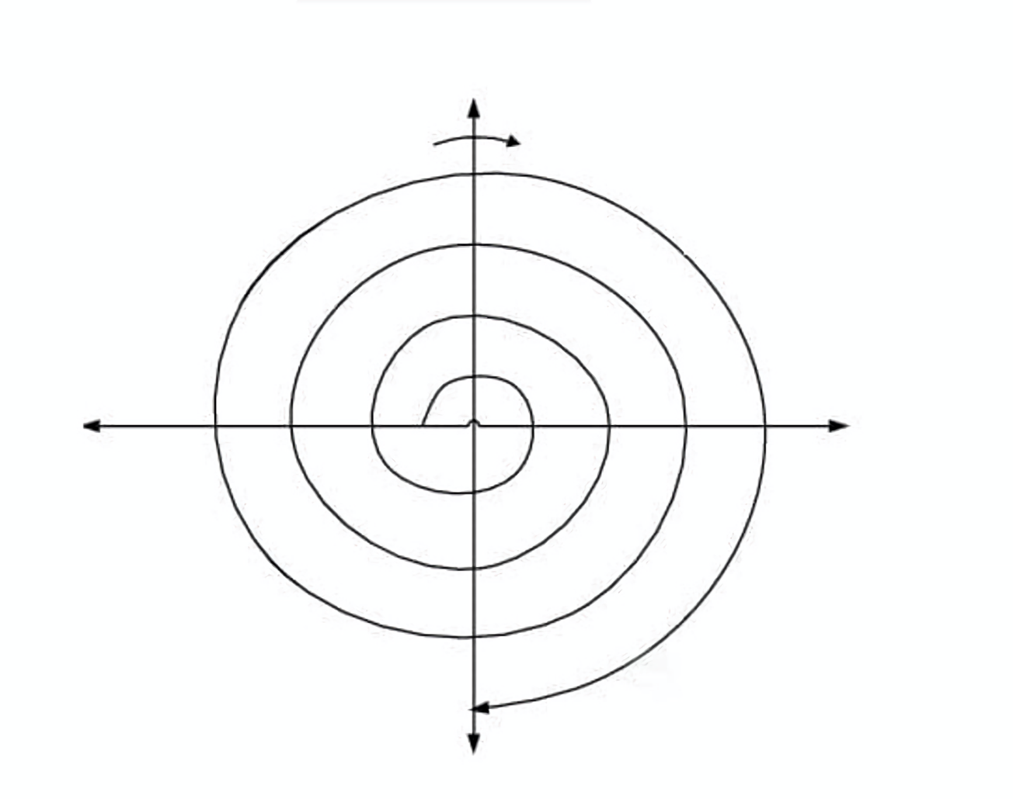
Risk Analysis:
- Identify Risks
- Risk Assessment
- Mitigation Strategy
- Prototyping

Planning:
- Define Objectives
- Identify Constraints
- Select Alternatives
- Resource Allocation

Fig2:The Spiral Model diagram
Engineering:
- Design
- Development
- Integration
- Verification
Evaluation:
- Customer Evaluation
- Testing
- Feedback Analysis
- Go/No-Go Decision

3.3 The Incremental Development Model

Model Description

Incremental Development Model provides an adequate compromise between structure and flexibility [12], [13]. Instead of creating the whole system at once, it is broken into smaller and manageable pieces with each of them being created in its mini-cycle of planning, design, implementation, and testing[12], [14]. The first release will be the one focused on the most vital functionality with other releases being more functionalities as the whole system is developed. This helps teams to provide value within a very short time and yet maintaining control. It can be done in one order where each phase is based on the preceding one or in parallel where various teams are working on another aspect of the system at the same time.
Advantages

Delivering Value at the Beginning: all participating stakeholders will be able to see and produce value while producing the remaining development ongoing. [13], [14]

Continuously Improve: Every delivery will produce a User Feedback, which will be used to improve all subsequent deliveries, thus preventing unnecessary development. [12]

Distributing Risk: The project will consist of many smaller & more frequent deliveries. [14], [13]

Testing & Managing Costs: By providing multiple smaller deliveries, there will be greater confidence in testing and approval of the budget [3], [12]

Disadvantages
- Good Architecture:One important reason is to minimize the amount of technical debt due to poor initial design [12], [14].

- The Risk of Scope:When you are developing software, users are going to want to add features along the way.

- Integration and Compatibility:The software you are creating must work well with all the previously released versions of that software. [13]

- Maintenance Costs:You will have multiple releases; therefore, there will be multiple deployments, train-ups, and support costs, as well as dealing with users expectations. [3], [14]

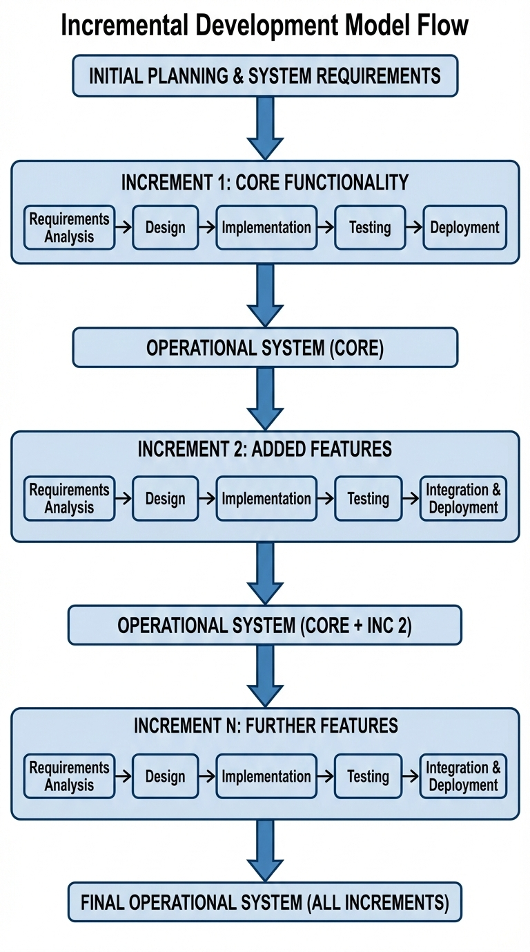
Fig3:The Incremental Model diagram

3.4. COMPARATIVE ANALYSIS

Suitability for Functional and Non-Functional Requirements
- Waterfall: Well Suited For Functional Requirements, Not For Conducting Testing.This works great for managing functional requirements but does not work well when the user does not understand what their requirements are until they actually use the system.
- Spiral: Best Model for Uncertain Requirements,When dealing with requirements that have a significant level of uncertainty the spiral model is the most appropriate and effective way to manage that volume of uncertainty.
- Incremental: Supports Odoo ERP Under The Module-Based Approach,The incremental model is the best approach to managing the complexities of an ERP system as it allows for dividing up an ERP system
Risk and Change Management
- Risk is Managed Actively in the Spiral Model: The Spiral Model puts much of their attention on how to manage risk while the project is under development.
- The Waterfall Method Does Not Adapt to Business Changes: Due to the rigidness of the Waterfall Model, it cannot accommodate business changes
- The Incremental Model Contains Changes at the Incremental Level: When there will be a change, only the increment that is currently being developed will be affected.
Time and Cost

Spiral : However Project Costs Cannot Be Estimated Accurately.We can estimate the cost of each iteration accurately, but the project timeline can only be estimated for an overall project;

Incremental: Provides Greater Flexibility in Budgeting for Projects.Each phase of the system can have its development defined and/or budgeted separately and will have some form of functionality before the whole system is completed

Faster Implementation Better Cash Flow: We are able to provide a complete operating system within a matter of months and therefore receive business value early on and also feel good about achieving milestones in a timely fashion.
Summary
- Odoo is a Great Fit for Incremental Implementations, The modular aspects of Odoo allow project teams to deploy and implement new functionality incrementally, thus limiting the impact of those changes on the overall system Early Value Pre-Deployment Investment,By launching the first release of critical modules, users will receive value from the system long before they make a single, large pre-deployment investment.
- Managing in Stable and Fluctuating Environments to Accommodate Changing Needs, Even in projects where there are changes in scope or other requirements.

- Type of Project Should Dictate Which Model is Used,

4. REQUIREMENTS ENGINEERING

4.1 Functional Requirements
- Financial management are defined following established software engineering practices [3], [4]: system that manages our chart of accounts and that should be capable of dealing with multiple currencies, deal with payables and receivables and generate financial reports
- warehouse management: We need real time tracking of our inventory, and it must be in a position to handle our inventory in various locations
- Supply chain visibility: The system must also be able to control our complete logistics and shipping and must also be able to trace every movement of our inventory in order to give us the full visibility of our inventory.

Customer Relationship Management: Contacts, sales pipelines, quotations, and after sales services are well managed and CRM and sales modules are well integrated to ensure that leads to customer conversion.

Marketing Support: The campaigns, prediction, approval processes, and performance analytics are activated to reinforce strategic and revenue-related decisions.

Manufacturing Operations.: It aligns the bills of materials, work orders, production scheduling, quality control, and material consumption to support by various production strategies including make to stock, make to order.

4.2 Non-Functional Requirements

Security: information in transit and at rest encryption,these non-functional requirements ensure system quality and operational effectiveness [3], [15].

high availability: the backups are automated and recovery time along with loss of data is well understood and in control.

Friendly Interface: Interfaces have a standard appearance is easily accessible

Scalability: The system architecture will be scaleable horizontally in order to support an increase.

Good Maintenance: Individual customizations are caused as per best practice, documentation is maintained and up-to-date

5. REQUIREMENTS VALIDATION STRATEGY
- We retrace our needs to make sure that it is responsive to the demands of our stakeholders, and provide the level of clarity necessary [15], [16].
- Implement systematic reviews. Our cross functional personnel will examine our needs in order to establish where we fail.

- Test cases will be specified as one of the measures of making our requirements clear and measurable.

- In case of conflict of priorities we will discuss them freely, not compromise but will use methods of prioritizing such as Must, Should, Could to make them agree on it.
- Be complete in processes. Business processes and business scenarios, integrations and non-functional qualities would have been verified and adequate.

- There are formal procedures to address changes, prioritization is undertaken as well as re-validation to ensure that our system remains in tune with the existing business reality.

6. RESULTS AND ANALYSIS

Comparative Evaluation Matrix

Waterfall: The compromise is a degree of rigidity, because you have to do a great deal of change management re-work on switching out components.

Spiral: Risk-based, but slower, needs a lot of risk management which is done on hands, but this is a fine trade off when a critical system such as a financial system or a security system is being rolled out where failure is not an option.

Incremental: realistic, risk-adverse, issues will be separated in their module, which will not affect the system as a whole.

Cost of Analysis

Sharp increase is usually experienced with the change costs in the waterfall process.

Incremental development assists in keeping changes at bay, the objectification of the modifications in the modular development lowers change costs.

Risk Manangment

The waterfall process is highly prone to steep rise in cost of change. Provided the requirements also have to vary, particularly towards the end of the process

Gradual growth assists in holding down developments. In case, say, an inventory module should be updated, it is done in bits

The modular development such as those deployed by Odoo makes the change expenses cheaper as compared to the traditional one that is linear and hard.

Modularity and Integration
- Naturally architecture grates along the way of gradual evolution. It is only necessary to look at the module flow in Odoo Sales, then Invoicing and finally Accounting
- In case of Waterfall, it is not that easy. Independent modules are essentially completed simultaneously and that is simply beckoning a pile of headaches.
- Incremental development assists in getting rid of integration headaches. Such an easy dependency network.

7. RISK MANAGEMENT AND QUALITY

7.1 Risk and Mitigation Strategy

Manage Module Dependencies Any modification executed on the core modules may impact on the other modules within the system [6], [21].

Avoid Performance Glitches Something that does not perform well may bring down the whole system [3]. Load tests are done to prevent such issues.

Mitigate Human & Scope Risks We also train the users to enable them to embrace the changes. We also keep a stringent scope to eliminate scope creep and risks.

7.2 Quality Assurance

Start with Unit Tests Early the engineer specific logic the computation of fields are written in Python to create tests that provide great test coverage [3], [4]

Integration of Stale Test Module In Detail Flow of data among applications in the staging environment is tested, and we verify that the integration of the modules is proper [3].

Feed System Worth and Regression Checks on a Continuous basis.

8. LIMITATIONS AND FUTURE SCOPE

8.1 Limitations of the Study

The process of planning may be highly rigorous when undergoing an idea of migration of legacy systems compared to the given process [20].

Brownfield Realities Have not been fully exploited not only are there process risks but also there are version risks. The structure and the framework may be varied.

8.2 Future Work
Construction and Testing of a True Devops Pipeline.Gain experience: Just implement CI/CD at Odoo. This may be related to a standard installation with Docker and Kubernetes [21].
Project critical business modules such as Accounting should be approached with a disciplined approach whereas the flexible modules such as eCommerce can be handled by Agile.
Application of AI in the generation of test cases and translating business requirements into code can serve to accelerate development phase and lower change cost [22].

9.CONCLUSION
Whereas in the scenario of Odoo ERP projects, best approach does not exist. All three, which are Waterfall, Spiral, and Incremental, possess their positives and negatives. But in the majority of projects, the tack to take has been noticed to be Incremental due to the module-based nature of Odoo. All the modules can be easily installed later and one in turn without impacting the whole system.

The requirements and validation have to be considered in any project and Odoo [3], [15]is no exception. All the functional and non-functional requirements should be defined. In addition, review, prototyping, and traceability are to be considered. The project should be able to adapt to change of the requirements without losing out on quality.

Odoo projects would require the best approach that depends on the situation. In certain situations, either spiral or waterfall approach can be the better. Incremental is however said to be the sweet point of most projects. The combination of all three can be of importance to see ahead, receive certain experience at the implementation level, and also improve the criteria to choose the most appropriate approach as Odoo and ERPs are developing.

10. REFERENCES
[1] B. W. Boehm, "A Spiral Model of Software Development and Enhancement,"
IEEE Computer, vol. 21, no. 5, pp. 61-72, May 1988.
[2] W. W. Royce, "Managing the Development of Large Software Systems,"
Proceedings of IEEE WESCON, vol. 26, no. 8, pp. 328-338, August 1970.
[3] I. Sommerville, Software Engineering, 10th ed. Boston, MA: Pearson, 2016.
[4] R. S. Pressman and B. R. Maxim, Software Engineering: A Practitioner's
Approach, 9th ed. New York: McGraw-Hill Education, 2020.
[5] "Odoo - Open Source ERP and CRM," Odoo S.A., 2025. [Online].
Available: https://www.odoo.com [Accessed: Feb. 14, 2026].
[6] "Architecture Overview - Odoo 18.0 Documentation," Odoo S.A., 2024. [Online].
Available: https://www.odoo.com/documentation/ [Accessed: Feb. 14, 2026].
[7] "Waterfall Model in Software Engineering," GeeksforGeeks, March 2018.
[Online]. Available: https://www.geeksforgeeks.org/software-engineering/waterfall-model/
[Accessed: Feb. 14, 2026].
[8] "Spiral Model: Phases, Advantages & Disadvantages," TeachingAgile.com,
April 2023. [Online]. [Accessed: Feb. 14, 2026].
[9] "Incremental Process Model - Software Engineering," GeeksforGeeks, May 2018.
[Online]. [Accessed: Feb. 14, 2026].
[10] "Incremental Model in Software Engineering," Scaler Topics, October 2025.
[Online]. [Accessed: Feb. 14, 2026].
[11] "What is Incremental Model - Advantages, Disadvantages," TryQA, 2024.
[Online]. [Accessed: Feb. 14, 2026].
[12] "Requirements Validation Techniques - Software Engineering," GeeksforGeeks,
July 2025. [Online]. [Accessed: Feb. 14, 2026].
[13] S. Maalem and N. Zarour, "Challenge of Validation in Requirements
Engineering," Journal of Innovation in Digital Ecosystems, vol. 3, no. 1,
pp. 15-21, 2016.
[14] "Understanding Requirements Validation in Business Analysis," AdaptiveUS,
May 2025. [Online]. [Accessed: Feb. 14, 2026].
[15] "Best Practices for Requirements Verification," ArgonDigital, August 2025.
[Online]. [Accessed: Feb. 14, 2026].

[16] "Odoo ERP Implementation: A Step-by-Step Guide," AHEX Technologies,
October 2025. [Online]. [Accessed: Feb. 14, 2026].
[17] "Technical Odoo Architecture and Deployment Structure," ERP Solutions
Oodles, September 2024. [Online]. [Accessed: Feb. 14, 2026].
[18] "The Pros and Cons of Waterfall Methodology," Lucidchart, August 2018.
[Online]. [Accessed: Feb. 14, 2026].
[19] "Navigating Complexity: Boehm's Spiral Model in Software Engineering,"
CodingMinutes Blog, April 2024. [Online]. [Accessed: Feb. 14, 2026].
[20] IEEE Std 830-1998, "IEEE Recommended Practice for Software Requirements
Specifications," Institute of Electrical and Electronics Engineers, 1998.
[21] "DevOps Best Practices for ERP Implementation," Atlassian, 2024. [Online].
Available: https://www.atlassian.com/devops [Accessed: Feb. 14, 2026].
[22] T. Menzies et al., "Artificial Intelligence for Software Engineering,"
IEEE Software, vol. 37, no. 5, pp. 26-35, 2020.
GITHUB REPOSITORY: https://github.com/bkshetty/SDLC-ON-ODOO-ERP-SYSTEM
11.DECLARATION
I hereby declare that this assignment is my original work and has not been copied or plagiarized from any source. All references and resources used have been properly cited. Any ambiguities will lead to forfeiting my marks.
Date: February 15, 2026
Signature: 

