SENTINEL-INFRA
AI-assisted OSINT platform for strategic infrastructure tracking and defence logistics planning
Project Report
Army Internship Selection Assignment
Item | Details
Submitted by | [Your Full Name]
Contact | [Email / Phone]
Repository | [Your GitHub link]
Version / Date | 1.1 | 31 October 2026
Classification | Unclassified - built from public information and illustrative sample data

Contents
1. Executive summary
2. Background and problem analysis
3. Objectives, scope and assumptions
4. System design
5. Methodology in detail
6. Results and analysis
7. Testing and validation
8. Risk register
9. Security, ethics and data handling
10. Limitations
11. Implementation roadmap
12. Conclusion
References
Appendix A - Sample feed items and extraction output
Appendix B - Repository contents and run instructions

Reading note
All figures, costs and dates in this report come from the 20 illustrative feed items bundled with the prototype. Project names are real and well known, but the numbers are written for demonstration and are not verified facts. Nothing in this document should be quoted as intelligence about an actual project.

1. Executive summary
Large infrastructure projects are quietly strategic. A six-lane expressway, a deep-water port or a freight railway decides how fast a brigade can move, how long a supply line can survive the loss of one bridge, and which coastal areas become busy with foreign-funded traffic. The facts needed to judge this are public, but they are scattered across PIB releases, NHAI and state government handles, newspapers and social media. Reading all of it by hand is slow, and the sources do not always agree.
SENTINEL-INFRA is a working prototype that automates the first half of that job. It takes raw text updates, extracts the key facts, checks how far each fact can be trusted, rates each project for dual-use value, flags delay risk, and runs a simple movement-time model on a network of strategic hubs. The result is a project register and a dashboard that a human analyst can review in minutes rather than days.

Headline results from the sample run
- 12 projects consolidated from 20 feed items; 1 anonymous social post kept out of the register as an unverified lead.
- Three projects (Vadhavan port, Vizhinjam port, Hyderabad-Vijayawada NH-65) flagged for human review because sources disagreed on cost.
- Three projects rated HIGH for dual-use value: Indore-Bhopal rail, the Western Dedicated Freight Corridor and the Mopa airport link.
- Hyderabad-Visakhapatnam found to be a single point of failure in the modelled road network until Hyderabad-Vijayawada six-laning is finished.
- Completing ongoing works cuts the modelled Bhopal to Visakhapatnam movement from 36.8 to 27.6 hours, a saving of 9.1 hours.
The most important caveat is honesty about data. I had no access to a live OSINT feed or restricted data, so the value of this submission lies in the method, the code and the reasoning, all of which will carry over unchanged once real collectors are attached.

2. Background and problem analysis
The assignment describes a country where infrastructure data is produced constantly across Maharashtra, Gujarat, Goa, Tamil Nadu, Andhra Pradesh, Telangana, Kerala and Madhya Pradesh, but remains siloed. These states hold major western and eastern ports, naval commands, large cantonments and the main north-south and east-west freight routes, so tracking them matters disproportionately for logistics planning.

2.1 Who would use this
User | Question they ask | What the platform gives them
Logistics planner | Which routes will be usable, and when? | Status, completion year, delay flags, route-time model
Security analyst | Which civilian assets have defence value, and where is there no backup? | Dual-use score with reasons; single-failure test
Intelligence cell | Has a budget or foreign-investment claim changed, and is it credible? | Confidence score, cost-conflict flag, unverified-lead list
Senior decision maker | What should I worry about this week? | One-page dashboard sorted by confidence and risk
Table 1. Intended users and the questions the system answers.

2.2 The three gaps and how each is addressed
Gap named in the assignment | Platform response
Logistics and mobilization risk: cannot judge real-time capacity, terrain changes or route availability | Hub network with convoy and rail speeds, shortest-time routing, capacity hints (lanes, asset type) in the dual-use score
Strategic vulnerability blind spots: dual-use assets and bottlenecks are hard to see | Dual-use score from 0 to 100; single-link failure test that exposes links with no alternative
Information asymmetry: late awareness of timelines, budget reallocations and foreign investment | Source-weighted confidence, cost-conflict detection, delay-risk flags, quarantine list for unverified leads
Table 2. Problem statement mapped to features.

3. Objectives, scope and assumptions

3.1 Objectives
- Turn unstructured public updates into a structured, comparable project record.
- Make source reliability visible and measurable instead of implicit.
- Highlight dual-use assets and logistics bottlenecks with reasons a human can challenge.
- Run end to end with no installation effort, so it can be reviewed on any machine.

3.2 In scope and out of scope
In scope | Out of scope
Roads, rail, ports and airports in the eight named states | Classified inputs, unit locations, troop strengths
Rule-based extraction from English text | Regional-language text, images, scanned PDFs
Confidence, dual-use and delay-risk scoring | Real-time traffic, weather and bridge load class
Hub-level movement model and failure test | Detailed route geometry and terrain modelling
Static dashboard, JSON and CSV outputs | Live web deployment and user management
Table 3. Scope boundaries.

3.3 Key assumptions
- Official sources (PIB, NHAI, state governments) are more reliable than news, and news more than anonymous social posts, though none is perfect.
- Average convoy speed is 40 km/h by road and 35 km/h by rail, including halts. These are planning figures, not doctrine.
- Two reports on the same project from different outlets are treated as independent. In reality outlets often copy each other, which makes confidence slightly optimistic.
- Distances between hubs are approximate road or rail kilometres.

4. System design
The system is a straight pipeline of six stages. Each stage is a separate Python module with a narrow job, so any stage can be replaced without touching the others. For example, the rule-based extractor can later be swapped for a named-entity model while keeping the same function signature.
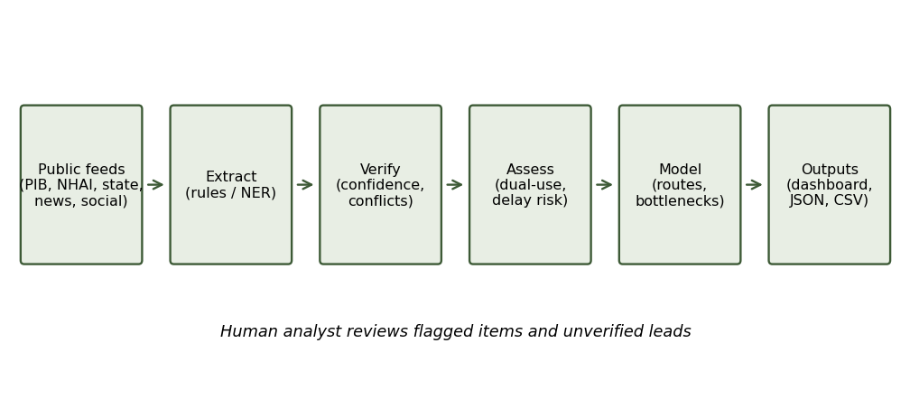
Figure 1. Pipeline architecture. Flagged items and unverified leads go to a human analyst.
Stage | Module | Input | Output
Collect | data/feeds.json | Raw items from sources | List of dicts: id, source, type, date, text
Extract | extract.py | One feed item | Project key, asset type, status, states, cost, length, lanes, year
Verify | verify.py | All extracted records | One consolidated project each, confidence, conflicts
Assess | dualuse.py, risk.py | Consolidated project | Dual-use score and tier, delay-risk level and flags
Model | bottleneck.py | Network of hubs and links | Route times, critical links, benefit of completion
Present | dashboard.py, pipeline.py | All results | analysis.json, projects.csv, dashboard.html
Table 4. Stages, modules and data flow.

4.1 Data dictionary
Field | Meaning | Example
source_type | Trust class: official, news or social | official
project_key | Canonical project name used to group reports | vadhavan
asset_type | highway, rail, port or airport | port
status | operational, under_construction or planned | planned
cost_crore | Cost in Rs crore, from the most credible source | 76,220
confidence | 0 to 1 score from source agreement and quality | 0.972
dual_use.score | 0 to 100 military usefulness rating | 63
needs_review | True if costs conflict or confidence is below 0.6 | True
Table 5. Main fields in the project record.

5. Methodology in detail

5.1 Information extraction
The extractor uses patterns and keyword lists, which keeps every decision traceable. Cost is read from phrases such as "Rs 76,220 crore", length from "701 km", lanes from "6-lane", and completion year from phrases like "expected 2029". States are matched against the eight-state list. A keyword table assigns project names, for instance any mention of "Samruddhi" or "Mumbai-Nagpur" maps to one canonical project.
Order matters in keyword matching. In early testing the word "airport" was caught by the rule for "port", so Mopa airport was classed as a port and scored too high. The airport rule now runs first, and a unit test guards the fix. This is the kind of error a pure statistical model could hide, and a reason I chose rules for the prototype.

5.2 Verification and confidence
Each source type gets a credibility weight w: official 0.90, news 0.65, social 0.20. For a project reported by several sources, confidence is:
Confidence = 1 - (1 - w1)(1 - w2)...(1 - wn)
Each additional source reduces the chance that everything is wrong, but a weak source adds very little. Worked example for Vadhavan port, reported by PIB (0.90), a local news item (0.65) and an anonymous social post (0.20): 1 - (0.10 x 0.35 x 0.80) = 0.972. A project supported only by one social post scores 0.20, which is below the 0.60 review line.
Cost conflicts are checked separately. If the highest and lowest cost claims differ by more than 15 percent, the project is flagged. The value from the most credible source is kept and the low-credibility sources are listed. Claims are never averaged, because an average of a real number and a rumour is a number nobody reported.

5.3 Dual-use scoring
The score is the sum of five components, capped at 100.
Component | Rule | Points
Asset type | Port 30, rail 28, airport 26, highway 22, unknown 10 | 10-30
Proximity | Distance to nearest army or naval hub: under 60 km 25, under 150 km 18, under 300 km 10, else 4 | 4-25
Status | Operational 20, under construction 12, planned 5 | 0-20
Capacity | 6-lane road, port or rail 10; 4-lane 5 | 0-10
Length | 400 km or more 10; 100 km or more 5 | 0-10
Table 6. Dual-use scoring components.
Worked example, Western Dedicated Freight Corridor: rail base 28; nearest army/naval hub 214 km -> 10; status operational -> 20; capacity -> 10; length -> 10. Total 78, tier HIGH. Tiers are HIGH at 75 or above, MEDIUM at 55 to 74 and LOW below 55. Every score stores its reasons, so an analyst can see exactly why a project ranks where it does and disagree with a specific component.

5.4 Delay-risk flags
The system looks for delay language in the reports ("delayed", "pushed", "land acquisition", "pending") and for timeline inconsistencies, such as an under-construction project whose completion year has already arrived, or progress below 80 percent with a deadline within a year. One flag gives MEDIUM risk and two or more give HIGH.

5.5 Mobilization and bottleneck model
Hubs (cantonment regions, naval regions, ports and rail junctions) are nodes. Each road or rail link is an edge with a distance, mode and status. Travel time on an edge equals distance divided by mode speed. Dijkstra gives the fastest route between two hubs, run on operational links only.
Two analyses are run on ten sample routes. First, the single-failure test removes each operational link in turn and records which routes are cut and how many extra hours others take. Second, a what-if run adds all under-construction links and compares the times, which shows what each ongoing project is worth in hours.

6. Results and analysis

6.1 Project register
Project | Type | Status | Cost (Rs cr) | Conf. | Dual-use | Delay | Review
Samruddhi Mahamarg | highway | operational | 55,335 | 0.99 | 72 MEDIUM | LOW | no
Vadhavan | port | planned | 76,220 | 0.972 | 63 MEDIUM | LOW | YES
Chennai Bengaluru | highway | under construction | 17,900 | 0.965 | 62 MEDIUM | HIGH | no
Western Dedicated Freight | rail | operational | 38,000 | 0.965 | 78 HIGH | HIGH | no
Vizhinjam | port | operational | 7,700 | 0.965 | 70 MEDIUM | LOW | YES
Hyderabad Vijayawada | highway | under construction | 10,000 | 0.92 | 57 MEDIUM | LOW | YES
Mopa Goa | airport | operational | 1,200 | 0.9 | 76 HIGH | LOW | no
Bhopal Jabalpur | highway | under construction | 7,800 | 0.9 | 57 MEDIUM | LOW | no
Indore Bhopal Rail | rail | operational | 4,100 | 0.9 | 81 HIGH | LOW | no
Hyderabad Rrr | highway | planned | 17,000 | 0.9 | 62 MEDIUM | MEDIUM | no
Mumbai Pune Expressway | highway | under construction | 6,300 | 0.9 | 59 MEDIUM | MEDIUM | no
Visakhapatnam Raipur | highway | under construction | 16,000 | 0.65 | 54 LOW | LOW | no
Table 7. Consolidated register from the sample run (illustrative data).
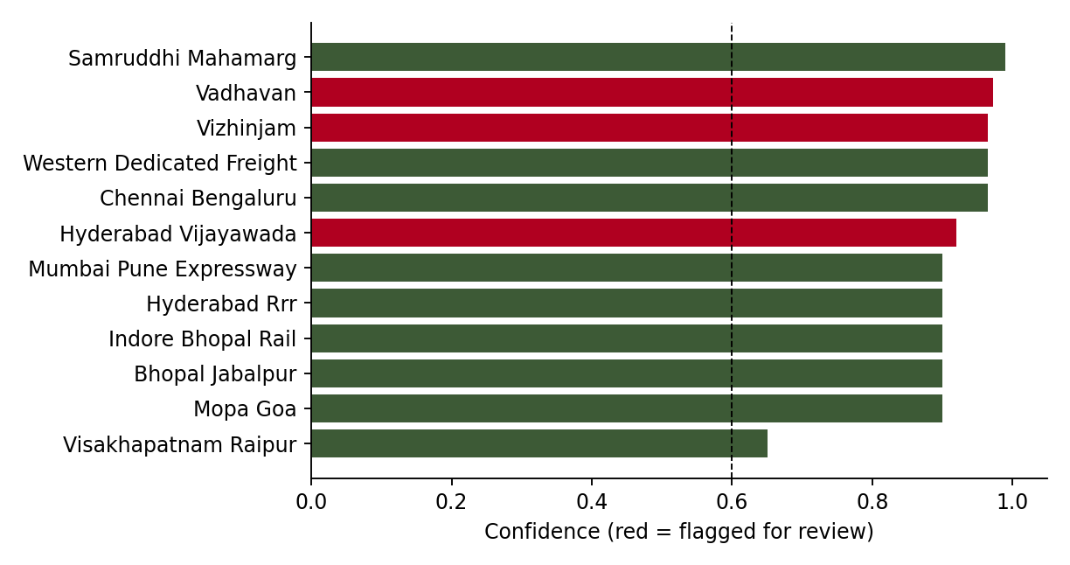
Figure 2. Confidence per project. Red bars are flagged for human review.
Vadhavan and NH-65 are flagged because an anonymous social post contradicts the official cost; the system keeps the official figure and lists the social source as low credibility. Vizhinjam is flagged because a news figure is well above the government figure. That may simply reflect phase 1 versus phase 2 costs, and only a person can settle it, which is exactly the kind of case the review flag exists for.
The Telegram post about a "secret new port near Kutch" matched no known project and gave no location detail. It is held in the unverified-leads list rather than the register. It is not dismissed: in a real deployment this is where an analyst would start a follow-up, but it must not be treated as fact.

6.2 Dual-use assessment
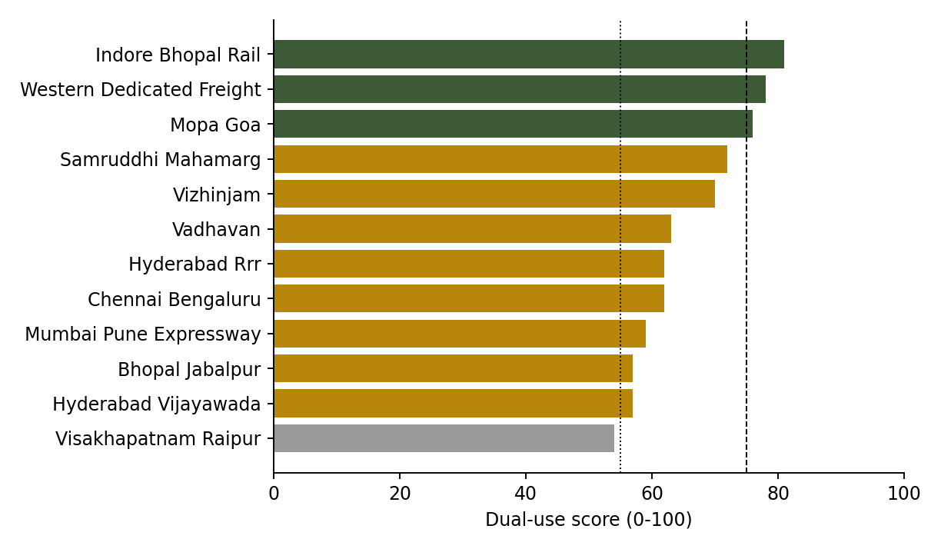
Figure 3. Dual-use scores. Dashed lines mark the HIGH (75) and MEDIUM (55) thresholds.
Airports and rail rank high because they are valuable for rapid movement of people and heavy loads and are operational today. The Mopa airport link scores highly mainly through proximity to the Goa naval region and operational status. Long expressways such as Samruddhi Mahamarg score MEDIUM: very useful, but the nearest defence hub is farther away in this simplified model. The ranking should be read as a prompt for attention, not a verdict.

6.3 Delay risk
Project | Risk | Flags raised
Chennai Bengaluru | HIGH | delayed, land acquisition, progress low for deadline, pushed
Western Dedicated Freight | HIGH | delayed, pending
Hyderabad Rrr | MEDIUM | land acquisition
Mumbai Pune Expressway | MEDIUM | completion year already reached
Table 8. Projects with delay flags.
The Chennai-Bengaluru expressway shows the benefit of combining sources. The government item gives 2027 for completion, while a later news item reports land acquisition trouble and a shift to 2028. Neither alone tells the full story. The Western Dedicated Freight Corridor is flagged for the pending JNPT terminal link: the main line is working but the last connection to the port is not, which matters if the aim is moving cargo to the coast.

6.4 Critical links
Link | Mode | Routes cut if it fails | Extra hours
Hyderabad-Visakhapatnam | road | 2 | 0
Nagpur-Jabalpur | road | 1 | 0
Hyderabad-Chennai | road | 1 | 0
Mumbai-Vadhavan | road | 1 | 0
Ahmedabad-Mundra | road | 1 | 0
Kochi-Vizhinjam | road | 1 | 0
Table 9. Single-failure test, top results.
Hyderabad-Visakhapatnam stands out. With Hyderabad-Vijayawada still under construction, there is no second operational path between those cities in the model. The finding connects a news item about NH-65 progress directly to a planning consequence. Several other rows are spur roads to ports such as Vadhavan and Mundra. These appear because each port hangs on one road in the model, which is realistic in part and partly a result of the network being simple.

6.5 Value of completing ongoing projects
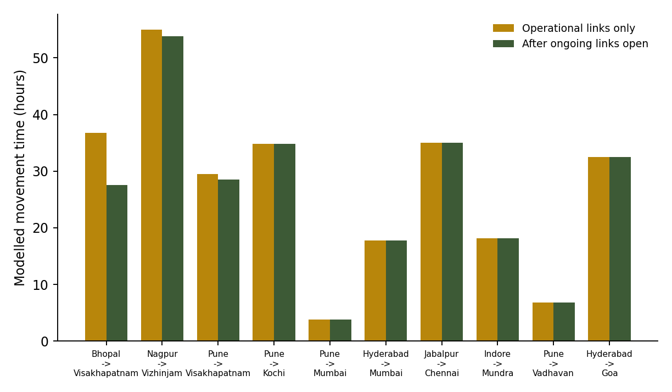
Figure 4. Modelled movement time before and after ongoing links open.
Only a few of the ten sample routes improve, but the largest gain is substantial: Bhopal to Visakhapatnam falls by 9.1 hours once Jabalpur-Bhopal and the Hyderabad-Vijayawada link are open. This gives a way to prioritise attention: projects that remove a single point of failure or shorten key routes deserve closer monitoring than projects with no effect on movement.

7. Testing and validation
The prototype ships with five automated unit tests, all passing, and the pipeline was also run from a clean unzip of the delivered archive to confirm it works without any local setup.
Test | What it checks | Result
Extraction fields | Cost, length, state and status read correctly from a sample sentence | Pass
Airport vs port | The word "airport" is not mistaken for "port" | Pass
Conflict detection | Official and social costs disagree: conflict flagged, official value kept | Pass
Low-credibility source | A lone social post stays under the 0.6 confidence line | Pass
Routing and failure test | Pune-Mumbai time equals 150 km / 40 km/h; failure test returns results | Pass
Table 10. Unit tests.
These tests show the logic behaves as designed. They do not prove accuracy on real feeds, because no labelled real data was available. The first step of a real deployment should be to hand-label a few hundred items and measure extraction precision and recall, and to compare model route times against real convoy data.

8. Risk register
Risk | Likelihood | Impact | Mitigation
Misleading or planted information (disinformation) | High | High | Source weighting, conflict flags, quarantine of unverified leads, human review
Extraction errors on unusual wording | Medium | Medium | Review queue, labelled test set, replace rules with NER model
Outlets copying one another inflate confidence | Medium | Medium | Add duplicate and originality detection
Model assumptions treated as fact | Medium | High | Show reasons with every score; expert calibration of weights and speeds
Aggregated outputs become sensitive | Medium | High | Access control, audit logs, separation from classified data
Stale data after a source stops updating | Medium | Medium | Record the last-seen date and alert on silence
Table 11. Main project and operational risks.

9. Security, ethics and data handling
The prototype uses only public information. Even so, a tool that combines infrastructure data with hub locations and movement times becomes more sensitive than any one of its inputs. A real deployment should run on an access-controlled network, log every query, and keep scraped public data separate from any classified overlay. Outputs should carry a handling marking.
On the ethics side, the system supports human analysts and does not decide anything. Rumours are never merged into the register. Every score stores the reasons behind it so an analyst can challenge it. Collection should respect website terms and rate limits and should use only content that is openly published.

10. Limitations
- The data is illustrative. Scores and numbers here are not facts about the real projects.
- Extraction relies on keyword rules and misses unusual phrasing, regional languages, images and PDFs. Accuracy has not been measured.
- The network has about 18 hubs with approximate distances. It ignores bridge load class, terrain, seasonal closures and traffic.
- Scoring weights and convoy speeds are my assumptions and need expert replacement.
- All official sources are given the same weight, though even official sources can lag or err.
- Independent-source assumption is optimistic when outlets copy each other.

11. Implementation roadmap
Phase | Timeframe | Deliverables
1. Data foundation | Weeks 1-4 | Collectors for PIB, NHAI, state portals and news APIs; duplicate detection; raw-data store
2. Better extraction | Weeks 5-8 | NER or LLM extractor with review queue; labelled set of 300+ items; accuracy report
3. Geospatial layer | Weeks 9-14 | OpenStreetMap routes, bridge and tunnel classes, spatial database, map view
4. Alerting and history | Weeks 15-18 | Change tracking per project; alerts on cost, date or status change
5. Secure deployment | Weeks 19-24 | Role-based access, audit logging, hardening, user training
Table 12. Proposed phases to take the prototype to a pilot.

12. Conclusion
SENTINEL-INFRA shows that scattered public infrastructure updates can be turned into a checked, scored and explained picture with modest tooling. The prototype is small, but it answers the three problems in the brief: it shows where information conflicts, where a civilian asset carries defence value, and where one broken link would hurt movement. With live feeds, a labelled test set and expert tuning it could become a practical decision-support tool. I would welcome the chance to build it further during the internship.

References
- Press Information Bureau (PIB), Government of India - official press releases on infrastructure approvals and reviews.
- National Highways Authority of India (NHAI) - project updates and official handles.
- Ministry of Road Transport and Highways (MoRTH) - highway programme information.
- Ministry of Ports, Shipping and Waterways - port development information.
- Dedicated Freight Corridor Corporation of India (DFCCIL) - freight corridor information.
- PM Gati Shakti National Master Plan - integrated infrastructure planning initiative.
- State government and road development corporation portals for the eight named states.

Appendix A - Sample feed items and extraction output
Feed | Source (type) | Text (shortened) | Extracted
F004 | PIB (official) | Cabinet note: Vadhavan deep-water port approved at Rs 76,220 crore | vadhavan; port; planned; cost 76,220
F005 | TwitterUser_77 (social) | Heard Vadhavan port cost has gone up to Rs 1,10,000 crore | vadhavan; cost 1,10,000; low credibility
F007 | BusinessDaily (news) | Chennai Bengaluru Expressway delayed; 78% complete, pushed to 2028 | chennai bengaluru; year 2028; delay flag
F019 | Telegram_chan (social) | Secret new port in Gujarat near Kutch, no details | No project match; unverified lead
Table A1. Four of the twenty feed items and what the extractor produced.

Appendix B - Repository contents and run instructions
Path | Purpose
README.md | Overview, quick start, sample results
data/ | feeds.json, nodes.csv, network.csv (sample inputs)
src/sentinel/ | extract, verify, dualuse, risk, bottleneck, geo, pipeline, dashboard
tests/test_core.py | Five unit tests
docs/ | Architecture, limitations, roadmap, this report
outputs/ | analysis.json, projects.csv, dashboard.html
To run: install Python 3.9 or later, unzip the project, then use "PYTHONPATH=src python -m sentinel" from the project folder and open outputs/dashboard.html. To test: "python -m unittest discover -s tests".

