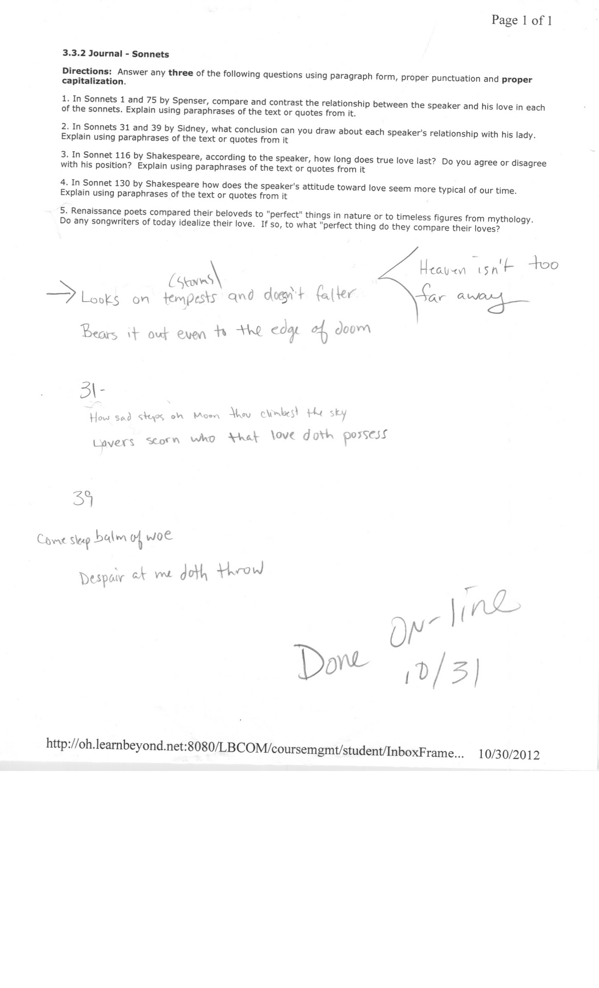
Kaine Fowler

The wind screams her name As I walk through the day.

And dreams fill my mind As in bed I do lay.

She stormed into my life Causing Chaos to reign.

Forming swells of emotion Swirling around in my brain.

I wish I could tame her And keep her with me.

But like wind when you chase it The more elusive it be.

So temperate weather will not come my way And storms

Still assail at the end of the day.

