

For Florida Students

Follow these simple steps to setup your student account:
- Go to http://www.shmoop.com/signup/flvs
- Have you ever created your own user account on Shmoop?
  - If “YES” Log into Shmoop and plug in your Magic Word.
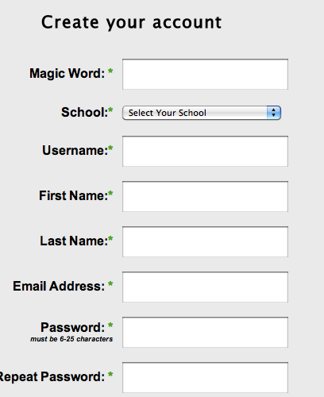
  - If “NO” create your personal account on Shmoop, and plug in your Magic Word.
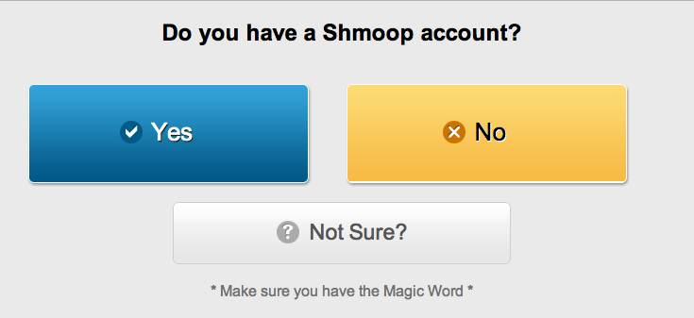

- Enter your Magic Word (all caps):
APALACHICOLA
- Choose Your School
Already Registered?
You will still need to go to the sign-up URL and click that Yes, you DO have a Shmoop account, and then enter the Magic Word (this is the only time -“please” doesn’t work). And voila! You are renewed. (Just like an expensive soap commercial.) It will be like a breath of fresh air... that you’ve already breathed in once before.

- Create Your Username and Password
- Click “CREATE”
- Welcome to the Greatest Test Prep on the Planet!
From now on visit www.shmoop.com
- Click Log In
- Enter your newly created Shmoop account
- Click “My Passes” to access your Shmoop test prep!
Want to learn the Shmoop Basics? Watch some videos:
- What is Shmoop?
Welcome to Shmoop for Students

