AirBNB Data Analysis

Bradley Kurit

May – June 2021

# Introduction

The report shown is an analysis of AirBNB metrics in New York City, New York for the year 2019. Our purpose is to show different ways to improve listings on AirBNB and which are the most profitable listings.

# Methodology

The following data was used in the analysis.

* Owner information (name)
* Location information (neighborhood, longitude and latitude)
* Room information (type of listing, number of reviews per listing, availability, price to rent for a day)

The data includes information from 48,896 listing for AirBNB in the New York area.

The first part of the analysis is dealing with the values that were not present in the reviews per month and the date of the last review.

We cleaned the original data to account for the missing information in the last review and review per month. Entered in the empty cells was a date that could be easily dealt with. The reviews per month were set to zero and the last review was set to a 1-1-2000 date as it would be easy to differentiate it from the rest of the data.

# Results and discussion

Shown below is the price distribution of the different cities in New York. The graph shows that Manhattan has the highest price of the different cities as well as the highest availability. Staten Island has the lowest number of rooms available.

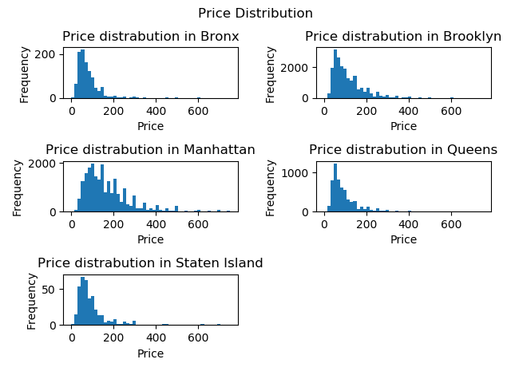

Figure 1: Price Distribution for Neighborhood groups in New York

The map below shows the heat map of the price of rooms in New York as well as location of each property. This heat map shows that Manhattan has the more expensive rooms as well as the highest density of listings in the New York city.

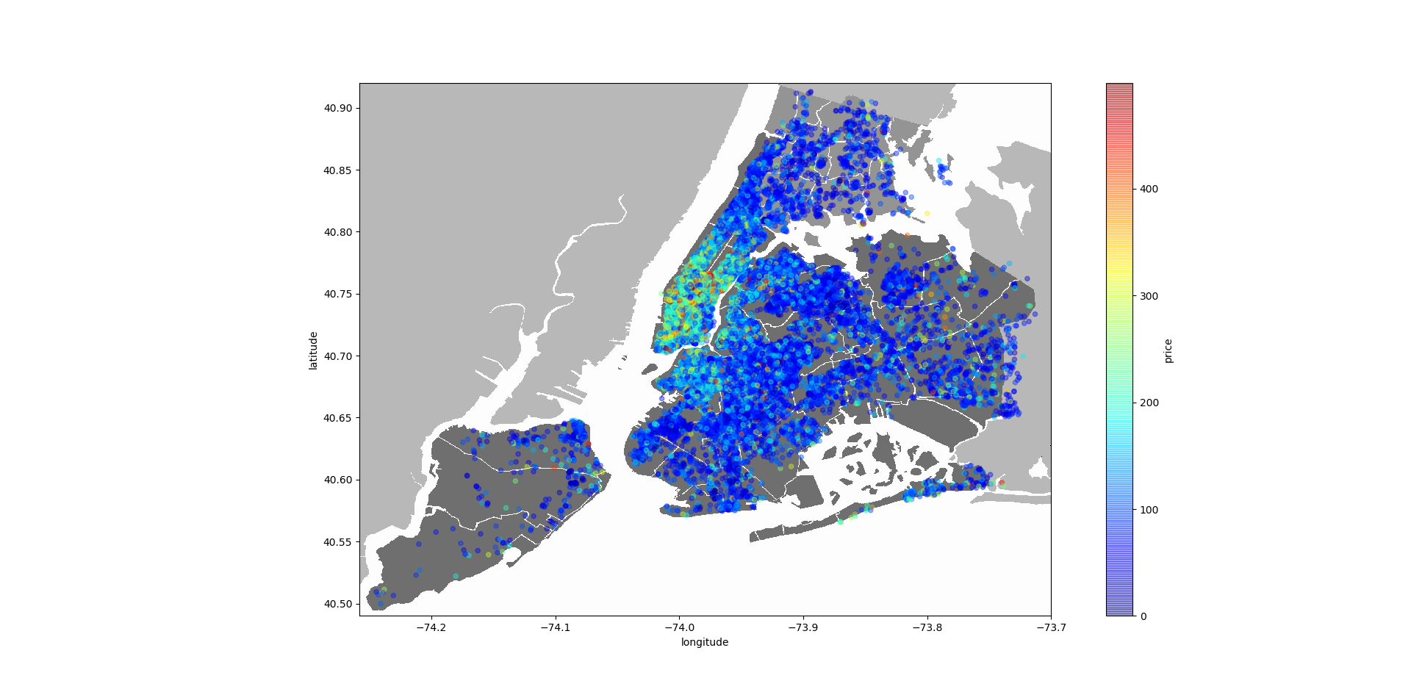

Figure 2: Heat map for listings in New York for AirBNB

The biggest factor in determining profitability would be the price for each unit. When looking at the highest profitability the entire house/apartment would be the most profitable. After the entire house the private room would be the next most profitable with the price being the determining factor in that as well. The rental prices are more expensive when renting an entire house/apartment and would be less expensive for the single room and even less for a shared room. The shared room despite being the least available and the least expensive only showed the average price at $70.12.

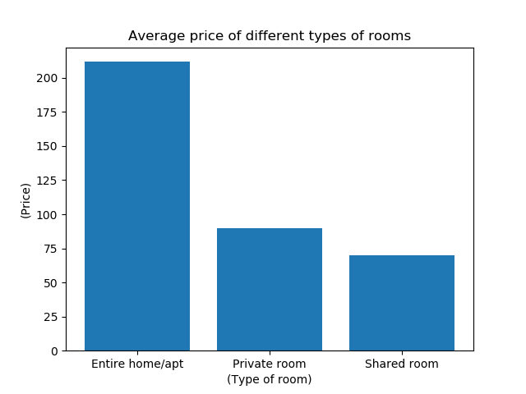

Figure 3: Average price for Rooms on AirBNB in New York for type of room

The average price for an entire home/apartment is higher than a private room and a shared room.

The reviews per month is comparable for an entire room and a private room.



Figure 4: Number of room types and Listings in neighborhood groups. Top listing for room types and neighborhood groups

The first graph shows us that there are more entire homes/apartment then there are private rooms and shared rooms. The next graph shows us that Manhattan has the most listings followed by Brooklyn then Queens, Bronx and lastly Staten Island.

With the third graph we took a look at the top listing in each of the types of rooms and found that the entire house/apartment shows the most top listing followed by private rooms then shared rooms. The fourth graph gives us an understanding where the top listings come from. The graph clearly shows that most of the top listings come from Manhattan, with Brooklyn showing us the second highest number of listings. The next highest number of listing are coming from Queens followed by the Bronx and the lowest number of top listings coming from Staten Island.

The top listings are majority entire homes and are located in Manhattan.

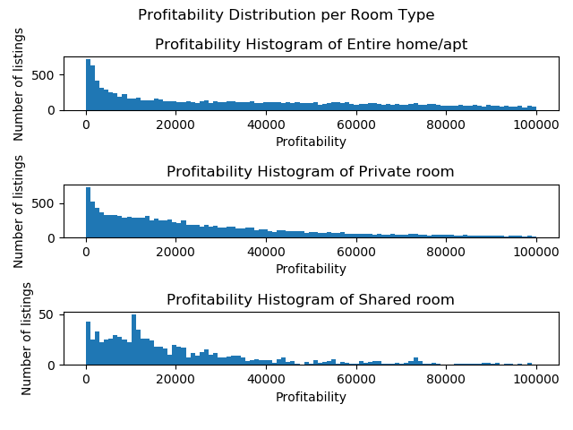

Figure 5: Price Distribution per room type

This graph shows that most of the Entire homes/apartment and private rooms are profitable, but also there is a high amount of non-profitable ones that we should take notice. The shared room graph shows us some profitable rooms, but the profitability quickly slows down.

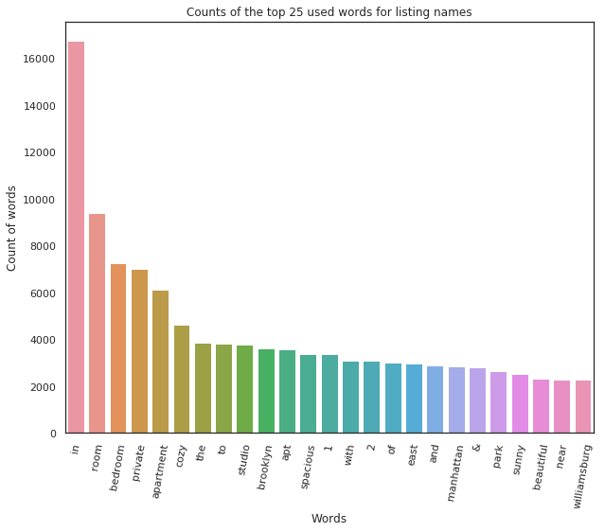

Figure 6: Top 25 words used in listing title

Among the top words are a lot of conjunctions, if we exclude those the most popular titles would contain the words room, bedroom, private, apartment or cozy. Words Manhattan and Brooklyn are also quite often which matches with our previous analysis, which showed that these two boroughs are the most popular.

# Conclusion

Some of the metrics that could be beneficial to perform a more detailed analysis would be to add the average length of stay, the average star rating of reviews, the profit per listing, and the average price per stay.

One recommendation to a potential client that was looking for a room/house to rent would be to look at Manhattan. Despite being more expensive it would be closer to all the major tourist attractions in the city. Due to the location, it would also be closer to where most of the sporting events would be as well as ease to get around to other cities where other events might possibly be. It is also where most of the entertainment is in the city.

Looking at one’s budget would be an important factor on where they should stay when visiting New York. If the client’s budget was on the higher end due to its location and proximity then Manhattan would be the most desirable location for one to stay, but if our client had a more frugal budget then I would recommend they stay in Brooklyn as its close to Manhattan while being a little less expensive.

Recommendations for listing owners

* Rent out entire home or apartment to increase the profit.
* To be able to raise the price you should consider renting in Manhattan. Real estate price was not taken into consideration.
* It is recommended that you use words like room, bedroom, private, apartment, cozy, and/or studio in your listing name.