Amazon Data Analysis

Bradley Kurit

July – August 2021

# Introduction

The report shown is an analysis of CGK Products Amazon account. Our purpose is to show different ways to improve Profit and ROI percentage and find ways improve sales. The following questions were used for the analysis in order to obtain our desired result.

* What is better, higher ROI or higher profit and which is a better parameter?
* Should we sell fewer higher ticket items (high profit) or more lower ticket items (higher ROI)?
* What type of item we sell at a loss (where profit < 2$)?
* Which suppliers make us the most money (total/average profit)?
* When should we spend money on advertisement?
* What are the percentages of products that we sell at a profit?

The following data variables were used in the analysis.

* Product information (supplier, price, buy cost, quantity purchased, other fees)
* Profit (ROI percentage, Profit Percentage, Net profit, Net profit percentage)
* Time data (product stocked, order placed and shipped)

The data includes information from 456 different suppliers through 6 years of data.

We calculated some new metrics such as profit per hold time. We wanted to include the values that would help determine what the profit is per how long we had the product and was it worth buying the product if the amount of time to sell was so long that it would be better to purchase other products instead.

We discarded some of the data that were on the extreme sides or if a purchase was from a one off or something that was donated from someone.

# Results and discussion

We are interested in decreasing the hold time of products, thereby we are interested in fasted selling products at the highest median profit. The sellers that satisfy these criteria are Girl Scouts, Nike Outlet, Bath & Body Works, Publix, Under Armour and Vera Bradley. These products are the more popular ones and are thereby sold faster and in higher quantities.

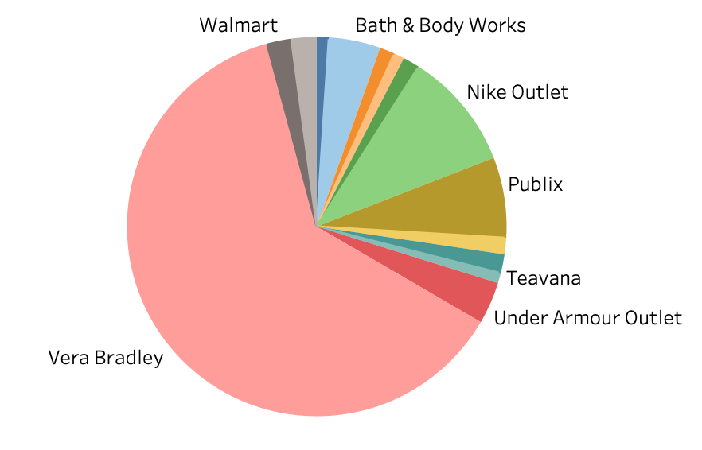

Figure 1: Number of sales per supplier.

The suppliers with the highest net profit are Vera Bradley, Nike Outlet, Publix, Bath and Body Works, Under Armour and Zulily. These suppliers have the highest net profits because they are the most accessible store to purchase from as well as the profit margins are some of the higher profit margins.

We looked at both ROI and higher profit and decided that it would be better to look at the higher profit then the higher ROI. Sales from some suppliers with higher ROI are the result of closeouts, inconsistent amount of inventory and other random factors. That is why we cannot use ROI percentage as a main determining factor of success.

All of products can divided into two separate groups, lower and higher ticket items. We set the criteria for the division of the groups at $20. Base on the histogram below we can see that the higher ticket items are representing the majority of the profits. We can also see that the losses are greater with lower ticket items. Based on the analysis lower ticket items are risker as the drop in price can quickly eliminate our profit due to low margins. Higher ticket items represent 83 % of the total profits.

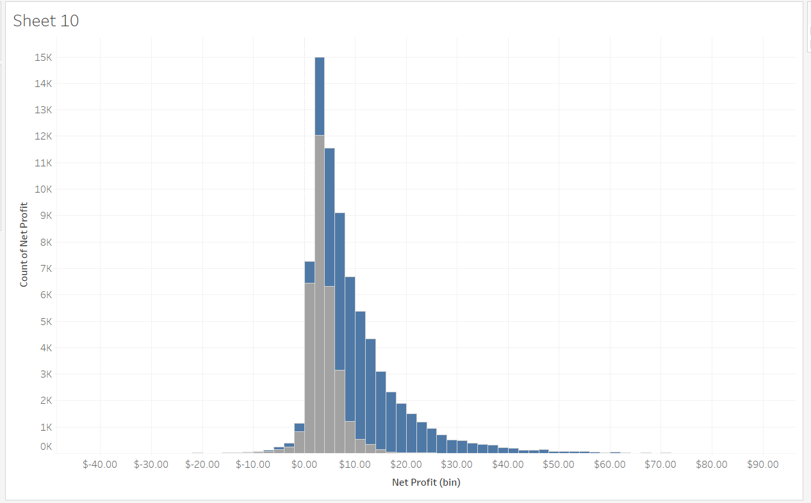

Figure 2: Histogram of net profit for lower and higher ticket items. The gray bars represent the lower ticket items and the blue bars represent the higher ticket items.

Based on the graph below one way to increase sales would be to start advertising our products during the historically low times. These times would be during the 1st quarter, January to March. This could help increase sales and turnover rate during our slowest months of the year.

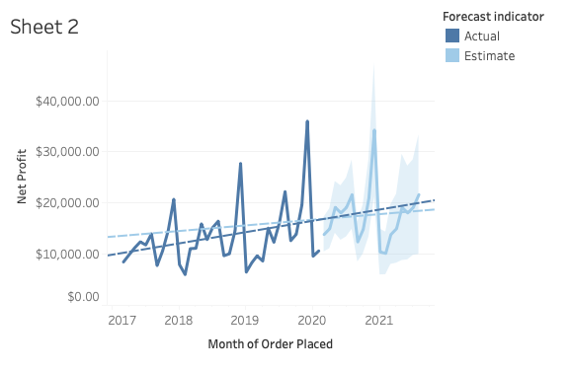

Figure 3: Monthly Sales From 2017 to 2020. On the graph we can also see the trendline showing an upwards sales trajectory.

Any item where the profit was less then $2 was considered a loss. One of the things we took into consideration was the time spent on product research, purchasing and packaging and that is why the limit was set at $2. Some of the bigger suppliers that we were selling at a loss included Disney and Bath and Body works. To stay competitive with those products we had to lower the price which resulted in a low profit.

CGK Products has sold approximately 76,500 total products. Around 75,000 products were sold as a profit and 1,440 were sold as a loss. The percent of products sold as a profit is 98 % while the products sold as a loss are at 1.9 %.

# Conclusions

Some recommendations to improve sales would be to purchase items that are more expensive with higher ROI. Stop purchasing items with lower margins because when the price drops the amount of profit quickly reduces to under $2, which would make the product not profitable. Another recommendation would be to advertise during January, February, and March where sales are the slowest. This would help create sales and improve cash flow. I would also focus on purchasing through the main suppliers Vera Bradley, Nike, Under Armour, and Publix as that is where the majority of the profits comes from.