**Report: Key Points for the Clustering**

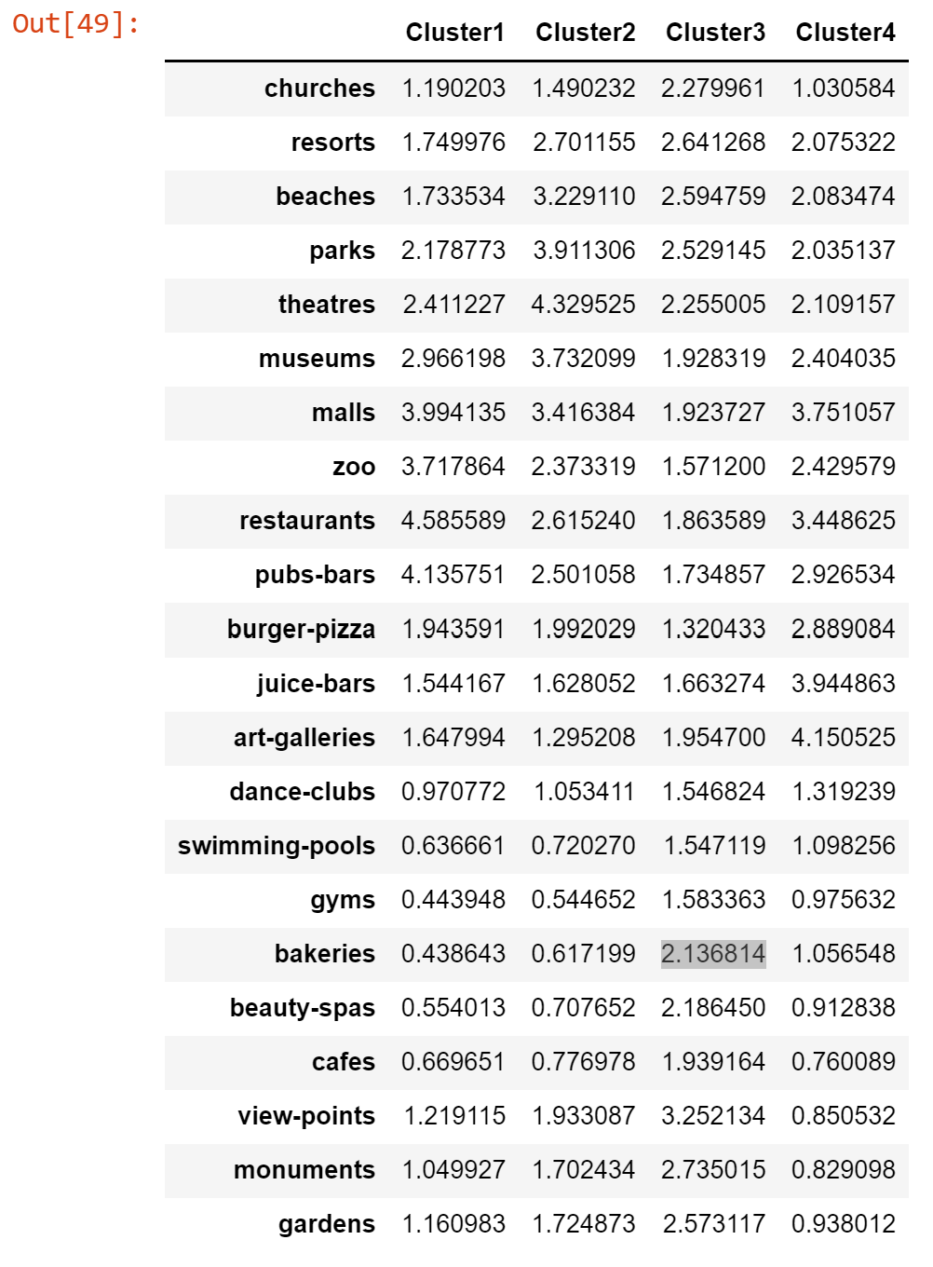

|  |  |  |  |  |
| --- | --- | --- | --- | --- |
|  | **Cluster 1** | **Cluster 2** | **Cluster 3** | **Cluster 4** |
|  | Big on pubs | Significant on Parks/Theatres | Open to nearly all options | Only one high on art |
|  |  |  |  |  |
|  |  |  |  |  |
|  |  |  |  |  |
|  |  |  |  |  |
|  |  |  |  |  |
|  |  |  |  |  |

**I would be quite happy to enjoy a café or baked good while taking in a beautiful view-point, church, monument or garden. {Large cluster 3}**

**Parks, theatres, or museums are frequented during my trips. {Large cluster 2}**

**I have a strong interest in pubs, bars, restaurants of a culture as I do with shopping and “organized attractions(?)”. {Med. Cluster 1}**

**Art galleries, restaurant visits, and the occasional shopping trip brings me great joy. {Large cluster 4}**

**Cluster 1 Cluster 2 Cluster 3 Cluster 4**

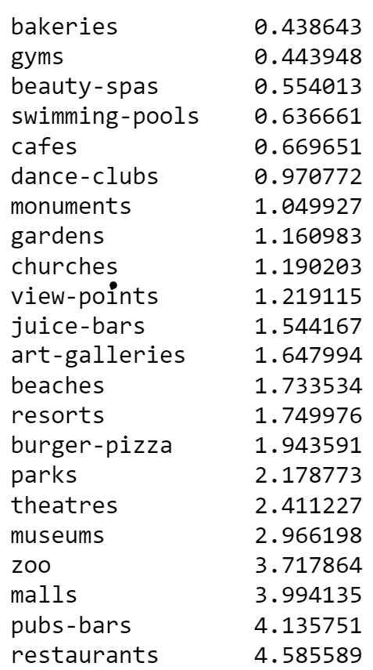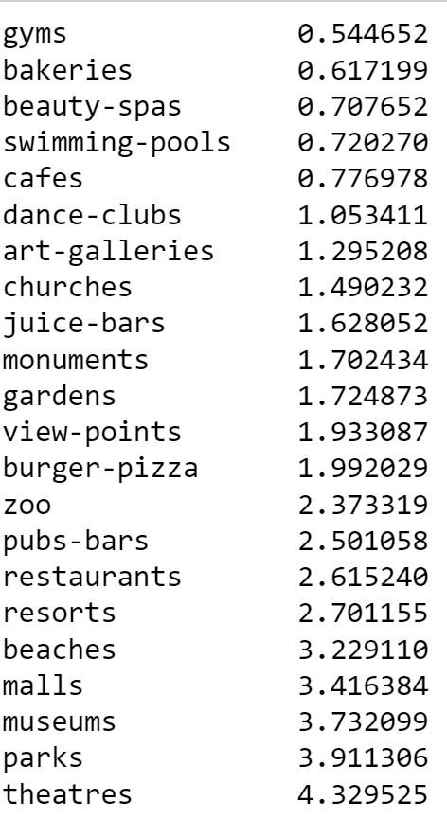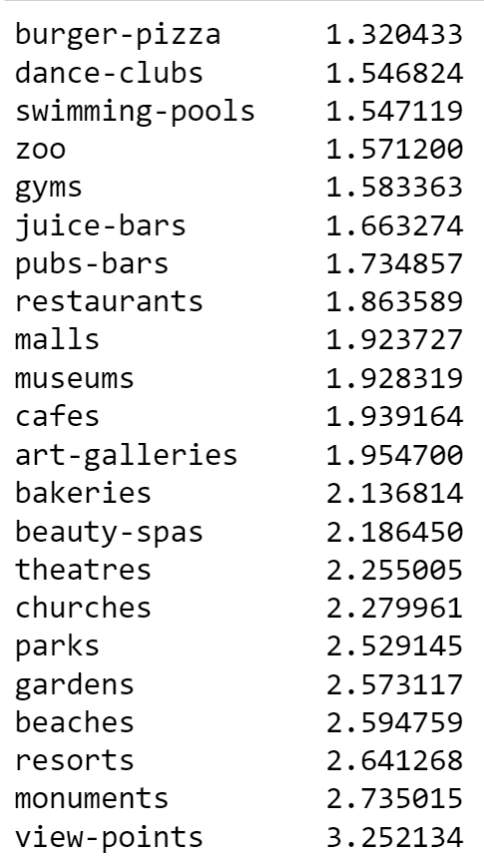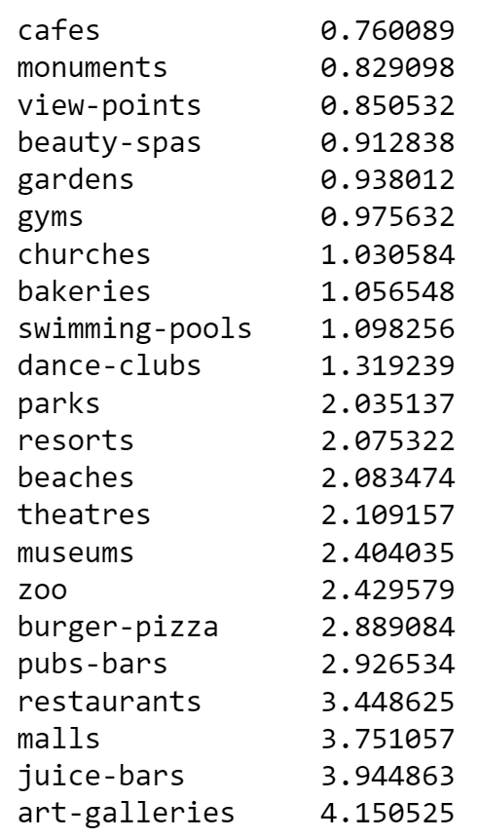

**No Food Included**

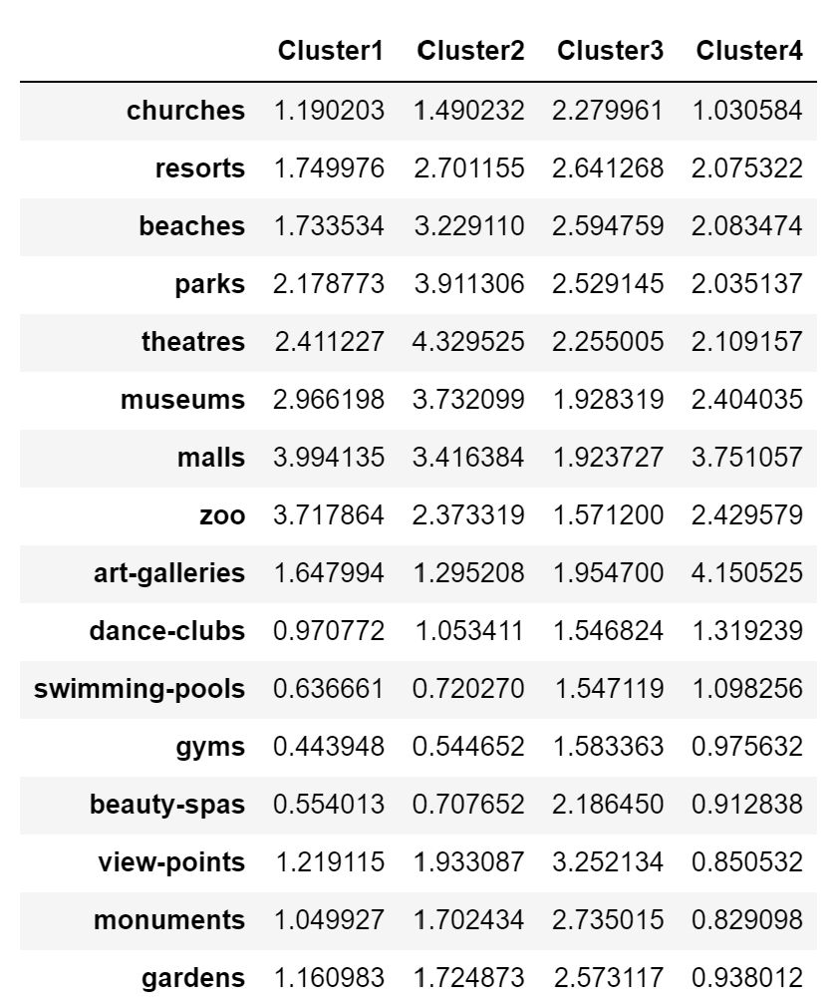

**Multiple Choice Question!!!!!!!!!!!!!!!!**

Rank by interest: Zoos, parks, art, view-points   
**Cluster 1: Zoo 🡪 parks 🡪 art 🡪 view-points**

**Cluster 2: Parks 🡪 zoo 🡪 view-points 🡪 art**

**Cluster 3: View-points 🡪 park 🡪 art 🡪 zoo**

**Cluster 4: Art 🡪 Zoo 🡪 park 🡪 view-points**

**Ranked: BEST ------------🡪 least**

**Cluster 1 (no food) Cluster 2 Cluster 3 Cluster 4**

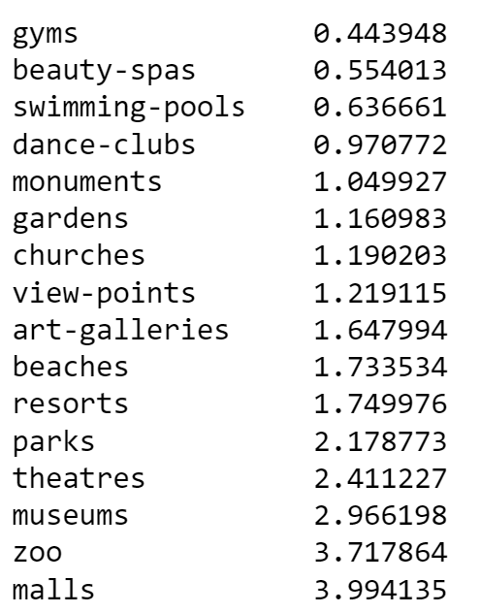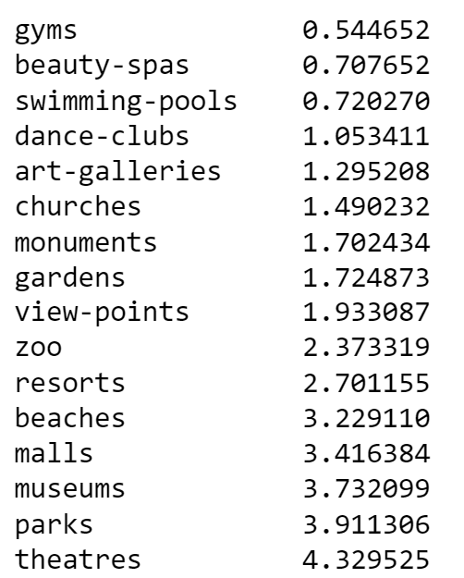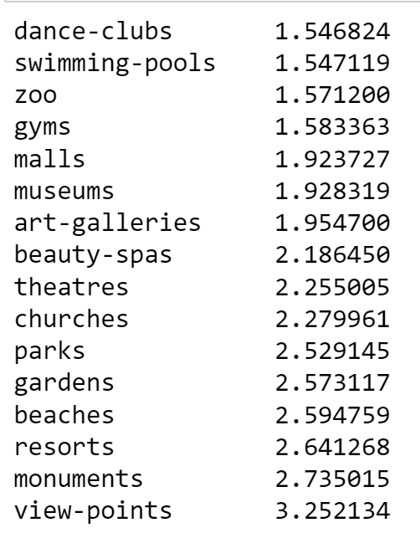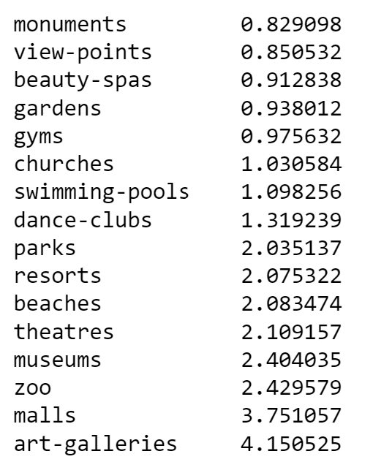

**Cluster 1: Zoo 🡪 parks 🡪 art 🡪 view-points**

**Cluster 2: Parks 🡪 zoo 🡪 view-points 🡪 art**

**Cluster 3: View-points 🡪 park 🡪 art 🡪 zoo**

**Cluster 4: Art 🡪 Zoo 🡪 park 🡪 view-points**

**Ranked: BEST ------------🡪 least**

