**Python基础 第七天作业 2023.8.14**

• **文件作业**

**首先通过如下代码创建目录与文件！**

**注意:最好创建一个新的或者不重要的目录来做这个实验**

import os

os.mkdir('test')

os.chdir('test')

qytang1 = open('qytang1','w')

qytang1.write('test file\n')

qytang1.write('this is qytang\n')

qytang1.close()

qytang2 = open('qytang2','w')

qytang2.write('test file\n')

qytang2.write('qytang python\n')

qytang2.close()

qytang3 = open('qytang3','w')

qytang3.write('test file\n')

qytang3.write('this is python\n')

qytang3.close()

os.mkdir('qytang4')

os.mkdir('qytang5')

#### 使用Python搜索这个目录！找到内容中有'qytang'关键字的文件！然后打印文件名！效果如下图:

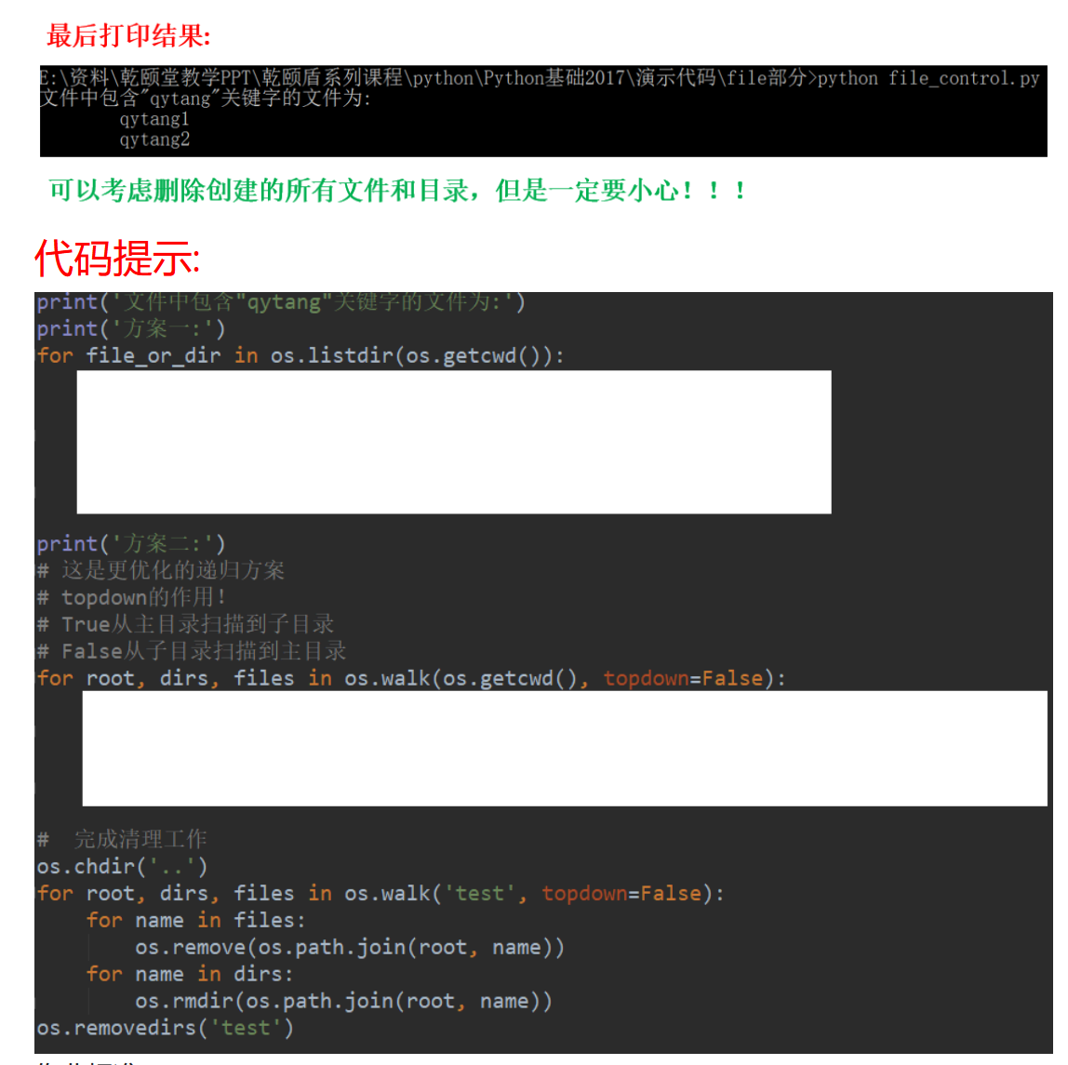

import os  
os.mkdir('test')  
os.chdir('test')  
qytang1 = open('qytang1', 'w')  
qytang1.write('test file\n')  
qytang1.write('this is qytang\n')  
qytang1.close()  
qytang2 = open('qytang2', 'w')  
qytang2.write('test file\n')  
qytang2.write('qytang python\n')  
qytang2.close()  
qytang3 = open('qytang3','w')  
qytang3.write('test file\n')  
qytang3.write('this is python\n')  
qytang3.close()  
os.mkdir('qytang4')  
os.mkdir('qytang5')  
  
print('文件中包含"qytang"关键字的文件为:')  
print('方案一:')  
os.chdir('/root/homework/2023.8.14/test/')  
for file_or_dir in os.listdir(os.getcwd()):  
 if os.path.isfile(file_or_dir):  
 with open(file_or_dir, 'r') as file:  
 if 'qytang' in file.read():  
 print(file_or_dir)  
  
print('方案二:')  
for root, dirs, files in os.walk(os.getcwd(), topdown=False):

os.chdir(root)  
 for file in files:  
 with open(file, 'r') as f:  
 if 'qytang' in f.read():  
 print(file)  
  
# 清理  
os.chdir('..')  
for root, dirs, files in os.walk('test', topdown=False):  
 for name in files:  
 os.remove(os.path.join(root, name))  
 for name in dirs:  
 os.rmdir(os.path.join(root, name))  
os.removedirs('test')

