**Python基础 第十三天作业**

1. **制作一个Ping的类**

**下面是执行测试的代码**

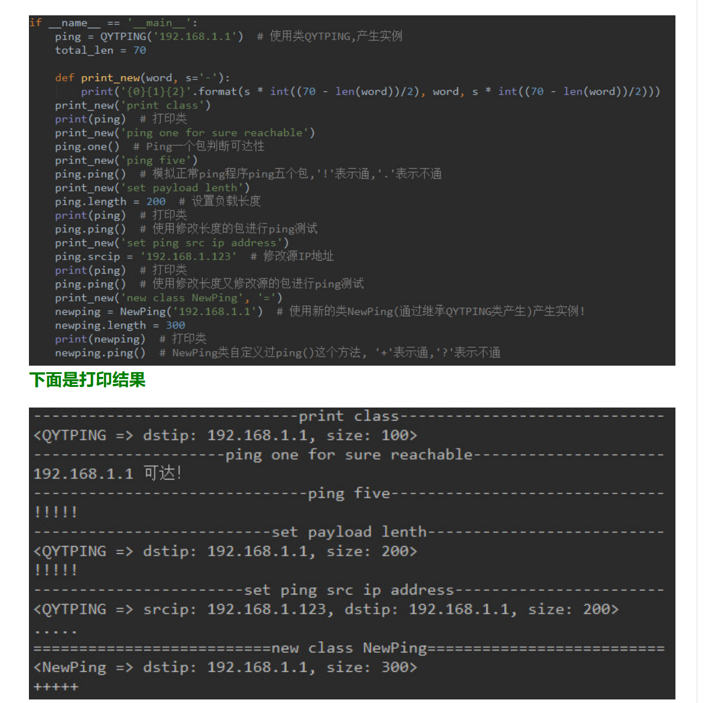

import logging  
logging.getLogger("kamene.runtime").setLevel(logging.ERROR)  
from kamene.all import sr1  
from kamene.layers.inet import ICMP, IP, Raw  
  
class QYTPING:  
 def __init__(self, dstip):  
 self.dstip = dstip  
 self.len = 100  
 self.srcip = ''  
  
 def __str__(self):  
 if self.srcip:  
 return 'QYTPING => srcip: {}, dstip: {}, size: {}>'.format(self.srcip, self.dstip, self.len)  
 else:  
 return 'QYTPING => dstip: {}, size: {}>'.format(self.dstip, self.len)  
  
 def one(self):  
 ping_payload = self.len  
 if self.srcip:  
 ping_echo = IP(src=self.srcip, dst=self.dstip) / ICMP() / Raw(load=b"X" * ping_payload)  
 ping_result = sr1(ping_echo, timeout=2, verbose=False)  
 else:  
 ping_echo = IP(dst=self.dstip) / ICMP() / Raw(load=b"X" * ping_payload)  
 ping_result = sr1(ping_echo, timeout=2, verbose=False)  
 if ping_result:  
 print(self.dstip + '可达!')  
 else:  
 return None  
  
 def ping(self):  
 ping_payload = self.len  
 if self.srcip:  
 ping_echo = IP(src=self.srcip, dst=self.dstip) / ICMP() / Raw(load=b"X" * ping_payload)  
 else:  
 ping_echo = IP(dst=self.dstip) / ICMP() / Raw(load=b"X" * ping_payload)  
 for n in range(5):  
 ping_result = sr1(ping_echo, timeout=2, verbose=False)  
 if ping_result:  
 result = '!!!!!'  
 else:  
 result = '.....'  
 print(result)  
  
class NewPing(QYTPING):  
 def __str__(self):  
 if self.srcip:  
 return '<NewPing => srcip: {}, dstip: {}, size: {}'.format(self.srcip, self.dstip, self.len)  
 else:  
 return '<NewPing => dstip: {}, size: {}'.format(self.dstip, self.len)  
  
 def ping(self):  
 ping_payload = self.len  
 if self.srcip:  
 ping_echo = IP(src=self.srcip, dst=self.dstip) / ICMP() / Raw(load=b"X" * ping_payload)  
 else:  
 ping_echo = IP(dst=self.dstip) / ICMP() / Raw(load=b"X" * ping_payload)  
 for n in range(5):  
 ping_result = sr1(ping_echo, timeout=2, verbose=False)  
 if ping_result:  
 result = '+++++'  
 else:  
 result = '?????'  
 print(result)  
  
if __name__ == '__main__':  
 ping = QYTPING('192.168.28.2')  
 total_len = 70  
  
 def print_new(word, s='-'):  
 print('{0}{1}{2}'.format(s * int((70 - len(word))/2), word, s * int((70 - len(word))/2)))  
 print_new('print class')  
 print(ping)  
 print_new('ping one for sure reachable')  
 ping.one()  
 print_new('ping five')  
 ping.ping()  
 print_new('set payload length')  
 ping.len = 200  
 print(ping)  
 ping.ping()  
 print_new('set ping src ip address')  
 ping.srcip = '192.168.28.130'  
 print(ping)  
 ping.ping()  
 print_new('new class NewPing', '=')  
 newping = NewPing('192.168.28.2')  
 newping.len = 300  
 print(newping)  
 newping.ping()

