FONTS

Roboto & Roboto-Slab:

<link href="https://fonts.googleapis.com/css2?family=Roboto:wght@300;400;500;700&display=swap" rel="stylesheet">

<link href="https://fonts.googleapis.com/css2?family=Roboto+Slab:wght@500;600;700&family=Roboto:wght@300;400;500;700&display=swap" rel="stylesheet">

HEADINGS

H1: Roboto Slab,  60px

H2: Roboto,  45px

H3: Roboto,  30px

BODY TEXT

B1: Roboto, 18px

B2: Roboto, 15px

B3: Roboto, 12px.

BUTTONS

Regular Button Hover Button



Font: Roboto

Color: White/Black dependent on background

Button Fill: Clear

Hover Fill: #191726

Regular Text Button Hover Text Button

HOME HOME



Font: Roboto

Color: White/Black dependent on background

Underline Color: #59363

NAVIGATION BAR & LOGO



Logo:  Roboto 30px

Link: Roboto 12px

Text Fill: white

Background Color Fill: #07070D

Link Underline Color: #59363

Navbar functionality:

* Logo will link to the landing page in same window
* Menu Items will link to designated page in same window
* No text decoration on logo hover or active
* Underline Text on menu items hover color #59363

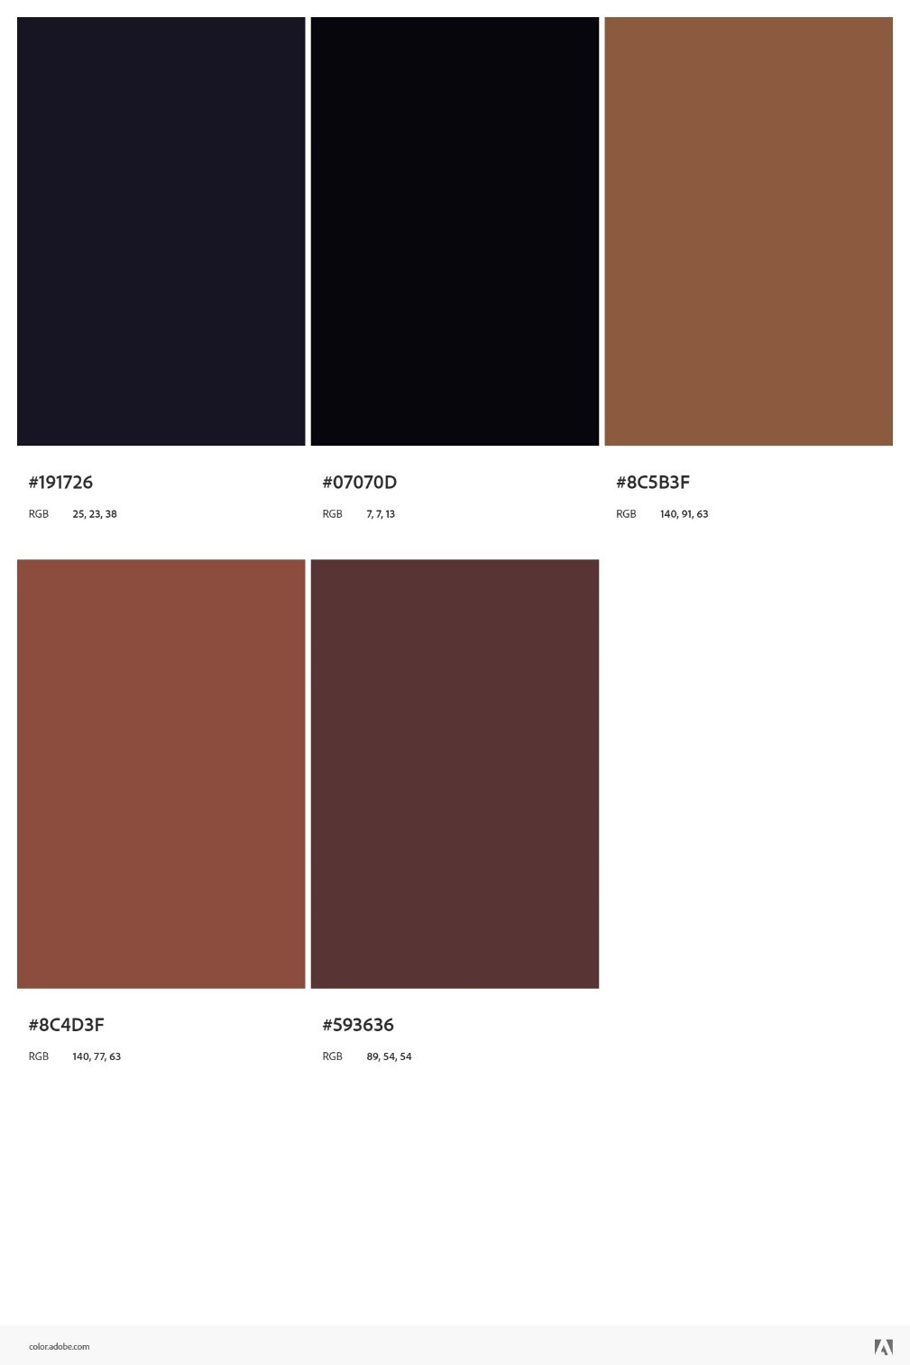COLOR PALETTE



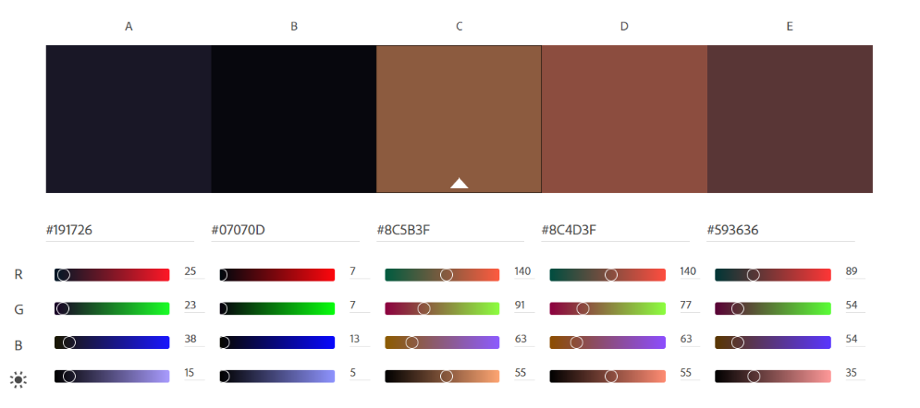

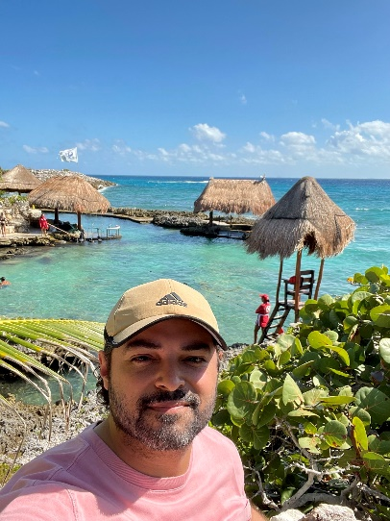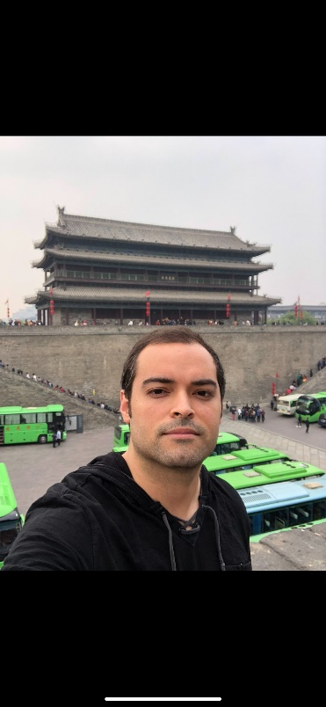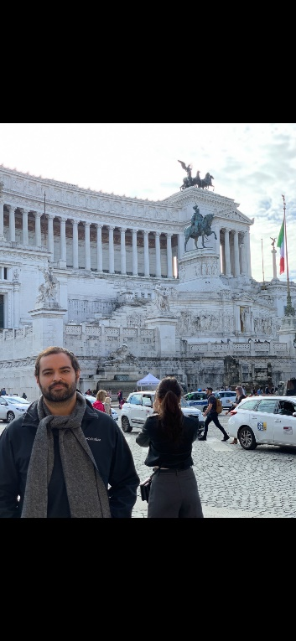IMAGES / GRAPHIC

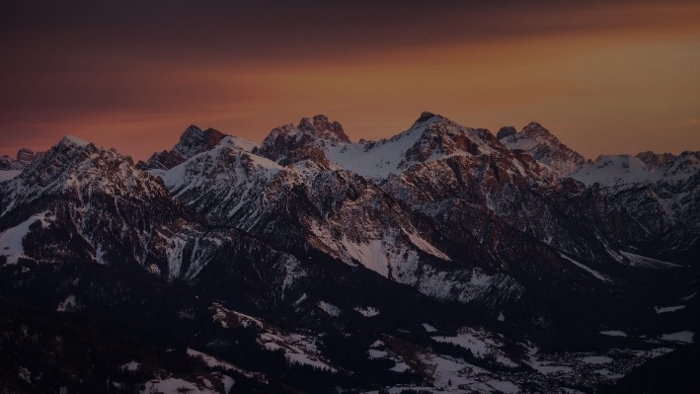

 \*Background img

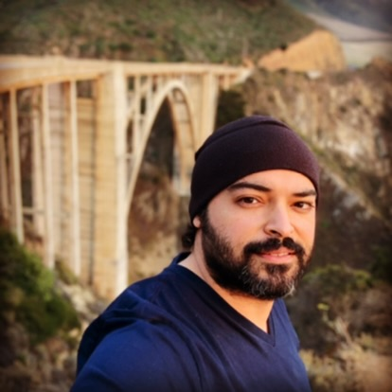

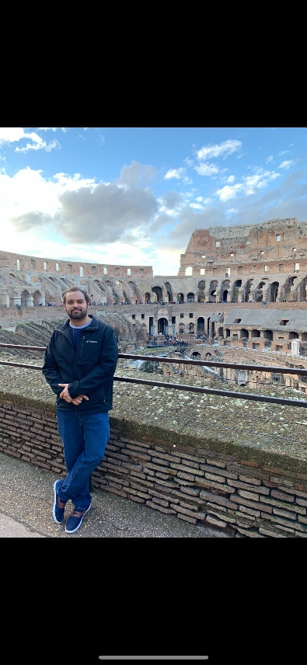

  \*Hobbies and Travel

Images

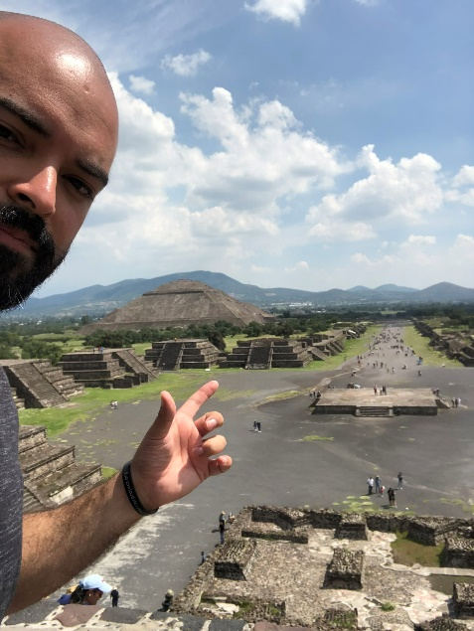



\*Possible Bio images

WIREFRAME / MOCKUP

\*Landing page

\*About page

SUBJECT INTERVIEW

1. What is your full name?

Christian Llinas

2. Where are you from?

Miami, FL

3. Where do you live now?

Denver, CO moved for a change of scenery and for work.

4. What is your primary language?

Speaks English and Spanish fluently.

5. What is your favorite subject to study?

History and Geopolitics because he enjoys the subject matter and always wants to be aware of what is going on in the world at large.

6. What is your favorite place you have lived in and why?

Colombia South America where he grew up. This is his favorite place he has lived and/or visited because he considers it home.

7. How many states/countries have you visited?

50 US states and countries combined. Most notably to him Florida, Virginia, Maryland, Ney York, South Carolina, North

Carolina, California, Nevada, Texas, Alabama, Washington, Spain, UK, Sweden, Switzerland, South Korea, China, and Portugal.

8. What do you like to do in your free time?

He enjoys going on road trips for the scenery. He enjoys going to museums. He enjoys outdoor activities such as hiking,  running, biking, pickleball, rollerblading, figure skating, kayaking, and hot yoga.

9. Do you like sports, which ones?

Football, soccer, tennis, MMA, boxing, basketball, rhythmic gymnastics, and curling. His favorite all-time sports team is the women’s doubles tennis team from Russia.

10. Do you have a favorite movie or tv show?

The fifth element movie.

Gone with the Wind.

Legends of the Fall.

24 the tv show with Keifer Sutherland.

11. What is your favorite color and why?

Dark green because he thinks it looks cool.

12. If you could be doing anything in the world right now what would it be?

Traveling because he enjoys seeing new cultures and experiencing new foods.

13. Where did you go to school?

Up until the age of 16 he went to school in Columbia and graduated early. Then moved to Miami FL and joined the army at the age of 17 and served for seven years. After this, he went to school college at Florida International majoring in international relationships and global studies. Then finished an MBA at Quantic Tech.

14. Any goals or interests you are working towards?

He is hoping to one day be able to purchase a home for his mother.

15. What moments or accomplishments from your life are you proud of?

Completed a half marathon without training once. (Almost died but made it through).

16. What are you doing now?

A senior consultant at a tax consulting firm. He is proud of his successful transition from military service to a corporate job.

INSPIRATION / RESEARCH

I was inspired to use Christian for the Bio Site project as he is one of the most interesting people I know. In order to learn more about him I sat down with him for a Q&A to try and gather a more in-depth understanding of his interests, hobbies, and timeline. The previous section lists those questions and answers. During our interview, I was able to learn much about him including his professional and educational background. I inquired about his origins and the various places he has lived. We also discussed his travels and focused on the favorite places he has visited. He traveled a great deal during his time in the military and on his own. I also learned that he values his family and aspires to provide support to them.

In addition, I learned about some of his personal interests such as what movies or tv shows he enjoys the most. I also learned more about his hobbies and preferred activities. I gained a good bit of information from just the questions alone. However, I wanted to get his opinion on the potential style and layout of the website, so we sat down and discussed the possibilities. I wanted the color palate and overall aesthetic of the website to be something that would be appealing to the individual who happens to be the topic of said website. I gathered his input on the color scheme and some layout options. We decided upon a darker color pallet and a background image for the landing page which includes a nature scene. This scene was chosen to relate to his current home in Denver as it is of mountains and his love of the outdoors. The underlying tone of the design is also muted and natural which I feel matches his serious and warm personality. My research also included gathering some images for the site. These images included are approved by him and the subject matter relates to his travels and hobbies.

SUBJECT BIO

Christian Llinas grew up in Columbia with his family. Which he remembers fondly as his home and makes trips back to visit often. At the age of 16, he and his family moved to Miami, FL. It was during this time that he decided to enroll in the army at the age of 17. He served for a total of seven years, during which time he made many new friends and experienced a breadth of new cultures. He has noted that his time in the service is what gave him a desire for travel, which he still loves to this day. He enjoys seeing new places, meeting new people, and above all trying new foods. After, his time in the army he pursued higher education at Florida International where he majored in international relationships and global studies. After his undergraduate studies were complete, he decided to pursue an MBA from Quantic Tech. Eventually, he moved to Denver, CO for a change of both climate and scenery. He is proud of his ability to have accomplished finishing his education while working. While also feeling fulfilled that he was able to successfully transition from military service to a corporate profession. Where he is now a consultant for a tax consulting firm.

Aside from these accomplishments, Christian is a fun-loving and adventurous induvial. He has been to over 50 states and countries. Most notably, he has visited Florida, Virginia, Maryland, Ney York, South Carolina, North Carolina, California, Nevada, Texas, Alabama, Washington, Spain, UK, Sweden, Switzerland, South Korea, China, and Portugal. He greatly values family and friends. He seeks to be a source of support for those around him, which is exemplified by his aspiration to one day to be able to purchase a house for his mother. He is fluent in both English and Spanish. He is an avid sports fan who loves soccer, football, and tennis among many other sports. In his free time, he loves to go on any adventure he can. He likes to go on long road trips and hiking to take in the scenery. He loves the arts as well and goes to museums and concerts whenever he has the chance.