**CISB366**

**Bioinformatics**

Project 2

Prediction of MHC binding peptide by Artificial Neural Network

D-B3-2615-3 IVAN, KUAN PUI ON

D-B3-2692-2 PHOEBE, UN IOK IAN

Part I

Flowchart

Output:

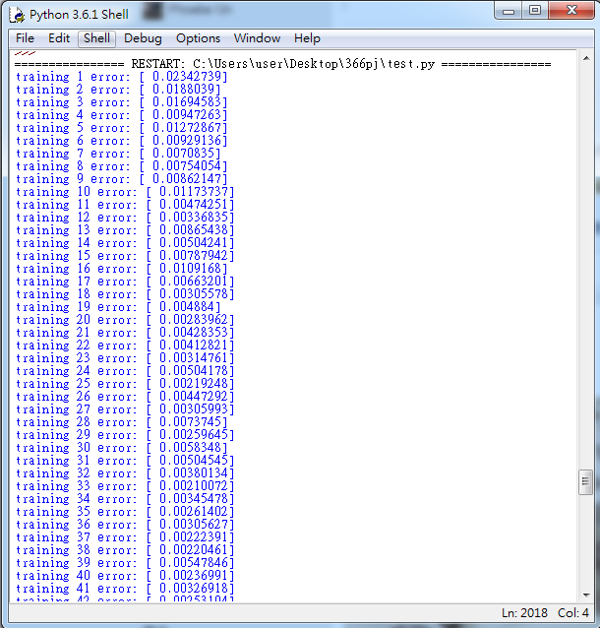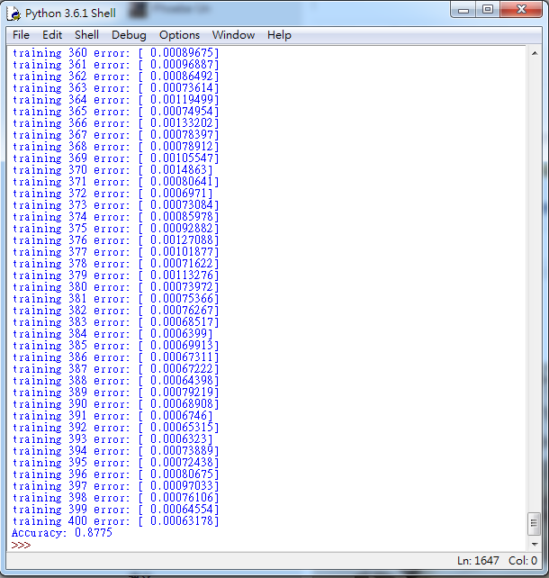

ANN architecture:

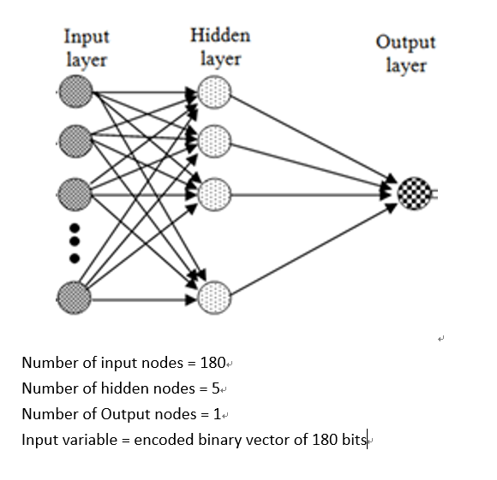

Part II

A.

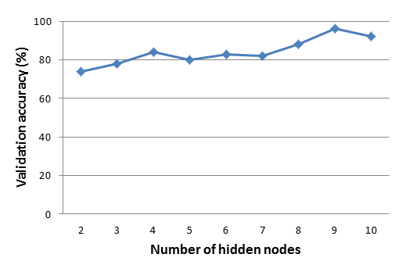

B.

|  |  |  |  |  |  |
| --- | --- | --- | --- | --- | --- |
| e | 0.1 | 0.5 | 1.0 | 1.5 | 2.0 |
| score | 96.66 | 97.012 | 96.567 | 94.562 | 90.886 |

We found that in order to get the optimal solution, manually changing the number of hidden nodes and the value of learning rate is needed. Since the input data is random, therefore we need to run more than 3 times with the same number of hidden nodes to get the average of each score. Although the ANN with 9 hidden nodes is our optimal solution at the moment, we still believe that there is a better solution if we could try more number of hidden nodes. For the learning rate, we found that as the value of learning rate is decreasing, the program runs slower. However, if we increase the learning rate, the score will get away from the optimal solution.