Assignment 4
  - Forms and Validation with HTML and Bootstrap
Student: Mukhametzhanov Batyrkhan
Group: IT-2511
Date: 18 October 2026

Project overview
This report describes three forms: a train ticket search, registration for AITU Hack 2026, and a corrected café reservation form. The implementation uses Bootstrap 5.3.8, HTML validation attributes and a shared CSS file for Tasks 1 and 2. Task 3 uses Bootstrap without custom CSS.
Browser checks covered the values in the assignment, additional boundary cases, keyboard navigation and layouts at 375 px and 1280 px. All 42 field validation cases matched the expected result. The W3C Nu checker reported no errors or warnings for the final HTML files.

Project files
File | Purpose
task1.html | Train ticket form and responsive Bootstrap layout.
task2.html | Hackathon registration with native HTML validation.
task3.html | Accessible café reservation form using Bootstrap only.
style.css | Task 1 appearance and Task 2 validation feedback.

Source repository
https://github.com/bl1rk/WEB2
The assignment source files belong in the assignment4 folder of this repository.

Scope
The forms demonstrate layout, accessibility and browser validation. They do not include a server that stores registrations or bookings. Task 1 uses GET; Tasks 2 and 3 use POST. A successful validation check does not create a booking or account.

Task 1 Train ticket form at 1280 px
The left image is the assignment reference. The right image is the implemented form captured at a 1280 px browser viewport; only the form area is shown.
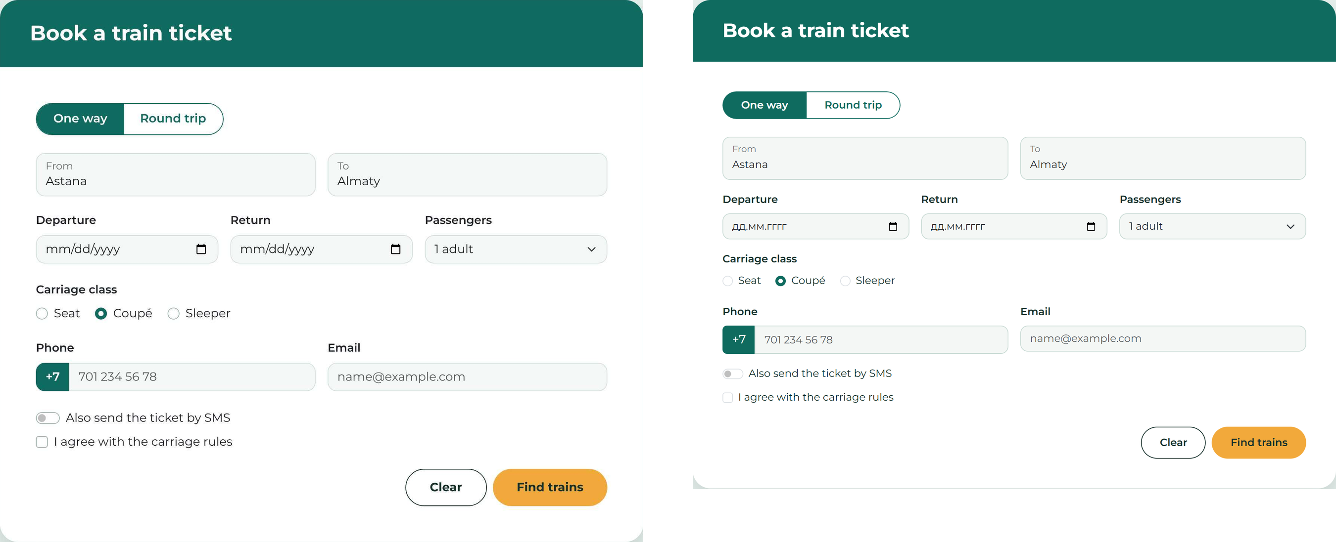
Figure 1 Desktop comparison at 1280 px | Reference on the left and implementation on the right
The form uses floating labels for From and To, date inputs, a passenger select, radio groups, a phone input group, an SMS switch and an agreement checkbox. The custom CSS applies Montserrat, the five specified colours, rounded corners and a shadow.
Bootstrap columns place From and To side by side, and Departure, Return and Passengers in one row. The card uses max-width rather than a fixed width. The custom stylesheet contains no absolute positioning.

Task 1 Train ticket form at 375 px
Reference on the left; implementation on the right. Both show One way, one adult and Coupé selected for comparison.
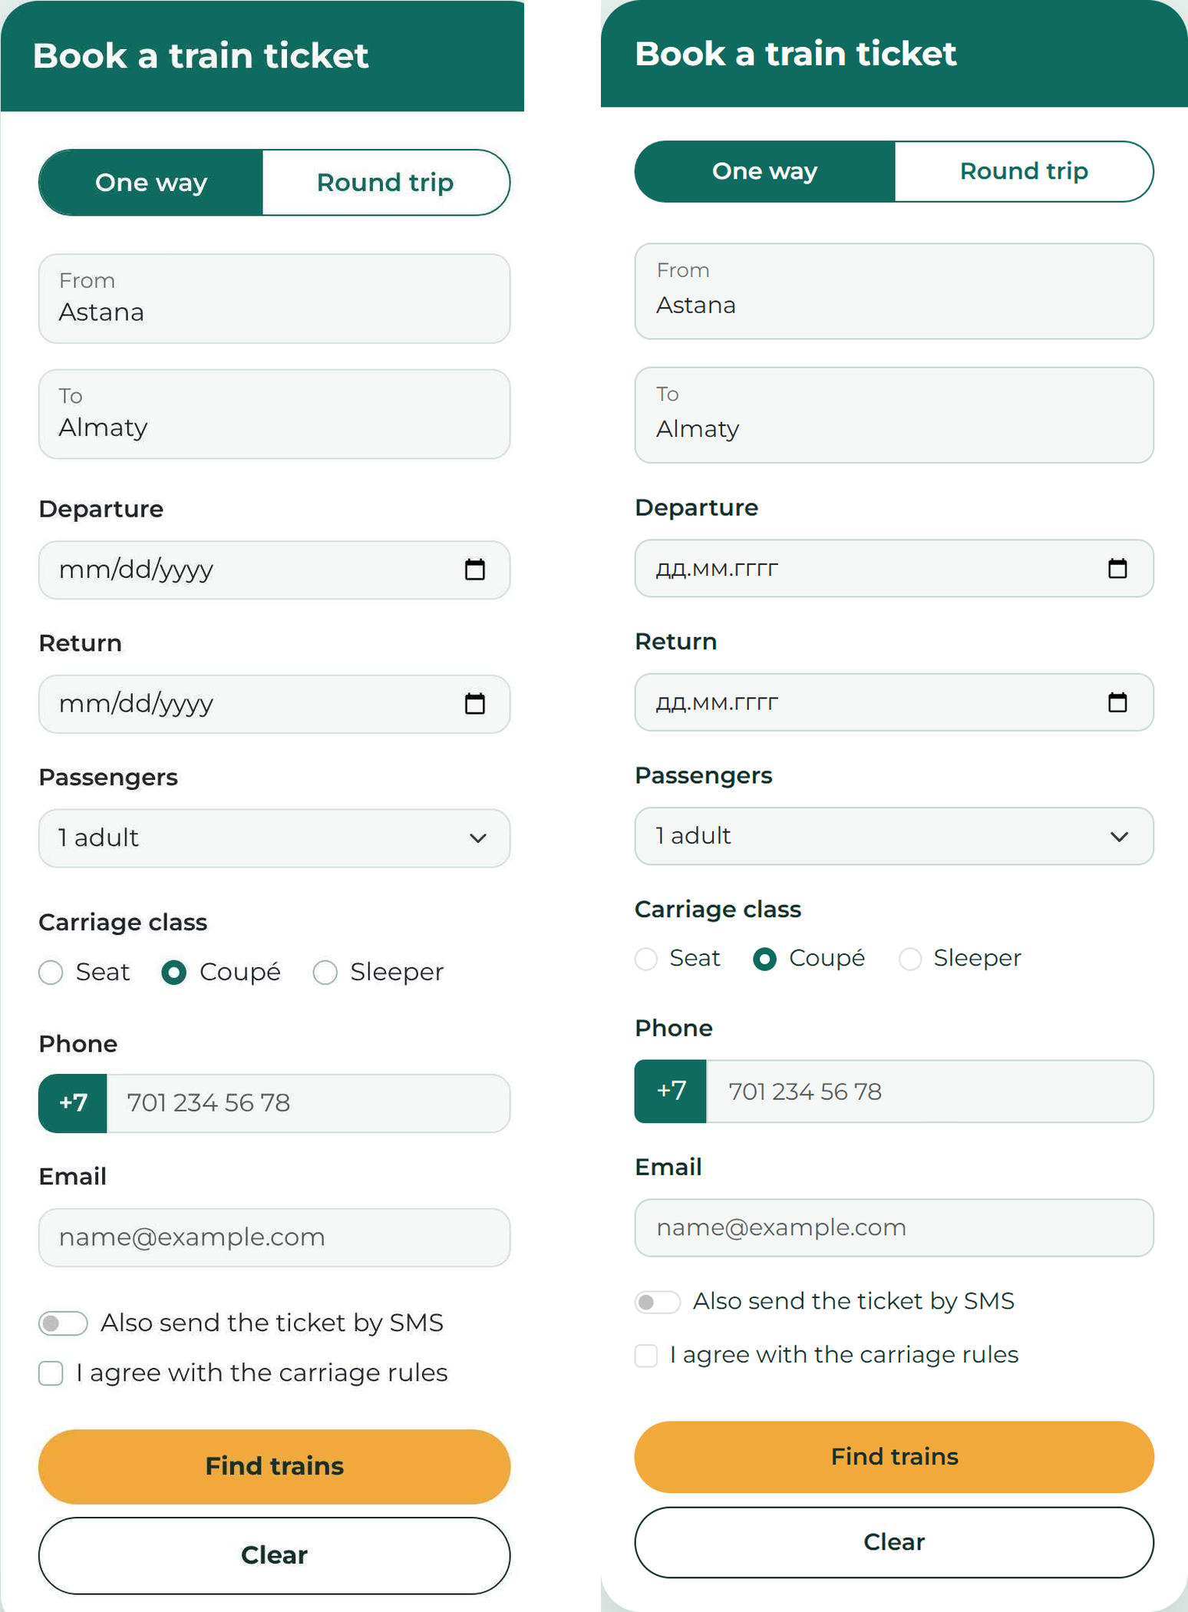
Figure 2 Mobile comparison at 375 px
At this width, Bootstrap stacks the fields. The button wrapper uses flex-column-reverse and flex-md-row: Find trains appears above Clear on a phone while the HTML order remains Clear, then Find trains.
From, To, Departure, Carriage class, Phone, Email and the agreement are required. Passengers allows 1–6 adults. Clear resets the form to empty values because the inputs have no preset values or checked options. The displayed cities in these screenshots were entered for the comparison.

Task 2 Hackathon registration
Each rule uses the input type and HTML attributes. Integer fields use step="1". Arrival uses the range 2026-11-20 to 2026-11-22. Check-in uses step="1800", which means 1800 seconds or 30 minutes. The fee uses step="500".
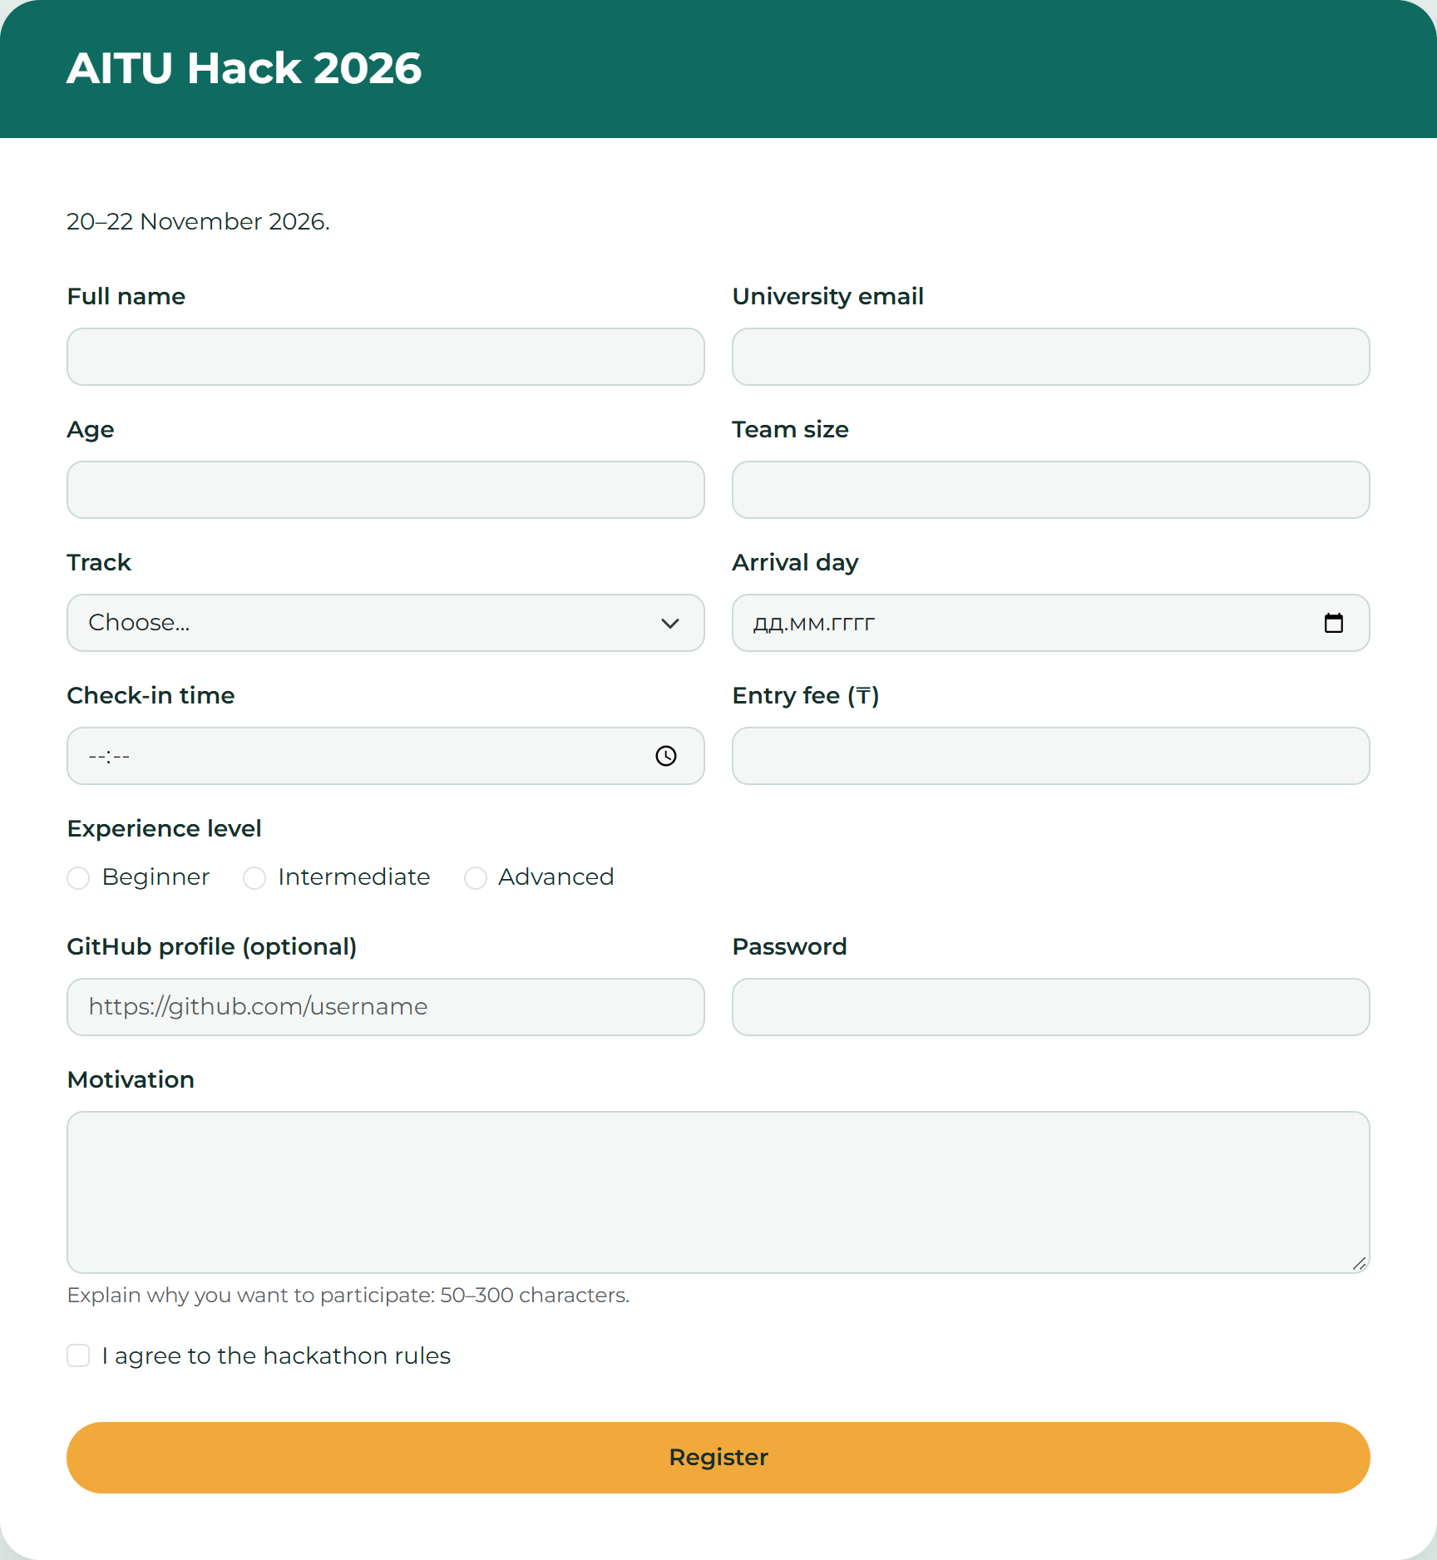
Figure 3 Registration form at a 1280 px viewport before interaction
The empty Track option has value="", so required rejects it. GitHub is optional and uses type="url". The email field checks email syntax, without restricting the university domain. The assignment does not require a domain restriction.

Task 2 Validation results
The table records 42 checks in Chrome. Accept and Reject describe native field validity, not a server response. Empty required values and invalid formats are rejected. Text length checks used browser input; the 120-character motivation case used a string of 120 characters.
Field | Test value | Expected | Actual
Full name | Anna-Maria Lee | Accept | Accept
Full name | A | Reject | Reject
Email | a.fedenko@astanait.edu.kz | Accept | Accept
Email | a.fedenko | Reject | Reject
Email | a.fedenko@ | Reject | Reject
Age | 18 | Accept | Accept
Age | 15 | Reject | Reject
Age | 31 | Reject | Reject
Age | 16 | Accept | Accept
Age | 30 | Accept | Accept
Age | 18.5 | Reject | Reject
Team size | 4 | Accept | Accept
Team size | 5 | Reject | Reject
Team size | 2.5 | Reject | Reject
Arrival day | 2026-11-21 | Accept | Accept
Arrival day | 2026-11-25 | Reject | Reject
Arrival day | (empty) | Reject | Reject
Check-in time | 10:30 | Accept | Accept
Check-in time | 10:15 | Reject | Reject
Check-in time | 19:00 | Reject | Reject
Check-in time | 09:00 | Accept | Accept
Check-in time | 18:00 | Accept | Accept
Entry fee | 1500 | Accept | Accept
Entry fee | 1250 | Reject | Reject
Entry fee | 6000 | Reject | Reject
Entry fee | 0 | Accept | Accept
Entry fee | 5000 | Accept | Accept
GitHub profile | (empty) | Accept | Accept
GitHub profile | https://github.com/yerassyl-dev | Accept | Accept
GitHub profile | github.com/yerassyl-dev | Reject | Reject
Password | Astana2026 | Accept | Accept
Password | short | Reject | Reject
Motivation | 120 characters | Accept | Accept
Motivation | 49 characters | Reject | Reject
Motivation | 50 characters | Accept | Accept
Motivation | 300 characters | Accept | Accept
Track | Choose... (empty value) | Reject | Reject
Track | Web | Accept | Accept
Experience | nothing chosen | Reject | Reject
Experience | Beginner selected | Accept | Accept
Agreement | Not ticked | Reject | Reject
Agreement | Ticked | Accept | Accept

Feedback after interaction
At page load, no error messages are visible. CSS :user-invalid adds a red border and reveals the related .invalid-feedback after interaction. The radio group uses :has(input:user-invalid) to show its shared message. No JavaScript, pattern or novalidate attribute is used.
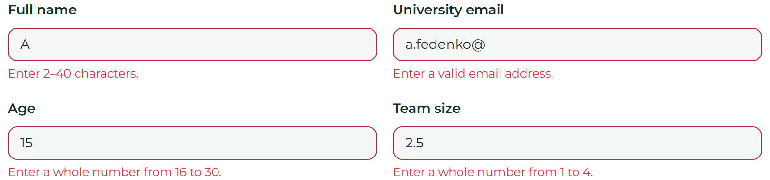
Figure 4 Errors after entering A, an incomplete email, age 15 and team size 2.5

Task 3 Corrected café reservation form
The corrected form keeps the original fields: name, email, phone, guests, date, seating, meal, comments and agreement. Bootstrap provides the layout and styling. Each field has a visible label, a unique id and a name for form submission.
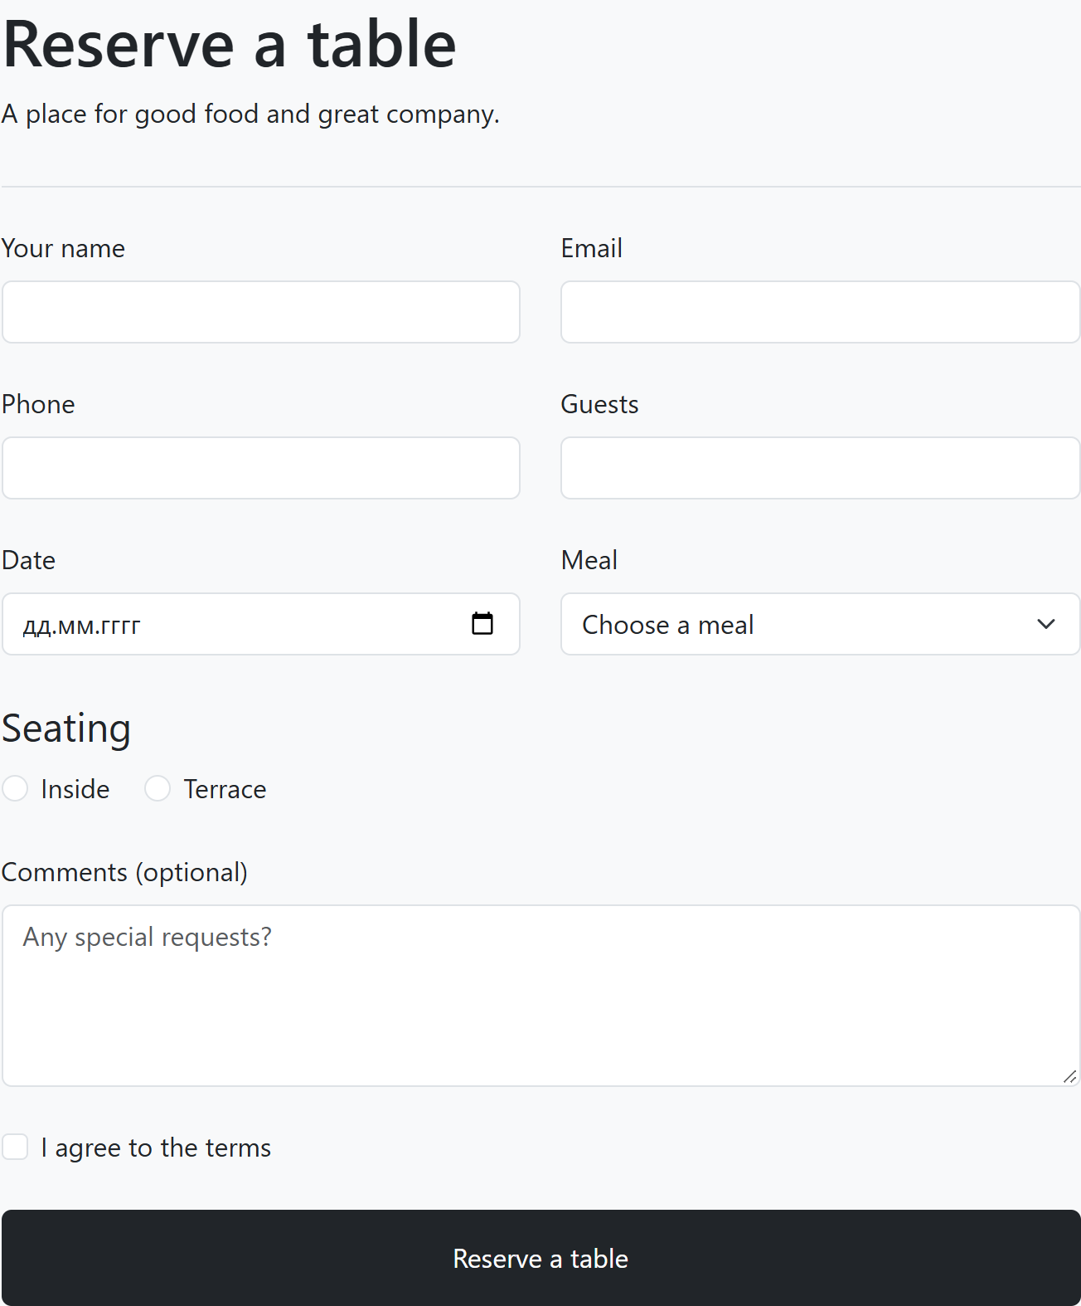
Figure 5 Corrected reservation form at a 1280 px viewport
The form uses type="email", type="tel", type="number" and type="date" for their matching data. The two seating radios share name="seating" and have different values. A real submit button replaces the original div. Comments remain optional.

Task 3 Problems in the original code
Line numbers refer to the code image on page 4 of Assignment 4.pdf, counted from line 1, <h2>Reserve a table</h2>. They do not refer to line numbers in the corrected file.
Line | Problem | Effect on the user | Correction
3 | Name has only a placeholder | The label disappears during entry and does not provide a permanent accessible name. | Add a visible label linked to id="guest-name".
4 | Email has only a placeholder | Users cannot identify the field reliably after typing. | Add a label linked to id="guest-email".
4 | Email uses type="text" | The browser accepts text that is not an email address. | Use type="email".
5–6 | Phone label has no for | Clicking the label does not focus the field; its relationship is unclear to assistive technology. | Match for="guest-phone" with the input id.
6 | Phone uses type="text" | Mobile users do not get the phone-oriented input keyboard. | Use type="tel" and autocomplete="tel".
7–8 | for="guests" does not match id="people" | The Guests label is not connected to its field. | Use id="guests" and for="guests".
8 | Guests uses type="text" | Words and fractional guest counts can be entered without a numeric constraint. | Use type="number", min="1" and step="1".
10 | Date uses type="text" | Users can enter an invalid or ambiguous date string. | Use type="date".
10, 12 | Duplicate id="date" | Labels and other references cannot identify one unique element. | Give the date and seating options unique ids.
11–13 | Seating group is introduced by p | Assistive technology does not receive a semantic group label. | Wrap the radios in fieldset with a legend.
12–13 | Radio buttons have different names | Inside and Terrace can both be selected. | Give both radios name="seating".
12–13 | Radio buttons lack useful values | Submitted data contains on rather than the selected seating option. | Set value="inside" and value="terrace".
12–13 | Radio text is not a label | Users cannot click the text to select an option; accessible names are missing. | Add a connected label for each radio.
14–17 | Select has no label | Users do not know what Lunch and Dinner represent. | Add the label Meal linked to id="meal".
18 | Comments has only a placeholder | The field loses its visible description when text is entered. | Add a persistent Comments label.
19 | Agreement text is not a label | Clicking the text does not toggle the checkbox. | Connect the label to id="terms".
3–10, 14, 18–19 | Most controls have no name | Their values are omitted from form submission. | Give each field a name; add a meaningful checkbox value.
20 | Reserve is a div | It is not a native keyboard-operable submit control. | Replace it with button type="submit".

Two alternative fixes
Name label, line 3: aria-label could provide an accessible name without a visible label. The chosen visible label also helps users who can see the page, because it remains present after typing.
Phone label, lines 5–6: the input could be nested inside its label instead of using for and id. The chosen explicit association allows the label and input group to be placed separately while preserving the connection.

Verification
Keyboard checks reached the fields and submit buttons using Tab. Arrow keys changed radio choices, and Space toggled checkboxes. The café form produced nine named entries when filled with a seating choice and accepted terms. No duplicate ids or missing connected labels were found.
HTML file | W3C Nu checker errors | Warnings
task1.html | 0 | 0
task2.html | 0 | 0
task3.html | 0 | 0
The final Task 1 phone field uses autocomplete="off". The browser layout checks found no horizontal page overflow at viewport widths of 375 px and 1280 px.

Conclusion
The three forms show how Bootstrap handles responsive layout while HTML attributes enforce input rules. The validation checks demonstrate the difference between a required field, a format constraint and a numeric or date range. The café corrections show why labels, unique ids, shared radio names and native buttons matter for keyboard use and submitted data.
For further work, a server would need to receive POST data, validate it again and save the booking or registration. That server functionality is outside the scope of this assignment.

References
Assignment 4.pdf. Forms and Validation. Task descriptions, reference screenshots and original café form.
Bootstrap 5.3 Forms
MDN HTML input time
MDN CSS user invalid
W3C Nu HTML Checker
Project source https://github.com/bl1rk/WEB2

