MAT-EZ User Guide

1. General Statements:
MAT-EZ is program created for calculating using strings for input and output. Using MAT-EZ you can calculate large number such as factorial of 150 or root of 1000 power for less than one second. MAT-EZ also provides mechanisms for different types of functions, which are constantly updated within new versions, such as Perrin sequence, Arabic number conversions and Base change. There is even a built-in IF…THEN...ELSE block functionality in MAT-EZ.

2. Installing and Running:
MAT-EZ is installed quite simple. All you need is unpack the archive and install lucmath.ttf font file. It should be in the package. If it is not, you can write me to my e-mail evg_zel@mail.ru and will send you a free package with new version. MAT-EZ special font is installed into Windows\Fonts folder by copying or form Control Panel -> Fonts utility.
To run the program you’ll need a .NET Framework 1.1 installed on your machine. It is available as an update at Microsoft WebSite.
Program is executed by opening file matez.exe. Be sure to check for viruses, who know where you’ve got it. Program welcomes you with about window you can close it by pressing START caption in bottom of the window. Notice that this help file is available from this window (caption HELP).
MAT-EZ has intuitive and user friendly interface. Below is a screenshot of it’s main window.
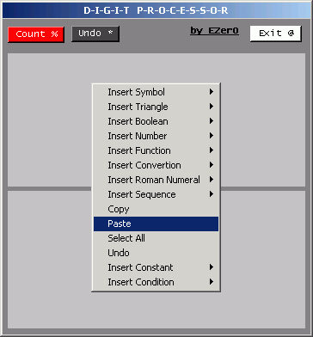
All you need is at hand in MAT-EZ. There are three buttons on MAT-EZ window. Count, Undo and Exit. Count executes analysis of entered text in Input text area (top one) and prints result into Output text area, (bottom one). Undo button reverts to previous calculation. Exit button closes MAT-EZ program. By clicking by EZer0 caption a familiar welcome window is opened.
MAT-EZ has a context menu which is activated through right-click on Input text area. All functions, constants, operations can be entered by means of context menu.

3. Arithmetical Operators:
As a string interpretative program MAT-EZ uses a number of conventions for arithmetic operations. Below is a list of such conventions:
Operation | Symbol in MAT-EZ | Common notation
Addition ** | 5+3 | 5+3
Subtraction | 5-3 | 5-3
Division ** | 5/3 | 5:3 or
Multiplication ** | 5*3 | 5×3 or 5•3
Power Raise ** | 5^3 | 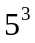
Root of power ** | 5√3 | 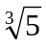
Integer division ** | 5\3 | n/a
Remainder ** | 5%3 | n/a
Factorial * | !5 | !5
Absolute * | |-5| | |5|
Double Factorial * | !!5 | !!5
Ceiling * | 〙5.1〚 | 〙5.1〚
Floor * | 〛5.1〜 | 〛5.1〜
Integer part * | [5.1] | [5.1]
* - These operations are used for one number only
** - These operations are used for two numbers only

4. Comparison Operators:
During usage of comparison special operators are used. Below is a list of such operators for MAT-EZ:
Operation | Symbol in MAT-EZ | Common notation
Is equal | 5==3 | 5=3
Is larger | 5>>3 | 5>3
Is below | 5<<3 | 5<3
Is below or equal | 5<=3 or 5=<3 or 5!>3 | 5≤3
Is larger or equal | 5>=3 or 5=>3 or 5!<3 | 5≥3
Is not equal | 5<>3 or 5><3 or 5!=3 | 5≠3

Comparison is used for IF…THEN...ELSE block or for simple true-false check.

5. Constants:
MAT-EZ has several built-in constants, including PI, Exponent, Golden ration and many others less common constants. Their usage is simple. Right-click the input window and in appeared context menu select Insert Constant, in sub-menu select the constant you need by clicking on it. A symbol of constant will appear, it will be counted after you press the Count Button.

6. Usage of functions:
There are many different functions in MAT-EZ and more is waited to come soon. All functions should be entered by means of context menu. While you can enter them by hand, they are hard to remember, so it is best to use this context menu.
There a one, two an multiple value (array) functions. When you separate values in two values function you should always enter ; sign between them. Multiple value functions, such as Max or Min, accept : sign as a separator.
Base conversion is an exception and has following syntax:
{F0001_Number_InputBase_OutputBase}
For example to convert number 34511 in number base 6 to number base 3, you should enter the following string: {F0001_34511_6_3}, for bases larger than 10-digit, MAT-EZ accepts letters from A to Z, for 11 to 36 correspondingly.
For example to enter some 18-digit number, you should use 0-9 digits and letters from A to H.

