NYC Restaurant Market Platform
  - Project scope and initial evidence • Prepared 7 October 2026
Build a public-data platform that helps prospective restaurant owners and existing operators compare possible concepts and locations in New York City. The first version supports exploratory decisions with restaurant supply, retail rent benchmarks and delivery economics. The meeting should confirm this scope and choose the next dashboard implementation.

User entry points
What the user knows | What the first version returns
A cuisine or restaurant concept | Compare that cuisine’s recorded supply across boroughs, then inspect ZIP-level counts.
A borough or ZIP code | Explore the local cuisine mix and compare relevant cost context where coverage exists.
Only that they want to open a restaurant | Start with a citywide overview and narrow the analysis using optional cuisine and location filters.

Research workflow and completed work
The working assumption is that users currently compare disconnected listings and reports manually; this needs validation with prospective users. The proposed workflow lets them enter a known preference, compare the available evidence, inspect its period and coverage, and export a shortlist for further research.
The current package reads six public sources, prepares 13 analysis tables, runs SQL aggregations and produces six charts. A local interactive prototype supports all three entry points, CSV downloads and an illustrative rent calculation. The restaurant snapshot contains 31,469 distinct active permit records; 3,860 lack cuisine information. Source data extracts, cleaning code, SQL and quality checks are included.

Next iteration and acceptance criteria
Rebuild the core supply view in one agreed BI tool, using the provided CSVs. Validate borough and cuisine filtering against the SQL totals, show missing data, and display the source date and unit beside each chart. Test all three user entry paths. A successful prototype returns consistent comparisons and makes unavailable information explicit. Tableau and Power BI instructions are included; native workbooks have not yet been created.

Decisions for the meeting
Confirm the first-version audience and scope, select Tableau or Power BI, and agree whether the next demand measure should be resident population or transit activity. Confirm the expected website format and evaluation criteria. Detailed revenue forecasts, labor-cost estimates and a composite opportunity score require additional evidence and are outside this first iteration.

Initial findings

Delivery growth needs a per-order view
From Q4 2024 to Q4 2025, average weekly deliveries grew 18.3%. The average subtotal less merchant platform fees rose from $24.08 to $24.26 per delivery, a 0.8% increase. This supports displaying fees alongside volume. The amount is before other restaurant costs and does not establish profit. [S2]
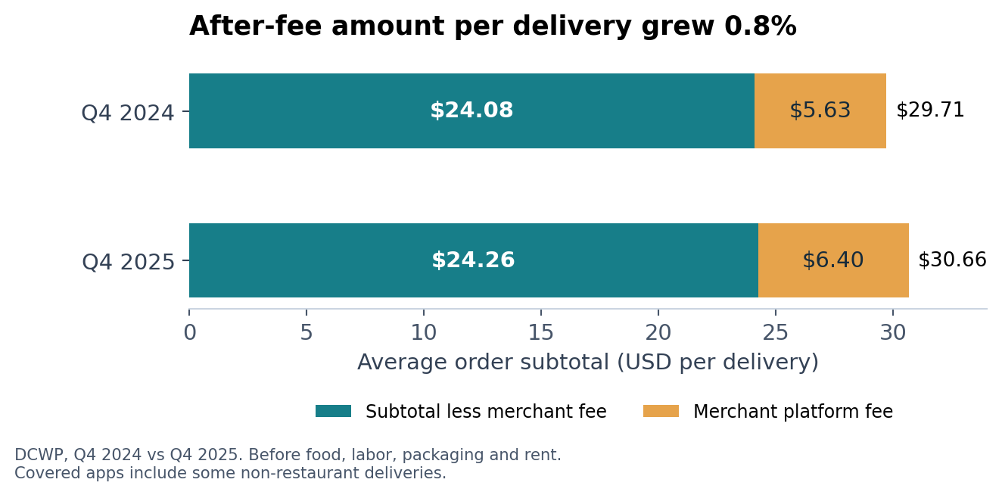

Location comparisons need rent context
In H1 2026, Times Square’s median retail asking rent was $1,328 per ground-floor square foot per year, versus $200 in the Financial District, a 6.6-fold difference. These benchmarks support cost comparisons; they do not confirm restaurant suitability or the rent available for an individual space. [S3]
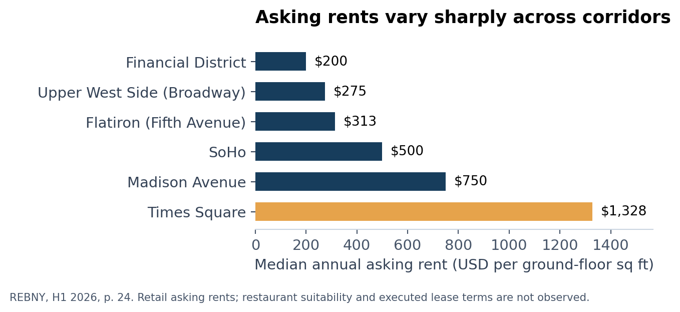
Sources [S2] NYC DCWP [S3] REBNY [S4] NYC Comptroller
Full source URLs, periods, definitions and limits are in source_catalog.csv and DATA_GUIDE.md.

