# CS 255 Business Requirements Document Template

Complete this template by replacing the bracketed text with the relevant information.

This template lays out all the different sections that you need to complete for Project One. Each section has guiding questions to prompt your thinking. These questions are meant to guide your initial responses to each area. You are encouraged to go beyond these questions using what you have learned in your readings. You will need to continually reference the interview transcript as you work to make sure that you are addressing your client’s needs. There is no required length for the final document. Instead, the goal is to complete each section based on your client’s needs.

**Tip:** You should respond in a bulleted list for each section. This will make your thoughts easier to reference when you move into the design phase for Project Two. One starter bullet has been provided for you in each section, but you will need to add more.

## System Components and Design

### Purpose

*What is the purpose of this project? Who is the client and what do they want their system to be able to do?*

* Client:
  + DriverPass
* Purpose:
  + DriverPass wants to create a way for soon to be drivers to be able to practice before trying to get their license.
  + Provide written practice tests and documentation for students to review.
  + Provide on-the-road driving practice to get students more comfortable behind the wheel before taking the driving portion of the license exam.

### System Background

*What does DriverPass want the system to do? What is the problem they want to fix? What are the different components needed for this system?*

* Problem to fix:
  + Students are unprepared for their tests
  + More than 65% of students fail to earn their driver's license on the first try
  + There are very few training options available to test takers
* What the system should do:
  + Give users the opportunity to pick their own training package
  + Give the users the ability to schedule their on-the-road training times
  + Saves data to be used for learning and analysis by DriverPass staff
  + Receive data from the DMV to update training curriculum
  + Have the ability to work both online and offline to view information
* Components needed for this system:
  + User interface
  + Security and authentication for user accounts
  + Scheduling system for on-the-road training
  + Database for staff analysis
  + Database for user accounts
  + Database for purchase logging
  + User account creation component
  + Notes area for taking and leaving notes/comments
  + Server/cloud to store/modify/transmit data
  + Server/cloud for security and backups
  + Tracking system for reservations
  + Test progress tracking

### Objectives and Goals

*What should this system be able to do when it is completed? What measurable tasks need to be included in the system design to achieve this?*

* What the system should do when completed:
  + Allow users to create an account.
  + Allow users to create/change/cancel on-the-road training.
  + Allow users to set pickup/drop-off locations
  + Allow users to buy different package levels for training
  + Allow users to reset login credentials
  + Create reports for DriverPass staff
  + Authenticate users at login
  + Restrict access to users based on their role
  + Allow comments/notes to be made for each user and driver
  + Contain training lessons for written exam
  + Contain practice tests for written exam
  + Allow users to view information offline
  + Allow Liam (Big boss) to download reports/ block access / and reset passwords
  + Store user information
  + Allow staff to register users when done over the phone
  + Track test progress and show it to the user
  + Include a page for contacting DriverPass
  + Have a way for DriverPass staff to contact the students
  + Ability to backup information

## Requirements

### Nonfunctional Requirements

*In this section, you will detail the different nonfunctional requirements for the DriverPass system. You will need to think about the different things that the system needs to function properly.*

#### Performance Requirements

*What environments (web-based, application, etc.) does this system need to run in? How fast should the system run? How often should the system be updated?*

* Environments the system needs to run in:
  + Phones, tablets, and computers via the web
* Speed of the system:
  + The system should be smooth
  + Webpages should load in less than 2.5 seconds
* How often should the system be updated:
  + System should be updated to show changes made by staff and users within 10 minutes.
  + System should be updated to show changes in content as needed.

#### Platform Constraints

*What platforms (Windows, Unix, etc.) should the system run on? Does the back end require any tools, such as a database, to support this application?*

* The system should be able to run on Windows, MacOS, Linux, and mobile devices via the internet. There will be a need for one or more databases to make this work on the back end. Making requests to the server will allow for use on multiple platforms.

#### Accuracy and Precision

*How will you distinguish between different users?* *Is the input case-sensitive? When should the system inform the admin of a problem?*

* We will distinguish between different users using an authenticator. Each user will have a unique username/email and password. The input of the password will be case-sensitive. The input of the username/email will not be case-sensitive. The system should inform the admin of a problem after a set number of failed attempts to access an account.

#### Adaptability

*Can you make changes to the user (add/remove/modify) without changing code? How will the system adapt to platform updates? What type of access does the IT admin need?*

* We can make changes to the user without changing the code if we create the code to do so from the beginning. We can store the user information in a database. If the user would like to add/remove/modify information on their account, we could do this with a crud design and modular programming. The system will adapt to platform changes on the front end. The backend should be able to stay consistent across different platform uses. The front end will change to take advantage of the abilities of the platform the user is on. The IT admin will need to be able to reset user passwords and monitor any issues within the system. The IT admin will need a high level of access to the system to be able to perform their job.

#### Security

*What is required for the user to log in? How can you secure the connection or the data exchange between the client and the server? What should happen to the account if there is a “brute force” hacking attempt? What happens if the user forgets their password?*

* Username/email and password will be required for the user to log in. We can secure the connection or data exchange between the client and server by setting up an encryption system to work in both directions. If there is a brute force attempt at entering an account, there should be a max login attempt amount that locks the user out after a certain number of missed attempts. After this, the user will have to reset their account password via a reset using their email address or contacting DriverPass to reset it. The same will happen if the user forgets their password. There should be a button to reset the password, or they can call in to reset their password.

### Functional Requirements

*Using the information from the scenario, think about the different functions the system needs to provide. Each of your bullets should start with “The system shall . . .” For example, one functional requirement might be, “The system shall validate user credentials when logging in.”*

* The system shall allow users to create an account.
* The system shall validate user credentials when logging in.
* The system shall lock out an account after too many attempts to enter.
* The system shall allow users to reset their login information.
* The system shall allow users to take practice tests.
* The system shall allow users to schedule/reschedule/cancel on-the-road practice.
* The system shall allow users to see their progress on tests/lessons.
* The system shall generate downloadable reports for staff.
* The system shall allow users and drivers to leave notes on a user account.
* The system shall show testing progress to users.

### User Interface

*What are the needs of the interface? Who are the different users for this interface? What will each user need to be able to do through the interface? How will the user interact with the interface (mobile, browser, etc.)?*

* The interface needs to be fast loading. It needs to allow users to view their account information, testing information, notes, scheduled drive times, etc.. There are three levels of users for the interface. Big boss (Liam), staff, and users are the three levels of access or types of accounts that are needed. Liam needs to be able to see and have access to everything. He needs to be able to see user data, his own data, be able to view and download reports, cancel packages, update parts of the system, and delete account access when needed. Staff level access will be able to see user information. They will need to be able to help with resetting passwords and registering users over a phone call. The users will need to be able to use the system to prep for their testing. They will need to be able to take practice tests, schedule driving practice, view and create notes, reset their password, register their account, view their testing progress, and view course information. The user will interact with the interface via the browser. The system will be web based. They will have access to it on any system that runs a browser and has internet connection.

### Assumptions

*What things were not specifically addressed in your design above? What assumptions are you making in your design about the users or the technology they have?*

* The user has an internet connection.
* The user has a device to access the system.
* The user has the ability to work their device.
* The device the user has is capable of running the system.

### Limitations

*Any system you build will naturally have limitations. What limitations do you see in your system design? What limitations do you have as far as resources, time, budget, or technology?*

* Budget will be low (Small company working in a local area with limited number of possible clients).
* Technology will be constrained due to the client pool being younger on average. They will not generally have money to have the latest or most powerful technology.
* Time will be limited. To keep the budget low, the product will need to be produced in a short timeframe.

### Gantt Chart

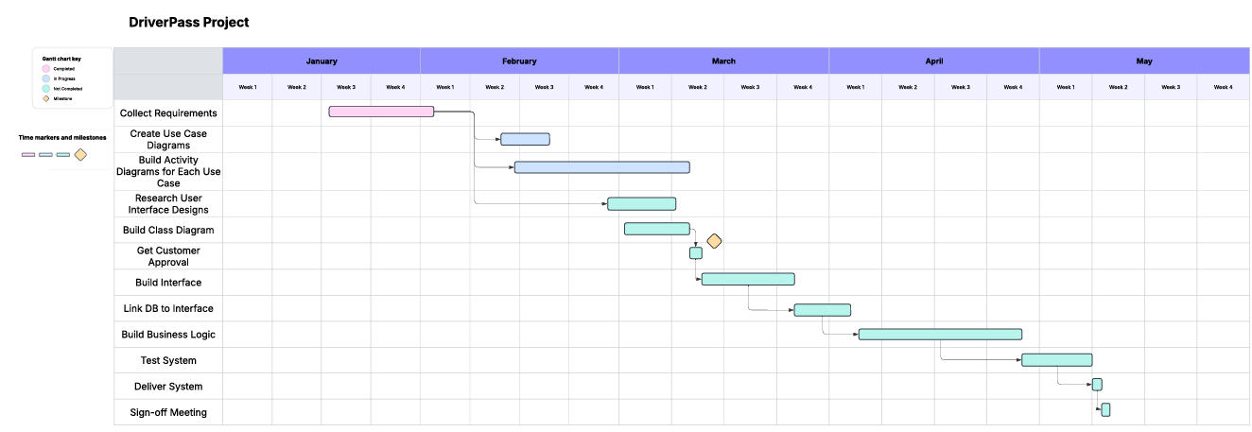*Please include a screenshot of the GANTT chart that you created with Lucidchart. Be sure to check that it meets the plan described by the characters in the interview.*