CSE534 Multimedia Systems Assignment1

Student Name: Chen, Shih-Chia

Student ID: 50207079

Problem (1)

(a) Record of the speech: Speech.wav

(c) Original recorded samples:

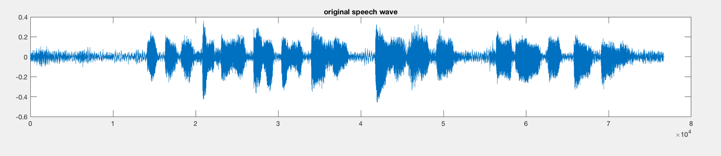

(d) (i) (ii) (iii) (iv) estimated parameters in list.xlsx

(v) Reconstruct by: $s(n)=\sum_{k=1}^{p=10}{a_{k}*s(n-k)}$ + e(n) , where e(n) = G\*u(n)

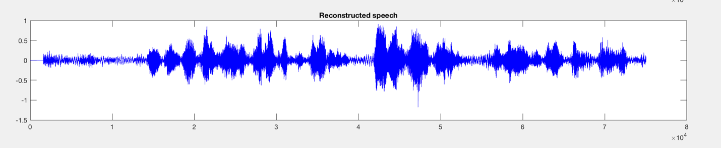

(e) MultiHw1.m

(f)Another reconstruction by [2]:

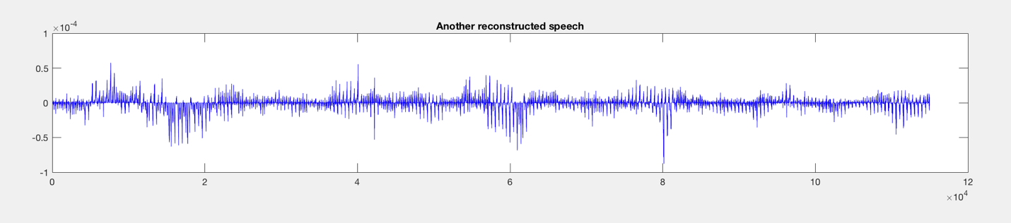

(g)

In the first reconstructed speech, it was similar with the original speech. Since the reconstructed equation still contain the original signal, which made them look similar. Also, the wave reduced in the first reconstruction, because of the voiced/unvoiced detection. In the code, we discarded the unvoiced frames, which were assigned 0 value. Then, got the reconstructed speech above.

However, in the second reconstruction, there were differences from the original, and even the first reconstruction in some part of the wave. Therefore, we knew that the parameters estimation might have some mistakes.

Reference:

[1] <http://www.seas.ucla.edu/~ingrid/ee213a/speech/vlad_present.pdf>

[2] <http://kom.aau.dk/group/04gr742/pdf/LPC_worksheet.pdf>