CSE 534 Multimedia Systems

Research on image compression JPEG in WIFI network

Name: Chen, Shih-Chia

Student ID: 50207079

Date of submission: May 18 2017

1. Introduction

In reference [1], it adapts the image compression parameters in order to deal with the wireless network difficulties, bandwidth and energy consumption. The image compression algorithm used in this issue is JPEG. It presents an approach to help choose the parameters, which lead to the optimal performance, and also meets other requirements, such as latency, bandwidth and the quality of image.

In reference [2], the topic focus on the effect of network-conscious on image compression. In order to have a better performance of transmitting the image through the network, not only reaching the minimum image size, but also the image compression algorithm should be taken into consideration.

In reference [3], it mentions eight image compression algorithms. Then after evaluation, we can find out that Set-Partitioning in Hierarchical Trees wavelet-based image compression is the most efficient algorithm for the wireless sensor network and it is also simple for programmer.

In reference [4], due to the fact that in the wireless sensor network, there are several challenging parts such as limited bandwidth, power, storage capability, and battery constraints of the appliances, finding an energy-efficient image compression algorithm can be a possible solution. An efficient compression scheme is presented in the paper to deal with the energy issue, and at the same time, meeting the requirement of the bandwidth constraint and image quality.

In reference [5], it presents an efficient image compression algorithm in the wireless multimedia sensor network by utilizing the lifting scheme to address the SPIHT coding to wavelet biorthogonal CDF 9/7. There are two advantages that help to reach this goal. One is that it can save the energy; the other one is improvement of the Quality of Service. In order to observe how the method saves energy, there are two experiments will be conducted. First, send an original image. Second, send the compressed image by implementing this method.

The idea to choose this topic came from the image people saw on the social network or Internet. Sometimes when people are checking out Facebook or surfing on the Internet, it always needs a few seconds for the images to clearly display on the pages. Then, I came up with an idea if what factor will affect the displaying or delivering time. After narrowing my ideas, I choose to do a research on how image compression parameters chosen can affect the transmission time through WIFI, and start to find some related materials.

The project will be implemented by the following steps:

First, select a grayscale image and encoding it with JPEG standard, with certain parameters.

Second, calculate how long will it take to transmit the original image and the grayscale image through WIFI network.

Third, decode the grayscale image, and compare if there is any difference between this two grayscale image.

Forth, change the encoding parameters, and repeat the above steps.

Fifth, compared all the encoding, decoding and transmission time, to find the best performance.

1. Proposed Approach

Use Matlab to encode and decode the grayscale image, and get the images.

Then calculate the transmission time.

Based on the transmission time and the bit stream length, we can roughly estimate the performance of transmitting through WIFI.

Code: Multi_final.m

1. Outcome

The quantization table:

Q1 = [16 11 10 16 24 40 51 61;

12 12 14 19 26 58 60 55;

14 13 16 24 40 57 69 56;

14 17 22 29 51 87 80 62;

18 22 37 56 68 109 103 77;

24 35 55 64 81 104 113 92;

49 64 78 87 103 121 120 101;

72 92 95 98 112 100 103 99];

The WIFI transmit rate = 365Mbps (802.11ac).

The WIFI is UB’s network: eduroam.

The following images outcomes are the result of changing parameter, virtual block size(VBS). We change the VBS from the normal size 8x8 decrease to 5x5. The figure is referenced from the reference [1]. We eliminate the values which are not in the 5x5 VBS, assign 0 to all these values.

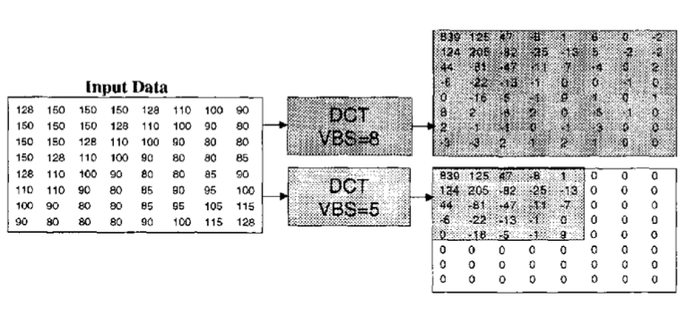

|  |  |  |
| --- | --- | --- |
| The original image | The reconstruct image | |
|  |  | |
| Use the following parameters:  Virtual Block Size (VBS) = 8x8  The result:  Psnr = 37.4514  Ratio = 5.2332  Size of the encoding image = 1602959 | | |
| The original image | | The reconstruct image |
|  | |  |
| Use the following parameters:  Virtual Block Size (VBS) = 7x7  The result:  Psnr = 37.4515  Ratio = 5.2332  Size of the encoding image = 1602959 | | |

|  |  |
| --- | --- |
| The original image | The reconstruct image |
|  |  |
| Use the following parameters:  Virtual Block Size (VBS) = 6x6  The result:  Psnr = 37.4514  Ratio = 5.2334  Size of the encoding image = 1602898 | |

|  |  |
| --- | --- |
| The original image | The reconstruct image |
|  |  |
| Use the following parameters:  Virtual Block Size (VBS) = 5x5  The result:  Psnr = 37.4478  Ratio = 5.2341  Size of the encoding image = 1602683 | |

1. Summary and Discussion

From the above images and statistics, we can observe several points.

First, although we change the size of virtual block size, the result only has slightly difference from the original greyscale. Also, there are slightly difference from each modified image. The image with the smaller virtual block size are more different from the original image than the one with bigger size. Therefore, this parameter, VBS, does not cause obvious difference on the image, although it is not same as the original image.

Second, the peak signal to noise ratio (psnr), ratio, and the size of the encoding image do not change dramatically between these experiments. This indicates that changing VBS does not have a huge effect on the image.

Third, since the size of the encoding image does not change a lot, the transmission time through WIFI are almost the same.

According to the above points, we can consider to change other parameters to check if there will be any obvious difference. However, if there is obvious difference, then the reconstruct image may not look similar to the original image, and this result is not what we expect in the image encoding and decoding. The reason we try to change the parameters is to find a better performance of image compression transmitting through WIFI. If this changing can show dramatic difference, but does not guarantee the similarity of the original image, then we should better try another changing.

The transmission performance of the WIFI, does not show large difference, either. In the five literature references, three of them compare the difference in the wireless sensor network. They compare the energy consumption, latency and other features in the wireless sensor network. If we have more equipment, then it is better to do the research on wireless sensor network rather than the WIFI, since the features of the WIFI is not as apparent as the wireless sensor network.

1. Reference

[1] Taylor, C., & Dey, S. (n.d.). Adaptive image compression for wireless multimedia communication. ICC 2001. IEEE International Conference on Communications. Conference Record (Cat. No.01CH37240). doi:10.1109/icc.2001.937125

[2] Iren, S., Amer, P. D., & Conrad, P. T. (1998). Network-conscious compressed images over wireless networks. Interactive Distributed Multimedia Systems and Telecommunication Services Lecture Notes in Computer Science, 149-158. doi:10.1007/bfb0055313

[3] Chew, L. W., Ang, L., & Seng, K. P. (2008). Survey of image compression algorithms in wireless sensor networks. 2008 International Symposium on Information Technology. doi:10.1109/itsim.2008.4631875

[4] Nasri, M., Helali, A., Sghaier, H., & Maaref, H. (2010). Energy-efficient wavelet image compression in Wireless Sensor Network. 2010 International Conference on Wireless and Ubiquitous Systems. doi:10.1109/icwus.2010.5670430

[5] Haouari, B., Khelifa, B., & Mohammed, B. (2016). Image Transmission Model with Quality of Service and Energy Economy in Wireless Multimedia Sensor Network. International Journal of Advanced Computer Science and Applications, 7(2). doi:10.14569/ijacsa.2016.070224