CSE 676 Deep Learning

Project Report 1

Convolutional Neural Network for age estimation based on facial images

Team 8:

Jiawei Zhao 50207069

Shih-Chia Chen 50207079

Title: Applying CNN for age estimation based on facial images

1. Project Description

* Task Type: classification
* Task Description: Applying CNN to learn age estimation by training them through some facial images (approximately 25,000), and then using some other images (5,000) to test the model. The goal is to get a model with which if we feed in a facial image, it gives us an age between 0 and 100 for that person.

1. Dataset

* Dataset: IMDB-WIKI facial images
* Dataset Description: The images from the dataset, which is 1 GB, are from wiki and only contain faces. The dataset comes with a mat file, in which there is a dictionary that maps between a image and its celebrity’s information like name, DOB, time photo taken, etc. The detailed description for the dataset is on the link below.
* Dataset link: https://data.vision.ee.ethz.ch/cvl/rrothe/imdb-wiki/

1. Machine Learning Method

* Model: CNN
* Architecture: CNN with two convolutional layer, two max pooling layer and one fully-connected layer
* Optimization: tf.train.AdamOptimizer()

1. Performance Measure

* Accuracy: using test dataset to compute the accuracy of the model we applied, we might take an age range as correct.
* Expected Result: Since our dataset is only part of the IMDB-WIKI dataset, also, the age range is huge (0-100), so the testing accuracy might not be so great, but we are confident that it would do better than random guess or at least reach a decent accuracy given a guessing range.

1. Main Challenges
   * Image data are tend to be rather large and consume lots of computing resource when we apply CNN, also the image data may not be uniform. Hence a preprocess of those images is required. For our particular needs, we convert all images to the same resolution as 100*100, and use grayscale images, since the color of image is somewhat irrelevant to age estimation.
   * Age estimation can be hard because the range is too big, which is from 0 to 100, and there’re 100 possible labels, so if we check for exact match, then the output might be very bad, so instead we take a range as match, for example, if the person’s age is 35, then it’s fine if our guess lies within [32,38] inclusively.
   * Convolutional Neural Networks generates heavy computation pressure and long runtime, hence we applied google cloud platform and run our code on the remote machine.

1. Results

* We measure the accuracy and the loss in four different ranges of age:

1. Check if the result is in the exact age
2. Check if the result lies in the interval of the exact age -1 to age +1
3. Check if the result lies in the interval of the exact age -3 to age +3
4. Check if the result lies in the interval of the exact age -5 to age +5

* Accuracy Table

|  |  |  |  |  |
| --- | --- | --- | --- | --- |
| Range of age | exact age | [age-1, age+1] | [age-3, age+3] | [age-5, age+5] |
| Accuracy | 53.71% | 87.55% | 93.62% | 97.48% |

* Loss Graph

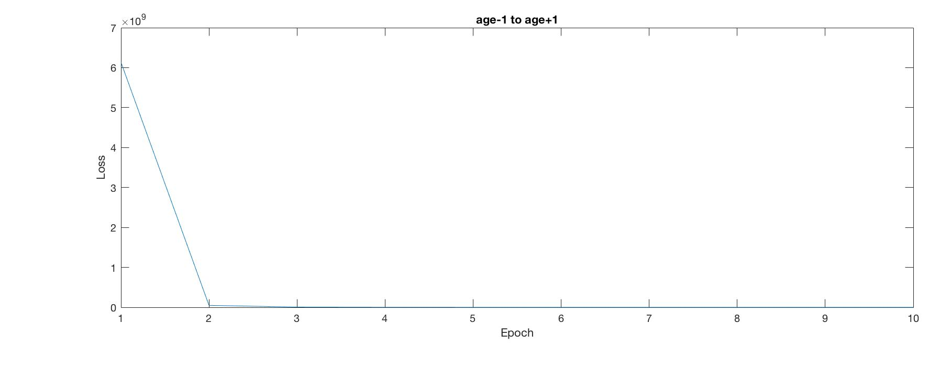

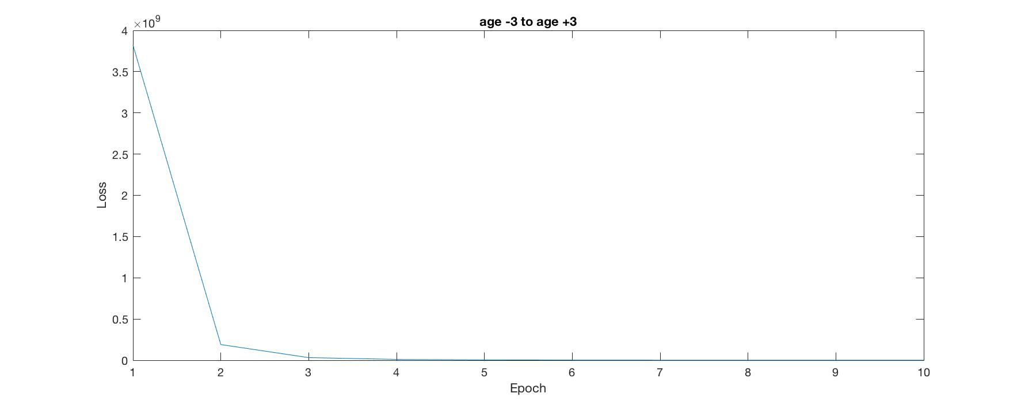

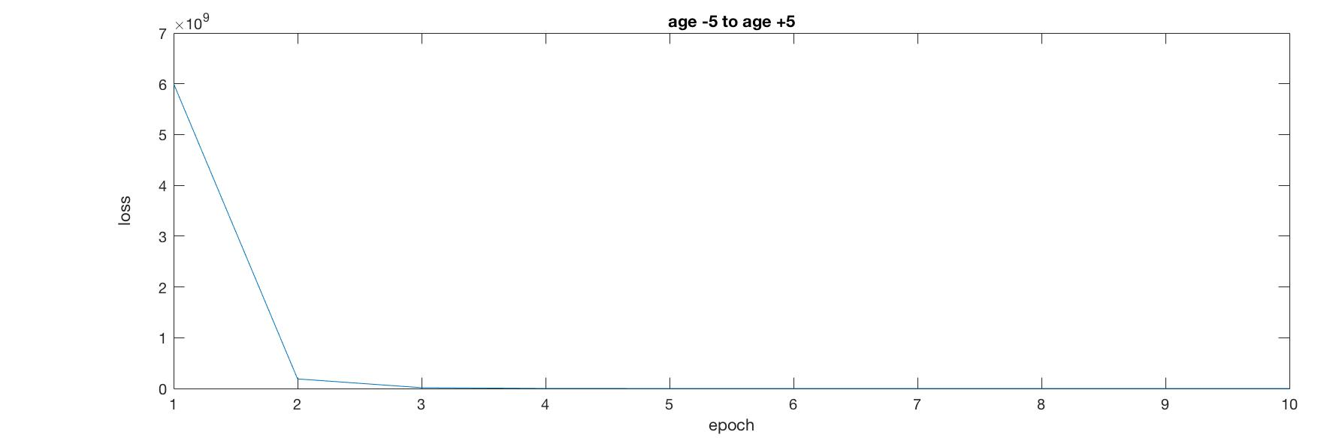

* We find out that if the range of correct age is wider, the accuracy will be higher. Since the training dataset we used is not big enough, result of the exact age is low, around 60%. However, if we try to train the whole IMDB-WIKI dataset, it will take several days. Therefore, we decide to train only a part of the dataset, in order to reduce the training time, and also widen the correct age range to increase the accuracy. And we can see, with only a small change to the age range, ie. [age-1, age+1], the accuracy has a significant increase.