Hyperledger Installation

1. Install Ubuntu on Virtual box for Windows.

<https://medium.com/@tushar0618/install-ubuntu-16-04-lts-on-virtual-box-desktop-version-30dc6f1958d0>

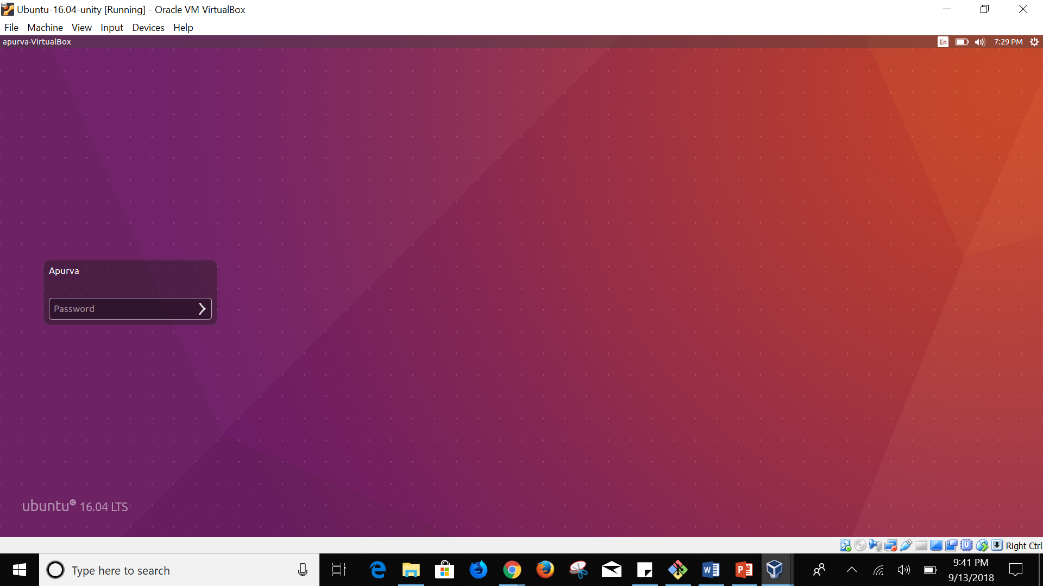

1. Create EC2 instance

<https://medium.com/@GalarnykMichael/aws-ec2-part-1-creating-ec2-instance-9d7f8368f78a>

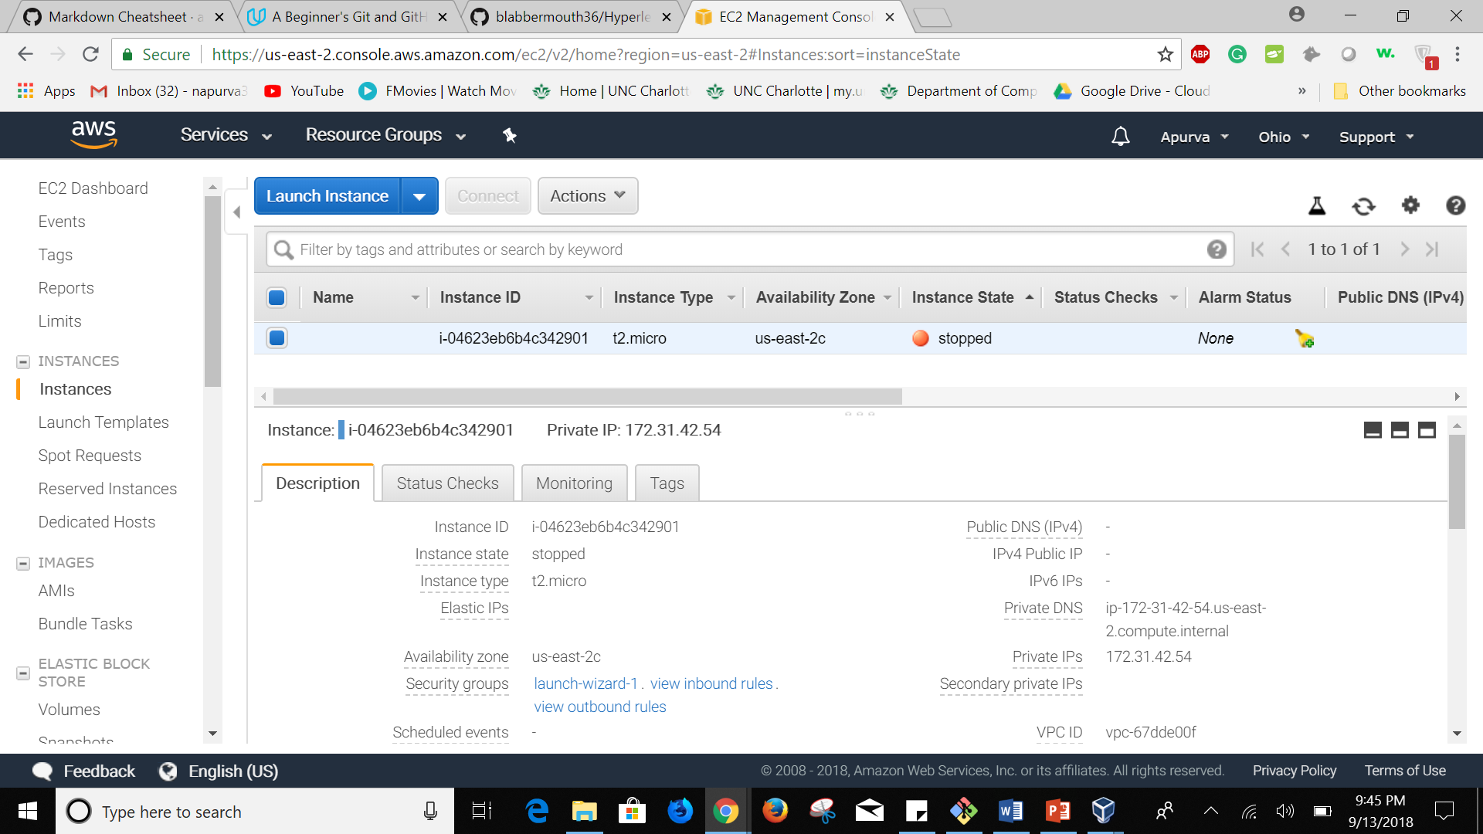

1. Connect to AWS instance from Ubuntu terminal

* Go to the folder containing the private key file (.pem)
* Execute the below command

ssh -i "basicnetwork.pem" ubuntu@Public DNS

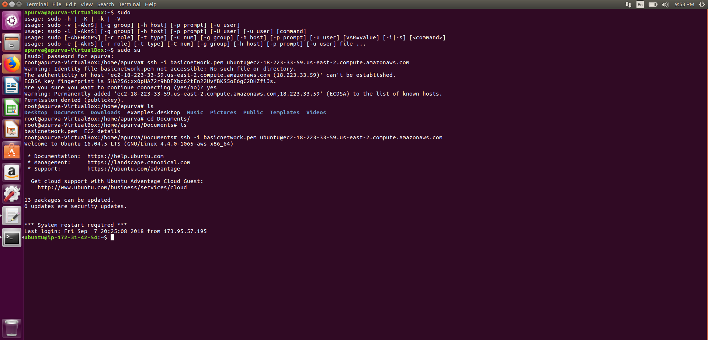

1. Install prerequisites
2. Install git
3. apt-get update
4. apt-get install git-core
5. git --version
6. Install curl
7. apt-get install curl
8. curl --version
9. Install Python v2
10. python --version
11. Install node
12. apt-get install nodejs
13. apt-get install npm
14. nodejs --v
15. Install Go
16. apt install golang-go
17. go version
18. In bashrc, set the below

export GOROOT=/usr/local/go

export GOPATH=$HOME/digcerti

export PATH=$GOPATH/bin:$GOROOT/bin:$PATH

1. Install Docker
2. Add GPG key for the official Docker repository to the system

curl -fsSL https://download.docker.com/linux/ubuntu/gpg | sudo apt-key add –

1. Add the Docker repository to APT sources:

sudo add-apt-repository "deb [arch=amd64] https://download.docker.com/linux/ubuntu $(lsb_release -cs) stable"

1. Next, update the package database with the Docker packages from the newly added repo:

sudo apt-get update

1. Make sure you are about to install from the Docker repo instead of the default Ubuntu 16.04 repo:

apt-cache policy docker-ce

1. Finally, install Docker:

sudo apt-get install -y docker-ce

1. Docker should now be installed, the daemon started, and the process enabled to start on boot. Check that it's running: sudo systemctl status docker add your username to the docker group:

sudo usermod -aG docker ${USER}

1. You will be prompted to enter your user's password to continue. Afterwards, you can confirm that your user is now added to the docker group by typing:

id -nG

1. Install Docker compose
2. sudo curl -L https://github.com/docker/compose/releases/download/1.22.0/docker-compose-$(uname -s)-$(uname -m) -o /usr/local/bin/docker-compose
3. Apply executable permissions to the binary:

sudo chmod +x /usr/local/bin/docker-compose

1. Test the installation.

$ docker-compose –

1. After installing docker-compose, restart ubuntu.

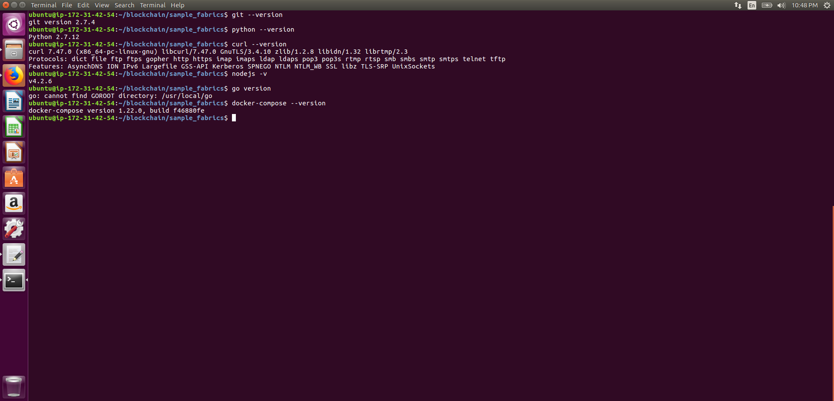

1. Launch network
2. Enter into the first-network directory. Generate the required certificates and artifacts for your first network

$ ./byfn.sh -m generate

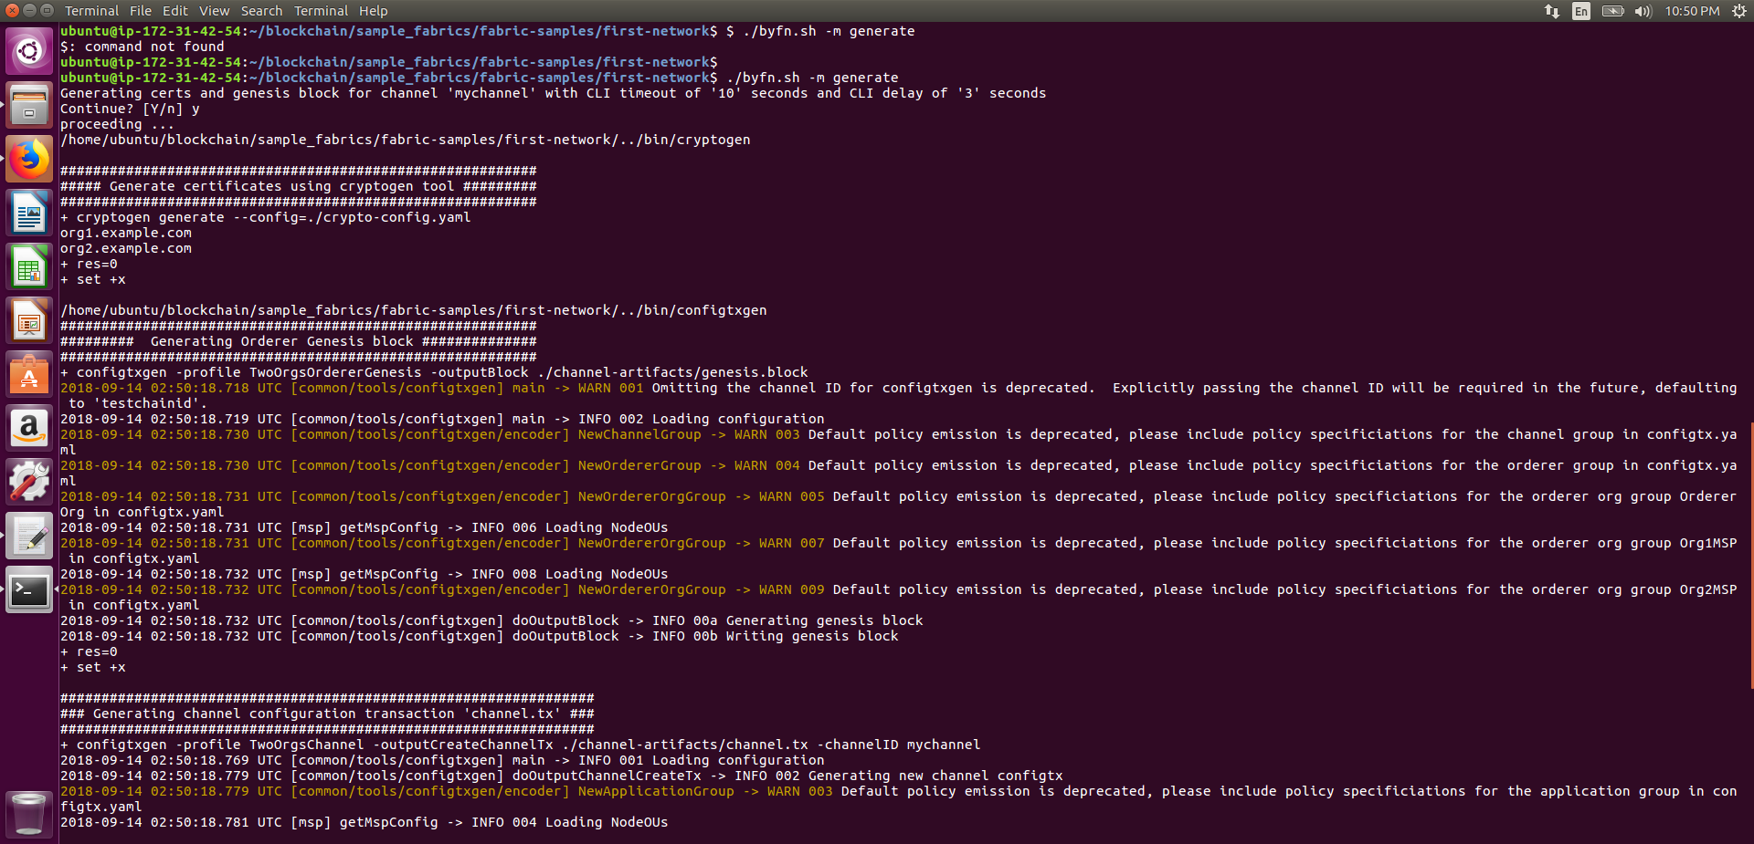

1. To see the generate certificates use the following command:

$ cd crypto-config

$ ls

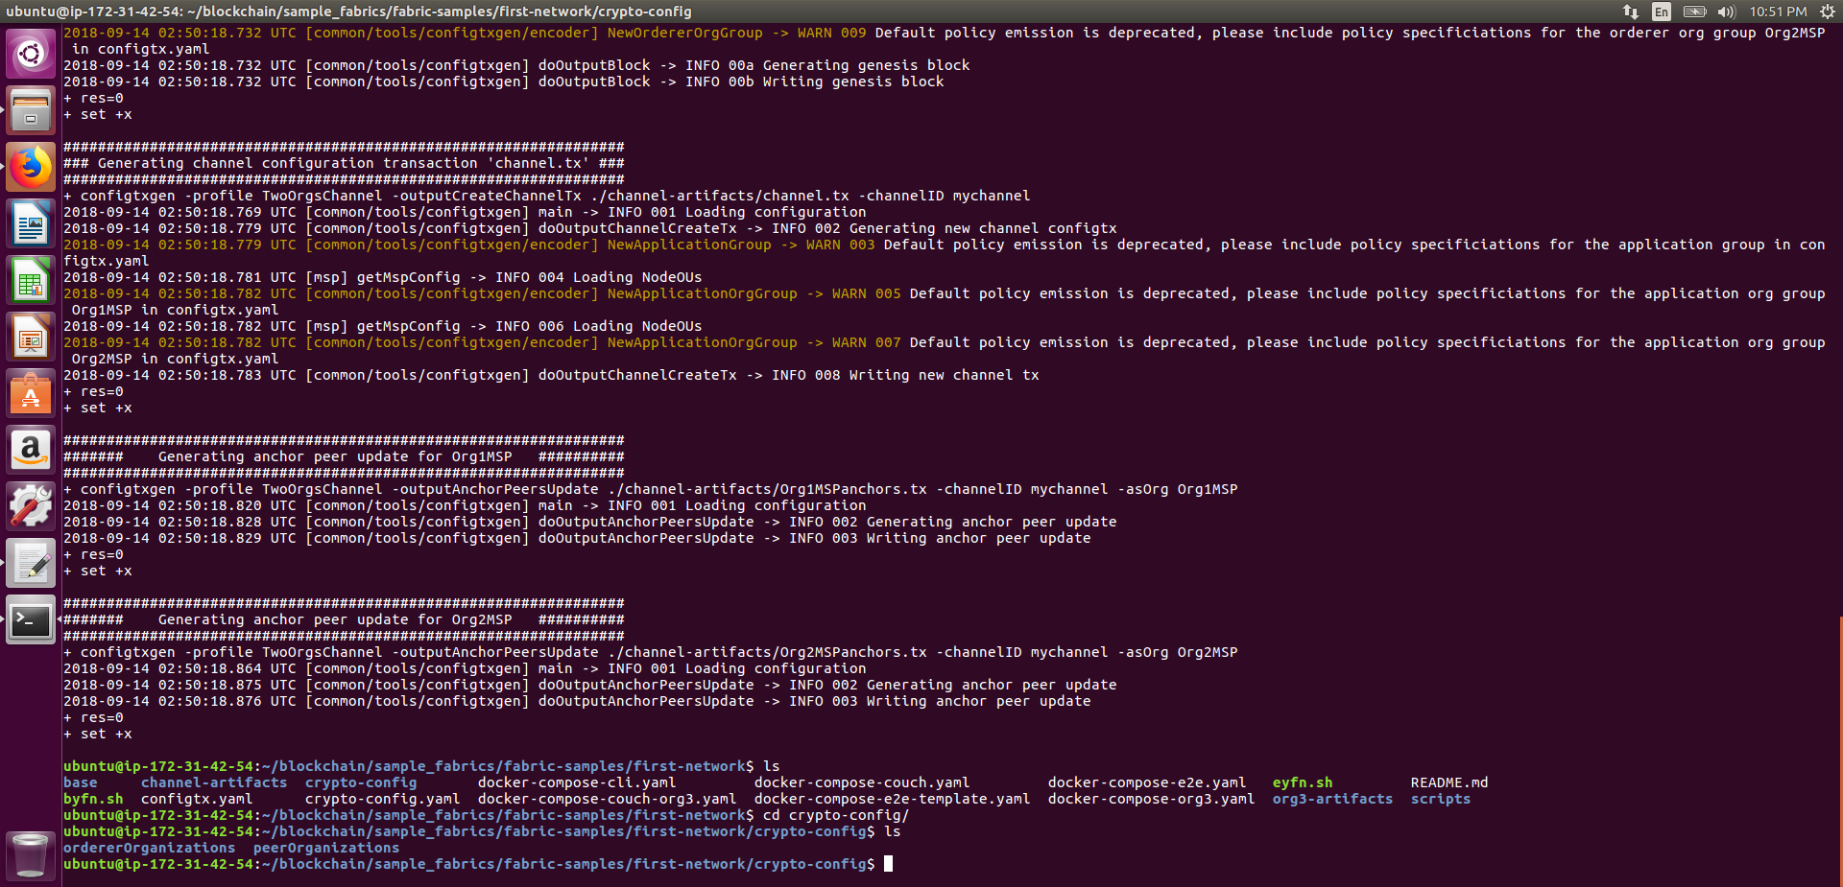

1. Create your first network using the following command

$ ./byfn.sh -m up

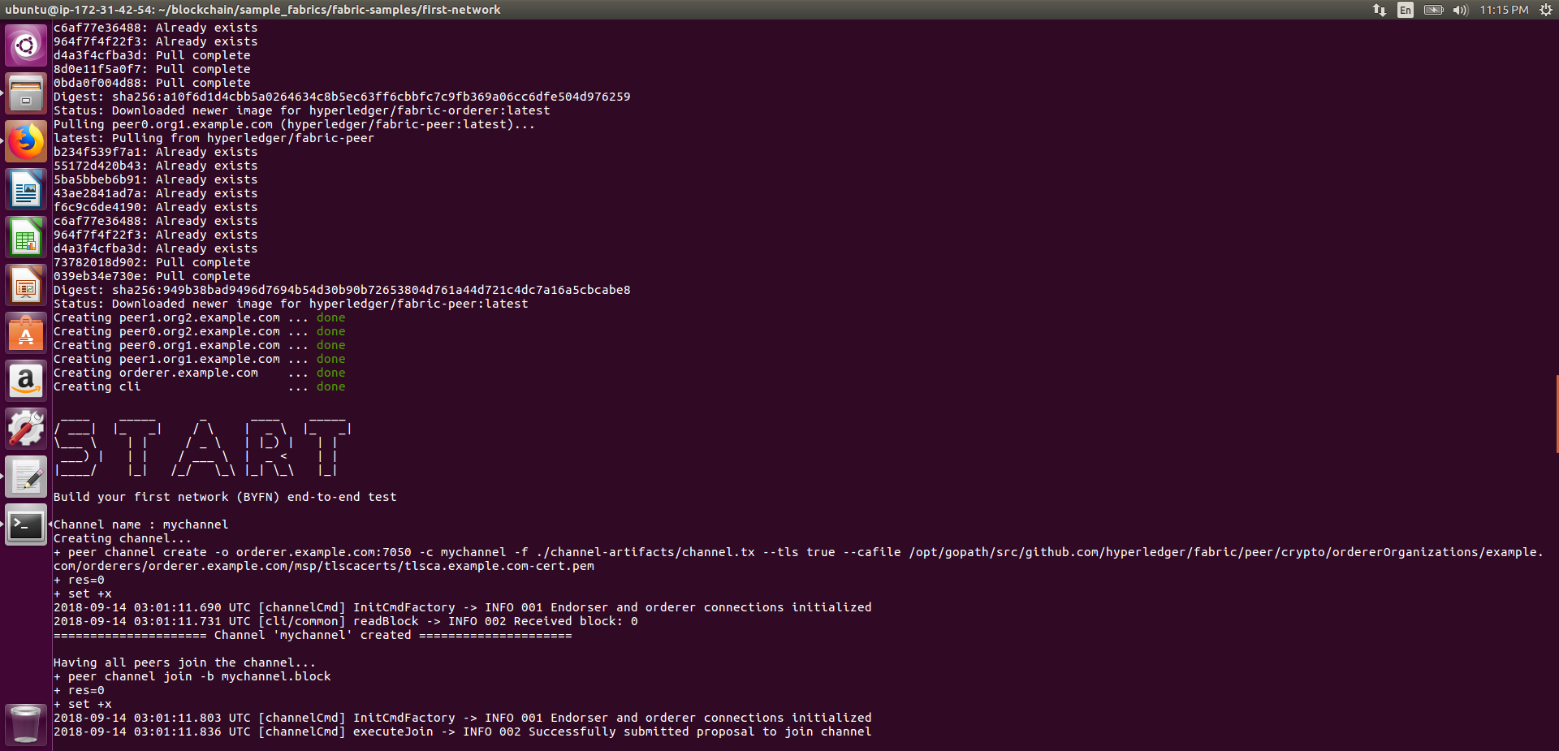

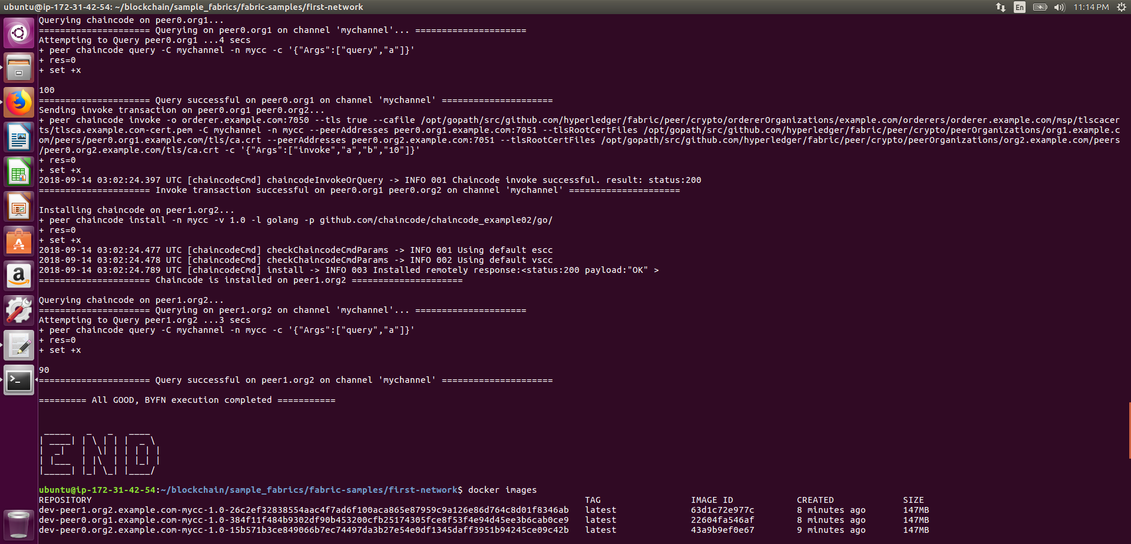

1. Check the generates images and running containers using the following command:

$ docker images

$ docker ps

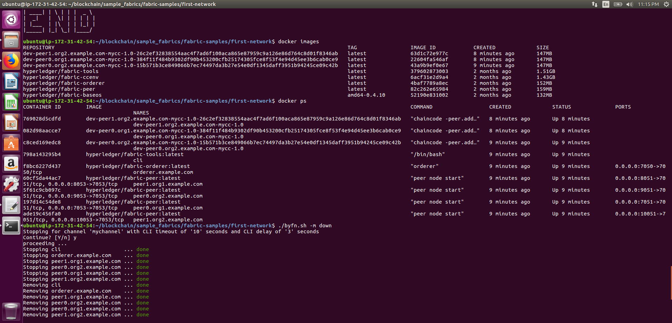

1. To bring down the created network executed the following command

$ ./byfn.sh -m down

1. You can check the created images have been removed using the following:

$ docker images

