|  |  |  |
| --- | --- | --- |
| A | X1 | X2 |
| S1 | S1/y2 | S3/y2 |
| S2 | S2/y2 | S2/y1 |
| S3 | S4/y1 | S3/y2 |
| S4 | S3/y1 | S2/y2 |

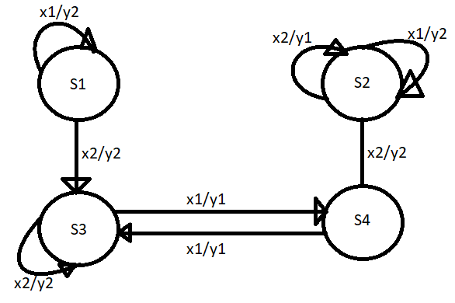S1={(S1,y1)}=S1’

S2={(S2,y1), (S2,y2)}=S2’,S3’

S3={(S3,y1),(S3,y2)}=S4’,S5’

S4={(S4,y1)}=S6’

x1 S1’= S1’ x1 S4’S5’ = S6’

x2 S1’= S5’ x2 S4’S5’ = S5’

x1 S2’S3’= S3’ x1 S6’ = S4’

x2 S2’S3’= S2’ x2 S6’ = S3’

|  |  |  |
| --- | --- | --- |
|  | X1 | X2 |
| S1' | S1' | S5' |
| S2' | S3' | S2' |
| S3' | S3' | S2' |
| S4' | S6' | S5' |
| S5' | S6' | S5' |
| S6' | S4' | S3' |

